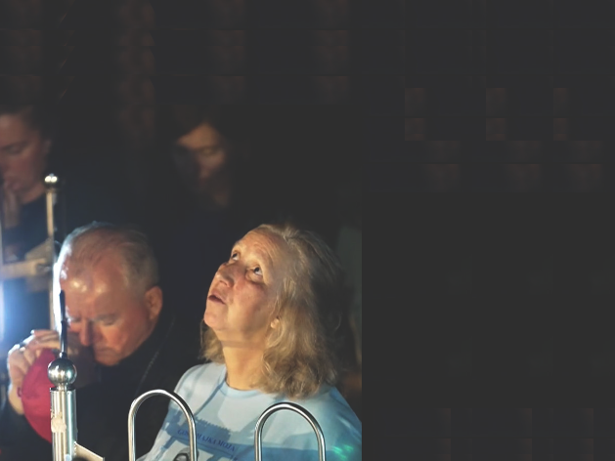
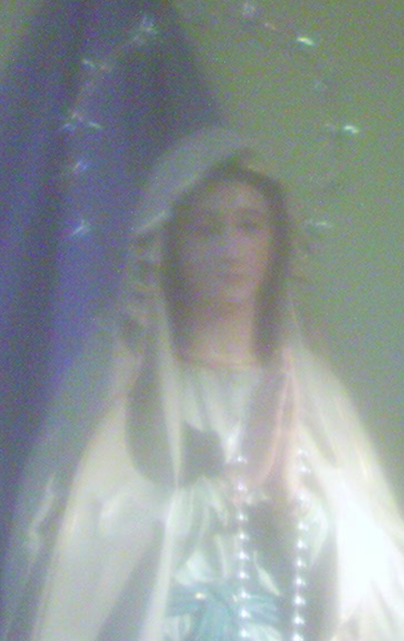
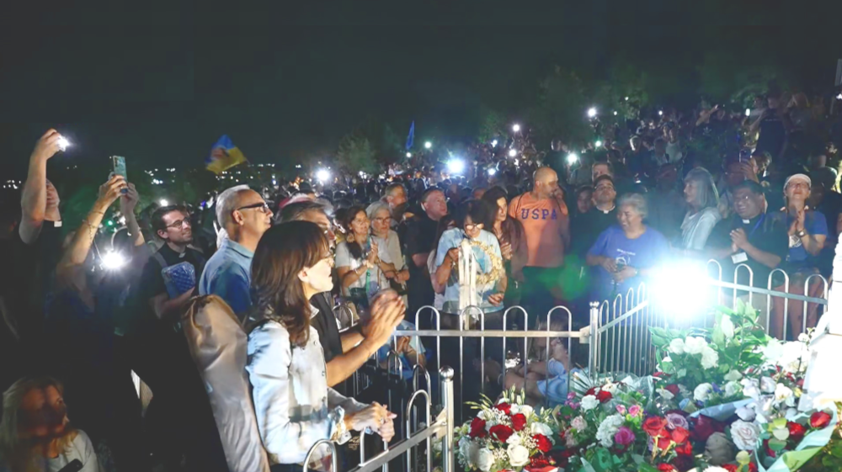
Our Lady’s Apparitions and Messages May 25th – August 25th 2026
English
through Marija Pavlović and Ivan Dragičević

Međugorje
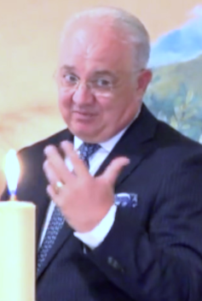
45th Anniversary Novena from MaryTV
All Apparitions and messages to Ivan from this period from MaryTV

More

Our Lady’s Apparitions and Messages May 25th – August 25th 2026
English
through Marija Pavlović and Ivan Dragičević

Međugorje
45th Anniversary Novena from MaryTV
All Apparitions and messages to Ivan from this period from MaryTV

More

Our Lady’s Apparitions and Messages May 25th – August 25th 2026
English
through Marija Pavlović and Ivan Dragičević

Međugorje
45th Anniversary Novena from MaryTV
All Apparitions and messages to Ivan from this period from MaryTV

More

Our Lady’s Apparitions and Messages May 25th – August 25th 2026
English
through Marija Pavlović and Ivan Dragičević

Međugorje
45th Anniversary Novena from MaryTV
All Apparitions and messages to Ivan from this period from MaryTV

More

Our Lady’s Apparitions and Messages May 25th – August 25th 2026
English
through Marija Pavlović and Ivan Dragičević

Međugorje
45th Anniversary Novena from MaryTV
All Apparitions and messages to Ivan from this period from MaryTV

More

The words of the Most Holy Virgin, which She said in Croatian to seers from Međugorje, and report of Her apparitions to them, we believe it is God’s will that they reach many and more people because those signs from Heaven[*] and those Heavenly words are capable of converting and saving people, so that peace may reign in the hearts, in the families and in the whole world.
For that we strive, and we are happy when these booklets are sought and read, as well as the latest messages (while still on separate leaflets).
But our reach is very limited, and we neither have means nor work capacity to do more. On a monthly basis, thousands of single leaflets with the latest message and hundreds of booklets with messages and apparitions, cover only a small part of Zagreb and reach to only a few other places in Croatia. And the counterepart English copies reach even shorter.
⁻⁻⁻⁻⁻⁻⁻⁻⁻⁻⁻⁻⁻⁻⁻⁻⁻
[*] Every apparition is a sign per se. See 1) Jim Caviezel’s witnessing on an apparition, 5th leaf, book. 1st half of 2025 2) the MaryTV video of June 21st 2026 this book.: the nun at Marija’s side sees Gospa too?

https://croatiafidelis.hr/cenz/
If any official or lay subject in the Church in Croatia or larger would be willing to take over even the entire project, in ways faithful to the recognition of Međugorje by Ruini’s commission[**], we are willing to hand the project over to them, if they can reach much larger and further than us.
And should access to our pages not be hindered, see to the right, it could be possible to spread the reach of these materials with Our Lady’s messages and apparitions if other laymen like us recognized the need and also started printing these booklets.
To that purpose we offer for download Office documents of our booklets, see the last pages of this booklet, so they can be printed elsewhere in Croatia (and those in English in the world).
But access to most of what we do is often hindered. And Internet is not surveilled by maverick hackers but often employees at companies and even state institutions illegally do censorship and regularly successfully hide it: visibility filtering is often used, as well as spoofing access to pages, even modifying those pages while serving them.
⁻⁻⁻⁻⁻⁻⁻⁻⁻⁻⁻⁻⁻⁻⁻⁻⁻
[**] Yes that was the official finding of the Papal commission of the Church and any later interpretations and findings, if they contradict it, are not correct. Read Crd. Ruini’s statement in 2024: “It really was Our Lady who spoke.” 4th leaf book. 2025 to 2026


You have proofs of censorship if you manage to successfully access the content that we posted on location at top (use the QR-code).
The head of the Association has been, by here mentioned, exposed to even worse internet violence than what is described to the left. They methodically try to control all his computers, and any transaction outside of country has been denied to him.
We will nevertheless dedicate most of our time to producing these booklets, and what free time remains, to solving these issues. And may God give as He wills.



Association Croatia Fidelis
Vankina 4, 10020 Zagreb
contact: Miroslav Rovis, miro.rovis@croatiafidelis.hr,
miroslav.rovis@proton.me,
+385 1 6602633
+385 91 2660202

version 2026-08-27
not
for sale
The words of the Most Holy Virgin, which She said in Croatian to seers from Međugorje, and report of Her apparitions to them, we believe it is God’s will that they reach many and more people because those signs from Heaven[*] and those Heavenly words are capable of converting and saving people, so that peace may reign in the hearts, in the families and in the whole world.
For that we strive, and we are happy when these booklets are sought and read, as well as the latest messages (while still on separate leaflets).
But our reach is very limited, and we neither have means nor work capacity to do more. On a monthly basis, thousands of single leaflets with the latest message and hundreds of booklets with messages and apparitions, cover only a small part of Zagreb and reach to only a few other places in Croatia. And the counterepart English copies reach even shorter.
⁻⁻⁻⁻⁻⁻⁻⁻⁻⁻⁻⁻⁻⁻⁻⁻⁻
[*] Every apparition is a sign per se. See 1) Jim Caviezel’s witnessing on an apparition, 5th leaf, book. 1st half of 2025 2) the MaryTV video of June 21st 2026 this book.: the nun at Marija’s side sees Gospa too?

https://croatiafidelis.hr/cenz/
If any official or lay subject in the Church in Croatia or larger would be willing to take over even the entire project, in ways faithful to the recognition of Međugorje by Ruini’s commission[**], we are willing to hand the project over to them, if they can reach much larger and further than us.
And should access to our pages not be hindered, see to the right, it could be possible to spread the reach of these materials with Our Lady’s messages and apparitions if other laymen like us recognized the need and also started printing these booklets.
To that purpose we offer for download Office documents of our booklets, see the last pages of this booklet, so they can be printed elsewhere in Croatia (and those in English in the world).
But access to most of what we do is often hindered. And Internet is not surveilled by maverick hackers but often employees at companies and even state institutions illegally do censorship and regularly successfully hide it: visibility filtering is often used, as well as spoofing access to pages, even modifying those pages while serving them.
⁻⁻⁻⁻⁻⁻⁻⁻⁻⁻⁻⁻⁻⁻⁻⁻⁻
[**] Yes that was the official finding of the Papal commission of the Church and any later interpretations and findings, if they contradict it, are not correct. Read Crd. Ruini’s statement in 2024: “It really was Our Lady who spoke.” 4th leaf book. 2025 to 2026

You have proofs of censorship if you manage to successfully access the content that we posted on location at top (use the QR-code).
The head of the Association has been, by here mentioned, exposed to even worse internet violence than what is described to the left. They methodically try to control all his computers, and any transaction outside of country has been denied to him.
We will nevertheless dedicate most of our time to producing these booklets, and what free time remains, to solving these issues. And may God give as He wills.

Association Croatia Fidelis
Vankina 4, 10020 Zagreb
contact: Miroslav Rovis, miro.rovis@croatiafidelis.hr,
miroslav.rovis@proton.me,
+385 1 6602633
+385 91 2660202

version 2026-08-27
not
for sale
The words of the Most Holy Virgin, which She said in Croatian to seers from Međugorje, and report of Her apparitions to them, we believe it is God’s will that they reach many and more people because those signs from Heaven[*] and those Heavenly words are capable of converting and saving people, so that peace may reign in the hearts, in the families and in the whole world.
For that we strive, and we are happy when these booklets are sought and read, as well as the latest messages (while still on separate leaflets).
But our reach is very limited, and we neither have means nor work capacity to do more. On a monthly basis, thousands of single leaflets with the latest message and hundreds of booklets with messages and apparitions, cover only a small part of Zagreb and reach to only a few other places in Croatia. And the counterepart English copies reach even shorter.
⁻⁻⁻⁻⁻⁻⁻⁻⁻⁻⁻⁻⁻⁻⁻⁻⁻
[*] Every apparition is a sign per se. See 1) Jim Caviezel’s witnessing on an apparition, 5th leaf, book. 1st half of 2025 2) the MaryTV video of June 21st 2026 this book.: the nun at Marija’s side sees Gospa too?

https://croatiafidelis.hr/cenz/
If any official or lay subject in the Church in Croatia or larger would be willing to take over even the entire project, in ways faithful to the recognition of Međugorje by Ruini’s commission[**], we are willing to hand the project over to them, if they can reach much larger and further than us.
And should access to our pages not be hindered, see to the right, it could be possible to spread the reach of these materials with Our Lady’s messages and apparitions if other laymen like us recognized the need and also started printing these booklets.
To that purpose we offer for download Office documents of our booklets, see the last pages of this booklet, so they can be printed elsewhere in Croatia (and those in English in the world).
But access to most of what we do is often hindered. And Internet is not surveilled by maverick hackers but often employees at companies and even state institutions illegally do censorship and regularly successfully hide it: visibility filtering is often used, as well as spoofing access to pages, even modifying those pages while serving them.
⁻⁻⁻⁻⁻⁻⁻⁻⁻⁻⁻⁻⁻⁻⁻⁻⁻
[**] Yes that was the official finding of the Papal commission of the Church and any later interpretations and findings, if they contradict it, are not correct. Read Crd. Ruini’s statement in 2024: “It really was Our Lady who spoke.” 4th leaf book. 2025 to 2026

You have proofs of censorship if you manage to successfully access the content that we posted on location at top (use the QR-code).
The head of the Association has been, by here mentioned, exposed to even worse internet violence than what is described to the left. They methodically try to control all his computers, and any transaction outside of country has been denied to him.
We will nevertheless dedicate most of our time to producing these booklets, and what free time remains, to solving these issues. And may God give as He wills.

Association Croatia Fidelis
Vankina 4, 10020 Zagreb
contact: Miroslav Rovis, miro.rovis@croatiafidelis.hr,
miroslav.rovis@proton.me,
+385 1 6602633
+385 91 2660202

version 2026-08-27
not
for sale
The words of the Most Holy Virgin, which She said in Croatian to seers from Međugorje, and report of Her apparitions to them, we believe it is God’s will that they reach many and more people because those signs from Heaven[*] and those Heavenly words are capable of converting and saving people, so that peace may reign in the hearts, in the families and in the whole world.
For that we strive, and we are happy when these booklets are sought and read, as well as the latest messages (while still on separate leaflets).
But our reach is very limited, and we neither have means nor work capacity to do more. On a monthly basis, thousands of single leaflets with the latest message and hundreds of booklets with messages and apparitions, cover only a small part of Zagreb and reach to only a few other places in Croatia. And the counterepart English copies reach even shorter.
⁻⁻⁻⁻⁻⁻⁻⁻⁻⁻⁻⁻⁻⁻⁻⁻⁻
[*] Every apparition is a sign per se. See 1) Jim Caviezel’s witnessing on an apparition, 5th leaf, book. 1st half of 2025 2) the MaryTV video of June 21st 2026 this book.: the nun at Marija’s side sees Gospa too?

https://croatiafidelis.hr/cenz/
If any official or lay subject in the Church in Croatia or larger would be willing to take over even the entire project, in ways faithful to the recognition of Međugorje by Ruini’s commission[**], we are willing to hand the project over to them, if they can reach much larger and further than us.
And should access to our pages not be hindered, see to the right, it could be possible to spread the reach of these materials with Our Lady’s messages and apparitions if other laymen like us recognized the need and also started printing these booklets.
To that purpose we offer for download Office documents of our booklets, see the last pages of this booklet, so they can be printed elsewhere in Croatia (and those in English in the world).
But access to most of what we do is often hindered. And Internet is not surveilled by maverick hackers but often employees at companies and even state institutions illegally do censorship and regularly successfully hide it: visibility filtering is often used, as well as spoofing access to pages, even modifying those pages while serving them.
⁻⁻⁻⁻⁻⁻⁻⁻⁻⁻⁻⁻⁻⁻⁻⁻⁻
[**] Yes that was the official finding of the Papal commission of the Church and any later interpretations and findings, if they contradict it, are not correct. Read Crd. Ruini’s statement in 2024: “It really was Our Lady who spoke.” 4th leaf book. 2025 to 2026

You have proofs of censorship if you manage to successfully access the content that we posted on location at top (use the QR-code).
The head of the Association has been, by here mentioned, exposed to even worse internet violence than what is described to the left. They methodically try to control all his computers, and any transaction outside of country has been denied to him.
We will nevertheless dedicate most of our time to producing these booklets, and what free time remains, to solving these issues. And may God give as He wills.

Association Croatia Fidelis
Vankina 4, 10020 Zagreb
contact: Miroslav Rovis, miro.rovis@croatiafidelis.hr,
miroslav.rovis@proton.me,
+385 1 6602633
+385 91 2660202

version 2026-08-27
not
for sale
The words of the Most Holy Virgin, which She said in Croatian to seers from Međugorje, and report of Her apparitions to them, we believe it is God’s will that they reach many and more people because those signs from Heaven[*] and those Heavenly words are capable of converting and saving people, so that peace may reign in the hearts, in the families and in the whole world.
For that we strive, and we are happy when these booklets are sought and read, as well as the latest messages (while still on separate leaflets).
But our reach is very limited, and we neither have means nor work capacity to do more. On a monthly basis, thousands of single leaflets with the latest message and hundreds of booklets with messages and apparitions, cover only a small part of Zagreb and reach to only a few other places in Croatia. And the counterepart English copies reach even shorter.
⁻⁻⁻⁻⁻⁻⁻⁻⁻⁻⁻⁻⁻⁻⁻⁻⁻
[*] Every apparition is a sign per se. See 1) Jim Caviezel’s witnessing on an apparition, 5th leaf, book. 1st half of 2025 2) the MaryTV video of June 21st 2026 this book.: the nun at Marija’s side sees Gospa too?

https://croatiafidelis.hr/cenz/
If any official or lay subject in the Church in Croatia or larger would be willing to take over even the entire project, in ways faithful to the recognition of Međugorje by Ruini’s commission[**], we are willing to hand the project over to them, if they can reach much larger and further than us.
And should access to our pages not be hindered, see to the right, it could be possible to spread the reach of these materials with Our Lady’s messages and apparitions if other laymen like us recognized the need and also started printing these booklets.
To that purpose we offer for download Office documents of our booklets, see the last pages of this booklet, so they can be printed elsewhere in Croatia (and those in English in the world).
But access to most of what we do is often hindered. And Internet is not surveilled by maverick hackers but often employees at companies and even state institutions illegally do censorship and regularly successfully hide it: visibility filtering is often used, as well as spoofing access to pages, even modifying those pages while serving them.
⁻⁻⁻⁻⁻⁻⁻⁻⁻⁻⁻⁻⁻⁻⁻⁻⁻
[**] Yes that was the official finding of the Papal commission of the Church and any later interpretations and findings, if they contradict it, are not correct. Read Crd. Ruini’s statement in 2024: “It really was Our Lady who spoke.” 4th leaf book. 2025 to 2026

You have proofs of censorship if you manage to successfully access the content that we posted on location at top (use the QR-code).
The head of the Association has been, by here mentioned, exposed to even worse internet violence than what is described to the left. They methodically try to control all his computers, and any transaction outside of country has been denied to him.
We will nevertheless dedicate most of our time to producing these booklets, and what free time remains, to solving these issues. And may God give as He wills.

Association Croatia Fidelis
Vankina 4, 10020 Zagreb
contact: Miroslav Rovis, miro.rovis@croatiafidelis.hr,
miroslav.rovis@proton.me,
+385 1 6602633
+385 91 2660202

version 2026-08-27
not
for sale
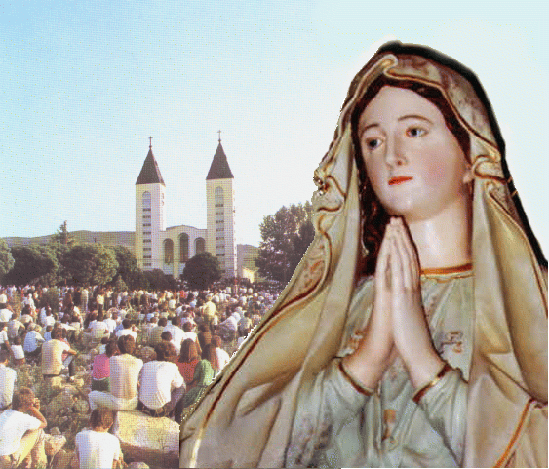
Our Lady’s message from Međugorje of May 25th 2026 through seer Marija Pavlović Lunetti
Dear children!
May this time be for you a time of prayer and fasting. Return, little children, in love to God who is your peace. I am with you, little children, and I love you with my motherly tenderness.
Thank you for having responded to my call.

(with Ecclesiastical approval)
taken from https://www.medjugorje.hr/, compared to locations https://marytv.tv/, https://rosasparalagospa.com/, https://www.medjugorje.ws/

Our Lady’s message from Međugorje of May 25th 2026 through seer Marija Pavlović Lunetti
Dear children!
May this time be for you a time of prayer and fasting. Return, little children, in love to God who is your peace. I am with you, little children, and I love you with my motherly tenderness.
Thank you for having responded to my call.

(with Ecclesiastical approval)
taken from https://www.medjugorje.hr/, compared to locations https://marytv.tv/, https://rosasparalagospa.com/, https://www.medjugorje.ws/

Our Lady’s message from Međugorje of May 25th 2026 through seer Marija Pavlović Lunetti
Dear children!
May this time be for you a time of prayer and fasting. Return, little children, in love to God who is your peace. I am with you, little children, and I love you with my motherly tenderness.
Thank you for having responded to my call.

(with Ecclesiastical approval)
taken from https://www.medjugorje.hr/, compared to locations https://marytv.tv/, https://rosasparalagospa.com/, https://www.medjugorje.ws/

Our Lady’s message from Međugorje of May 25th 2026 through seer Marija Pavlović Lunetti
Dear children!
May this time be for you a time of prayer and fasting. Return, little children, in love to God who is your peace. I am with you, little children, and I love you with my motherly tenderness.
Thank you for having responded to my call.

(with Ecclesiastical approval)
taken from https://www.medjugorje.hr/, compared to locations https://marytv.tv/, https://rosasparalagospa.com/, https://www.medjugorje.ws/

Our Lady’s message from Međugorje of May 25th 2026 through seer Marija Pavlović Lunetti
Dear children!
May this time be for you a time of prayer and fasting. Return, little children, in love to God who is your peace. I am with you, little children, and I love you with my motherly tenderness.
Thank you for having responded to my call.

(with Ecclesiastical approval)
taken from https://www.medjugorje.hr/, compared to locations https://marytv.tv/, https://rosasparalagospa.com/, https://www.medjugorje.ws/



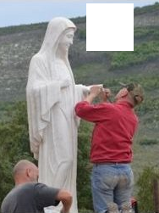


https://mysticpost.com/the-miracle-that-built-the-famous-statue-on-apparition-hill-20-years-ago/
([user] speranza Aug 29 2008 14:41) How deep the hatred towards Our Lady and all that is sacred to us is. Last night from August 28 to 29 the statue of Our Lady on the Apparition Hill was damaged. Somebody broke the arm and nose and ruined the stand of the statue of Our Lady.
the above QR-code/link give our source for the picture of repair of the statue on the right, which is a page in English, the center picture of the scarred statue of Our Lady is from youtube channel of centermirmedjugorje.com
the text of the entrire page is from QR-codes/links to posts of the forum www.tebe-trazim.com (the info of the two sources correspond, except in Croatian report there is no mention of arson, reported in page in Engish)
https://www.tebe-trazim.com/forum/viewtopic.php?f=1&t=1056&start=230#p77169

https://www.tebe-trazim.com/forum/viewtopic.php?f=1&t=1056&start=250#p77677
(speranza Sep 02 2008 23:05) Unfortunately who did this hated Our Lady with strong hatred. Looks like it was satanists. Only broken fingers were found, not the rest of the arm. The nose is broken as well. Hopefully it can be repaired.

(speranza Sep 23 2008 10:32)
The statue of Our Lady on the Apparition Hill which was damaged in the night Aug 28/29 by unknown perpetrator has been repaired thanks to expedient intervention by workshop Dino and Mirko Felici from Carrara (Italy). [but the scar remained, editor’s note]
https://www.tebe-trazim.com/forum/viewtopic.php?f=1&t=1056&start=300#p79993


Last Sunday [Aug 01, editor’s note] as has been custom for years the parish goes to the Apparition Hill and the rosary was led by friar Katalinić. When he arrived before the statue he wept and everybody present wept.
these are all translations of the posts in Croatian

https://mysticpost.com/the-miracle-that-built-the-famous-statue-on-apparition-hill-20-years-ago/
([user] speranza Aug 29 2008 14:41) How deep the hatred towards Our Lady and all that is sacred to us is. Last night from August 28 to 29 the statue of Our Lady on the Apparition Hill was damaged. Somebody broke the arm and nose and ruined the stand of the statue of Our Lady.
the above QR-code/link give our source for the picture of repair of the statue on the right, which is a page in English, the center picture of the scarred statue of Our Lady is from youtube channel of centermirmedjugorje.com
the text of the entrire page is from QR-codes/links to posts of the forum www.tebe-trazim.com (the info of the two sources correspond, except in Croatian report there is no mention of arson, reported in page in Engish)
https://www.tebe-trazim.com/forum/viewtopic.php?f=1&t=1056&start=230#p77169

https://www.tebe-trazim.com/forum/viewtopic.php?f=1&t=1056&start=250#p77677
(speranza Sep 02 2008 23:05) Unfortunately who did this hated Our Lady with strong hatred. Looks like it was satanists. Only broken fingers were found, not the rest of the arm. The nose is broken as well. Hopefully it can be repaired.
https://www.tebe-trazim.com/forum/viewtopic.php?f=1&t=1056&start=300#p79993
(speranza Sep 23 2008 10:32)
The statue of Our Lady on the Apparition Hill which was damaged in the night Aug 28/29 by unknown perpetrator has been repaired thanks to expedient intervention by workshop Dino and Mirko Felici from Carrara (Italy). [but the scar remained, editor’s note]

Last Sunday [Aug 01, editor’s note] as has been custom for years the parish goes to the Apparition Hill and the rosary was led by friar Katalinić. When he arrived before the statue he wept and everybody present wept.
these are all translations of the posts in Croatian

https://mysticpost.com/the-miracle-that-built-the-famous-statue-on-apparition-hill-20-years-ago/
([user] speranza Aug 29 2008 14:41) How deep the hatred towards Our Lady and all that is sacred to us is. Last night from August 28 to 29 the statue of Our Lady on the Apparition Hill was damaged. Somebody broke the arm and nose and ruined the stand of the statue of Our Lady.
the above QR-code/link give our source for the picture of repair of the statue on the right, which is a page in English, the center picture of the scarred statue of Our Lady is from youtube channel of centermirmedjugorje.com
the text of the entrire page is from QR-codes/links to posts of the forum www.tebe-trazim.com (the info of the two sources correspond, except in Croatian report there is no mention of arson, reported in page in Engish)
https://www.tebe-trazim.com/forum/viewtopic.php?f=1&t=1056&start=230#p77169

https://www.tebe-trazim.com/forum/viewtopic.php?f=1&t=1056&start=250#p77677
(speranza Sep 02 2008 23:05) Unfortunately who did this hated Our Lady with strong hatred. Looks like it was satanists. Only broken fingers were found, not the rest of the arm. The nose is broken as well. Hopefully it can be repaired.
https://www.tebe-trazim.com/forum/viewtopic.php?f=1&t=1056&start=300#p79993
(speranza Sep 23 2008 10:32)
The statue of Our Lady on the Apparition Hill which was damaged in the night Aug 28/29 by unknown perpetrator has been repaired thanks to expedient intervention by workshop Dino and Mirko Felici from Carrara (Italy). [but the scar remained, editor’s note]

Last Sunday [Aug 01, editor’s note] as has been custom for years the parish goes to the Apparition Hill and the rosary was led by friar Katalinić. When he arrived before the statue he wept and everybody present wept.
these are all translations of the posts in Croatian

https://mysticpost.com/the-miracle-that-built-the-famous-statue-on-apparition-hill-20-years-ago/
([user] speranza Aug 29 2008 14:41) How deep the hatred towards Our Lady and all that is sacred to us is. Last night from August 28 to 29 the statue of Our Lady on the Apparition Hill was damaged. Somebody broke the arm and nose and ruined the stand of the statue of Our Lady.
the above QR-code/link give our source for the picture of repair of the statue on the right, which is a page in English, the center picture of the scarred statue of Our Lady is from youtube channel of centermirmedjugorje.com
the text of the entrire page is from QR-codes/links to posts of the forum www.tebe-trazim.com (the info of the two sources correspond, except in Croatian report there is no mention of arson, reported in page in Engish)
https://www.tebe-trazim.com/forum/viewtopic.php?f=1&t=1056&start=230#p77169

https://www.tebe-trazim.com/forum/viewtopic.php?f=1&t=1056&start=250#p77677
(speranza Sep 02 2008 23:05) Unfortunately who did this hated Our Lady with strong hatred. Looks like it was satanists. Only broken fingers were found, not the rest of the arm. The nose is broken as well. Hopefully it can be repaired.
https://www.tebe-trazim.com/forum/viewtopic.php?f=1&t=1056&start=300#p79993
(speranza Sep 23 2008 10:32)
The statue of Our Lady on the Apparition Hill which was damaged in the night Aug 28/29 by unknown perpetrator has been repaired thanks to expedient intervention by workshop Dino and Mirko Felici from Carrara (Italy). [but the scar remained, editor’s note]

Last Sunday [Aug 01, editor’s note] as has been custom for years the parish goes to the Apparition Hill and the rosary was led by friar Katalinić. When he arrived before the statue he wept and everybody present wept.
these are all translations of the posts in Croatian

https://mysticpost.com/the-miracle-that-built-the-famous-statue-on-apparition-hill-20-years-ago/
([user] speranza Aug 29 2008 14:41) How deep the hatred towards Our Lady and all that is sacred to us is. Last night from August 28 to 29 the statue of Our Lady on the Apparition Hill was damaged. Somebody broke the arm and nose and ruined the stand of the statue of Our Lady.
the above QR-code/link give our source for the picture of repair of the statue on the right, which is a page in English, the center picture of the scarred statue of Our Lady is from youtube channel of centermirmedjugorje.com
the text of the entrire page is from QR-codes/links to posts of the forum www.tebe-trazim.com (the info of the two sources correspond, except in Croatian report there is no mention of arson, reported in page in Engish)
https://www.tebe-trazim.com/forum/viewtopic.php?f=1&t=1056&start=230#p77169

https://www.tebe-trazim.com/forum/viewtopic.php?f=1&t=1056&start=250#p77677
(speranza Sep 02 2008 23:05) Unfortunately who did this hated Our Lady with strong hatred. Looks like it was satanists. Only broken fingers were found, not the rest of the arm. The nose is broken as well. Hopefully it can be repaired.
https://www.tebe-trazim.com/forum/viewtopic.php?f=1&t=1056&start=300#p79993
(speranza Sep 23 2008 10:32)
The statue of Our Lady on the Apparition Hill which was damaged in the night Aug 28/29 by unknown perpetrator has been repaired thanks to expedient intervention by workshop Dino and Mirko Felici from Carrara (Italy). [but the scar remained, editor’s note]

Last Sunday [Aug 01, editor’s note] as has been custom for years the parish goes to the Apparition Hill and the rosary was led by friar Katalinić. When he arrived before the statue he wept and everybody present wept.
these are all translations of the posts in Croatian

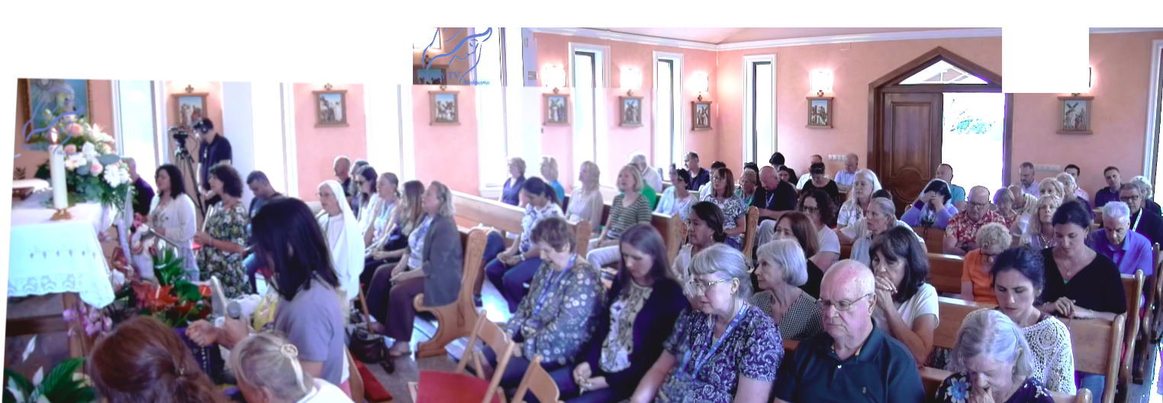

June 6th 2026
https://video.marytv.tv/watch/m62DYHsZVj0
Dear children! Let your prayer be not just words on your lips but encounter with living God. Put Jesus in the first place in your families, renew family prayer and read the Holy Scripture. Allow God’s word to guide you through daily life. I call you especially to pray for peace, peace in your own heart, peace in the family, peace in the Church and peace in the whole world. Satan wants unrest, division and discouragement, and God calls us to love, forgiveness, hope. Dear children, be carriers of light. Let everybody who encounters you feel God’s closeness through your words, goodness and your witness of life. Thank you for having this evening as well responded to my call. I pray with you and I plead for you before my Son. Thank you!
Ivan received the message the previous day, but he had it be read publicly in this video.

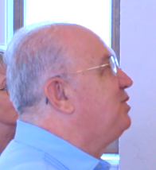
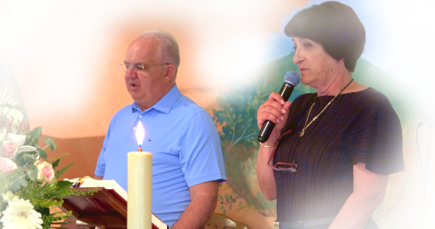
Our Lady’s Apparition and Message (June 5th) through Ivan Dragičević

https://video.marytv.tv/watch/m62DYHsZVj0
June 6th 2026
Dear children! Let your prayer be not just words on your lips but encounter with living God. Put Jesus in the first place in your families, renew family prayer and read the Holy Scripture. Allow God’s word to guide you through daily life. I call you especially to pray for peace, peace in your own heart, peace in the family, peace in the Church and peace in the whole world. Satan wants unrest, division and discouragement, and God calls us to love, forgiveness, hope. Dear children, be carriers of light. Let everybody who encounters you feel God’s closeness through your words, goodness and your witness of life. Thank you for having this evening as well responded to my call. I pray with you and I plead for you before my Son. Thank you!
Ivan received the message the previous day, but he had it be read publicly in this video.

Our Lady’s Apparition and Message (June 5th) through Ivan Dragičević

https://video.marytv.tv/watch/m62DYHsZVj0
June 6th 2026
Dear children! Let your prayer be not just words on your lips but encounter with living God. Put Jesus in the first place in your families, renew family prayer and read the Holy Scripture. Allow God’s word to guide you through daily life. I call you especially to pray for peace, peace in your own heart, peace in the family, peace in the Church and peace in the whole world. Satan wants unrest, division and discouragement, and God calls us to love, forgiveness, hope. Dear children, be carriers of light. Let everybody who encounters you feel God’s closeness through your words, goodness and your witness of life. Thank you for having this evening as well responded to my call. I pray with you and I plead for you before my Son. Thank you!
Ivan received the message the previous day, but he had it be read publicly in this video.

Our Lady’s Apparition and Message (June 5th) through Ivan Dragičević

June 6th 2026
https://video.marytv.tv/watch/m62DYHsZVj0
Dear children! Let your prayer be not just words on your lips but encounter with living God. Put Jesus in the first place in your families, renew family prayer and read the Holy Scripture. Allow God’s word to guide you through daily life. I call you especially to pray for peace, peace in your own heart, peace in the family, peace in the Church and peace in the whole world. Satan wants unrest, division and discouragement, and God calls us to love, forgiveness, hope. Dear children, be carriers of light. Let everybody who encounters you feel God’s closeness through your words, goodness and your witness of life. Thank you for having this evening as well responded to my call. I pray with you and I plead for you before my Son. Thank you!
Ivan received the message the previous day, but he had it be read publicly in this video.

Our Lady’s Apparition and Message (June 5th) through Ivan Dragičević

June 6th 2026
Dear children! Let your prayer be not just words on your lips but encounter with living God. Put Jesus in the first place in your families, renew family prayer and read the Holy Scripture. Allow God’s word to guide you through daily life. I call you especially to pray for peace, peace in your own heart, peace in the family, peace in the Church and peace in the whole world. Satan wants unrest, division and discouragement, and God calls us to love, forgiveness, hope. Dear children, be carriers of light. Let everybody who encounters you feel God’s closeness through your words, goodness and your witness of life. Thank you for having this evening as well responded to my call. I pray with you and I plead for you before my Son. Thank you!
https://video.marytv.tv/watch/m62DYHsZVj0
Ivan received the message the previous day, but he had it be read publicly in this video.

Our Lady’s Apparition and Message (June 5th) through Ivan Dragičević

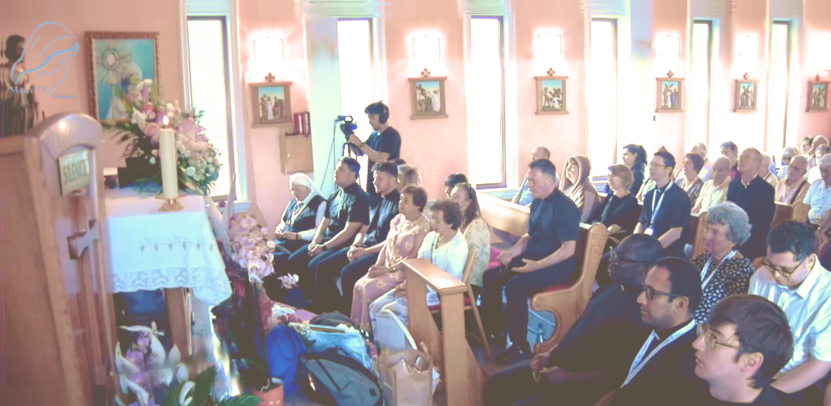

June 13th 2026
https://video.marytv.tv/watch/m6VK2psZkmw
Our Lady’s Apparition and Message through Ivan Dragičević
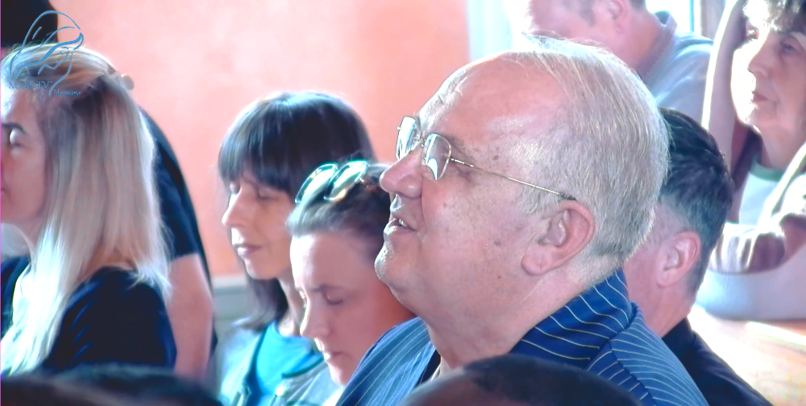
Dear children! I came to you and introduced myself as Queen of Peace. Also today in this coming time of grace I want to call you in a special way to renew my messages. I know with what fervor, with joy, you received me in the beginning. Renew my messages also today with the same joy, the same fervor. Mother prays for all of you. And I plead before my Son for you all. I need you, dear children. Thank you also today for having responded to my call.

For each encounter with Our Lady we prepare here by praying rosary, and I with you too. I personally, as the time is closer to 20 to 7, I feel all the more Her presence in my heart. The moment that I came and knelt, that was the moment when Our Lady comes. When my voice ceases, when you no longer hear my voice, that is the sign of Her arrival, a light that appears. And that is the visible sign of Her arrival. When Our Lady arrives I then no longer see anything in front of me, nor behind me. I then do not feel neither time nor space.

https://video.marytv.tv/watch/m6VK2psZkmw
June 13th 2026
Our Lady’s Apparition and Message through Ivan Dragičević
Dear children! I came to you and introduced myself as Queen of Peace. Also today in this coming time of grace I want to call you in a special way to renew my messages. I know with what fervor, with joy, you received me in the beginning. Renew my messages also today with the same joy, the same fervor. Mother prays for all of you. And I plead before my Son for you all. I need you, dear children. Thank you also today for having responded to my call.

For each encounter with Our Lady we prepare here by praying rosary, and I with you too. I personally, as the time is closer to 20 to 7, I feel all the more Her presence in my heart. The moment that I came and knelt, that was the moment when Our Lady comes. When my voice ceases, when you no longer hear my voice, that is the sign of Her arrival, a light that appears. And that is the visible sign of Her arrival. When Our Lady arrives I then no longer see anything in front of me, nor behind me. I then do not feel neither time nor space.

https://video.marytv.tv/watch/m6VK2psZkmw
June 13th 2026
Our Lady’s Apparition and Message through Ivan Dragičević
Dear children! I came to you and introduced myself as Queen of Peace. Also today in this coming time of grace I want to call you in a special way to renew my messages. I know with what fervor, with joy, you received me in the beginning. Renew my messages also today with the same joy, the same fervor. Mother prays for all of you. And I plead before my Son for you all. I need you, dear children. Thank you also today for having responded to my call.

For each encounter with Our Lady we prepare here by praying rosary, and I with you too. I personally, as the time is closer to 20 to 7, I feel all the more Her presence in my heart. The moment that I came and knelt, that was the moment when Our Lady comes. When my voice ceases, when you no longer hear my voice, that is the sign of Her arrival, a light that appears. And that is the visible sign of Her arrival. When Our Lady arrives I then no longer see anything in front of me, nor behind me. I then do not feel neither time nor space.

https://video.marytv.tv/watch/m6VK2psZkmw
June 13th 2026
Our Lady’s Apparition and Message through Ivan Dragičević
Dear children! I came to you and introduced myself as Queen of Peace. Also today in this coming time of grace I want to call you in a special way to renew my messages. I know with what fervor, with joy, you received me in the beginning. Renew my messages also today with the same joy, the same fervor. Mother prays for all of you. And I plead before my Son for you all. I need you, dear children. Thank you also today for having responded to my call.

For each encounter with Our Lady we prepare here by praying rosary, and I with you too. I personally, as the time is closer to 20 to 7, I feel all the more Her presence in my heart. The moment that I came and knelt, that was the moment when Our Lady comes. When my voice ceases, when you no longer hear my voice, that is the sign of Her arrival, a light that appears. And that is the visible sign of Her arrival. When Our Lady arrives I then no longer see anything in front of me, nor behind me. I then do not feel neither time nor space.

https://video.marytv.tv/watch/m6VK2psZkmw
Our Lady’s Apparition and Message through Ivan Dragičević
June 13th 2026
Dear children! I came to you and introduced myself as Queen of Peace. Also today in this coming time of grace I want to call you in a special way to renew my messages. I know with what fervor, with joy, you received me in the beginning. Renew my messages also today with the same joy, the same fervor. Mother prays for all of you. And I plead before my Son for you all. I need you, dear children. Thank you also today for having responded to my call.

For each encounter with Our Lady we prepare here by praying rosary, and I with you too. I personally, as the time is closer to 20 to 7, I feel all the more Her presence in my heart. The moment that I came and knelt, that was the moment when Our Lady comes. When my voice ceases, when you no longer hear my voice, that is the sign of Her arrival, a light that appears. And that is the visible sign of Her arrival. When Our Lady arrives I then no longer see anything in front of me, nor behind me. I then do not feel neither time nor space.

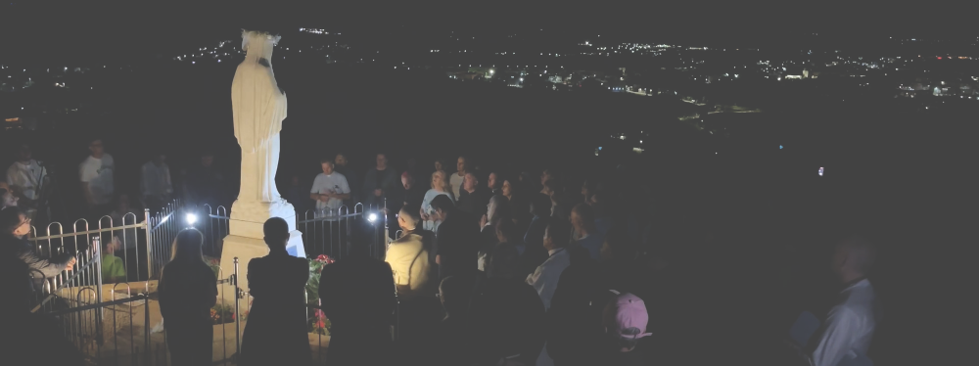

June 16th 2026
https://video.marytv.tv/watch/m6PFGwsZZHv
45th Anniversary Novena
1st Day
During the apparition when Our Lady came I recommended to Our Lady all of us, all our intentions, all that we have in our hearts, and people who recommended into our prayers.
Our Lady looked at us, extended Her hands over us and prayed to God over us. She prayed in Her motherly Aramaic tongue. Then She said to us thus, that She has homework for us for tomorrow. That we pass the day all the more in prayer, that our day be prayer. And then She smiled, extended Her hand, with the sign of the cross blessed us, and went to Heaven.

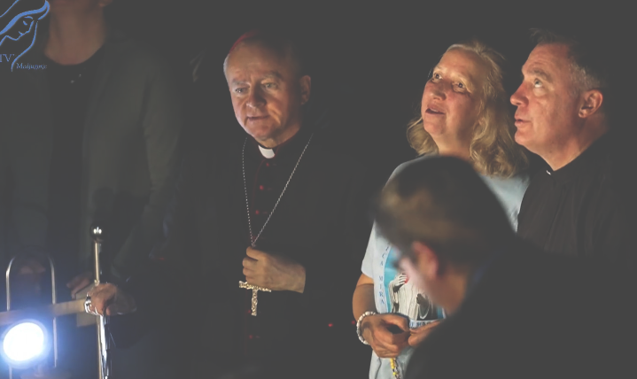
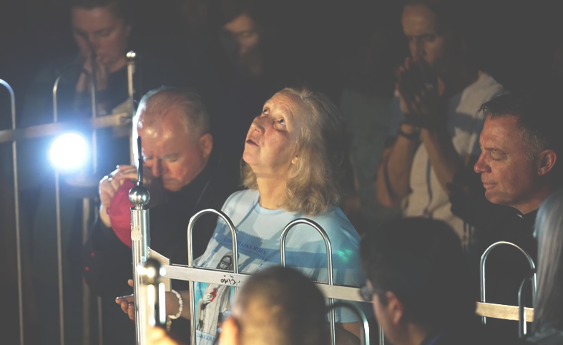

https://video.marytv.tv/watch/m6PFGwsZZHv
1st Day
June 16th 2026
45th Anniversary Novena
During the apparition when Our Lady came I recommended to Our Lady all of us, all our intentions, all that we have in our hearts, and people who recommended into our prayers.
Our Lady looked at us, extended Her hands over us and prayed to God over us. She prayed in Her motherly Aramaic tongue. Then She said to us thus, that She has homework for us for tomorrow. That we pass the day all the more in prayer, that our day be prayer. And then She smiled, extended Her hand, with the sign of the cross blessed us, and went to Heaven.

https://video.marytv.tv/watch/m6PFGwsZZHv
1st Day
45th Anniversary Novena
June 16th 2026
During the apparition when Our Lady came I recommended to Our Lady all of us, all our intentions, all that we have in our hearts, and people who recommended into our prayers.
Our Lady looked at us, extended Her hands over us and prayed to God over us. She prayed in Her motherly Aramaic tongue. Then She said to us thus, that She has homework for us for tomorrow. That we pass the day all the more in prayer, that our day be prayer. And then She smiled, extended Her hand, with the sign of the cross blessed us, and went to Heaven.

https://video.marytv.tv/watch/m6PFGwsZZHv
1st Day
45th Anniversary Novena
June 16th 2026
During the apparition when Our Lady came I recommended to Our Lady all of us, all our intentions, all that we have in our hearts, and people who recommended into our prayers.
Our Lady looked at us, extended Her hands over us and prayed to God over us. She prayed in Her motherly Aramaic tongue. Then She said to us thus, that She has homework for us for tomorrow. That we pass the day all the more in prayer, that our day be prayer. And then She smiled, extended Her hand, with the sign of the cross blessed us, and went to Heaven.

https://video.marytv.tv/watch/m6PFGwsZZHv
1st Day
45th Anniversary Novena
June 16th 2026
During the apparition when Our Lady came I recommended to Our Lady all of us, all our intentions, all that we have in our hearts, and people who recommended into our prayers.
Our Lady looked at us, extended Her hands over us and prayed to God over us. She prayed in Her motherly Aramaic tongue. Then She said to us thus, that She has homework for us for tomorrow. That we pass the day all the more in prayer, that our day be prayer. And then She smiled, extended Her hand, with the sign of the cross blessed us, and went to Heaven.

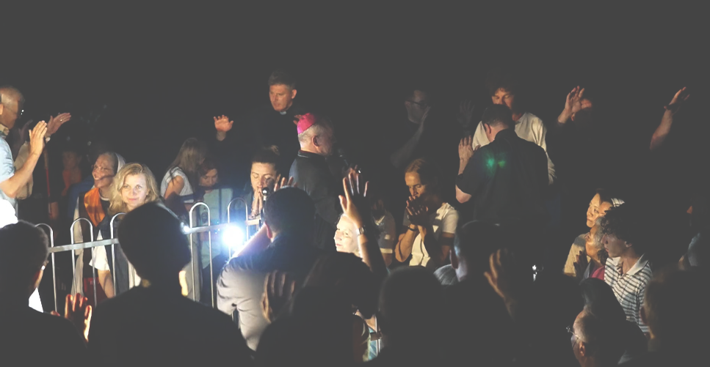
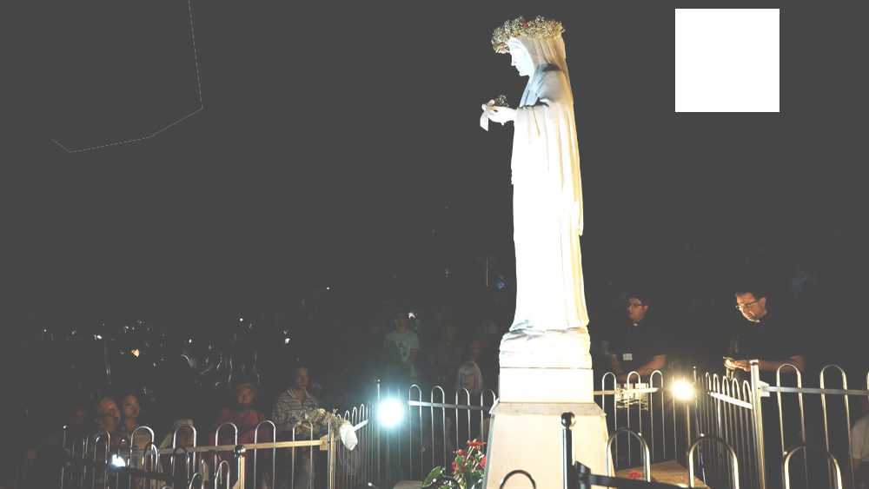

June 17th 2026
https://video.marytv.tv/watch/m695YKsZZaz
2nd Day
Our Lady extended Her hands and prayed over us for long. Tonight as well She prayed in Her motherly tongue, in Aramaic. At last Our Lady gave us another homework: to thank God for life and protect life with joy. At last Our Lady blessed us with the sign of the cross.
45th Anniversary Novena
In a special way I prayed Our Lady to plead before Her Son Jesus for peace in our hearts, for peace in our families and for peace in the whole world.

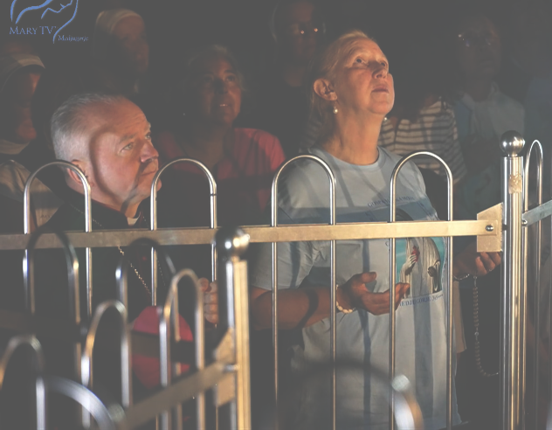

https://video.marytv.tv/watch/m695YKsZZaz
2nd Day
Our Lady extended Her hands and prayed over us for long. Tonight as well She prayed in Her motherly tongue, in Aramaic. At last Our Lady gave us another homework: to thank God for life and protect life with joy. At last Our Lady blessed us with the sign of the cross.
June 17th 2026
45th Anniversary Novena
In a special way I prayed Our Lady to plead before Her Son Jesus for peace in our hearts, for peace in our families and for peace in the whole world.

https://video.marytv.tv/watch/m695YKsZZaz
2nd Day
Our Lady extended Her hands and prayed over us for long. Tonight as well She prayed in Her motherly tongue, in Aramaic. At last Our Lady gave us another homework: to thank God for life and protect life with joy. At last Our Lady blessed us with the sign of the cross.
June 17th 2026
45th Anniversary Novena
In a special way I prayed Our Lady to plead before Her Son Jesus for peace in our hearts, for peace in our families and for peace in the whole world.

https://video.marytv.tv/watch/m695YKsZZaz
2nd Day
Our Lady extended Her hands and prayed over us for long. Tonight as well She prayed in Her motherly tongue, in Aramaic. At last Our Lady gave us another homework: to thank God for life and protect life with joy. At last Our Lady blessed us with the sign of the cross.
June 17th 2026
45th Anniversary Novena
In a special way I prayed Our Lady to plead before Her Son Jesus for peace in our hearts, for peace in our families and for peace in the whole world.

https://video.marytv.tv/watch/m695YKsZZaz
2nd Day
Our Lady extended Her hands and prayed over us for long. Tonight as well She prayed in Her motherly tongue, in Aramaic. At last Our Lady gave us another homework: to thank God for life and protect life with joy. At last Our Lady blessed us with the sign of the cross.
June 17th 2026
45th Anniversary Novena
In a special way I prayed Our Lady to plead before Her Son Jesus for peace in our hearts, for peace in our families and for peace in the whole world.

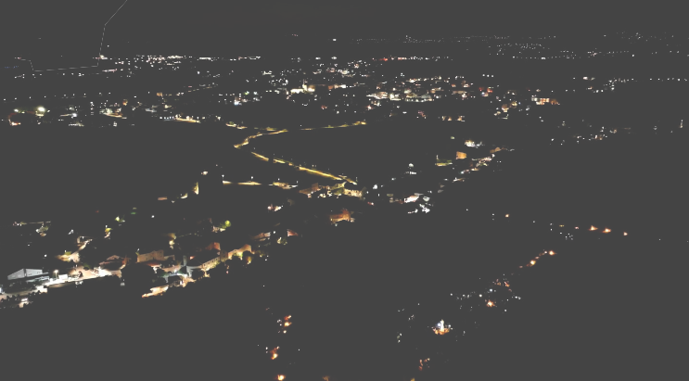
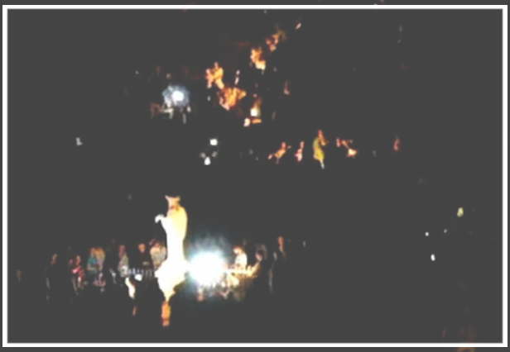

https://video.marytv.tv/watch/m6GVSUsZZzQ
3rd Day
45th Anniversary Novena
June 18th 2026
Our Lady extended Her hands over us, She prayed in Her motherly Aramaic language. She looked at us all and blessed us with the sign of the cross.
Today as well She gave us homework: to pray for all our deceased and for all our kin. That the Lord may free us from all evil, all that the ours, our kindred, did of evil, that we with our penance pray and obtain that our ancestors come out of Purgatory and go to Paradise. And Our Lady at last with the sign of the cross blessed all of us. And She left in peace.

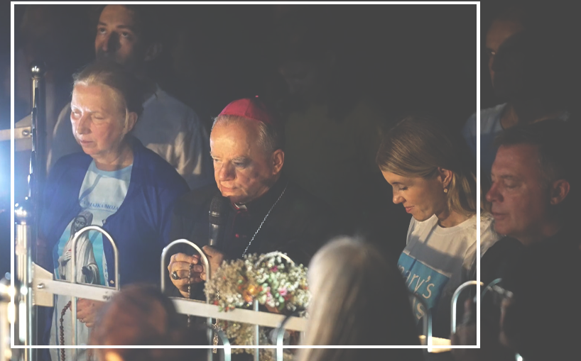




3rd Day
45th Anniversary Novena
June 18th 2026
https://video.marytv.tv/watch/m6GVSUsZZzQ
Our Lady extended Her hands over us, She prayed in Her motherly Aramaic language. She looked at us all and blessed us with the sign of the cross.
Today as well She gave us homework: to pray for all our deceased and for all our kin. That the Lord may free us from all evil, all that the ours, our kindred, did of evil, that we with our penance pray and obtain that our ancestors come out of Purgatory and go to Paradise. And Our Lady at last with the sign of the cross blessed all of us. And She left in peace.

https://video.marytv.tv/watch/m6GVSUsZZzQ
3rd Day
45th Anniversary Novena
June 18th 2026
Today as well She gave us homework: to pray for all our deceased and for all our kin. That the Lord may free us from all evil, all that the ours, our kindred, did of evil, that we with our penance pray and obtain that our ancestors come out of Purgatory and go to Paradise. And Our Lady at last with the sign of the cross blessed all of us. And She left in peace.
Our Lady extended Her hands over us, She prayed in Her motherly Aramaic language. She looked at us all and blessed us with the sign of the cross.

https://video.marytv.tv/watch/m6GVSUsZZzQ
3rd Day
45th Anniversary Novena
June 18th 2026
Today as well She gave us homework: to pray for all our deceased and for all our kin. That the Lord may free us from all evil, all that the ours, our kindred, did of evil, that we with our penance pray and obtain that our ancestors come out of Purgatory and go to Paradise. And Our Lady at last with the sign of the cross blessed all of us. And She left in peace.
Our Lady extended Her hands over us, She prayed in Her motherly Aramaic language. She looked at us all and blessed us with the sign of the cross.

https://video.marytv.tv/watch/m6GVSUsZZzQ
3rd Day
45th Anniversary Novena
June 18th 2026
Today as well She gave us homework: to pray for all our deceased and for all our kin. That the Lord may free us from all evil, all that the ours, our kindred, did of evil, that we with our penance pray and obtain that our ancestors come out of Purgatory and go to Paradise. And Our Lady at last with the sign of the cross blessed all of us. And She left in peace.
Our Lady extended Her hands over us, She prayed in Her motherly Aramaic language. She looked at us all and blessed us with the sign of the cross.

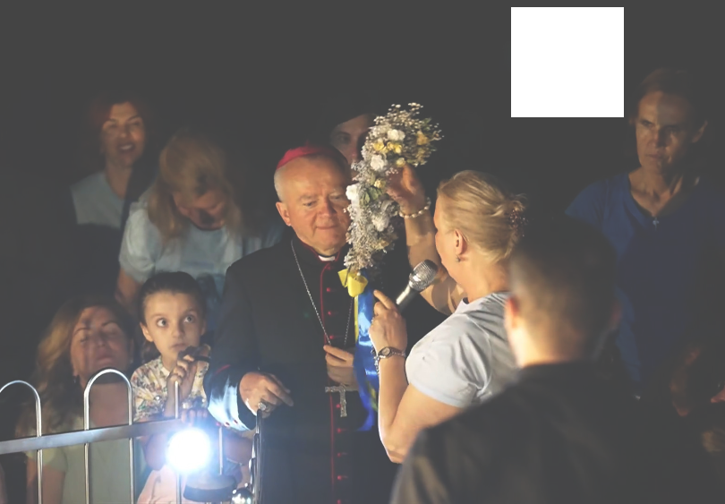
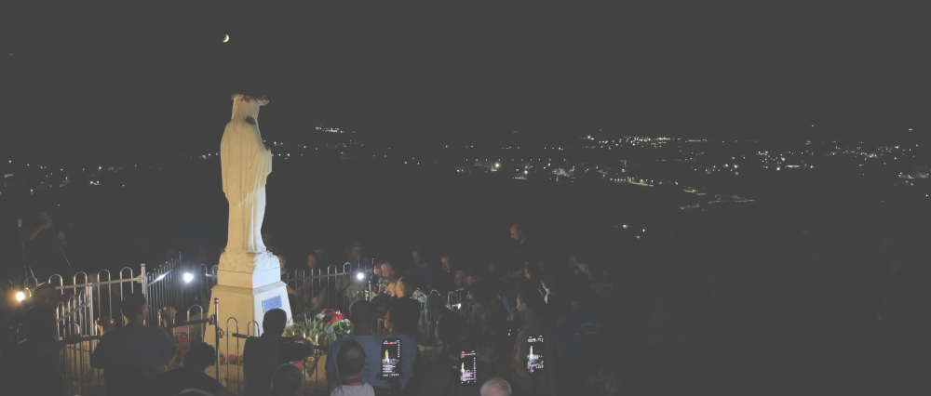

June 19th 2026
https://video.marytv.tv/watch/m6FN8TsZ10d
4th Day
45th Anniversary Novena
Our Lady prayed over us and we prayed that She plead before Her Son Jesus for peace in our hearts, for peace in our families and for peace in the whole world, especially where there is war.
Our Lady extended Her hands, She looked at us all, and prayed over us. Also tonight She gave us homework: that She has called us in all these years and that She keeps calling us to holiness, and She told us that our life here on earth is transient and let us leave trace of our presence and that we ponder and prepare for eternal life. At last Our Lady with the sign of the cross blessed all of us and went to Heaven.
And She said: “Tomorrow at the same time in the same place!”

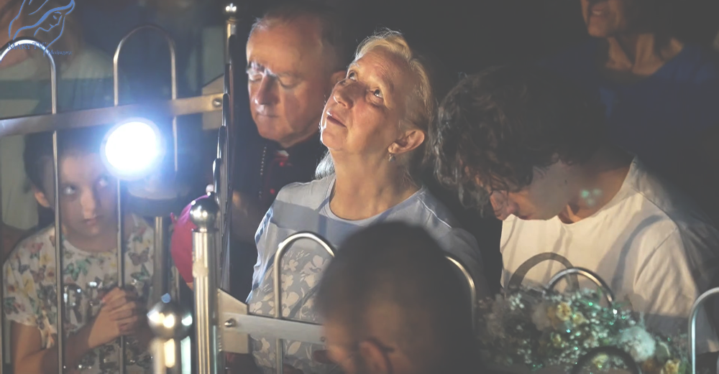

https://video.marytv.tv/watch/m6FN8TsZ10d
4th Day
45th Anniversary Novena
June 19th 2026
Our Lady prayed over us and we prayed that She plead before Her Son Jesus for peace in our hearts, for peace in our families and for peace in the whole world, especially where there is war.
Our Lady extended Her hands, She looked at us all, and prayed over us. Also tonight She gave us homework: that She has called us in all these years and that She keeps calling us to holiness, and She told us that our life here on earth is transient and let us leave trace of our presence and that we ponder and prepare for eternal life. At last Our Lady with the sign of the cross blessed all of us and went to Heaven.
And She said: “Tomorrow at the same time in the same place!”

https://video.marytv.tv/watch/m6FN8TsZ10d
4th Day
45th Anniversary Novena
June 19th 2026
Our Lady prayed over us and we prayed that She plead before Her Son Jesus for peace in our hearts, for peace in our families and for peace in the whole world, especially where there is war.
Our Lady extended Her hands, She looked at us all, and prayed over us. Also tonight She gave us homework: that She has called us in all these years and that She keeps calling us to holiness, and She told us that our life here on earth is transient and let us leave trace of our presence and that we ponder and prepare for eternal life. At last Our Lady with the sign of the cross blessed all of us and went to Heaven.
And She said: “Tomorrow at the same time in the same place!”

https://video.marytv.tv/watch/m6FN8TsZ10d
4th Day
June 19th 2026
45th Anniversary Novena
Our Lady prayed over us and we prayed that She plead before Her Son Jesus for peace in our hearts, for peace in our families and for peace in the whole world, especially where there is war.
Our Lady extended Her hands, She looked at us all, and prayed over us. Also tonight She gave us homework: that She has called us in all these years and that She keeps calling us to holiness, and She told us that our life here on earth is transient and let us leave trace of our presence and that we ponder and prepare for eternal life. At last Our Lady with the sign of the cross blessed all of us and went to Heaven.
And She said: “Tomorrow at the same time in the same place!”

https://video.marytv.tv/watch/m6FN8TsZ10d
4th Day
45th Anniversary Novena
June 19th 2026
Our Lady prayed over us and we prayed that She plead before Her Son Jesus for peace in our hearts, for peace in our families and for peace in the whole world, especially where there is war.
Our Lady extended Her hands, She looked at us all, and prayed over us. Also tonight She gave us homework: that She has called us in all these years and that She keeps calling us to holiness, and She told us that our life here on earth is transient and let us leave trace of our presence and that we ponder and prepare for eternal life. At last Our Lady with the sign of the cross blessed all of us and went to Heaven.
And She said: “Tomorrow at the same time in the same place!”

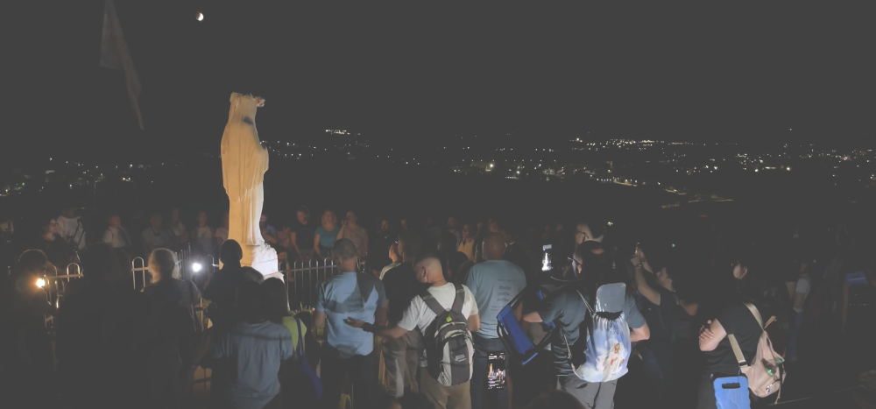

https://video.marytv.tv/watch/m66B4wsZ1VW
5th Day
45th Anniversary Novena
June 20th 2026
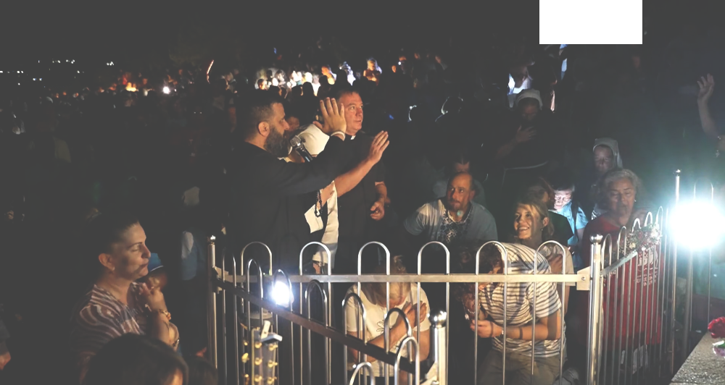
In a special way I entrusted to Our Lady to plead before Her Son Jesus for peace in our hearts, for peace in our families and for peace in the whole world.
Our Lady extended Her hands and prayer over us for long. She prayed tonight as well in Her motherly tongue, so that I wasn’t able to understand not even a single word. Ant at last Our Lady blessed us all with the sign of the cross and said: “Go in peace, dear children of mine, we see each other tomorrow at the same time in the same place!”

[later:] Tonight it looked as if Our Lady forgot to give us homework and so I asked Her if She had a word to tell us tonight. Our Lady smiled and said:
"Love God and give glory to God with all your heart!"
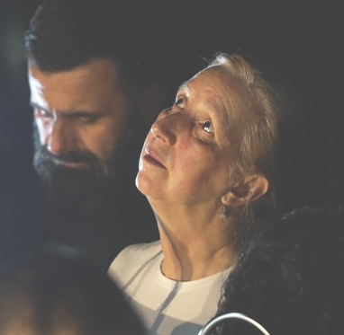

https://video.marytv.tv/watch/m66B4wsZ1VW
5th Day
45th Anniversary Novena
June 20th 2026
In a special way I entrusted to Our Lady to plead before Her Son Jesus for peace in our hearts, for peace in our families and for peace in the whole world.
Our Lady extended Her hands and prayer over us for long. She prayed tonight as well in Her motherly tongue, so that I wasn’t able to understand not even a single word. Ant at last Our Lady blessed us all with the sign of the cross and said: “Go in peace, dear children of mine, we see each other tomorrow at the same time in the same place!”

[later:] Tonight it looked as if Our Lady forgot to give us homework and so I asked Her if She had a word to tell us tonight. Our Lady smiled and said:
"Love God and give glory to God with all your heart!"

https://video.marytv.tv/watch/m66B4wsZ1VW
5th Day
45th Anniversary Novena
June 20th 2026
In a special way I entrusted to Our Lady to plead before Her Son Jesus for peace in our hearts, for peace in our families and for peace in the whole world.
Our Lady extended Her hands and prayer over us for long. She prayed tonight as well in Her motherly tongue, so that I wasn’t able to understand not even a single word. Ant at last Our Lady blessed us all with the sign of the cross and said: “Go in peace, dear children of mine, we see each other tomorrow at the same time in the same place!”

[later:] Tonight it looked as if Our Lady forgot to give us homework and so I asked Her if She had a word to tell us tonight. Our Lady smiled and said:
"Love God and give glory to God with all your heart!"

45th Anniversary Novena
https://video.marytv.tv/watch/m66B4wsZ1VW
5th Day
June 20th 2026
In a special way I entrusted to Our Lady to plead before Her Son Jesus for peace in our hearts, for peace in our families and for peace in the whole world.
Our Lady extended Her hands and prayer over us for long. She prayed tonight as well in Her motherly tongue, so that I wasn’t able to understand not even a single word. Ant at last Our Lady blessed us all with the sign of the cross and said: “Go in peace, dear children of mine, we see each other tomorrow at the same time in the same place!”

[later:] Tonight it looked as if Our Lady forgot to give us homework and so I asked Her if She had a word to tell us tonight. Our Lady smiled and said:
"Love God and give glory to God with all your heart!"

45th Anniversary Novena
https://video.marytv.tv/watch/m66B4wsZ1VW
5th Day
June 20th 2026
In a special way I entrusted to Our Lady to plead before Her Son Jesus for peace in our hearts, for peace in our families and for peace in the whole world.
Our Lady extended Her hands and prayer over us for long. She prayed tonight as well in Her motherly tongue, so that I wasn’t able to understand not even a single word. Ant at last Our Lady blessed us all with the sign of the cross and said: “Go in peace, dear children of mine, we see each other tomorrow at the same time in the same place!”

[later:] Tonight it looked as if Our Lady forgot to give us homework and so I asked Her if She had a word to tell us tonight. Our Lady smiled and said:
"Love God and give glory to God with all your heart!"

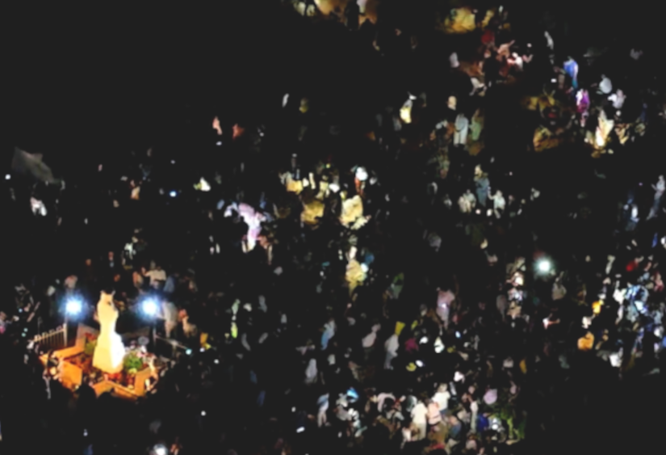
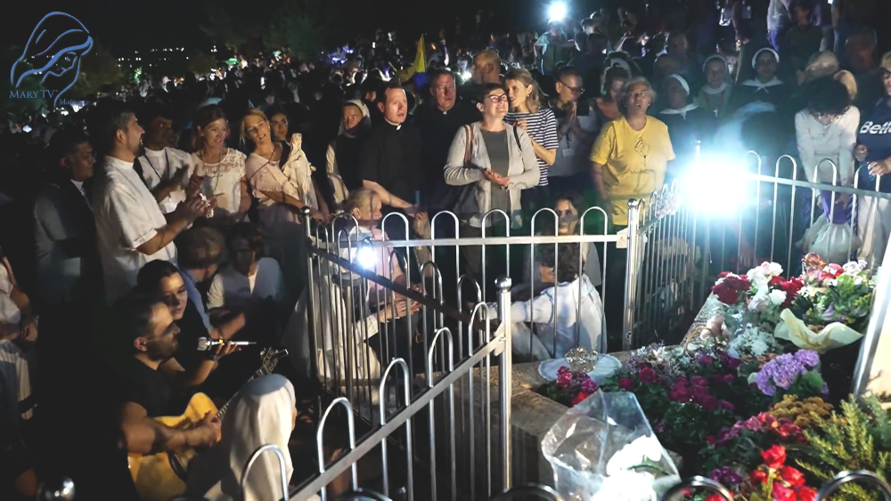

https://video.marytv.tv/watch/m6eRcOsZ1BG
6th Day
Our Lady extended Her hands and looked at us all and prayed in Her motherly tongue for longer. And She said at last that we spend these three days in contemplation, in prayer, in thanksgiving, in fasting, that these three days be three days of prayer, of giving thanks to God for all that God gives us through Her.
June 21st 2026
45th Anniversary Novena
During the apparition when Our Lady came tonight, as always, Our Lady says: “Praised be Jesus!” and we reply: “Praised be Jesus and Mary!” and Our Lady smiles, so tonight as well our encounter started with a smile. […] We prayed for peace, as every day. During the apparition we ask Our Lady to intercede before Her Son Jesus for peace in our hearts, for peace in our families, and for peace in the whole world.
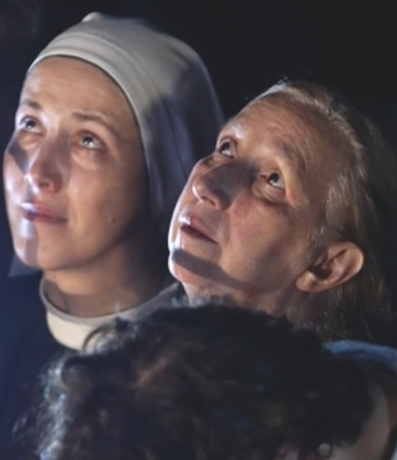

https://video.marytv.tv/watch/m6eRcOsZ1BG
6th Day
June 21st 2026
45th Anniversary Novena
Our Lady extended Her hands and looked at us all and prayed in Her motherly tongue for longer. And She said at last that we spend these three days in contemplation, in prayer, in thanksgiving, in fasting, that these three days be three days of prayer, of giving thanks to God for all that God gives us through Her.
During the apparition when Our Lady came tonight, as always, Our Lady says: “Praised be Jesus!” and we reply: “Praised be Jesus and Mary!” and Our Lady smiles, so tonight as well our encounter started with a smile. […] We prayed for peace, as every day. During the apparition we ask Our Lady to intercede before Her Son Jesus for peace in our hearts, for peace in our families, and for peace in the whole world.

https://video.marytv.tv/watch/m6eRcOsZ1BG
6th Day
45th Anniversary Novena
June 21st 2026
Our Lady extended Her hands and looked at us all and prayed in Her motherly tongue for longer. And She said at last that we spend these three days in contemplation, in prayer, in thanksgiving, in fasting, that these three days be three days of prayer, of giving thanks to God for all that God gives us through Her.
During the apparition when Our Lady came tonight, as always, Our Lady says: “Praised be Jesus!” and we reply: “Praised be Jesus and Mary!” and Our Lady smiles, so tonight as well our encounter started with a smile. […] We prayed for peace, as every day. During the apparition we ask Our Lady to intercede before Her Son Jesus for peace in our hearts, for peace in our families, and for peace in the whole world.

https://video.marytv.tv/watch/m6eRcOsZ1BG
6th Day
June 21st 2026
45th Anniversary Novena
Our Lady extended Her hands and looked at us all and prayed in Her motherly tongue for longer. And She said at last that we spend these three days in contemplation, in prayer, in thanksgiving, in fasting, that these three days be three days of prayer, of giving thanks to God for all that God gives us through Her.
During the apparition when Our Lady came tonight, as always, Our Lady says: “Praised be Jesus!” and we reply: “Praised be Jesus and Mary!” and Our Lady smiles, so tonight as well our encounter started with a smile. […] We prayed for peace, as every day. During the apparition we ask Our Lady to intercede before Her Son Jesus for peace in our hearts, for peace in our families, and for peace in the whole world.

June 21st 2026
45th Anniversary Novena
https://video.marytv.tv/watch/m6eRcOsZ1BG
6th Day
Our Lady extended Her hands and looked at us all and prayed in Her motherly tongue for longer. And She said at last that we spend these three days in contemplation, in prayer, in thanksgiving, in fasting, that these three days be three days of prayer, of giving thanks to God for all that God gives us through Her.
During the apparition when Our Lady came tonight, as always, Our Lady says: “Praised be Jesus!” and we reply: “Praised be Jesus and Mary!” and Our Lady smiles, so tonight as well our encounter started with a smile. […] We prayed for peace, as every day. During the apparition we ask Our Lady to intercede before Her Son Jesus for peace in our hearts, for peace in our families, and for peace in the whole world.

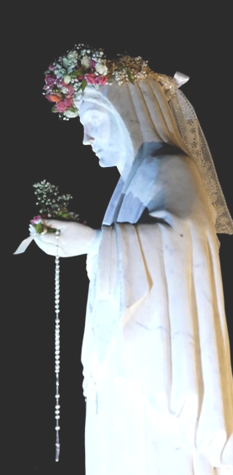

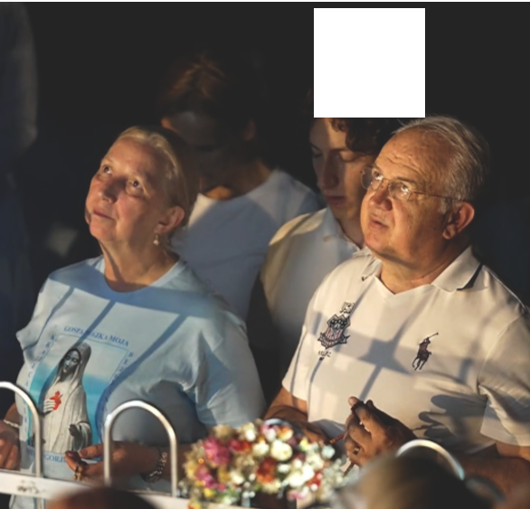
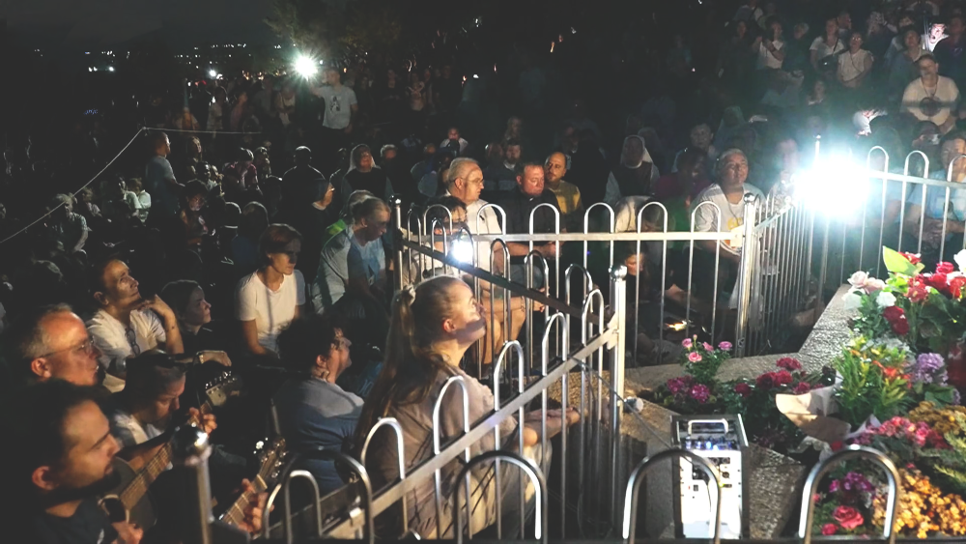


https://video.marytv.tv/watch/m6zRrBsZt0J
7th Day
After that Our Lady continues, with extended hands, She prays over this parish that She has chosen in particular way, also for a longer time.
June 22nd 2026
45th Anniversary Novena
Also today Mother came to us joyfull and merry and She greets us all with Her motherly greeting: “Praised be Jesus my dear children!”
After that She raises Her gaze on us all truly with so much joy on Her face, in Her eyes [...]



https://video.marytv.tv/watch/m6zRrBsZt0J
7th Day
June 22nd 2026
45th Anniversary Novena
After that Our Lady continues, with extended hands, She prays over this parish that She has chosen in particular way, also for a longer time.
Also today Mother came to us joyfull and merry and She greets us all with Her motherly greeting: “Praised be Jesus my dear children!”
After that She raises Her gaze on us all truly with so much joy on Her face, in Her eyes [...]

https://video.marytv.tv/watch/m6zRrBsZt0J
7th Day
June 22nd 2026
45th Anniversary Novena
After that Our Lady continues, with extended hands, She prays over this parish that She has chosen in particular way, also for a longer time.
Also today Mother came to us joyfull and merry and She greets us all with Her motherly greeting: “Praised be Jesus my dear children!”
After that She raises Her gaze on us all truly with so much joy on Her face, in Her eyes [...]

https://video.marytv.tv/watch/m6zRrBsZt0J
7th Day
June 22nd 2026
45th Anniversary Novena
After that Our Lady continues, with extended hands, She prays over this parish that She has chosen in particular way, also for a longer time.
Also today Mother came to us joyfull and merry and She greets us all with Her motherly greeting: “Praised be Jesus my dear children!”
After that She raises Her gaze on us all truly with so much joy on Her face, in Her eyes [...]

https://video.marytv.tv/watch/m6zRrBsZt0J
7th Day
June 22nd 2026
45th Anniversary Novena
After that Our Lady continues, with extended hands, She prays over this parish that She has chosen in particular way, also for a longer time.
After that She raises Her gaze on us all truly with so much joy on Her face, in Her eyes [...]
Also today Mother came to us joyfull and merry and She greets us all with Her motherly greeting: “Praised be Jesus my dear children!”

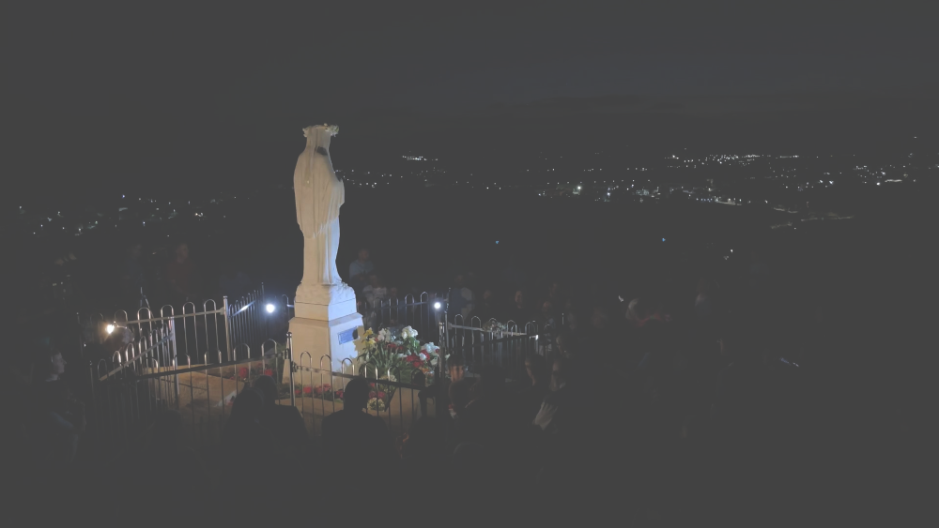
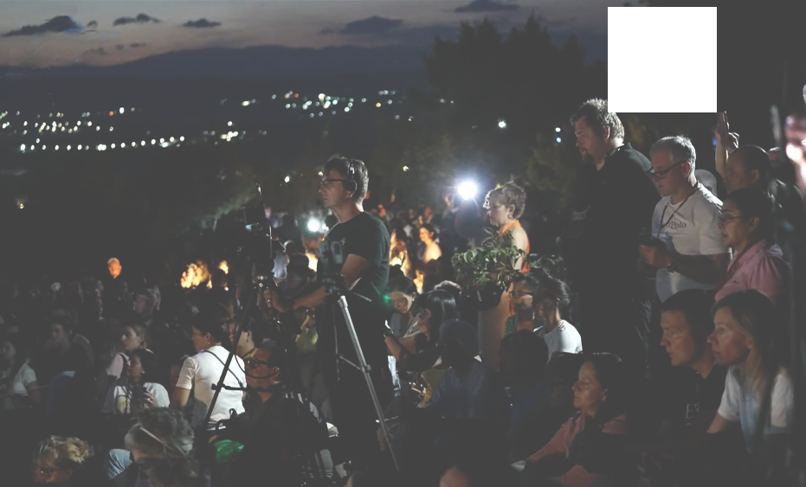
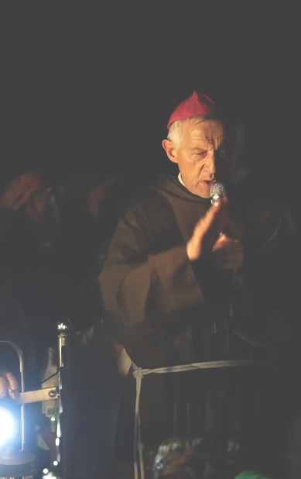

45th Anniversary Novena
June 23rd 2026
https://video.marytv.tv/watch/m658YzsZtpO
8th Day
Now we will kindly ask all the priests and our dear bishop who is here with us, to bless us with Jesus’ blessing.

During the apparition when Our Lady came we recommended to Our Lady all us present, and all those who have been spiritually connected with us. We prayed before Our Lady for all the people who have been in relation with us through prayer for these nine days, and in the end we asked Our Lady to plead before Her Son Jesus for peace in our hearts, for peace in our families, and for peace in the whole world.
Our Lady extended Her hands, and prayed for long in Her motherly tongue, in Aramaic. And in the end She greeted us all, and said: “At the same time, to the same place!” She made the sign of the cross, She blessed us all with Her motherly blessing.

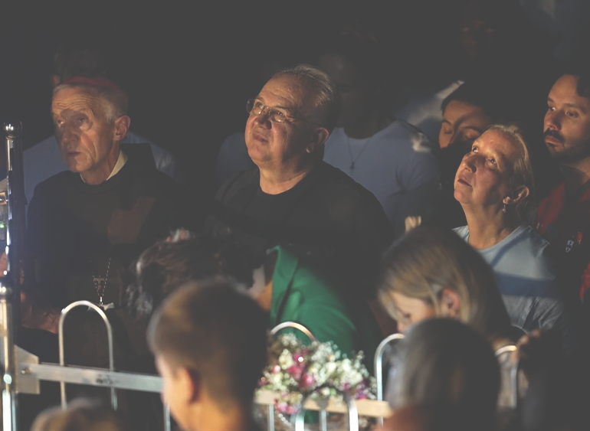

June 23rd 2026
Now we will kindly ask all the priests and our dear bishop who is here with us, to bless us with Jesus’ blessing.

https://video.marytv.tv/watch/m658YzsZtpO
8th Day
45th Anniversary Novena
Our Lady extended Her hands, and prayed for long in Her motherly tongue, in Aramaic. And in the end She greeted us all, and said: “At the same time, to the same place!” She made the sign of the cross, She blessed us all with Her motherly blessing.
During the apparition when Our Lady came we recommended to Our Lady all us present, and all those who have been spiritually connected with us. We prayed before Our Lady for all the people who have been in relation with us through prayer for these nine days, and in the end we asked Our Lady to plead before Her Son Jesus for peace in our hearts, for peace in our families, and for peace in the whole world.

https://video.marytv.tv/watch/m658YzsZtpO
45th Anniversary Novena
8th Day
Now we will kindly ask all the priests and our dear bishop who is here with us, to bless us with Jesus’ blessing.

June 23rd 2026
Our Lady extended Her hands, and prayed for long in Her motherly tongue, in Aramaic. And in the end She greeted us all, and said: “At the same time, to the same place!” She made the sign of the cross, She blessed us all with Her motherly blessing.
During the apparition when Our Lady came we recommended to Our Lady all us present, and all those who have been spiritually connected with us. We prayed before Our Lady for all the people who have been in relation with us through prayer for these nine days, and in the end we asked Our Lady to plead before Her Son Jesus for peace in our hearts, for peace in our families, and for peace in the whole world.

https://video.marytv.tv/watch/m658YzsZtpO
8th Day
June 23rd 2026
Now we will kindly ask all the priests and our dear bishop who is here with us, to bless us with Jesus’ blessing.

45th Anniversary Novena
During the apparition when Our Lady came we recommended to Our Lady all us present, and all those who have been spiritually connected with us. We prayed before Our Lady for all the people who have been in relation with us through prayer for these nine days, and in the end we asked Our Lady to plead before Her Son Jesus for peace in our hearts, for peace in our families, and for peace in the whole world.
Our Lady extended Her hands, and prayed for long in Her motherly tongue, in Aramaic. And in the end She greeted us all, and said: “At the same time, to the same place!” She made the sign of the cross, She blessed us all with Her motherly blessing.

https://video.marytv.tv/watch/m658YzsZtpO
8th Day
Now we will kindly ask all the priests and our dear bishop who is here with us, to bless us with Jesus’ blessing.

45th Anniversary Novena
June 23rd 2026
Our Lady extended Her hands, and prayed for long in Her motherly tongue, in Aramaic. And in the end She greeted us all, and said: “At the same time, to the same place!” She made the sign of the cross, She blessed us all with Her motherly blessing.
During the apparition when Our Lady came we recommended to Our Lady all us present, and all those who have been spiritually connected with us. We prayed before Our Lady for all the people who have been in relation with us through prayer for these nine days, and in the end we asked Our Lady to plead before Her Son Jesus for peace in our hearts, for peace in our families, and for peace in the whole world.

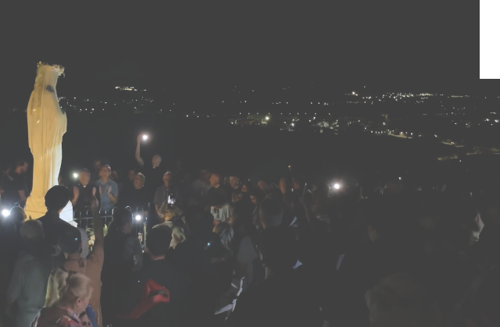
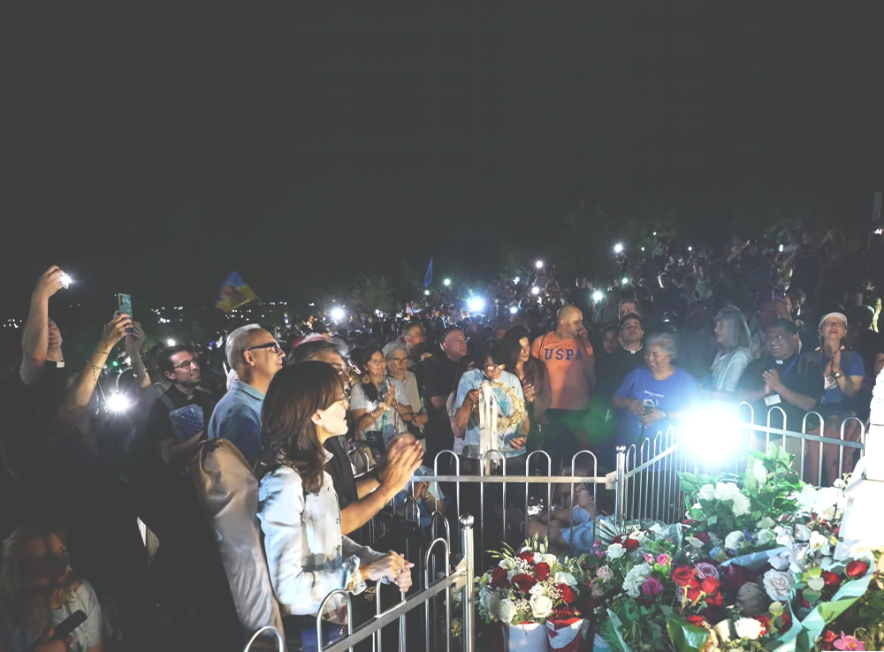
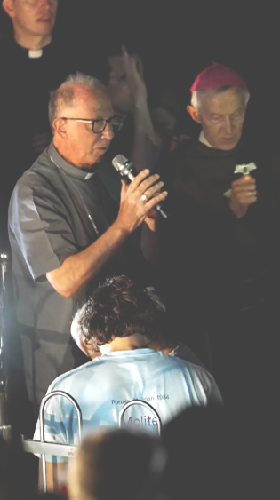

https://video.marytv.tv/watch/m6dfjLsZtSi
June 24th 2026
45th Anniversary Novena
9th Day
In that moment Our Lady extended Her hands for the third time and with joy made the sign of the Cross and said: "Go in peace dear children of mine!"
And Our Lady went to Heaven.

Our Lady was particularly joyful […] Our Lady looked at us for long, She extended Her hands and prayed long, long over us […]
Our Lady gave the message:
"Dear children! I thank you for each of your support, prayer that you offered on my intentions. And you will not regret, neither you, nor your children, nor your children’s children!"

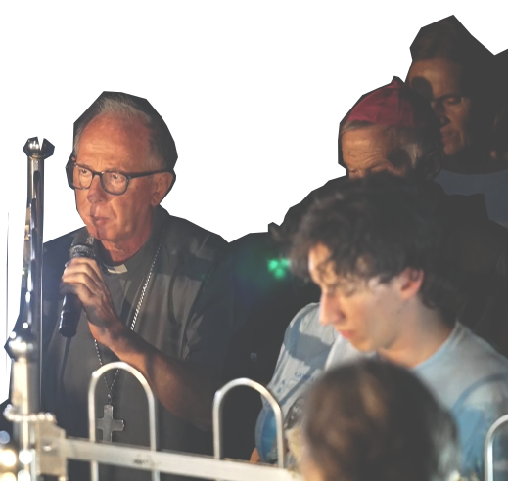
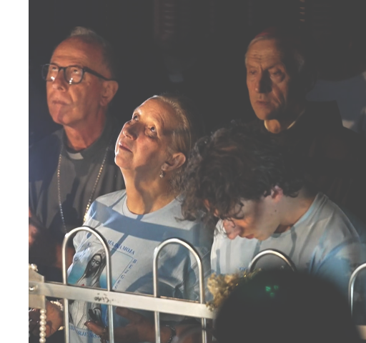

https://video.marytv.tv/watch/m6dfjLsZtSi
June 24th 2026
45th Anniversary Novena
9th Day
In that moment Our Lady extended Her hands for the third time and with joy made the sign of the Cross and said: "Go in peace dear children of mine!"
And Our Lady went to Heaven.
Our Lady was particularly joyful […] Our Lady looked at us for long, She extended Her hands and prayed long, long over us […]
Our Lady gave the message:
"Dear children! I thank you for each of your support, prayer that you offered on my intentions. And you will not regret, neither you, nor your children, nor your children’s children!"

https://video.marytv.tv/watch/m6dfjLsZtSi
June 24th 2026
45th Anniversary Novena
9th Day
In that moment Our Lady extended Her hands for the third time and with joy made the sign of the Cross and said: "Go in peace dear children of mine!"
And Our Lady went to Heaven.
Our Lady was particularly joyful […] Our Lady looked at us for long, She extended Her hands and prayed long, long over us […]
Our Lady gave the message:
"Dear children! I thank you for each of your support, prayer that you offered on my intentions. And you will not regret, neither you, nor your children, nor your children’s children!"

https://video.marytv.tv/watch/m6dfjLsZtSi
June 24th 2026
45th Anniversary Novena
9th Day
In that moment Our Lady extended Her hands for the third time and with joy made the sign of the Cross and said: "Go in peace dear children of mine!"
And Our Lady went to Heaven.
Our Lady was particularly joyful […] Our Lady looked at us for long, She extended Her hands and prayed long, long over us […]
Our Lady gave the message:
"Dear children! I thank you for each of your support, prayer that you offered on my intentions. And you will not regret, neither you, nor your children, nor your children’s children!"

https://video.marytv.tv/watch/m6dfjLsZtSi
June 24th 2026
45th Anniversary Novena
9th Day
In that moment Our Lady extended Her hands for the third time and with joy made the sign of the Cross and said: "Go in peace dear children of mine!"
And Our Lady went to Heaven.
Our Lady was particularly joyful […] Our Lady looked at us for long, She extended Her hands and prayed long, long over us […]
Our Lady gave the message:
"Dear children! I thank you for each of your support, prayer that you offered on my intentions. And you will not regret, neither you, nor your children, nor your children’s children!"

Our Lady’s message from Međugorje June 25th 2026 through seer Marija Pavlović Lunetti

Dear children!
Rejoice with me because the Most High permits me to be with you, to lead you to Him Who is the Way, the Truth and the Life. Rejoice, little children, and be joyful also in difficulties and you will have strength, because you will be aware that you are transient and you will know to offer everything to God. That is why, do not forget: I am your Mother and I love you.
Thank you for having responded to my call.

(with Eccleseastical approval)
taken from https://www.medjugorje.hr, compared to locations https://www.medjugorje.ws, https://marytv.tv, https://centermirmedjugorje.com, https://www.catholic365.com, https://rosasparalagospa.com

Our Lady’s message from Međugorje June 25th 2026 through seer Marija Pavlović Lunetti

Dear children!
Rejoice with me because the Most High permits me to be with you, to lead you to Him Who is the Way, the Truth and the Life. Rejoice, little children, and be joyful also in difficulties and you will have strength, because you will be aware that you are transient and you will know to offer everything to God. That is why, do not forget: I am your Mother and I love you.
Thank you for having responded to my call.

(with Eccleseastical approval)
taken from https://www.medjugorje.hr, compared to locations https://www.medjugorje.ws, https://marytv.tv, https://centermirmedjugorje.com, https://www.catholic365.com, https://rosasparalagospa.com

Our Lady’s message from Međugorje June 25th 2026 through seer Marija Pavlović Lunetti

Dear children!
Rejoice with me because the Most High permits me to be with you, to lead you to Him Who is the Way, the Truth and the Life. Rejoice, little children, and be joyful also in difficulties and you will have strength, because you will be aware that you are transient and you will know to offer everything to God. That is why, do not forget: I am your Mother and I love you.
Thank you for having responded to my call.

(with Eccleseastical approval)
taken from https://www.medjugorje.hr, compared to locations https://www.medjugorje.ws, https://marytv.tv, https://centermirmedjugorje.com, https://www.catholic365.com, https://rosasparalagospa.com

Our Lady’s message from Međugorje June 25th 2026 through seer Marija Pavlović Lunetti

Dear children!
Rejoice with me because the Most High permits me to be with you, to lead you to Him Who is the Way, the Truth and the Life. Rejoice, little children, and be joyful also in difficulties and you will have strength, because you will be aware that you are transient and you will know to offer everything to God. That is why, do not forget: I am your Mother and I love you.
Thank you for having responded to my call.

(with Eccleseastical approval)
taken from https://www.medjugorje.hr, compared to locations https://www.medjugorje.ws, https://marytv.tv, https://centermirmedjugorje.com, https://www.catholic365.com, https://rosasparalagospa.com

Our Lady’s message from Međugorje June 25th 2026 through seer Marije Pavlović Lunetti

Dear children!
Rejoice with me because the Most High permits me to be with you, to lead you to Him Who is the Way, the Truth and the Life. Rejoice, little children, and be joyful also in difficulties and you will have strength, because you will be aware that you are transient and you will know to offer everything to God. That is why, do not forget: I am your Mother and I love you.
Thank you for having responded to my call.

(with Eccleseastical approval)
taken from https://www.medjugorje.hr, compared to locations https://www.medjugorje.ws, https://marytv.tv, https://centermirmedjugorje.com, https://www.catholic365.com, https://rosasparalagospa.com

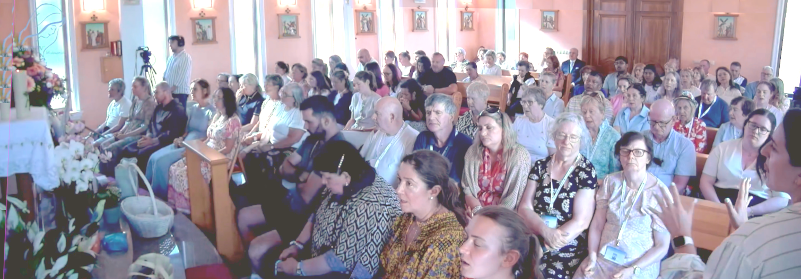

June 20th 2026
https://video.marytv.tv/watch/m66fiHsZ1L1
Our Lady’s Apparition to Ivan Dragičević
She prays for all of you and your families. For all that which you carry in your hearts. She prays expecially here over you present sick. And She turns Her gaze toward the church and prays over all the pilgrims who are right now at the evening program.

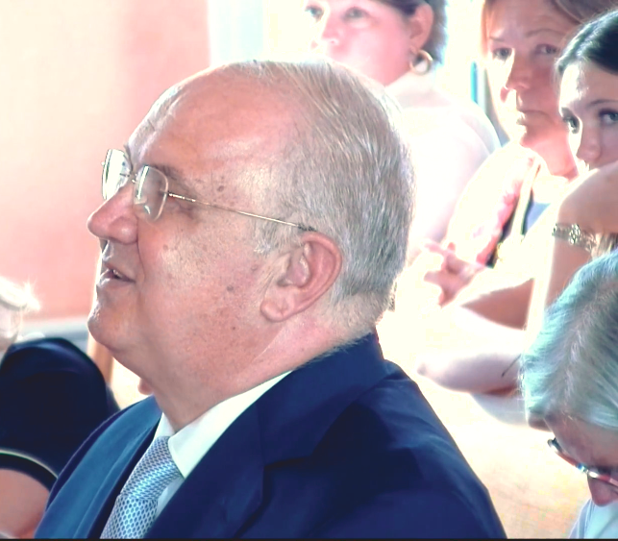

It is hard to describe the beauty of Our Lady Herself […] And on Our Lady Herself so much joy, so much joy in Her eyes, on Her face. […] Also today She came to us very joyful and merry […] Our Lady lifts Her gaze upon us all. From left to right, right to left, She looks at all of us […] with a smile on Her face and in Her eyes.

Let us not allow that Our Lady’s messages remain just beautiful words. Let us turn them into our life, let us pray more, forgive more, love more, believe more. In that way Mother will be able to respond joyously with the words: "Thank you dear children also today for having responded to my call!"

https://video.marytv.tv/watch/m66fiHsZ1L1
She prays for all of you and your families. For all that which you carry in your hearts. She prays expecially here over you present sick. And She turns Her gaze toward the church and prays over all the pilgrims who are right now at the evening program.
June 20th 2026
Our Lady’s Apparition to Ivan Dragičević

It is hard to describe the beauty of Our Lady Herself […] And on Our Lady Herself so much joy, so much joy in Her eyes, on Her face. […] Also today She came to us very joyful and merry […] Our Lady lifts Her gaze upon us all. From left to right, right to left, She looks at all of us […] with a smile on Her face and in Her eyes.

Let us not allow that Our Lady’s messages remain just beautiful words. Let us turn them into our life, let us pray more, forgive more, love more, believe more. In that way Mother will be able to respond joyously with the words: "Thank you dear children also today for having responded to my call!"

https://video.marytv.tv/watch/m66fiHsZ1L1
She prays for all of you and your families. For all that which you carry in your hearts. She prays expecially here over you present sick. And She turns Her gaze toward the church and prays over all the pilgrims who are right now at the evening rprogram.
Our Lady’s Apparition to Ivan Dragičević
June 20th 2026

It is hard to describe the beauty of Our Lady Herself […] And on Our Lady Herself so much joy, so much joy in Her eyes, on Her face. […] Also today She came to us very joyful and merry […] Our Lady lifts Her gaze upon us all. From left to right, right to left, She looks at all of us […] with a smile on Her face and in Her eyes.

Let us not allow that Our Lady’s messages remain just beautiful words. Let us turn them into our life, let us pray more, forgive more, love more, believe more. In that way Mother will be able to respond joyously with the words: "Thank you dear children also today for having responded to my call!"

https://video.marytv.tv/watch/m66fiHsZ1L1
She prays for all of you and your families. For all that which you carry in your hearts. She prays expecially here over you present sick. And She turns Her gaze toward the church and prays over all the pilgrims who are right now at the evening program.
Our Lady’s Apparition to Ivan Dragičević
June 20th 2026

It is hard to describe the beauty of Our Lady Herself […] And on Our Lady Herself so much joy, so much joy in Her eyes, on Her face. […] Also today She came to us very joyful and merry […] Our Lady lifts Her gaze upon us all. From left to right, right to left, She looks at all of us […] with a smile on Her face and in Her eyes.

Let us not allow that Our Lady’s messages remain just beautiful words. Let us turn them into our life, let us pray more, forgive more, love more, believe more. In that way Mother will be able to respond joyously with the words: "Thank you dear children also today for having responded to my call!"

https://video.marytv.tv/watch/m66fiHsZ1L1
She prays for all of you and your families. For all that which you carry in your hearts. She prays expecially here over you present sick. And She turns Her gaze toward the church and prays over all the pilgrims who are right now at the evening program.
Our Lady’s Apparition to Ivan Dragičević
June 20th 2026

It is hard to describe the beauty of Our Lady Herself […] And on Our Lady Herself so much joy, so much joy in Her eyes, on Her face. […] Also today She came to us very joyful and merry […] Our Lady lifts Her gaze upon us all. From left to right, right to left, She looks at all of us […] with a smile on Her face and in Her eyes.

Let us not allow that Our Lady’s messages remain just beautiful words. Let us turn them into our life, let us pray more, forgive more, love more, believe more. In that way Mother will be able to respond joyously with the words: "Thank you dear children also today for having responded to my call!"

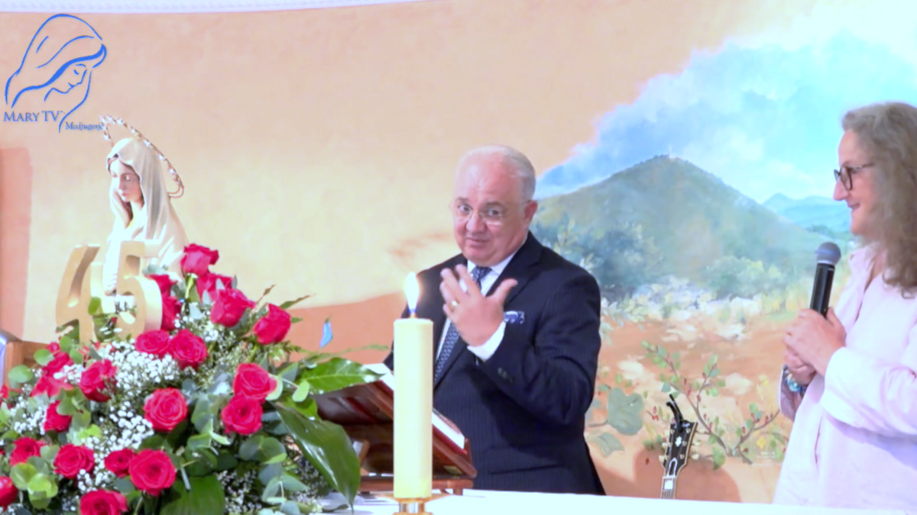
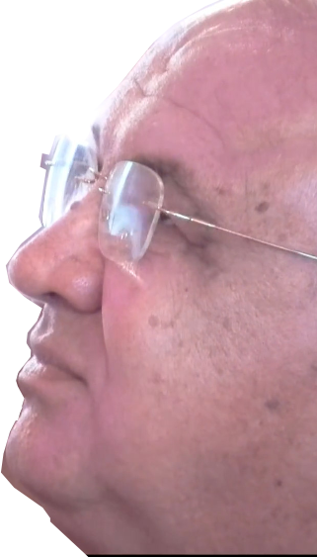

It’s hard to describe all with words but I don’t know when I’ll return but I will return. It’s something, truly, the heart is overwhelmed, it gets to your heart, something special I’m saying, hard to tell… And at that when Our Lady comes so close to you in a special way and gives you, and... and says thank you, dear little children, thank you for all these years. [jokingly] I’m not crying!
June 24th 2026
Our Lady’s Apparition to Ivan Dragičević
After that Our Lady for some time prays in particular for my family, my children, in a special way.

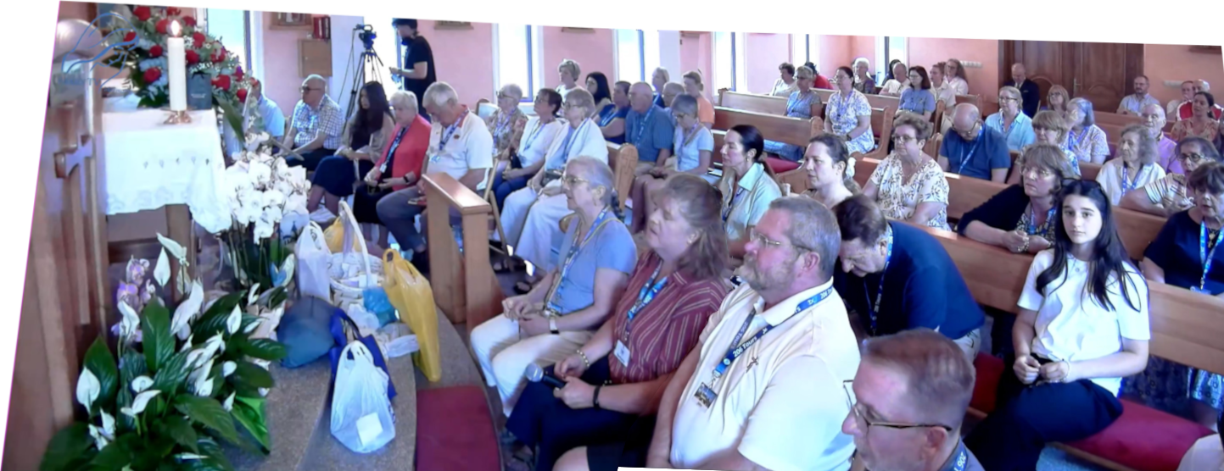
https://video.marytv.tv/watch/m6B6zrsZtJc
After that a conversation that’s so sweet that I won’t be able to sleep tonight because of it.

June 24th 2026
Our Lady’s Apparition to Ivan Dragičević
It’s hard to describe all with words but I don’t know when I’ll return but I will return. It’s something, truly, the heart is overwhelmed, it gets to your heart, something special I’m saying, hard to tell… And at that when Our Lady comes so close to you in a special way and gives you, and... and says thank you, dear little children, thank you for all these years. [jokingly] I’m not crying!
After that Our Lady for some time prays in particular for my family, my children, in a special way.

https://video.marytv.tv/watch/m6B6zrsZtJc
After that a conversation that’s so sweet that I won’t be able to sleep tonight because of it.

June 24th 2026
Our Lady’s Apparition to Ivan Dragičević
It’s hard to describe all with words but I don’t know when I’ll return but I will return. It’s something, truly, the heart is overwhelmed, it gets to your heart, something special I’m saying, hard to tell… And at that when Our Lady comes so close to you in a special way and gives you, and... and says thank you, dear little children, thank you for all these years. [jokingly] I’m not crying!
After that Our Lady for some time prays in particular for my family, my children, in a special way.

https://video.marytv.tv/watch/m6B6zrsZtJc
After that a conversation that’s so sweet that I won’t be able to sleep tonight because of it.

June 24th 2026
Our Lady’s Apparition to Ivan Dragičević
It’s hard to describe all with words but I don’t know when I’ll return but I will return. It’s something, truly, the heart is overwhelmed, it gets to your heart, something special I’m saying, hard to tell… And at that when Our Lady comes so close to you in a special way and gives you, and... and says thank you, dear little children, thank you for all these years. [jokingly] I’m not crying!
After that Our Lady for some time prays in particular for my family, my children, in a special way.

After that a conversation that’s so sweet that I won’t be able to sleep tonight because of it.
https://video.marytv.tv/watch/m6B6zrsZtJc

June 24th 2026
Our Lady’s Apparition to Ivan Dragičević
It’s hard to describe all with words but I don’t know when I’ll return but I will return. It’s something, truly, the heart is overwhelmed, it gets to your heart, something special I’m saying, hard to tell… And at that when Our Lady comes so close to you in a special way and gives you, and... and says thank you, dear little children, thank you for all these years. [jokingly] I’m not crying!
After that Our Lady for some time prays in particular for my family, my children, in a special way.

After that a conversation that’s so sweet that I won’t be able to sleep tonight because of it.
https://video.marytv.tv/watch/m6B6zrsZtJc

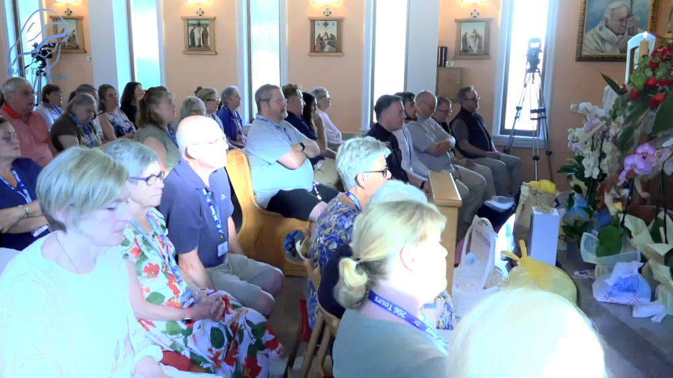

https://video.marytv.tv/watch/m6nUGcsZwxg
June 27th 2026
Our Lady’s Apparition and Message through Ivan Dragičević
It is hard to describe the beauty of Our Lady Herself, Her eyes, Her voice […] Her face […] So much joy, hard to describe with words. Once when we were in front of Our Lady watching Her beauty, we asked: "Mother, why are you so beautiful?" And you know what She said? "Dear children, I’m beautiful because I love. You love too, and you will be beautiful.”
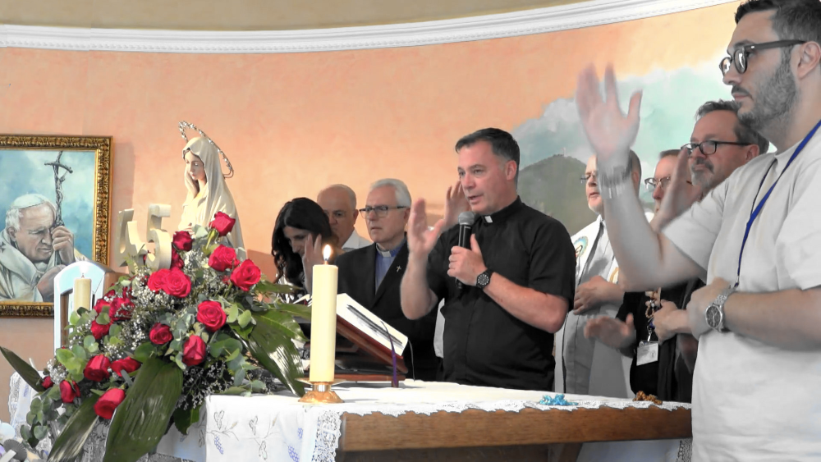
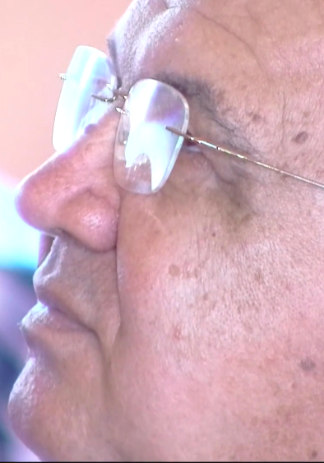
[…] Our Lady keeps on for some time especially praying for the family and for us, and then She says:
"Dear children! Pray for the family,
pray for the holiness in the family!"

https://video.marytv.tv/watch/m6nUGcsZwxg
June 27th 2026
Our Lady’s Apparition and Message through Ivan Dragičević
It is hard to describe the beauty of Our Lady Herself, Her eyes, Her voice […] Her face […] So much joy, hard to describe with words. Once when we were in front of Our Lady watching Her beauty, we asked: "Mother, why are you so beautiful?" And you know what She said? "Dear children, I’m beautiful because I love. You love too, and you will be beautiful.”
[…] Our Lady keeps on for some time especially praying for the family and for us, and then She says:
"Dear children! Pray for the family,
pray for the holiness in the family!"

https://video.marytv.tv/watch/m6nUGcsZwxg
June 27th 2026
Our Lady’s Apparition and Message through Ivan Dragičević
It is hard to describe the beauty of Our Lady Herself, Her eyes, Her voice […] Her face […] So much joy, hard to describe with words. Once when we were in front of Our Lady watching Her beauty, we asked: "Mother, why are you so beautiful?" And you know what She said? "Dear children, I’m beautiful because I love. You love too, and you will be beautiful.”
[…] Our Lady keeps on for some time especially praying for the family and for us, and then She says:
"Dear children! Pray for the family,
pray for the holiness in the family!"

https://video.marytv.tv/watch/m6nUGcsZwxg
June 27th 2026
Our Lady’s Apparition and Message through Ivan Dragičević
It is hard to describe the beauty of Our Lady Herself, Her eyes, Her voice […] Her face […] So much joy, hard to describe with words. Once when we were in front of Our Lady watching Her beauty, we asked: "Mother, why are you so beautiful?" And you know what She said? "Dear children, I’m beautiful because I love. You love too, and you will be beautiful.”
[…] Our Lady keeps on for some time especially praying for the family and for us, and then She says:
"Dear children! Pray for the family,
pray for the holiness in the family!"

https://video.marytv.tv/watch/m6nUGcsZwxg
June 27th 2026
Our Lady’s Apparition and Message through Ivan Dragičević
It is hard to describe the beauty of Our Lady Herself, Her eyes, Her voice […] Her face […] So much joy, hard to describe with words. Once when we were in front of Our Lady watching Her beauty, we asked: "Mother, why are you so beautiful?" And you know what She said? "Dear children, I’m beautiful because I love. You love too, and you will be beautiful.”
[…] Our Lady keeps on for some time especially praying for the family and for us, and then She says:
"Dear children! Pray for the family,
pray for the holiness in the family!"

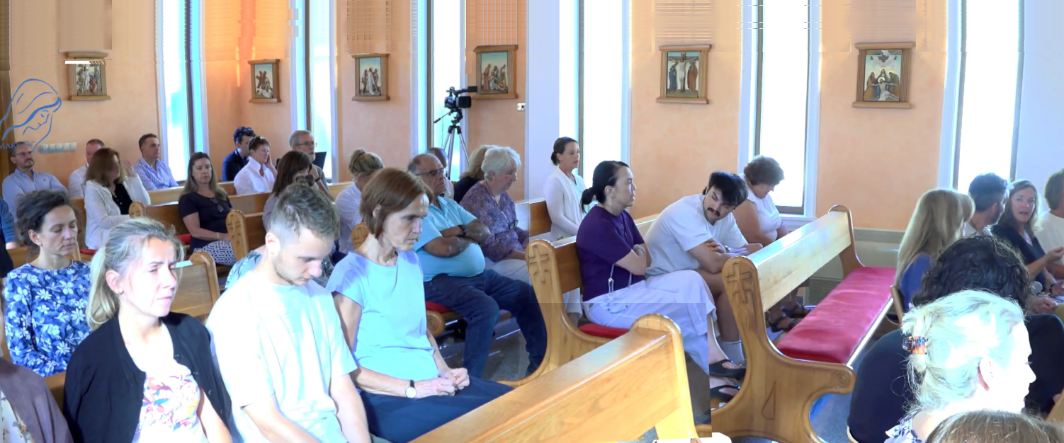
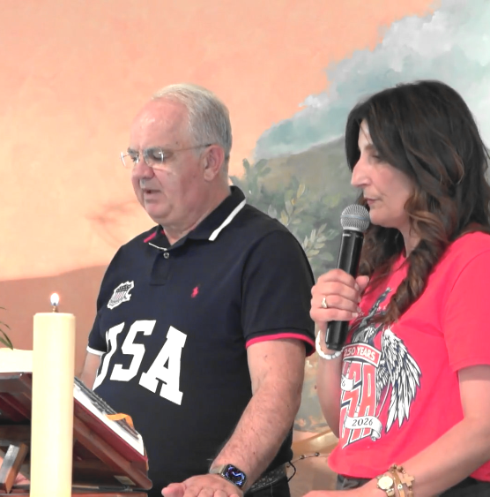

July 4th 2026
https://video.marytv.tv/watch/mSjB0NsZxBk
Dear children! Also this evening I call you to open your hearts to Holy Spirit. Let your common prayer, although you are connected via screen, be a meeting of living hearts seeking God.
Do not let the distance separate you because where there is prayer with faith, love and humility, my Son is present and pours out His peace. Be encouragement to one another. Hear you in prayer one another and do not get tired of praying for peace in your families, in the Church and in the entire world.
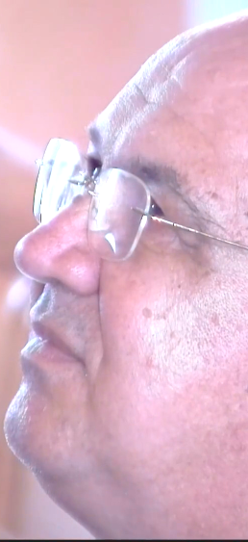
Ivan received this message the previous day, but he read it publicly in this video.
Let rosary be your daily strenth, Holy Scripture your light, Holy Mass the center of your life.
Each day say anew: "Yes!" to God and allow Him to guide you on the way of holiness.

Our Lady’s Apparition and Message (July 3rd) through Ivan Dragičević
I am with you and I plead before my Son for you all. Thank you dear children also today for having responded to my call.

https://video.marytv.tv/watch/mSjB0NsZxBk
July 4th 2026
Dear children! Also this evening I call you to open your hearts to Holy Spirit. Let your common prayer, although you are connected via screen, be a meeting of living hearts seeking God.
Do not let the distance separate you because where there is prayer with faith, love and humility, my Son is present and pours out His peace. Be encouragement to one another. Hear you in prayer one another and do not get tired of praying for peace in your families, in the Church and in the entire world.
Ivan received this message the previous day, but he read it publicly in this video.
Let rosary be your daily strenth, Holy Scripture your light, Holy Mass the center of your life.
Each day say anew: "Yes!" to God and allow Him to guide you on the way of holiness.

I am with you and I plead before my Son for you all. Thank you dear children also today for having responded to my call.
Our Lady’s Apparition and Message (July 3rd) through Ivan Dragičević

https://video.marytv.tv/watch/mSjB0NsZxBk
July 4th 2026
Dear children! Also this evening I call you to open your hearts to Holy Spirit. Let your common prayer, although you are connected via screen, be a meeting of living hearts seeking God.
Do not let the distance separate you because where there is prayer with faith, love and humility, my Son is present and pours out His peace. Be encouragement to one another. Hear you in prayer one another and do not get tired of praying for peace in your families, in the Church and in the entire world.
Ivan received this message the previous day, but he read it publicly in this video.
Let rosary be your daily strenth, Holy Scripture your light, Holy Mass the center of your life.
Each day say anew: "Yes!" to God and allow Him to guide you on the way of holiness.

I am with you and I plead before my Son for you all. Thank you dear children also today for having responded to my call.
Our Lady’s Apparition and Message (July 3rd) through Ivan Dragičević

July 4th 2026
https://video.marytv.tv/watch/mSjB0NsZxBk
Do not let the distance separate you because where there is prayer with faith, love and humility, my Son is present and pours out His peace. Be encouragement to one another. Hear you in prayer one another and do not get tired of praying for peace in your families, in the Church and in the entire world.
Dear children! Also this evening I call you to open your hearts to Holy Spirit. Let your common prayer, although you are connected via screen, be a meeting of living hearts seeking God.
Ivan received this message the previous day, but he read it publicly in this video.
Let rosary be your daily strenth, Holy Scripture your light, Holy Mass the center of your life.
Each day say anew: "Yes!" to God and allow Him to guide you on the way of holiness.

I am with you and I plead before my Son for you all. Thank you dear children also today for having responded to my call.
Our Lady’s Apparition and Message (July 3rd) through Ivan Dragičević

July 4th 2026
https://video.marytv.tv/watch/mSjB0NsZxBk
Do not let the distance separate you because where there is prayer with faith, love and humility, my Son is present and pours out His peace. Be encouragement to one another. Hear you in prayer one another and do not get tired of praying for peace in your families, in the Church and in the entire world.
Dear children! Also this evening I call you to open your hearts to Holy Spirit. Let your common prayer, although you are connected via screen, be a meeting of living hearts seeking God.
Ivan received this message the previous day, but he read it publicly in this video.
Let rosary be your daily strenth, Holy Scripture your light, Holy Mass the center of your life.
Each day say anew: "Yes!" to God and allow Him to guide you on the way of holiness.

I am with you and I plead before my Son for you all. Thank you dear children also today for having responded to my call.
Our Lady’s Apparition and Message (July 3rd) through Ivan Dragičević

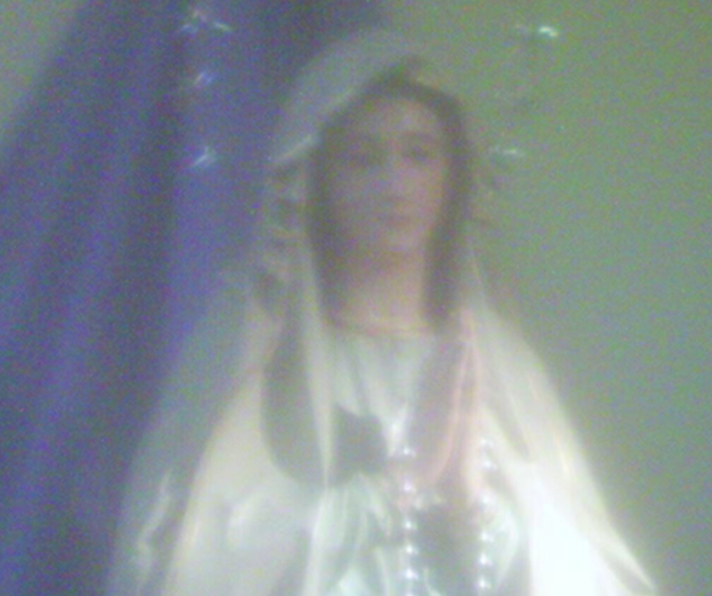
Our Lady’s message from Međugorja, July 25th 2026. through seer Marije Pavlović Lunetti

Dear children!
While darkness and peacelessness rule in many hearts, you, little children, be prayer and my extended hands of love. Little children, place the Sacred Scripture in a visible place in your family and read it, so that it may be an encouragement for you to conversion and a new life; because Satan is strong and seduces hearts. Your hearts, through my maternal Heart, I desire to commend to the Heart of my Son Jesus, so that He, the Risen One, may reign in you and joy may begin to reign in you and around you.
Thank you for having responded to my call.

(with Ecclesiastical approval)
taken from https://www.medjugorje.hr, compared to locations https://www.medjugorje.ws, https://marytv.tv https://rosasparalagospa.com

Our Lady’s message from Međugorja, July 25th 2026. through seer Marije Pavlović Lunetti

Dear children!
While darkness and peacelessness rule in many hearts, you, little children, be prayer and my extended hands of love. Little children, place the Sacred Scripture in a visible place in your family and read it, so that it may be an encouragement for you to conversion and a new life; because Satan is strong and seduces hearts. Your hearts, through my maternal Heart, I desire to commend to the Heart of my Son Jesus, so that He, the Risen One, may reign in you and joy may begin to reign in you and around you.
Thank you for having responded to my call.

(with Ecclesiastical approval)
taken from https://www.medjugorje.hr, compared to locations https://www.medjugorje.ws, https://marytv.tv https://rosasparalagospa.com

Our Lady’s message from Međugorja, July 25th 2026. through seer Marije Pavlović Lunetti

Dear children!
While darkness and peacelessness rule in many hearts, you, little children, be prayer and my extended hands of love. Little children, place the Sacred Scripture in a visible place in your family and read it, so that it may be an encouragement for you to conversion and a new life; because Satan is strong and seduces hearts. Your hearts, through my maternal Heart, I desire to commend to the Heart of my Son Jesus, so that He, the Risen One, may reign in you and joy may begin to reign in you and around you.
Thank you for having responded to my call.

(with Ecclesiastical approval)
taken from https://www.medjugorje.hr, compared to locations https://www.medjugorje.ws, https://marytv.tv https://rosasparalagospa.com

Our Lady’s message from Međugorja, July 25th 2026. through seer Marije Pavlović Lunetti

Dear children!
While darkness and peacelessness rule in many hearts, you, little children, be prayer and my extended hands of love. Little children, place the Sacred Scripture in a visible place in your family and read it, so that it may be an encouragement for you to conversion and a new life; because Satan is strong and seduces hearts. Your hearts, through my maternal Heart, I desire to commend to the Heart of my Son Jesus, so that He, the Risen One, may reign in you and joy may begin to reign in you and around you.
Thank you for having responded to my call.

(with Ecclesiastical approval)
taken from https://www.medjugorje.hr, compared to locations https://www.medjugorje.ws, https://marytv.tv https://rosasparalagospa.com

Our Lady’s message from Međugorja, July 25th 2026. through seer Marije Pavlović Lunetti

Dear children!
While darkness and peacelessness rule in many hearts, you, little children, be prayer and my extended hands of love. Little children, place the Sacred Scripture in a visible place in your family and read it, so that it may be an encouragement for you to conversion and a new life; because Satan is strong and seduces hearts. Your hearts, through my maternal Heart, I desire to commend to the Heart of my Son Jesus, so that He, the Risen One, may reign in you and joy may begin to reign in you and around you.
Thank you for having responded to my call.

(with Ecclesiastical approval)
taken from https://www.medjugorje.hr, compared to locations https://www.medjugorje.ws, https://marytv.tv https://rosasparalagospa.com

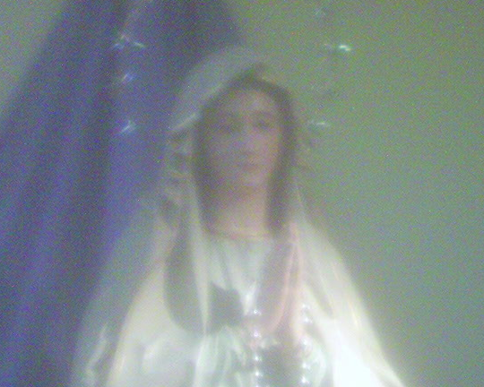

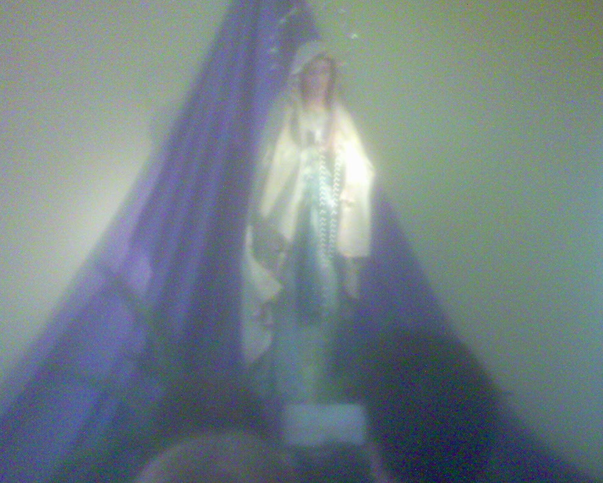
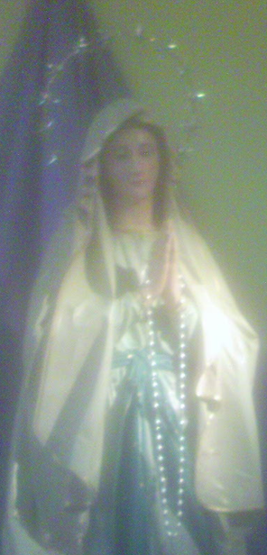


https://exdeo.net/medjugor/stueLsJ1/
“Međugorje, Sunday April 9th 2006. Using my own mobile I went, after a few hours of prayer in the church of Međugorje, remembering that the website [*] from which I was granted permission to use the pictures of Our Lady of Lourdes of the church of Međugorje [has disappeared], to photograph that dear statue of Gospa. ⮥
[*] confer to our booklet (in Croatian only yet) with Our Lady’s messages and apparitions of 2023 to 2024
[And I got] these three pictures.”
That is the text, unchanged for 20 years on the location that you should get by scanning the QR-code futher right above.

Sony Ericsson (I don’t remember the model) to the right opened, with the shaft in the middle with the camera (not seen as it is in the back).
2nd and 3rd photos have been cropped for printing. Unfortunately it rained and the camera of the device, furtherest right, was blurry from drops of rain.

I used this device only as any other user. I never dismantled it nor have I ever known its insides.
The camera can be seen on the center shaft on the closer picture of the device folded, at top in the middle.

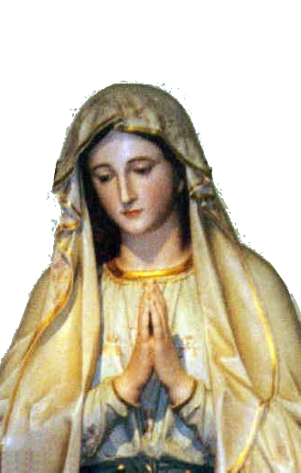
This picture to the right, from different viewpoint, is this statue as the artist made it.
Is there anybody sufficiently knowledgeable who would wish to verify these photos? Extract them from this cellphone with exact undenianble technical methods? It’s some 17-18 yrs that I have never moved it, let alone used it in any way, and I only took pictures of it now for this occasion. But to thoroughy plan and prepare with me how to verify this truth!
Association Croatia Fidelis
Vankina 4, Zapruđe, Zagreb, Croatia
contact: Miroslav Rovis, miro.rovis@croatiafidelis.hr,
miroslav.rovis@proton.me,
+385 1 6602633
+385 91 2660202

https://exdeo.net/medjugor/stueLsJ1/
“Međugorje, Sunday April 9th 2006. Using my own mobile I went, after a few hours of prayer in the church of Međugorje, remembering that the website [*] from which I was granted permission to use the pictures of Our Lady of Lourdes of the church of Međugorje [has disappeared], to photograph that dear statue of Gospa. ⮥
[*] confer to our booklet (in Croatian only yet) with Our Lady’s messages and apparitions of 2023 to 2024
[And I got] these three pictures.”
That is the text, unchanged for 20 years on the location that you should get by scanning the QR-code futher right above.

Sony Ericsson (I don’t remember the model) to the right opened, with the shaft in the middle with the camera (not seen as it is in the back).
2nd and 3rd photos have been cropped for printing. Unfortunately it rained and the camera of the device, furtherest right, was blurry from drops of rain.

I used this device only as any other user. I never dismantled it nor have I ever known its insides.
The camera can be seen on the center shaft on the closer picture of the device folded, at top in the middle.
This picture to the right, from different viewpoint, is this statue as the artist made it.
Is there anybody sufficiently knowledgeable who would wish to verify these photos? Extract them from this cellphone with exact undenianble technical methods? It’s some 17-18 yrs that I have never moved it, let alone used it in any way, and I only took pictures of it now for this occasion. But to thoroughy plan and prepare with me how to verify this truth!
Association Croatia Fidelis
Vankina 4, Zapruđe, Zagreb, Croatia
contact: Miroslav Rovis, miro.rovis@croatiafidelis.hr,
miroslav.rovis@proton.me,
+385 1 6602633
+385 91 2660202

https://exdeo.net/medjugor/stueLsJ1/
“Međugorje, Sunday April 9th 2006. Using my own mobile I went, after a few hours of prayer in the church of Međugorje, remembering that the website [*] from which I was granted permission to use the pictures of Our Lady of Lourdes of the church of Međugorje [has disappeared], to photograph that dear statue of Gospa. ⮥
[*] confer to our booklet (in Croatian only yet) with Our Lady’s messages and apparitions of 2023 to 2024
[And I got] these three pictures.”
That is the text, unchanged for 20 years on the location that you should get by scanning the QR-code futher right above.

Sony Ericsson (I don’t remember the model) to the right opened, with the shaft in the middle with the camera (not seen as it is in the back).
2nd and 3rd photos have been cropped for printing. Unfortunately it rained and the camera of the device, furtherest right, was blurry from drops of rain.

I used this device only as any other user. I never dismantled it nor have I ever known its insides.
The camera can be seen on the center shaft on the closer picture of the device folded, at top in the middle.
This picture to the right, from different viewpoint, is this statue as the artist made it.
Is there anybody sufficiently knowledgeable who would wish to verify these photos? Extract them from this cellphone with exact undenianble technical methods? It’s some 17-18 yrs that I have never moved it, let alone used it in any way, and I only took pictures of it now for this occasion. But to thoroughy plan and prepare with me how to verify this truth!
Association Croatia Fidelis
Vankina 4, Zapruđe, Zagreb, Croatia
contact: Miroslav Rovis, miro.rovis@croatiafidelis.hr,
miroslav.rovis@proton.me,
+385 1 6602633
+385 91 2660202

https://exdeo.net/medjugor/stueLsJ1/
“Međugorje, Sunday April 9th 2006. Using my own mobile I went, after a few hours of prayer in the church of Međugorje, remembering that the website [*] from which I was granted permission to use the pictures of Our Lady of Lourdes of the church of Međugorje [has disappeared], to photograph that dear statue of Gospa. ⮥
[*] confer to our booklet (in Croatian only yet) with Our Lady’s messages and apparitions of 2023 to 2024
[And I got] these three pictures.”
That is the text, unchanged for 20 years on the location that you should get by scanning the QR-code futher right above.

Sony Ericsson (I don’t remember the model) to the right opened, with the shaft in the middle with the camera (not seen as it is in the back).
2nd and 3rd photos have been cropped for printing. Unfortunately it rained and the camera of the device, furtherest right, was blurry from drops of rain.

I used this device only as any other user. I never dismantled it nor have I ever known its insides.
The camera can be seen on the center shaft on the closer picture of the device folded, at top in the middle.
This picture to the right, from different viewpoint, is this statue as the artist made it.
Is there anybody sufficiently knowledgeable who would wish to verify these photos? Extract them from this cellphone with exact undenianble technical methods? It’s some 17-18 yrs that I have never moved it, let alone used it in any way, and I only took pictures of it now for this occasion. But to thoroughy plan and prepare with me how to verify this truth!
Association Croatia Fidelis
Vankina 4, Zapruđe, Zagreb, Croatia
contact: Miroslav Rovis, miro.rovis@croatiafidelis.hr,
miroslav.rovis@proton.me,
+385 1 6602633
+385 91 2660202

https://exdeo.net/medjugor/stueLsJ1/
“Međugorje, Sunday April 9th 2006. Using my own mobile I went, after a few hours of prayer in the church of Međugorje, remembering that the website [*] from which I was granted permission to use the pictures of Our Lady of Lourdes of the church of Međugorje [has disappeared], to photograph that dear statue of Gospa. ⮥
[*] confer to our booklet (in Croatian only yet) with Our Lady’s messages and apparitions of 2023 to 2024
[And I got] these three pictures.”
That is the text, unchanged for 20 years on the location that you should get by scanning the QR-code futher right above.

Sony Ericsson (I don’t remember the model) to the right opened, with the shaft in the middle with the camera (not seen as it is in the back).
2nd and 3rd photos have been cropped for printing. Unfortunately it rained and the camera of the device, furtherest right, was blurry from drops of rain.

I used this device only as any other user. I never dismantled it nor have I ever known its insides.
The camera can be seen on the center shaft on the closer picture of the device folded, at top in the middle.
This picture to the right, from different viewpoint, is this statue as the artist made it.
Is there anybody sufficiently knowledgeable who would wish to verify these photos? Extract them from this cellphone with exact undenianble technical methods? It’s some 17-18 yrs that I have never moved it, let alone used it in any way, and I only took pictures of it now for this occasion. But to thoroughy plan and prepare with me how to verify this truth!
Association Croatia Fidelis
Vankina 4, Zapruđe, Zagreb, Croatia
contact: Miroslav Rovis, miro.rovis@croatiafidelis.hr,
miroslav.rovis@proton.me,
+385 1 6602633
+385 91 2660202

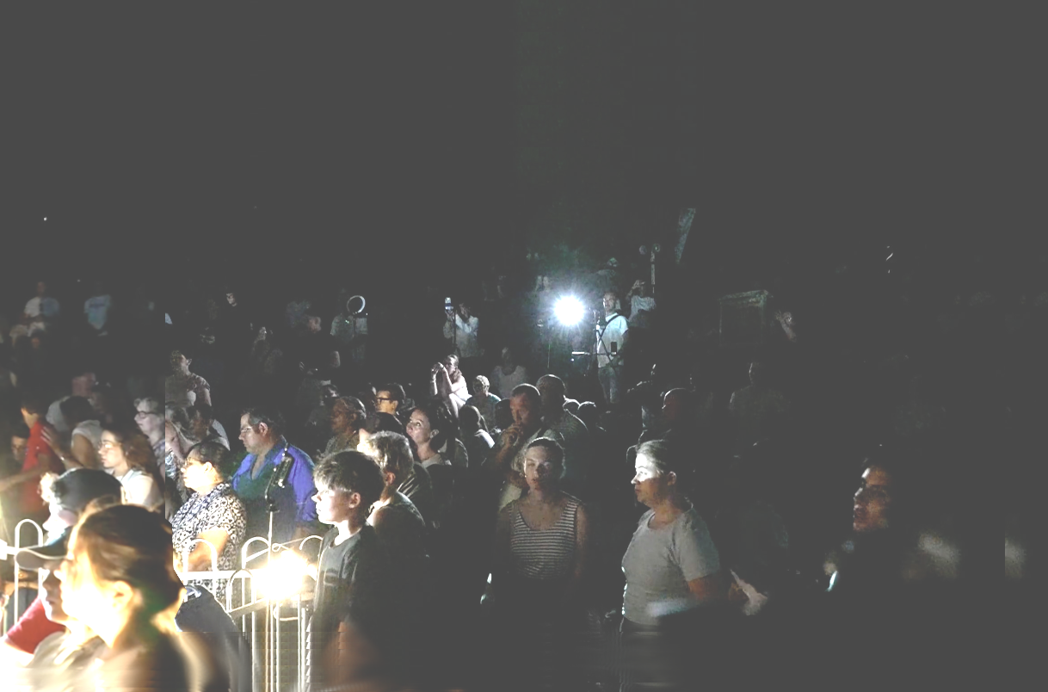
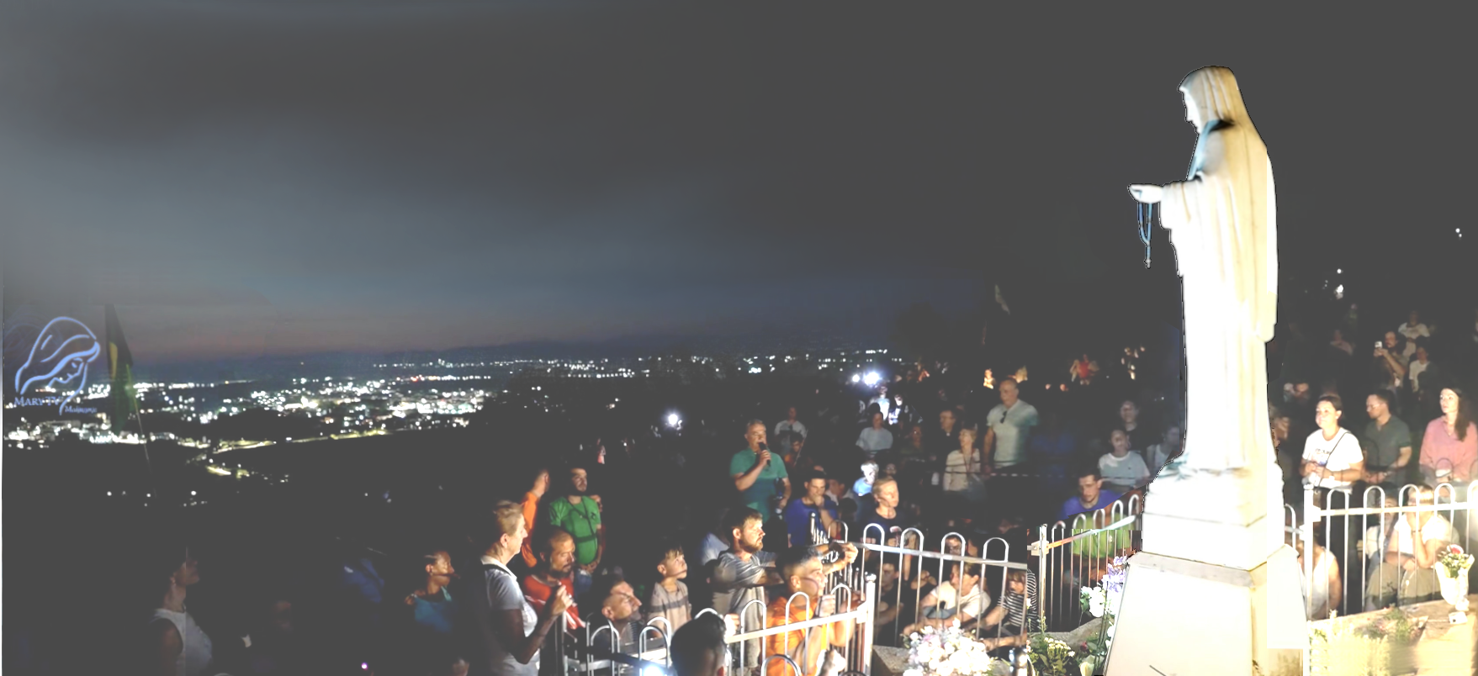

July 31st 2026
Our Lady’s Apparition and Message through Ivan Dragičević
https://video.marytv.tv/watch/mCkJJQsZ3zR
[…] After that Our Lady lifts Her eyes toward all of us, extends Her hands [...] prays over us all. […] After that She addresses us all briefly with these words:
[…] After that Our Lady in a special way for some time prays for peace in the world. And after that She leaves, in prayer, in the sign of the light of the Cross with the greeting: "Go in peace, my dear children!"
Dear children! Also today in a special way I wish to invite you to pray, through this time, time of grace, for the young and for the family, for holiness in the families. Return prayer in your families, put God in your families in the first place and together with Him set out. Set out into the future. Mother is following you. I plead before my Son for all of you. Thank you dear children also today for having responded to my call!

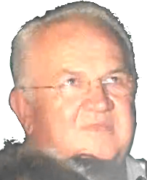

July 31st 2026
Our Lady’s Apparition and Message through Ivan Dragičević
https://video.marytv.tv/watch/mCkJJQsZ3zR
[…] After that Our Lady in a special way for some time prays for peace in the world. And after that She leaves, in prayer, in the sign of the light of the Cross with the greeting: "Go in peace, my dear children!"
[…] After that Our Lady lifts Her eyes toward all of us, extends Her hands [...] prays over us all. […] After that She addresses us all briefly with these words:
Dear children! Also today in a special way I wish to invite you to pray, through this time, time of grace, for the young and for the family, for holiness in the families. Return prayer in your families, put God in your families in the first place and together with Him set out. Set out into the future. Mother is following you. I plead before my Son for all of you. Thank you dear children also today for having responded to my call!

July 31st 2026
Our Lady’s Apparition and Message through Ivan Dragičević
https://video.marytv.tv/watch/mCkJJQsZ3zR
[…] After that Our Lady lifts Her eyes toward all of us, extends Her hands [...] prays over us all. […] After that She addresses us all briefly with these words:
[…] After that Our Lady in a special way for some time prays for peace in the world. And after that She leaves, in prayer, in the sign of the light of the Cross with the greeting: "Go in peace, my dear children!"
Dear children! Also today in a special way I wish to invite you to pray, through this time, time of grace, for the young and for the family, for holiness in the families. Return prayer in your families, put God in your families in the first place and together with Him set out. Set out into the future. Mother is following you. I plead before my Son for all of you. Thank you dear children also today for having responded to my call!

July 31st 2026
Our Lady’s Apparition and Message through Ivan Dragičević
https://video.marytv.tv/watch/mCkJJQsZ3zR
[…] After that Our Lady lifts Her eyes toward all of us, extends Her hands [...] prays over us all. […] After that She addresses us all briefly with these words:
[…] After that Our Lady in a special way for some time prays for peace in the world. And after that She leaves, in prayer, in the sign of the light of the Cross with the greeting: "Go in peace, my dear children!"
Dear children! Also today in a special way I wish to invite you to pray, through this time, time of grace, for the young and for the family, for holiness in the families. Return prayer in your families, put God in your families in the first place and together with Him set out. Set out into the future. Mother is following you. I plead before my Son for all of you. Thank you dear children also today for having responded to my call!

July 31st 2026
Our Lady’s Apparition and Message through Ivan Dragičević
https://video.marytv.tv/watch/mCkJJQsZ3zR
[…] After that Our Lady lifts Her eyes toward all of us, extends Her hands [...] prays over us all. […] After that She addresses us all briefly with these words:
[…] After that Our Lady in a special way for some time prays for peace in the world. And after that She leaves, in prayer, in the sign of the light of the Cross with the greeting: "Go in peace, my dear children!"
Dear children! Also today in a special way I wish to invite you to pray, through this time, time of grace, for the young and for the family, for holiness in the families. Return prayer in your families, put God in your families in the first place and together with Him set out. Set out into the future. Mother is following you. I plead before my Son for all of you. Thank you dear children also today for having responded to my call!

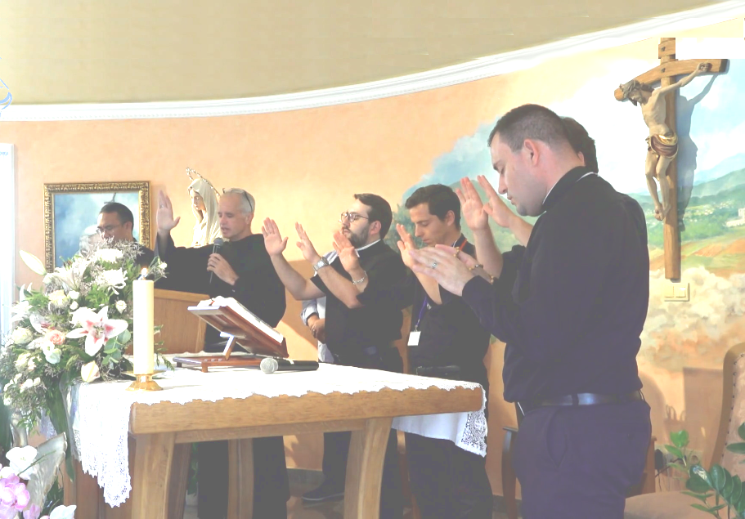
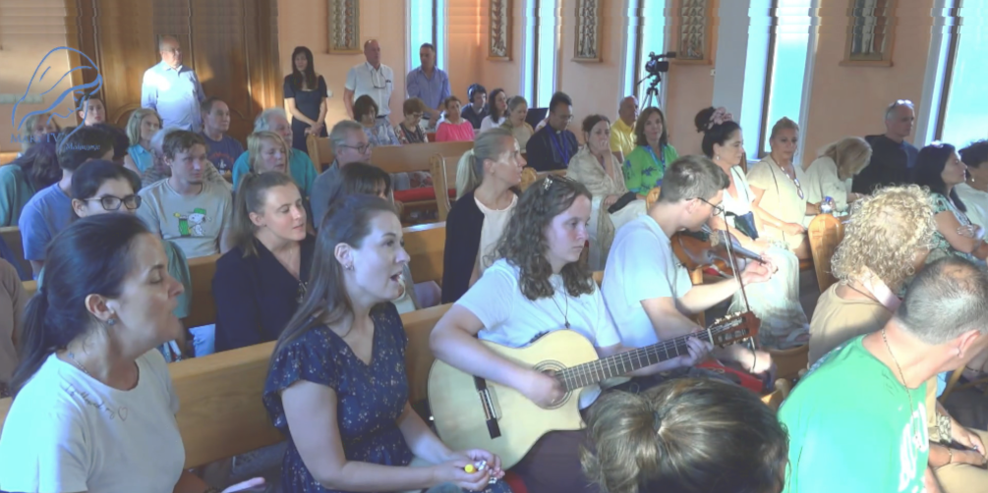

Our Lady’s Apparition to Ivan Dragičević
Our Lady lifts Her eyes toward all of us and in Her Aramaic language prays over us all.
After that She directs Her gaze toward the church and prays over all who are there prepeparing for today’s Holy Mass and the prayer program.
August 1st 2026

[…] Our Lady [prays] over you sick and you priests present. […] prays for the young, for all the young who will attend here in these days [note.: the Youth festival is in Međugorje ].
https://video.marytv.tv/watch/mC9hRxsZQ6E
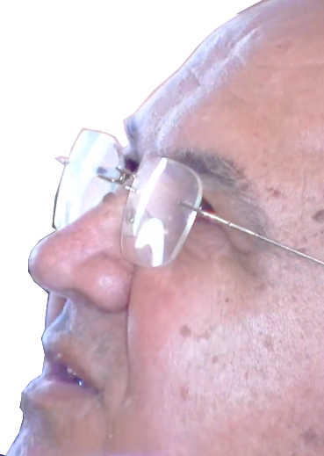
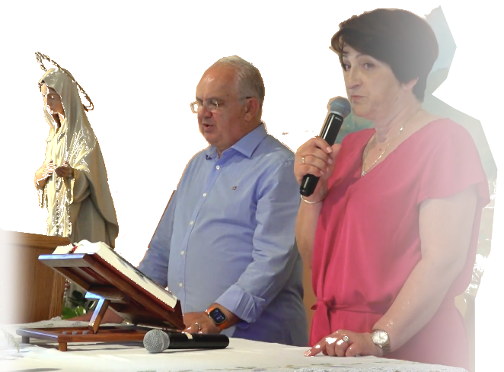

Our Lady lifts Her eyes toward all of us and in Her Aramaic language prays over us all.
After that She directs Her gaze toward the church and prays over all who are there prepeparing for today’s Holy Mass and the prayer program.
August 1st 2026
Our Lady’s Apparition to Ivan Dragičević

https://video.marytv.tv/watch/mC9hRxsZQ6E
[…] Our Lady [prays] over you sick and you priests present. […] prays for the young, for all the young who will attend here in these days [note.: the Youth festival is in Međugorje ].

Our Lady lifts Her eyes toward all of us and in Her Aramaic language prays over us all.
After that She directs Her gaze toward the church and prays over all who are there prepeparing for today’s Holy Mass and the prayer program.
August 1st 2026
Our Lady’s Apparition to Ivan Dragičević

https://video.marytv.tv/watch/mC9hRxsZQ6E
[…] Our Lady [prays] over you sick and you priests present. […] prays for the young, for all the young who will attend here in these days [note.: the Youth festival is in Međugorje ].

Our Lady lifts Her eyes toward all of us and in Her Aramaic language prays over us all.
After that She directs Her gaze toward the church and prays over all who are there prepeparing for today’s Holy Mass and the prayer program.
August 1st 2026
Our Lady’s Apparition to Ivan Dragičević

https://video.marytv.tv/watch/mC9hRxsZQ6E
[…] Our Lady [prays] over you sick and you priests present. […] prays for the young, for all the young who will attend here in these days [note.: the Youth festival is in Međugorje ].

Our Lady lifts Her eyes toward all of us and in Her Aramaic language prays over us all.
After that She directs Her gaze toward the church and prays over all who are there prepeparing for today’s Holy Mass and the prayer program.
August 1st 2026
Our Lady’s Apparition to Ivan Dragičević

https://video.marytv.tv/watch/mC9hRxsZQ6E
[…] Our Lady [prays] over you sick and you priests present. […] prays for the young, for all the young who will attend here in these days [note.: the Youth festival is in Međugorje ].

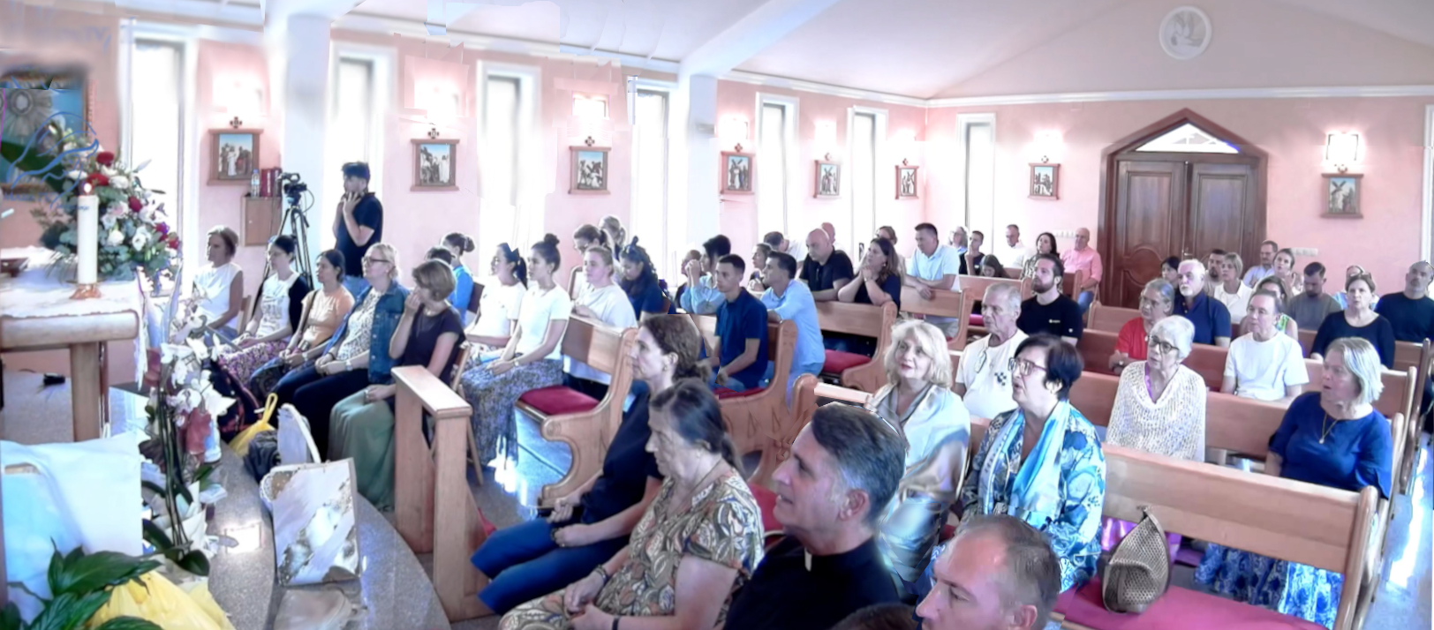
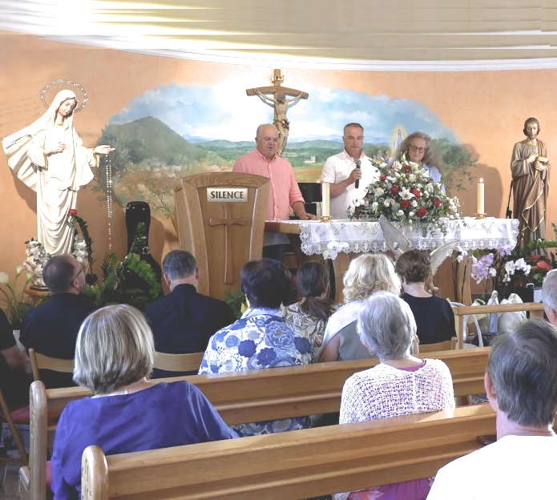

After that She lifts Her eyes toward us all here, so much joy on Her face, in Her eyes, She extends Her hands and in Her mother tongue, in Aramaic, prays over all of us here.
[…] After that Our Lady today in a special way for a longer time keeps on praying for priests and the Holy Father and in a special way for vocations in the Church.
August 8th 2026
Our Lady’s Apparition to Ivan Dragičević
Also today Our Lady came to us joyful and merry and greets su all at the beginning with Her motherly greeting: "Praised be Jesus, dear children of mine!"
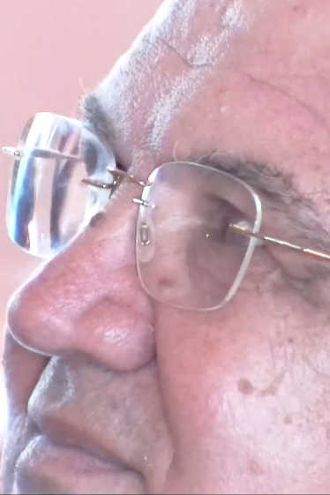
https://video.marytv.tv/watch/meR9SusZnAh

After that She lifts Her eyes toward us all here, so much joy on Her face, in Her eyes, She extends Her hands and in Her mother tongue, in Aramaic, prays over all of us here.
[…] After that Our Lady today in a special way for a longer time keeps on praying for priests and the Holy Father and in a special way for vocations in the Church.
August 8th 2026
Our Lady’s Apparition to Ivan Dragičević
Also today Our Lady came to us joyful and merry and greets su all at the beginning with Her motherly greeting: "Praised be Jesus, dear children of mine!"
https://video.marytv.tv/watch/meR9SusZnAh

After that She lifts Her eyes toward us all here, so much joy on Her face, in Her eyes, She extends Her hands and in Her mother tongue, in Aramaic, prays over all of us here.
[…] After that Our Lady today in a special way for a longer time keeps on praying for priests and the Holy Father and in a special way for vocations in the Church.
August 8th 2026
Our Lady’s Apparition to Ivan Dragičević
Also today Our Lady came to us joyful and merry and greets su all at the beginning with Her motherly greeting: "Praised be Jesus, dear children of mine!"
https://video.marytv.tv/watch/meR9SusZnAh

After that She lifts Her eyes toward us all here, so much joy on Her face, in Her eyes, She extends Her hands and in Her mother tongue, in Aramaic, prays over all of us here.
[…] After that Our Lady today in a special way for a longer time keeps on praying for priests and the Holy Father and in a special way for vocations in the Church.
August 8th 2026
Our Lady’s Apparition to Ivan Dragičević
Also today Our Lady came to us joyful and merry and greets su all at the beginning with Her motherly greeting: "Praised be Jesus, dear children of mine!"
https://video.marytv.tv/watch/meR9SusZnAh

After that She lifts Her eyes toward us all here, so much joy on Her face, in Her eyes, She extends Her hands and in Her mother tongue, in Aramaic, prays over all of us here.
[…] After that Our Lady today in a special way for a longer time keeps on praying for priests and the Holy Father and in a special way for vocations in the Church.
August 8th 2026
Our Lady’s Apparition to Ivan Dragičević
Also today Our Lady came to us joyful and merry and greets su all at the beginning with Her motherly greeting: "Praised be Jesus, dear children of mine!"
https://video.marytv.tv/watch/meR9SusZnAh


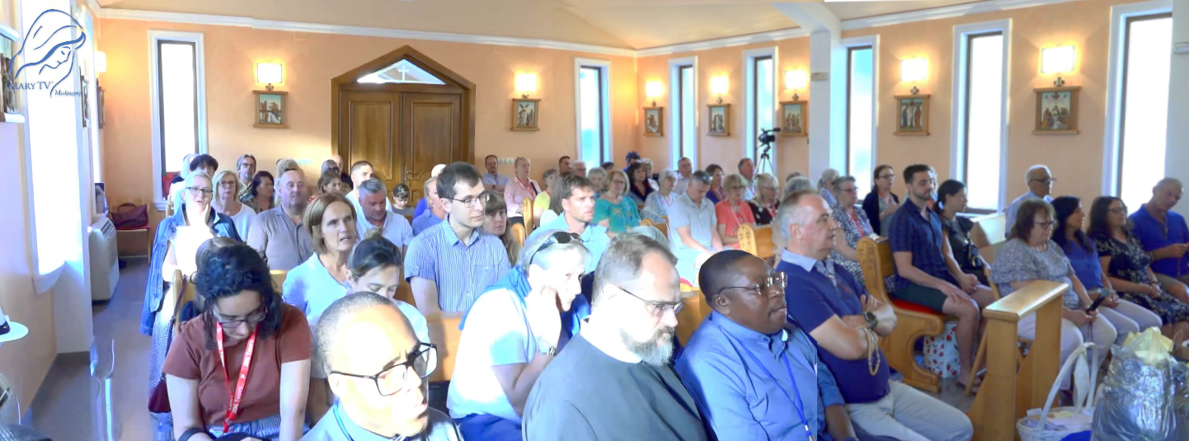
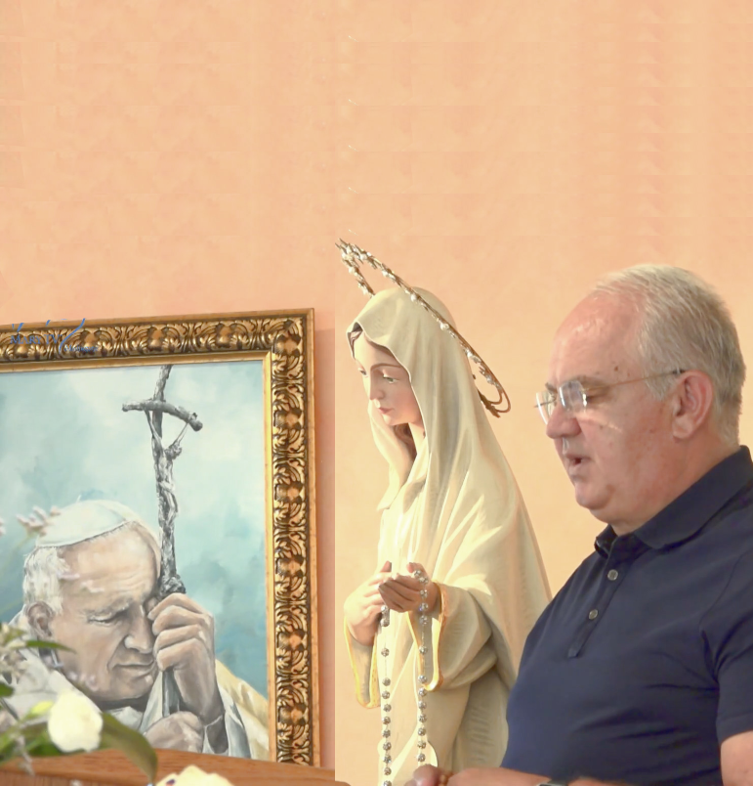

https://video.marytv.tv/watch/medEt4s1AxH
August 15th 2026
Our Lady’s Apparition and Message through Ivan Dragičević
It is truly hard to explain on special feasts of Hers like it is the today’s feast of Hers. And in a special way that joy of Hers. And She came today truly very joyful and merry. […] She came in a kind of golden dress. […] Our Lady calls us with these words:
Dear children, also today with my motherly call I invite you to open your heart. Lift your hearts to Heaven. Put Jesus in the first place in your life, and in your family.
Do not be afraid of the future, but pray. Love and forgive! Be carriers of peace, to your families and to the world. I am with you. I take you all to my Son. Thank you dear children also today for having responded to my call.

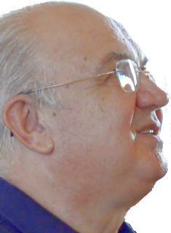

https://video.marytv.tv/watch/medEt4s1AxH
Our Lady’s Apparition and Message through Ivan Dragičević
August 15th 2026
It is truly hard to explain on special feasts of Hers like it is the today’s feast of Hers. And in a special way that joy of Hers. And She came today truly very joyful and merry. […] She came in a kind of golden dress. […] Our Lady calls us with these words:
Dear children, also today with my motherly call I invite you to open your heart. Lift your hearts to Heaven. Put Jesus in the first place in your life, and in your family.
Do not be afraid of the future, but pray. Love and forgive! Be carriers of peace, to your families and to the world. I am with you. I take you all to my Son. Thank you dear children also today for having responded to my call.

https://video.marytv.tv/watch/medEt4s1AxH
Our Lady’s Apparition and Message through Ivan Dragičević
August 15th 2026
It is truly hard to explain on special feasts of Hers like it is the today’s feast of Hers. And in a special way that joy of Hers. And She came today truly very joyful and merry. […] She came in a kind of golden dress. […] Our Lady calls us with these words:
Dear children, also today with my motherly call I invite you to open your heart. Lift your hearts to Heaven. Put Jesus in the first place in your life, and in your family.
Do not be afraid of the future, but pray. Love and forgive! Be carriers of peace, to your families and to the world. I am with you. I take you all to my Son. Thank you dear children also today for having responded to my call.

https://video.marytv.tv/watch/medEt4s1AxH
Our Lady’s Apparition and Message through Ivan Dragičević
August 15th 2026
It is truly hard to explain on special feasts of Hers like it is the today’s feast of Hers. And in a special way that joy of Hers. And She came today truly very joyful and merry. […] She came in a kind of golden dress. […] Our Lady calls us with these words:
Dear children, also today with my motherly call I invite you to open your heart. Lift your hearts to Heaven. Put Jesus in the first place in your life, and in your family.
Do not be afraid of the future, but pray. Love and forgive! Be carriers of peace, to your families and to the world. I am with you. I take you all to my Son. Thank you dear children also today for having responded to my call.

Our Lady’s Apparition and Message through Ivan Dragičević
https://video.marytv.tv/watch/medEt4s1AxH
August 15th 2026
It is truly hard to explain on special feasts of Hers like it is the today’s feast of Hers. And in a special way that joy of Hers. And She came today truly very joyful and merry. […] She came in a kind of golden dress. […] Our Lady calls us with these words:
Dear children, also today with my motherly call I invite you to open your heart. Lift your hearts to Heaven. Put Jesus in the first place in your life, and in your family.
Do not be afraid of the future, but pray. Love and forgive! Be carriers of peace, to your families and to the world. I am with you. I take you all to my Son. Thank you dear children also today for having responded to my call.

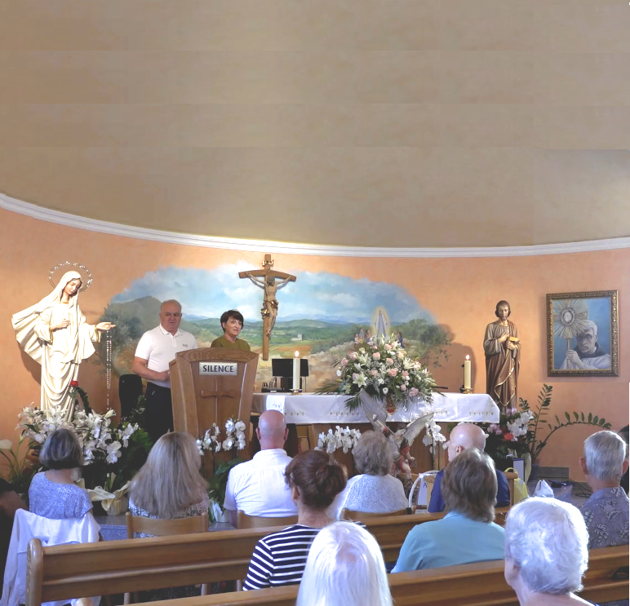
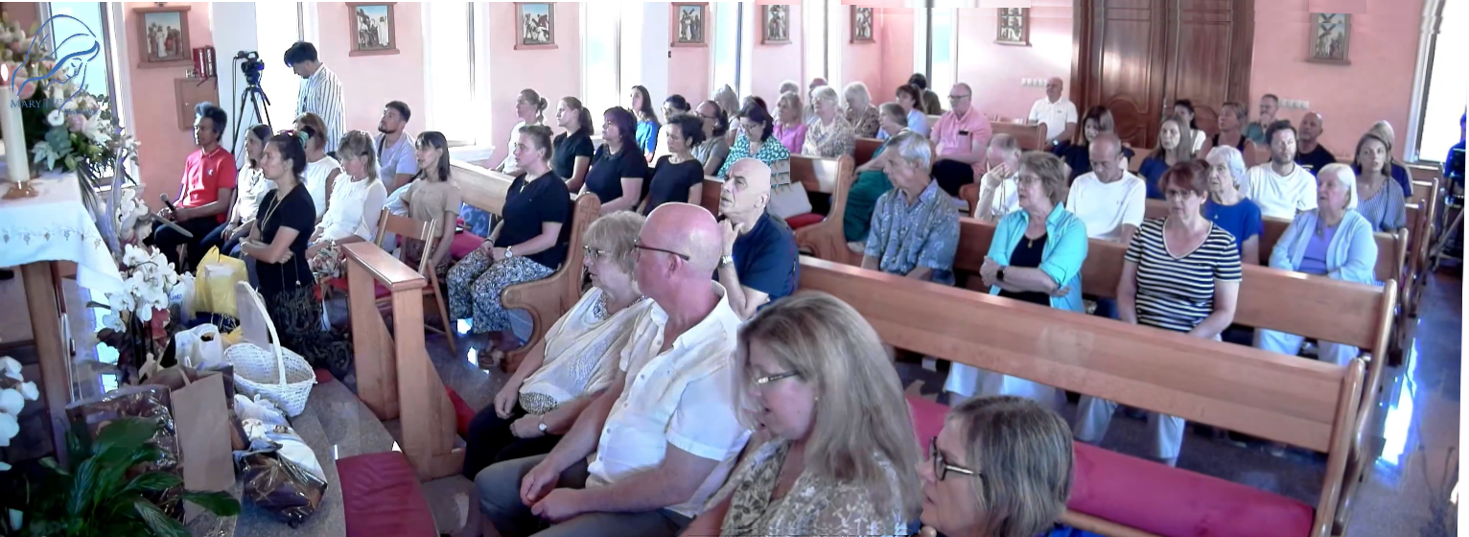

https://video.marytv.tv/watch/mNZ2NQs1oCH
Also today Our Lady came to us joyful and merry and She greets us all with Her motherly greeting: "Praised be Jesus, my dear children!" […] I wish to share with you the message that Our Lady gave yesterday through me.
August 22nd 2026
Dear children! Today I call you anew, return to God and prayer. The world is restless because many hearts have lost peace.
Do not allow fear, hatred and divisions to separate you from my Son. Little children, do not wait for the world to change, allow God to change your hearts first.
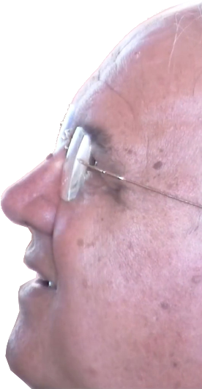

Our Lady’s Apparition and Message (August 21st) through Ivan Dragičević
Be peace there where unrest is, love where there is hatred, forgiveness where wounds are, and light where darkness is. I am with you and as Mother I wish to take you to my Son. Therefore, dear children, be my extended hands, hands of love and peace in this wounded world.
Pray, pray, pray! And do not lose hope! Peace starts in the heart that has returned to God. Thank you dear children for having responded to my call!

August 22nd 2026
Also today Our Lady came to us joyful and merry and She greets us all with Her motherly greeting: "Praised be Jesus, my dear children!" […] I wish to share with you the message that Our Lady gave yesterday through me.
https://video.marytv.tv/watch/mNZ2NQs1oCH
Dear children! Today I call you anew, return to God and prayer. The world is restless because many hearts have lost peace.
Do not allow fear, hatred and divisions to separate you from my Son. Little children, do not wait for the world to change, allow God to change your hearts first.

Our Lady’s Apparition and Message (August 21st) through Ivan Dragičević
Be peace there where unrest is, love where there is hatred, forgiveness where wounds are, and light where darkness is. I am with you and as Mother I wish to take you to my Son. Therefore, dear children, be my extended hands, hands of love and peace in this wounded world.
Pray, pray, pray! And do not lose hope! Peace starts in the heart that has returned to God. Thank you dear children for having responded to my call!

August 22nd 2026
Also today Our Lady came to us joyful and merry and She greets us all with Her motherly greeting: "Praised be Jesus, my dear children!" […] I wish to share with you the message that Our Lady gave yesterday through me.
https://video.marytv.tv/watch/mNZ2NQs1oCH
Dear children! Today I call you anew, return to God and prayer. The world is restless because many hearts have lost peace.
Do not allow fear, hatred and divisions to separate you from my Son. Little children, do not wait for the world to change, allow God to change your hearts first.

Our Lady’s Apparition and Message (August 21st) through Ivan Dragičević
Be peace there where unrest is, love where there is hatred, forgiveness where wounds are, and light where darkness is. I am with you and as Mother I wish to take you to my Son. Therefore, dear children, be my extended hands, hands of love and peace in this wounded world.
Pray, pray, pray! And do not lose hope! Peace starts in the heart that has returned to God. Thank you dear children for having responded to my call!

August 22nd 2026
Also today Our Lady came to us joyful and merry and She greets us all with Her motherly greeting: "Praised be Jesus, my dear children!" […] I wish to share with you the message that Our Lady gave yesterday through me.
https://video.marytv.tv/watch/mNZ2NQs1oCH
Dear children! Today I call you anew, return to God and prayer. The world is restless because many hearts have lost peace.
Do not allow fear, hatred and divisions to separate you from my Son. Little children, do not wait for the world to change, allow God to change your hearts first.

Our Lady’s Apparition and Message (August 21st) through Ivan Dragičević
Be peace there where unrest is, love where there is hatred, forgiveness where wounds are, and light where darkness is. I am with you and as Mother I wish to take you to my Son. Therefore, dear children, be my extended hands, hands of love and peace in this wounded world.
Pray, pray, pray! And do not lose hope! Peace starts in the heart that has returned to God. Thank you dear children for having responded to my call!

August 22nd 2026
Also today Our Lady came to us joyful and merry and She greets us all with Her motherly greeting: "Praised be Jesus, my dear children!" […] I wish to share with you the message that Our Lady gave yesterday through me.
https://video.marytv.tv/watch/mNZ2NQs1oCH
Dear children! Today I call you anew, return to God and prayer. The world is restless because many hearts have lost peace.
Do not allow fear, hatred and divisions to separate you from my Son. Little children, do not wait for the world to change, allow God to change your hearts first.

Our Lady’s Apparition and Message (August 21st) through Ivan Dragičević
Be peace there where unrest is, love where there is hatred, forgiveness where wounds are, and light where darkness is. I am with you and as Mother I wish to take you to my Son. Therefore, dear children, be my extended hands, hands of love and peace in this wounded world.
Pray, pray, pray! And do not lose hope! Peace starts in the heart that has returned to God. Thank you dear children for having responded to my call!

Our Lady’s message from Međugorje, August 25th 2026 through seer Marija Pavlović Lunetti

Dear children!
Today I am calling you: return to God, return to prayer, so that you may become carriers of peace. Pray, little children, for peace that is in danger; and may prayer begin to flow anew from your hearts and from your families, so that, in joy, you may feel the voice of Jesus in your hearts: 'Peace be with you.' Be, little children, carriers of peace and prayer for all those who do not pray. I am with you and I pray for you before my Son Jesus.
Thank you for having responded to my call.

talen from https://www.medjugorje.hr, compaređ to locations https://marytv.tv, https://www.medjugorje.ws, https://rosasparalagospa.com, https://spiritofmedjugorje.org, https://medjugorje.org
(With Ecclesiastical approval)

Our Lady’s message from Međugorje, August 25th 2026 through seer Marija Pavlović Lunetti

Dear children!
Today I am calling you: return to God, return to prayer, so that you may become carriers of peace. Pray, little children, for peace that is in danger; and may prayer begin to flow anew from your hearts and from your families, so that, in joy, you may feel the voice of Jesus in your hearts: 'Peace be with you.' Be, little children, carriers of peace and prayer for all those who do not pray. I am with you and I pray for you before my Son Jesus.
Thank you for having responded to my call.

talen from https://www.medjugorje.hr, compaređ to locations https://marytv.tv, https://www.medjugorje.ws, https://rosasparalagospa.com, https://spiritofmedjugorje.org, https://medjugorje.org
(With Ecclesiastical approval)

Our Lady’s message from Međugorje, August 25th 2026 through seer Marija Pavlović Lunetti

Dear children!
Today I am calling you: return to God, return to prayer, so that you may become carriers of peace. Pray, little children, for peace that is in danger; and may prayer begin to flow anew from your hearts and from your families, so that, in joy, you may feel the voice of Jesus in your hearts: 'Peace be with you.' Be, little children, carriers of peace and prayer for all those who do not pray. I am with you and I pray for you before my Son Jesus.
Thank you for having responded to my call.

talen from https://www.medjugorje.hr, compaređ to locations https://marytv.tv, https://www.medjugorje.ws, https://rosasparalagospa.com, https://spiritofmedjugorje.org, https://medjugorje.org
(With Ecclesiastical approval)

Our Lady’s message from Međugorje, August 25th 2026 through seer Marija Pavlović Lunetti

Dear children!
Today I am calling you: return to God, return to prayer, so that you may become carriers of peace. Pray, little children, for peace that is in danger; and may prayer begin to flow anew from your hearts and from your families, so that, in joy, you may feel the voice of Jesus in your hearts: 'Peace be with you.' Be, little children, carriers of peace and prayer for all those who do not pray. I am with you and I pray for you before my Son Jesus.
Thank you for having responded to my call.

talen from https://www.medjugorje.hr, compaređ to locations https://marytv.tv, https://www.medjugorje.ws, https://rosasparalagospa.com, https://spiritofmedjugorje.org, https://medjugorje.org
(With Ecclesiastical approval)

Our Lady’s message from Međugorje, August 25th 2026 through seer Marija Pavlović Lunetti

Dear children!
Today I am calling you: return to God, return to prayer, so that you may become carriers of peace. Pray, little children, for peace that is in danger; and may prayer begin to flow anew from your hearts and from your families, so that, in joy, you may feel the voice of Jesus in your hearts: 'Peace be with you.' Be, little children, carriers of peace and prayer for all those who do not pray. I am with you and I pray for you before my Son Jesus.
Thank you for having responded to my call.

talen from https://www.medjugorje.hr, compaređ to locations https://marytv.tv, https://www.medjugorje.ws, https://rosasparalagospa.com, https://spiritofmedjugorje.org, https://medjugorje.org
(With Ecclesiastical approval)

