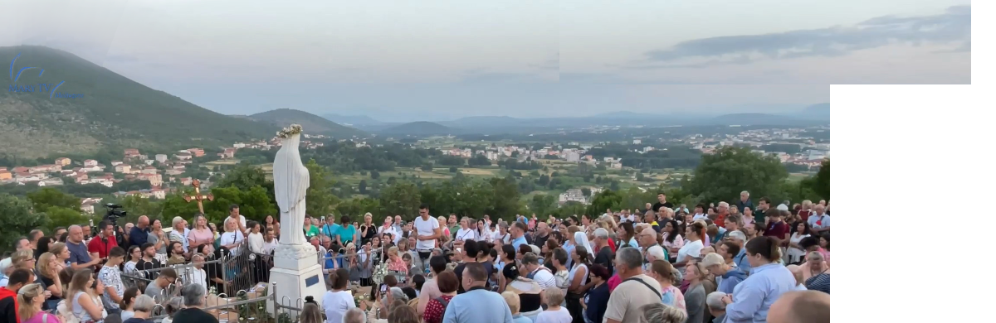
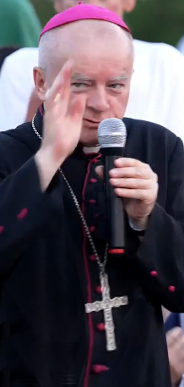
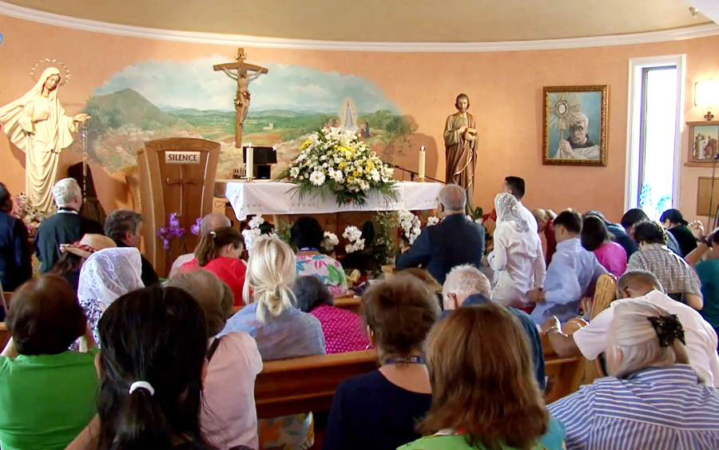
Our Lady’s Apparitions and Messages from January 25th to July 5th 2025
through Marija Pavlović Lunetti (including 44th anniversary novena), and through Ivan Dragičević

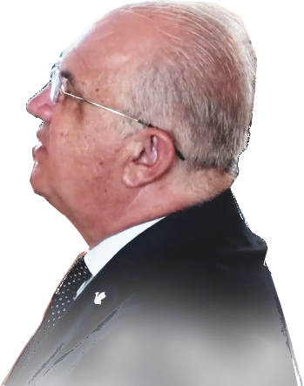
English
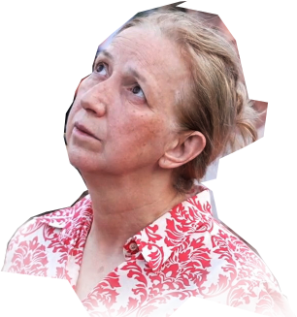

Međugorje

Our Lady’s Apparitions and Messages from January 25th to July 5th 2025
through Marija Pavlović Lunetti (including 44th anniversary novena), and through Ivan Dragičević

English

Međugorje

Our Lady’s Apparitions and Messages from January 25th to July 5th 2025
through Marija Pavlović Lunetti (including 44th anniversary novena), and through Ivan Dragičević

English

Međugorje

Our Lady’s Apparitions and Messages from January 25th to July 5th 2025
through Marija Pavlović Lunetti (including 44th anniversary novena), and through Ivan Dragičević

English

Međugorje

Our Lady’s Apparitions and Messages from January 25th to July 5th 2025
through Marija Pavlović Lunetti (including 44th anniversary novena), and through Ivan Dragičević

English

Međugorje


Our Lady came to Međugorje in 1981, and the Papal Commission (often called Ruini’s Commission after the cardinal who presided it) approved Her first apparitions as true, without disclaiming later apparitions.
This booklet is being made in Croatia due to an increasing need for the messages of Our Lady through Međugorje seers, and reports of Her apparitions, in English, in Croatia, the land of these revelations. This entire booklet in Word document will, God willing, be freely available for anyone anywhere, to print for the faithful, under main condition that it remain free and non-commercial.
https://exdeo.net/medjugor/print/
version 2025-12-05
Scan this QR-code and you’ll get the link above.
The location holds Office documents for download, such as the document which this booklet is the printout of. If we are not censored, or the domain blocked or hacked.
not for sale

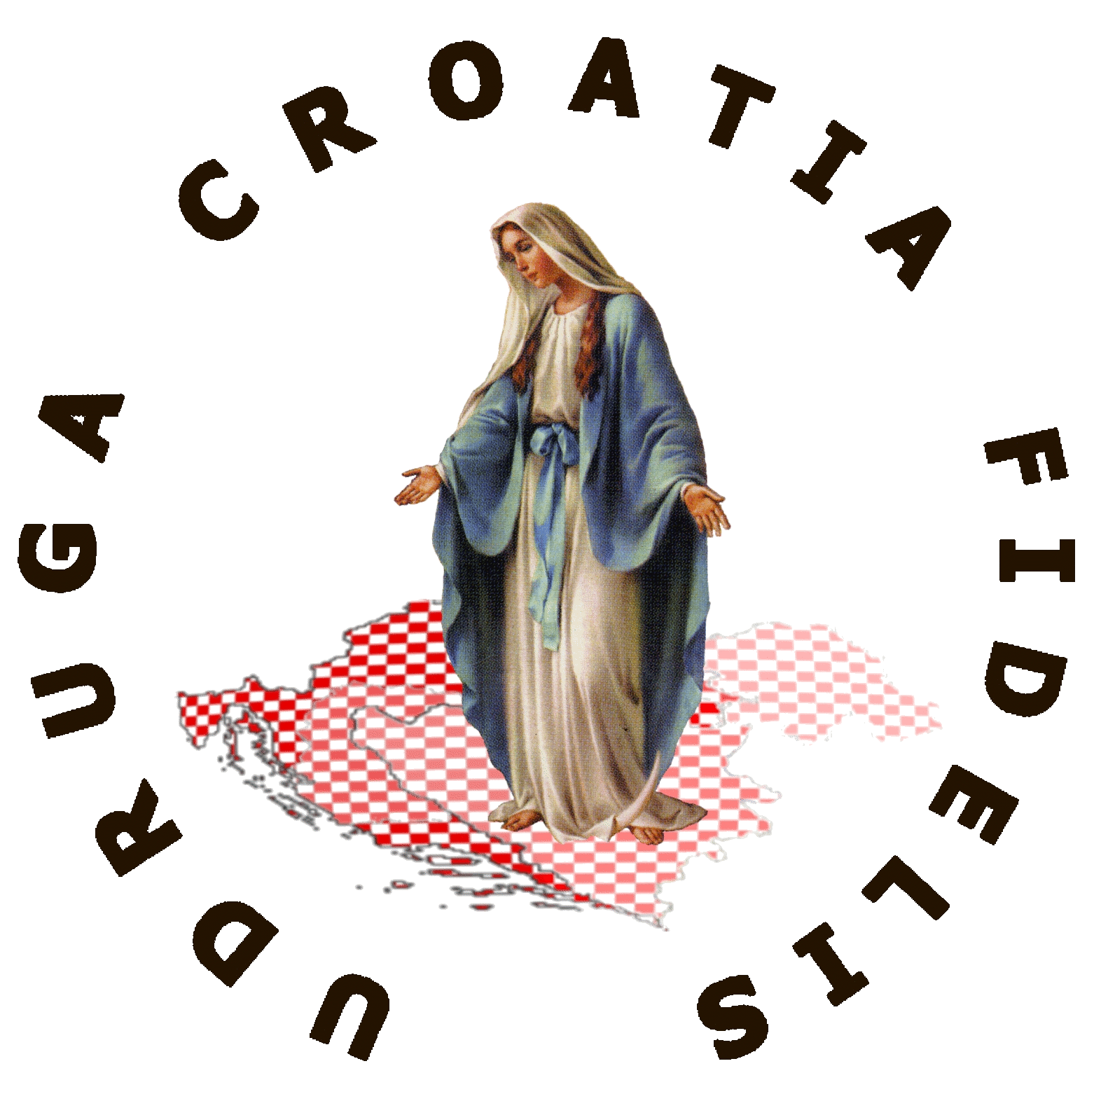

And this QR-code gives link to video on how almost anybody can print this booklet that’s possibly in your hands as well as other booklets, without much financial investment, just an ordinary laser color printer, a good paper cutter and a few even simpler tools. However it’s the time and manual work of all the printing and cutting and sorting and stapling that you may find to be the real obstacle. See the video how it is done.
https://rumble.com/v6uv951-medjugorje-print.html

Association Croatia Fidelis
contact: Miroslav Rovis, miro.rovis@croatiafidelis.hr,
miroslav.rovis@proton.me,
+385 1 6602633
+385 91 2660202
Some of the leaflets with messages and reports on apparitions were first printed as single leaflets, therefore some are still marked with big note so mostly Croatian public would not confuse
them with Croatian leaflets.
This is the first version prepared with limited time available. It may contain typoes and substandard language and technical solutions. The next version should correct most of it.
English

Our Lady came to Međugorje in 1981, and the Papal Commission (often called Ruini’s Commission after the cardinal who presided it) approved Her first apparitions as true, without disclaiming later apparitions.
This booklet is being made in Croatia due to an increasing need for the messages of Our Lady through Međugorje seers, and reports of Her apparitions, in English, in Croatia, the land of these revelations. This entire booklet in Word document will, God willing, be freely available for anyone anywhere, to print for the faithful, under main condition that it remain free and non-commercial.
https://exdeo.net/medjugor/print/
version 2025-12-05
Scan this QR-code and you’ll get the link above.
The location holds Office documents for download, such as the document which this booklet is the printout of. If we are not censored, or the domain blocked or hacked.
not for sale

https://rumble.com/v6uv951-medjugorje-print.html
And this QR-code gives link to video on how almost anybody can print this booklet that’s possibly in your hands as well as other booklets, without much financial investment, just an ordinary laser color printer, a good paper cutter and a few even simpler tools. However it’s the time and manual work of all the printing and cutting and sorting and stapling that you may find to be the real obstacle. See the video how it is done.

Association Croatia Fidelis
contact: Miroslav Rovis, miro.rovis@croatiafidelis.hr,
miroslav.rovis@proton.me,
+385 1 6602633
+385 91 2660202
Some of the leaflets with messages and reports on apparitions were first printed as single leaflets, therefore some are still marked with big note so mostly Croatian public would not confuse
them with Croatian leaflets.
This is the first version prepared with limited time available. It may contain typoes and substandard language and technical solutions. The next version should correct most of it.
English

Our Lady came to Međugorje in 1981, and the Papal Commission (often called Ruini’s Commission after the cardinal who presided it) approved Her first apparitions as true, without disclaiming later apparitions.
This booklet is being made in Croatia due to an increasing need for the messages of Our Lady through Međugorje seers, and reports of Her apparitions, in English, in Croatia, the land of these revelations. This entire booklet in Word document will, God willing, be freely available for anyone anywhere, to print for the faithful, under main condition that it remain free and non-commercial.
https://exdeo.net/medjugor/print/
version 2025-12-05
Scan this QR-code and you’ll get the link above.
The location holds Office documents for download, such as the document which this booklet is the printout of. If we are not censored, or the domain blocked or hacked.
not for sale

https://rumble.com/v6uv951-medjugorje-print.html
And this QR-code gives link to video on how almost anybody can print this booklet that’s possibly in your hands as well as other booklets, without much financial investment, just an ordinary laser color printer, a good paper cutter and a few even simpler tools. However it’s the time and manual work of all the printing and cutting and sorting and stapling that you may find to be the real obstacle. See the video how it is done.

Association Croatia Fidelis
contact: Miroslav Rovis, miro.rovis@croatiafidelis.hr,
miroslav.rovis@proton.me,
+385 1 6602633
+385 91 2660202
Some of the leaflets with messages and reports on apparitions were first printed as single leaflets, therefore some are still marked with big note so mostly Croatian public would not confuse
them with Croatian leaflets.
This is the first version prepared with limited time available. It may contain typoes and substandard language and technical solutions. The next version should correct most of it.
English

Our Lady came to Međugorje in 1981, and the Papal Commission (often called Ruini’s Commission after the cardinal who presided it) approved Her first apparitions as true, without disclaiming later apparitions.
This booklet is being made in Croatia due to an increasing need for the messages of Our Lady through Međugorje seers, and reports of Her apparitions, in English, in Croatia, the land of these revelations. This entire booklet in Word document will, God willing, be freely available for anyone anywhere, to print for the faithful, under main condition that it remain free and non-commercial.
https://exdeo.net/medjugor/print/
version 2025-12-05
Scan this QR-code and you’ll get the link above.
The location holds Office documents for download, such as the document which this booklet is the printout of. If we are not censored, or the domain blocked or hacked.
not for sale

https://rumble.com/v6uv951-medjugorje-print.html
And this QR-code gives link to video on how almost anybody can print this booklet that’s possibly in your hands as well as other booklets, without much financial investment, just an ordinary laser color printer, a good paper cutter and a few even simpler tools. However it’s the time and manual work of all the printing and cutting and sorting and stapling that you may find to be the real obstacle. See the video how it is done.

Association Croatia Fidelis
contact: Miroslav Rovis, miro.rovis@croatiafidelis.hr,
miroslav.rovis@proton.me,
+385 1 6602633
+385 91 2660202
Some of the leaflets with messages and reports on apparitions were first printed as single leaflets, therefore some are still marked with big note so mostly Croatian public would not confuse
them with Croatian leaflets.
English
This is the first version prepared with limited time available. It may contain typoes and substandard language and technical solutions. The next version should correct most of it.

Our Lady came to Međugorje in 1981, and the Papal Commission (often called Ruini’s Commission after the cardinal who presided it) approved Her first apparitions as true, without disclaiming later apparitions.
This booklet is being made in Croatia due to an increasing need for the messages of Our Lady through Međugorje seers, and reports of Her apparitions, in English, in Croatia, the land of these revelations. This entire booklet in Word document will, God willing, be freely available for anyone anywhere, to print for the faithful, under main condition that it remain free and non-commercial.
https://exdeo.net/medjugor/print/
version 2025-12-05
Scan this QR-code and you’ll get the link above.
The location holds Office documents for download, such as the document which this booklet is the printout of. If we are not censored, or the domain blocked or hacked.
not for sale

https://rumble.com/v6uv951-medjugorje-print.html
And this QR-code gives link to video on how almost anybody can print this booklet that’s possibly in your hands as well as other booklets, without much financial investment, just an ordinary laser color printer, a good paper cutter and a few even simpler tools. However it’s the time and manual work of all the printing and cutting and sorting and stapling that you may find to be the real obstacle. See the video how it is done.

Association Croatia Fidelis
contact: Miroslav Rovis, miro.rovis@croatiafidelis.hr,
miroslav.rovis@proton.me,
+385 1 6602633
+385 91 2660202
Some of the leaflets with messages and reports on apparitions were first printed as single leaflets, therefore some are still marked with big note so mostly Croatian public would not confuse
them with Croatian leaflets.
This is the first version prepared with limited time available. It may contain typoes and substandard language and technical solutions. The next version should correct most of it.
English

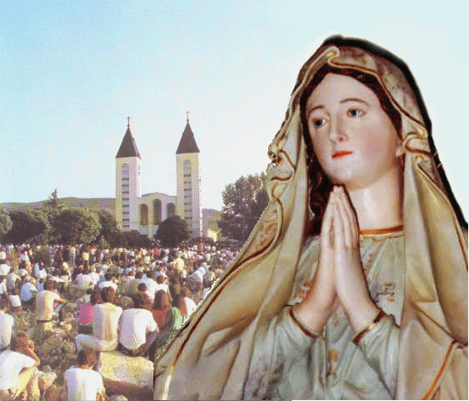
Our Lady’s message from Međugorje, January 25th 2025 through visionary Marija Pavlović Lunetti
Dear children!
In this year of grace, I am calling you to conversion. Put God, dear children, in the center of your living and the fruits will be love towards neighbor and joy of witnessing, and the holiness of your life will become a true witnessing of faith.
Thank you for having responded to my call.

(with Ecclesiastical approval)
taken from https://www.medjugorje.hr, compared to locations: https://www.medjugorje.ws, https://www.countdowntothekingdom.com, https://marytv.tv, https://sardegnaterradipace.com, https://consecratedhearts.com

Our Lady’s message from Međugorje, January 25th 2025 through visionary Marija Pavlović Lunetti
Dear children!
In this year of grace, I am calling you to conversion. Put God, dear children, in the center of your living and the fruits will be love towards neighbor and joy of witnessing, and the holiness of your life will become a true witnessing of faith.
Thank you for having responded to my call.

(with Ecclesiastical approval)
taken from https://www.medjugorje.hr, compared to locations: https://www.medjugorje.ws, https://www.countdowntothekingdom.com, https://marytv.tv, https://sardegnaterradipace.com, https://consecratedhearts.com

Our Lady’s message from Međugorje, January 25th 2025 through visionary Marija Pavlović Lunetti
Dear children!
In this year of grace, I am calling you to conversion. Put God, dear children, in the center of your living and the fruits will be love towards neighbor and joy of witnessing, and the holiness of your life will become a true witnessing of faith.
Thank you for having responded to my call.

(with Ecclesiastical approval)
taken from https://www.medjugorje.hr, compared to locations: https://www.medjugorje.ws, https://www.countdowntothekingdom.com, https://marytv.tv, https://sardegnaterradipace.com, https://consecratedhearts.com

Our Lady’s message from Međugorje, January 25th 2025 through visionary Marija Pavlović Lunetti
Dear children!
In this year of grace, I am calling you to conversion. Put God, dear children, in the center of your living and the fruits will be love towards neighbor and joy of witnessing, and the holiness of your life will become a true witnessing of faith.
Thank you for having responded to my call.

(with Ecclesiastical approval)
taken from https://www.medjugorje.hr, compared to locations: https://www.medjugorje.ws, https://www.countdowntothekingdom.com, https://marytv.tv, https://sardegnaterradipace.com, https://consecratedhearts.com

Our Lady’s message from Međugorje, January 25th 2025 through visionary Marija Pavlović Lunetti
Dear children!
In this year of grace, I am calling you to conversion. Put God, dear children, in the center of your living and the fruits will be love towards neighbor and joy of witnessing, and the holiness of your life will become a true witnessing of faith.
Thank you for having responded to my call.

(with Ecclesiastical approval)
taken from https://www.medjugorje.hr, compared to locations: https://www.medjugorje.ws, https://www.countdowntothekingdom.com, https://marytv.tv, https://sardegnaterradipace.com, https://consecratedhearts.com


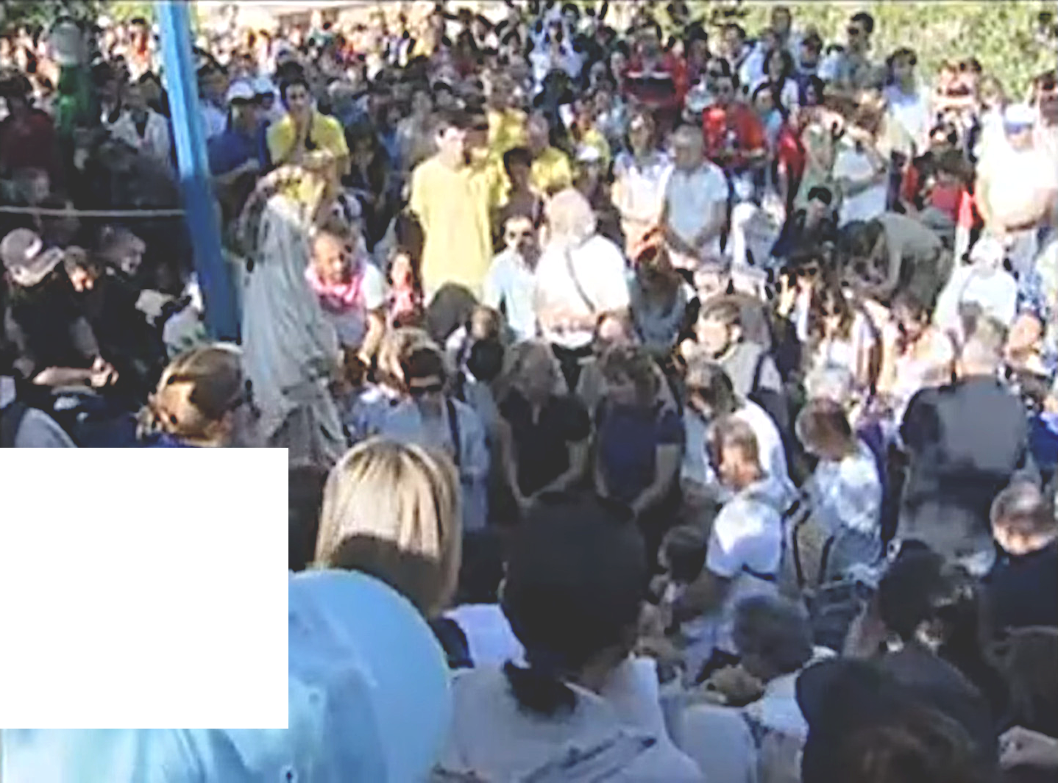
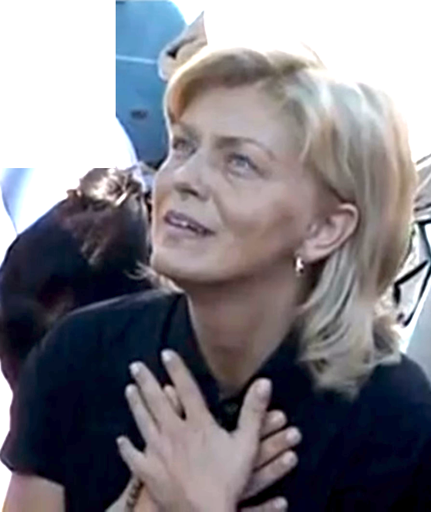

Our Lady’s Apparition and Message through Mirjana Dragičević August 2nd 2010
QR code gives that link to original video

that you may forget that what is personal and led by the example of my Son think of what is of God.
https://video.marytv.tv/watch/iOnUKosYbaR
Dear Children! Today I call you, together with me, to begin to build the Kingdom of Heaven in your hearts,

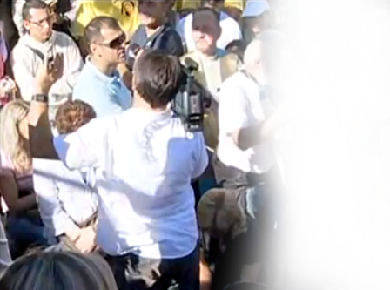
What does He desire of you? Do not permit to Satan to open paths of earthly happiness to you,
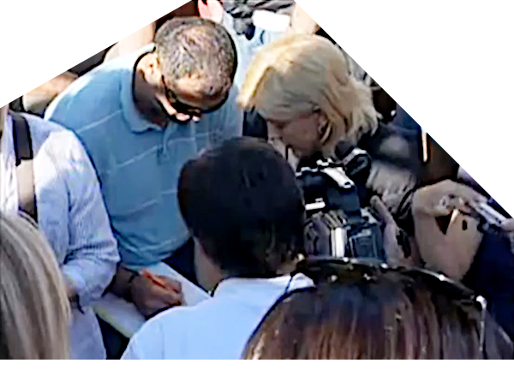
paths without my Son. My children, they are false and last a short time. My Son is. I offer you eternal happiness and peace, unity with my Son, with God. I offer you the Kingdom of God.
Thank you. ”
first printout in January 2025

original footage worked for today’s devices and with Croatian
Mirjana during apparition
left to right: prayer, Mirjana dictates the message to (the friar), and he says it (translates it) in English.
Association Croatia Fidelis
contact: Miroslav Rovis, miro.rovis@croatiafidelis.hr,
miroslav.rovis@proton.me,
+385 1 6602633
+385 91 2660202
This message is a sample from the (planned) booklet of 39 messages through Mirjana in 2010/11/12.

https://rumble.com/v6cjj6j-medjugorje-mirjana-dragicevic-gospas-message-2010-08-02.html
Our Lady’s Apparition and Message through Mirjana Dragičević August 2nd 2010
QR code gives that link to original video
https://video.marytv.tv/watch/iOnUKosYbaR
Dear Children! Today I call you, together with me, to begin to build the Kingdom of Heaven in your hearts,
that you may forget that what is personal and led by the example of my Son think of what is of God.

What does He desire of you? Do not permit to Satan to open paths of earthly happiness to you,
paths without my Son. My children, they are false and last a short time. My Son is. I offer you eternal happiness and peace, unity with my Son, with God. I offer you the Kingdom of God.
Thank you. ”
first printout in January 2025
original footage worked for today’s devices and with Croatian
Mirjana during apparition
left to right: prayer, Mirjana dictates the message to (the friar), and he says it (translates it) in English.
Association Croatia Fidelis
contact: Miroslav Rovis, miro.rovis@croatiafidelis.hr,
miroslav.rovis@proton.me,
+385 1 6602633
+385 91 2660202
This message is a sample from the (planned) booklet of 39 messages through Mirjana in 2010/11/12.
https://rumble.com/v6cjj6j-medjugorje-mirjana-dragicevic-gospas-message-2010-08-02.html
Our Lady’s Apparition and Message through Mirjana Dragičević August 2nd 2010
QR code gives that link to original video
https://video.marytv.tv/watch/iOnUKosYbaR
Dear Children! Today I call you, together with me, to begin to build the Kingdom of Heaven in your hearts,
that you may forget that what is personal and led by the example of my Son think of what is of God.

What does He desire of you? Do not permit to Satan to open paths of earthly happiness to you,
paths without my Son. My children, they are false and last a short time. My Son is. I offer you eternal happiness and peace, unity with my Son, with God. I offer you the Kingdom of God.
Thank you. ”
first printout in January 2025
original footage worked for today’s devices and with Croatian
Mirjana during apparition
left to right: prayer, Mirjana dictates the message to (the friar), and he says it (translates it) in English.
Association Croatia Fidelis
contact: Miroslav Rovis, miro.rovis@croatiafidelis.hr,
miroslav.rovis@proton.me,
+385 1 6602633
+385 91 2660202
This message is a sample from the (planned) booklet of 39 messages through Mirjana in 2010/11/12.
https://rumble.com/v6cjj6j-medjugorje-mirjana-dragicevic-gospas-message-2010-08-02.html
Our Lady’s Apparition and Message through Mirjana Dragičević August 2nd 2010
QR code gives that link to original video
https://video.marytv.tv/watch/iOnUKosYbaR
Dear Children! Today I call you, together with me, to begin to build the Kingdom of Heaven in your hearts,
that you may forget that what is personal and led by the example of my Son think of what is of God.

What does He desire of you? Do not permit to Satan to open paths of earthly happiness to you,
paths without my Son. My children, they are false and last a short time. My Son is. I offer you eternal happiness and peace, unity with my Son, with God. I offer you the Kingdom of God.
Thank you. ”
first printout in January 2025
original footage worked for today’s devices and with Croatian
Mirjana during apparition
left to right: prayer, Mirjana dictates the message to (the friar), and he says it (translates it) in English.
Association Croatia Fidelis
contact: Miroslav Rovis, miro.rovis@croatiafidelis.hr,
miroslav.rovis@proton.me,
+385 1 6602633
+385 91 2660202
This message is a sample from the (planned) booklet of 39 messages through Mirjana in 2010/11/12.
https://rumble.com/v6cjj6j-medjugorje-mirjana-dragicevic-gospas-message-2010-08-02.html
Our Lady’s Apparition and Message through Mirjana Dragičević August 2nd 2010
QR code gives that link to original video
https://video.marytv.tv/watch/iOnUKosYbaR
Dear Children! Today I call you, together with me, to begin to build the Kingdom of Heaven in your hearts,
that you may forget that what is personal and led by the example of my Son think of what is of God.

What does He desire of you? Do not permit to Satan to open paths of earthly happiness to you,
paths without my Son. My children, they are false and last a short time. My Son is. I offer you eternal happiness and peace, unity with my Son, with God. I offer you the Kingdom of God.
Thank you. ”
first printout in January 2025
original footage worked for today’s devices and with Croatian
Mirjana during apparition
left to right: prayer, Mirjana dictates the message to (the friar), and he says it (translates it) in English.
Association Croatia Fidelis
contact: Miroslav Rovis, miro.rovis@croatiafidelis.hr,
miroslav.rovis@proton.me,
+385 1 6602633
+385 91 2660202
https://rumble.com/v6cjj6j-medjugorje-mirjana-dragicevic-gospas-message-2010-08-02.html
This message is a sample from the (planned) booklet of 39 messages through Mirjana in 2010/11/12.

Our Lady’s message from Međugorje, February 25th 2025 through visionary Marija Pavlović Lunetti
Dear children!
May this springtime be an encouragement for personal conversion for you, that with your lives you may pray and love God above all, for all those who are in need. Little children, be my hands of peace and prayer, be love for all those who do not love, do not pray and do not want peace.
Thank you for having responded to my call.

(with Ecclesiastical approval)
taken from https://www.medjugorje.hr, compared to locations https://medjugorje.ws, https://marytv.tv, https://amicidilazzaro.it, https://medjugorje.com, https://consecratedhearts.com

Our Lady’s message from Međugorje, February 25th 2025 through visionary Marija Pavlović Lunetti
Dear children!
May this springtime be an encouragement for personal conversion for you, that with your lives you may pray and love God above all, for all those who are in need. Little children, be my hands of peace and prayer, be love for all those who do not love, do not pray and do not want peace.
Thank you for having responded to my call.

(with Ecclesiastical approval)
taken from https://www.medjugorje.hr, compared to locations https://medjugorje.ws, https://marytv.tv, https://amicidilazzaro.it, https://medjugorje.com, https://consecratedhearts.com

Our Lady’s message from Međugorje, February 25th 2025 through visionary Marija Pavlović Lunetti
Dear children!
May this springtime be an encouragement for personal conversion for you, that with your lives you may pray and love God above all, for all those who are in need. Little children, be my hands of peace and prayer, be love for all those who do not love, do not pray and do not want peace.
Thank you for having responded to my call.

(with Ecclesiastical approval)
taken from https://www.medjugorje.hr, compared to locations https://medjugorje.ws, https://marytv.tv, https://amicidilazzaro.it, https://medjugorje.com, https://consecratedhearts.com

Our Lady’s message from Međugorje, February 25th 2025 through visionary Marija Pavlović Lunetti
Dear children!
May this springtime be an encouragement for personal conversion for you, that with your lives you may pray and love God above all, for all those who are in need. Little children, be my hands of peace and prayer, be love for all those who do not love, do not pray and do not want peace.
Thank you for having responded to my call.

(with Ecclesiastical approval)
taken from https://www.medjugorje.hr, compared to locations https://medjugorje.ws, https://marytv.tv, https://amicidilazzaro.it, https://medjugorje.com, https://consecratedhearts.com

Our Lady’s message from Međugorje, February 25th 2025 through visionary Marija Pavlović Lunetti
Dear children!
May this springtime be an encouragement for personal conversion for you, that with your lives you may pray and love God above all, for all those who are in need. Little children, be my hands of peace and prayer, be love for all those who do not love, do not pray and do not want peace.
Thank you for having responded to my call.

(with Ecclesiastical approval)
taken from https://www.medjugorje.hr, compared to locations https://medjugorje.ws, https://marytv.tv, https://amicidilazzaro.it, https://medjugorje.com, https://consecratedhearts.com


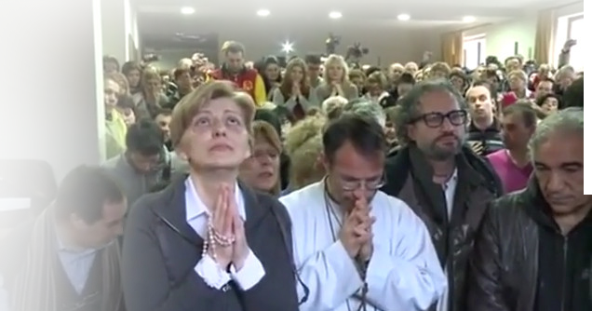
March 18th 2013
https://video.marytv.tv/watch/iOnVaZsYbaU
“Dear children! I call you to, with complete trust and joy, bless the name of the Lord and, day by day, give Him thanks from the heart for His great love. My Son, through that love which He showed by the Cross, gave you the possibility to be forgiven for everything, so that you do not have to be ashamed or to hide, and out of fear not to open the door of your heart to my Son. To the contrary, my children, reconcile with the Heavenly Father so that you may be able to come to love yourselves as my Son loves you. When you come to love yourselves, you will also love others, in them you will see my Son and recognize the greatness of His love. Live in faith! Through me, my Son is preparing you for the works which He desires to do through you, works through which He desires to be glorified. Give Him thanks. Especially thank Him for the shepherds, for your intercessors in the reconcilliation with the Heavenly Father. I am thanking you, my children. Thank you.”

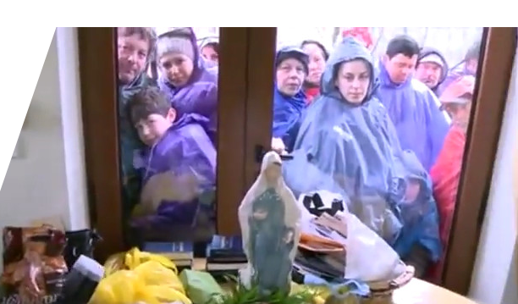

Association Croatia Fidelis
contact: Miroslav Rovis, miro.rovis@croatiafidelis.hr,
miroslav.rovis@proton.me,
+385 1 6602633 +385 91 2660202
This message is a sample from the (planned) booklet of 26 messages through Mirjana in 2013/14.

https://video.marytv.tv/watch/iOnVaZsYbaU
March 18th 2013
“Dear children! I call you to, with complete trust and joy, bless the name of the Lord and, day by day, give Him thanks from the heart for His great love. My Son, through that love which He showed by the Cross, gave you the possibility to be forgiven for everything, so that you do not have to be ashamed or to hide, and out of fear not to open the door of your heart to my Son. To the contrary, my children, reconcile with the Heavenly Father so that you may be able to come to love yourselves as my Son loves you. When you come to love yourselves, you will also love others, in them you will see my Son and recognize the greatness of His love. Live in faith! Through me, my Son is preparing you for the works which He desires to do through you, works through which He desires to be glorified. Give Him thanks. Especially thank Him for the shepherds, for your intercessors in the reconcilliation with the Heavenly Father. I am thanking you, my children. Thank you.”

Association Croatia Fidelis
contact: Miroslav Rovis, miro.rovis@croatiafidelis.hr,
miroslav.rovis@proton.me,
+385 1 6602633 +385 91 2660202
This message is a sample from the (planned) booklet of 26 messages through Mirjana in 2013/14.

https://video.marytv.tv/watch/iOnVaZsYbaU
March 18th 2013
“Dear children! I call you to, with complete trust and joy, bless the name of the Lord and, day by day, give Him thanks from the heart for His great love. My Son, through that love which He showed by the Cross, gave you the possibility to be forgiven for everything, so that you do not have to be ashamed or to hide, and out of fear not to open the door of your heart to my Son. To the contrary, my children, reconcile with the Heavenly Father so that you may be able to come to love yourselves as my Son loves you. When you come to love yourselves, you will also love others, in them you will see my Son and recognize the greatness of His love. Live in faith! Through me, my Son is preparing you for the works which He desires to do through you, works through which He desires to be glorified. Give Him thanks. Especially thank Him for the shepherds, for your intercessors in the reconcilliation with the Heavenly Father. I am thanking you, my children. Thank you.”

Association Croatia Fidelis
contact: Miroslav Rovis, miro.rovis@croatiafidelis.hr,
miroslav.rovis@proton.me,
+385 1 6602633 +385 91 2660202
This message is a sample from the (planned) booklet of 26 messages through Mirjana in 2013/14.

https://video.marytv.tv/watch/iOnVaZsYbaU
March 18th 2013
“Dear children! I call you to, with complete trust and joy, bless the name of the Lord and, day by day, give Him thanks from the heart for His great love. My Son, through that love which He showed by the Cross, gave you the possibility to be forgiven for everything, so that you do not have to be ashamed or to hide, and out of fear not to open the door of your heart to my Son. To the contrary, my children, reconcile with the Heavenly Father so that you may be able to come to love yourselves as my Son loves you. When you come to love yourselves, you will also love others, in them you will see my Son and recognize the greatness of His love. Live in faith! Through me, my Son is preparing you for the works which He desires to do through you, works through which He desires to be glorified. Give Him thanks. Especially thank Him for the shepherds, for your intercessors in the reconcilliation with the Heavenly Father. I am thanking you, my children. Thank you.”

Association Croatia Fidelis
contact: Miroslav Rovis, miro.rovis@croatiafidelis.hr,
miroslav.rovis@proton.me,
+385 1 6602633 +385 91 2660202
This message is a sample from the (planned) booklet of 26 messages through Mirjana in 2013/14.

https://video.marytv.tv/watch/iOnVaZsYbaU
March 18th 2013
“Dear children! I call you to, with complete trust and joy, bless the name of the Lord and, day by day, give Him thanks from the heart for His great love. My Son, through that love which He showed by the Cross, gave you the possibility to be forgiven for everything, so that you do not have to be ashamed or to hide, and out of fear not to open the door of your heart to my Son. To the contrary, my children, reconcile with the Heavenly Father so that you may be able to come to love yourselves as my Son loves you. When you come to love yourselves, you will also love others, in them you will see my Son and recognize the greatness of His love. Live in faith! Through me, my Son is preparing you for the works which He desires to do through you, works through which He desires to be glorified. Give Him thanks. Especially thank Him for the shepherds, for your intercessors in the reconcilliation with the Heavenly Father. I am thanking you, my children. Thank you.”
Association Croatia Fidelis
contact: Miroslav Rovis, miro.rovis@croatiafidelis.hr,
miroslav.rovis@proton.me,
+385 1 6602633 +385 91 2660202
This message is a sample from the (planned) booklet of 26 messages through Mirjana in 2013/14.
Our Lady’s message from Međugorje, March 25th 2025 through visionary Marija Pavlović Lunetti
Dear children!
In this time of grace when you are called to conversion, I encourage you, little children, offer me your prayers, sufferings, and tears for conversion of hearts that are far from the Heart of my Son Jesus. Pray with me, because, little children, without God you do not have future nor eternal life. I love you, but I cannot help you without you, therefore, say 'yes' to God.
Thank you for having responded to my call.

(with Ecclesiastical approval)
taken from http://www.medjugorje.hr, compared to locations https://www.medjugorje.ws, https://www.countdowntothekingdom.com, https://consecratedhearts.com

Our Lady’s message from Međugorje, March 25th 2025 through visionary Marija Pavlović Lunetti
Dear children!
In this time of grace when you are called to conversion, I encourage you, little children, offer me your prayers, sufferings, and tears for conversion of hearts that are far from the Heart of my Son Jesus. Pray with me, because, little children, without God you do not have future nor eternal life. I love you, but I cannot help you without you, therefore, say 'yes' to God.
Thank you for having responded to my call.

(with Ecclesiastical approval)
taken from http://www.medjugorje.hr, compared to locations https://www.medjugorje.ws, https://www.countdowntothekingdom.com, https://consecratedhearts.com

Our Lady’s message from Međugorje, March 25th 2025 through visionary Marija Pavlović Lunetti
Dear children!
In this time of grace when you are called to conversion, I encourage you, little children, offer me your prayers, sufferings, and tears for conversion of hearts that are far from the Heart of my Son Jesus. Pray with me, because, little children, without God you do not have future nor eternal life. I love you, but I cannot help you without you, therefore, say 'yes' to God.
Thank you for having responded to my call.

(with Ecclesiastical approval)
taken from http://www.medjugorje.hr, compared to locations https://www.medjugorje.ws, https://www.countdowntothekingdom.com, https://consecratedhearts.com

Our Lady’s message from Međugorje, March 25th 2025 through visionary Marija Pavlović Lunetti
Dear children!
In this time of grace when you are called to conversion, I encourage you, little children, offer me your prayers, sufferings, and tears for conversion of hearts that are far from the Heart of my Son Jesus. Pray with me, because, little children, without God you do not have future nor eternal life. I love you, but I cannot help you without you, therefore, say 'yes' to God.
Thank you for having responded to my call.

(with Ecclesiastical approval)
taken from http://www.medjugorje.hr, compared to locations https://www.medjugorje.ws, https://www.countdowntothekingdom.com, https://consecratedhearts.com

Our Lady’s message from Međugorje, March 25th 2025 through visionary Marija Pavlović Lunetti
Dear children!
In this time of grace when you are called to conversion, I encourage you, little children, offer me your prayers, sufferings, and tears for conversion of hearts that are far from the Heart of my Son Jesus. Pray with me, because, little children, without God you do not have future nor eternal life. I love you, but I cannot help you without you, therefore, say 'yes' to God.
Thank you for having responded to my call.

(with Ecclesiastical approval)
taken from http://www.medjugorje.hr, compared to locations https://www.medjugorje.ws, https://www.countdowntothekingdom.com, https://consecratedhearts.com

Our Lady’s message from Međugorje, March 18th 2025 through visionary Mirjani Dragićević-Soldo
Dear children!
With motherly love I implore you: give me your hands folded in prayer, give me your hearts cleansed in confession and I will lead you to my Son. Because, my children, only my Son, with His light, can illuminate the darkness, only He, with His Word, can remove suffering. Therefore, do not be afraid to walk with me, because I am leading you to my Son, salvation. Thank you.

taken from http://www.medjugorje.hr, compared to locations https://www.countdowntothekingdom.com, https://consecratedhearts.com, https://www.medjugorje.ws, https://medjugorje.com https://mysticpost.com

Our Lady’s message from Međugorje, March 18th 2025 through visionary Mirjani Dragićević-Soldo
Dear children!
With motherly love I implore you: give me your hands folded in prayer, give me your hearts cleansed in confession and I will lead you to my Son. Because, my children, only my Son, with His light, can illuminate the darkness, only He, with His Word, can remove suffering. Therefore, do not be afraid to walk with me, because I am leading you to my Son, salvation. Thank you.

taken from http://www.medjugorje.hr, compared to locations https://www.countdowntothekingdom.com, https://consecratedhearts.com, https://www.medjugorje.ws, https://medjugorje.com https://mysticpost.com

Our Lady’s message from Međugorje, March 18th 2025 through visionary Mirjani Dragićević-Soldo
Dear children!
With motherly love I implore you: give me your hands folded in prayer, give me your hearts cleansed in confession and I will lead you to my Son. Because, my children, only my Son, with His light, can illuminate the darkness, only He, with His Word, can remove suffering. Therefore, do not be afraid to walk with me, because I am leading you to my Son, salvation. Thank you.

taken from http://www.medjugorje.hr, compared to locations https://www.countdowntothekingdom.com, https://consecratedhearts.com, https://www.medjugorje.ws, https://medjugorje.com https://mysticpost.com

Our Lady’s message from Međugorje, March 18th 2025 through visionary Mirjani Dragićević-Soldo
Dear children!
With motherly love I implore you: give me your hands folded in prayer, give me your hearts cleansed in confession and I will lead you to my Son. Because, my children, only my Son, with His light, can illuminate the darkness, only He, with His Word, can remove suffering. Therefore, do not be afraid to walk with me, because I am leading you to my Son, salvation. Thank you.

taken from http://www.medjugorje.hr, compared to locations https://www.countdowntothekingdom.com, https://consecratedhearts.com, https://www.medjugorje.ws, https://medjugorje.com https://mysticpost.com

Our Lady’s message from Međugorje, March 18th 2025 through visionary Mirjani Dragićević-Soldo
Dear children!
With motherly love I implore you: give me your hands folded in prayer, give me your hearts cleansed in confession and I will lead you to my Son. Because, my children, only my Son, with His light, can illuminate the darkness, only He, with His Word, can remove suffering. Therefore, do not be afraid to walk with me, because I am leading you to my Son, salvation. Thank you.

taken from http://www.medjugorje.hr, compared to locations https://www.countdowntothekingdom.com, https://consecratedhearts.com, https://www.medjugorje.ws, https://medjugorje.com https://mysticpost.com

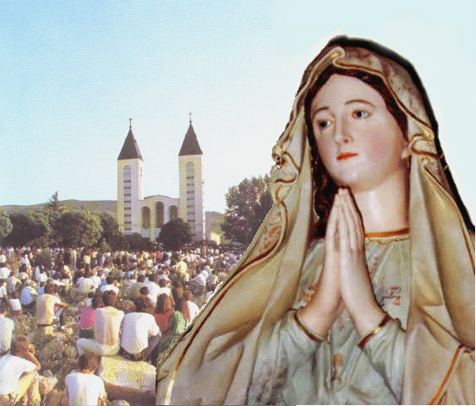
Our Lady’s message from Međugorje, April 25th 2025, through visionary Marija Pavlović Lunetti
Dear children,
Winds of peacelessness, selfishness and sin are catching hold of many hearts and leading them into peacelessness and perdition. That is why I am calling you, little children: return to God and to prayer, so that it may be good for you in the hearts and on the earth on which you live. I love you, little children, and that is why I am not tiring of calling you to conversion.
Thank you for having responded to my call.

taken from https://www.medjugorje.hr, compared to other locations https://medjugorje.org/, https://www.privaterevelation.org/, https://qpmm.org/
(with Ecclesiastical approval)

Our Lady’s message from Međugorje, April 25th 2025, through visionary Marija Pavlović Lunetti
Dear children,
Winds of peacelessness, selfishness and sin are catching hold of many hearts and leading them into peacelessness and perdition. That is why I am calling you, little children: return to God and to prayer, so that it may be good for you in the hearts and on the earth on which you live. I love you, little children, and that is why I am not tiring of calling you to conversion.
Thank you for having responded to my call.

taken from https://www.medjugorje.hr, compared to other locations https://medjugorje.org/, https://www.privaterevelation.org/, https://qpmm.org/
(with Ecclesiastical approval)

Our Lady’s message from Međugorje, April 25th 2025, through visionary Marija Pavlović Lunetti
Dear children,
Winds of peacelessness, selfishness and sin are catching hold of many hearts and leading them into peacelessness and perdition. That is why I am calling you, little children: return to God and to prayer, so that it may be good for you in the hearts and on the earth on which you live. I love you, little children, and that is why I am not tiring of calling you to conversion.
Thank you for having responded to my call.

taken from https://www.medjugorje.hr, compared to other locations https://medjugorje.org/, https://www.privaterevelation.org/, https://qpmm.org/
(with Ecclesiastical approval)

Our Lady’s message from Međugorje, April 25th 2025, through visionary Marija Pavlović Lunetti
Dear children,
Winds of peacelessness, selfishness and sin are catching hold of many hearts and leading them into peacelessness and perdition. That is why I am calling you, little children: return to God and to prayer, so that it may be good for you in the hearts and on the earth on which you live. I love you, little children, and that is why I am not tiring of calling you to conversion.
Thank you for having responded to my call.

taken from https://www.medjugorje.hr, compared to other locations https://medjugorje.org/, https://www.privaterevelation.org/, https://qpmm.org/
(with Ecclesiastical approval)

Our Lady’s message from Međugorje, April 25th 2025, through visionary Marija Pavlović Lunetti
Dear children,
Winds of peacelessness, selfishness and sin are catching hold of many hearts and leading them into peacelessness and perdition. That is why I am calling you, little children: return to God and to prayer, so that it may be good for you in the hearts and on the earth on which you live. I love you, little children, and that is why I am not tiring of calling you to conversion.
Thank you for having responded to my call.

taken from https://www.medjugorje.hr, compared to other locations https://medjugorje.org/, https://www.privaterevelation.org/, https://qpmm.org/
(with Ecclesiastical approval)

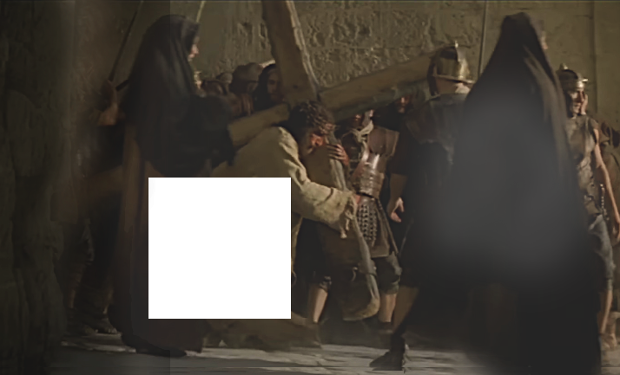
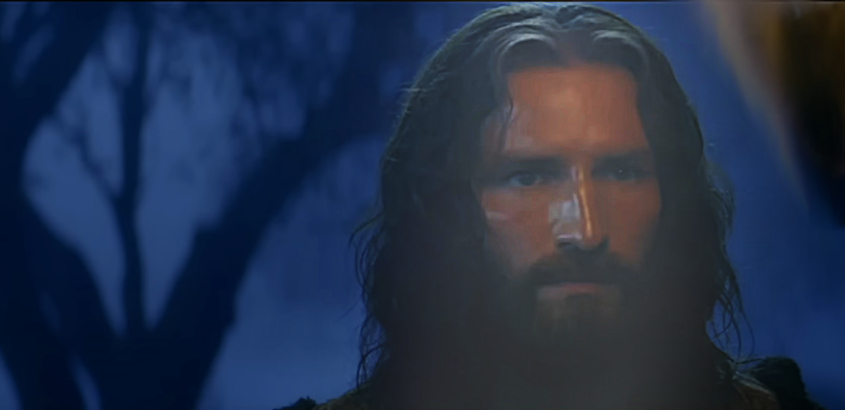

“I believed in the apparitions in Lourdes and Fatima, but as if I did not believe in the apparitions in Međugorje. Everything was strange to me. In the moment when the apparition began, I looked at Ivan's face. I could see smile and gaze of ecstasy. I looked at him as actor and I thought to myself that he really needed to be great actor to play out those impressions. I started to question that and to question Gospa too. I said - You need to tell me what this is, is this true or not, is he faking it or not! I prayed, I prayed... I need your help, I said. Suddenly, it was as if I could feel a smile on my soul. It was as if the part of Heaven touched me. Tears were falling down my face. I became aware how many times I threw God out of my life.”
When asked about Gospa’s messages, this American actor said: „When I read one Gospa's message, I immediately recognize the voice of my Shepherd and my Mother who speak to me. The gift we have when we read Our Lady's messages is more than anything else we can perceive or imagine in this world. We have a gift that God speaks to us now, but many people reject that. I am sure that movie Passion would have never been filmed if it wasn't for Međugorje. This world would have been a wrack without Gospa and Her apparitions. This is a blessed time, we live in the time of many graces and hope.
Jim Caviezel on Međugorje
Jim converted in Međugorje in 2004 and was
called by Mel Gibson to play Jesus Christ in Passion.
The movie, only slightly incomplete, was first seen in Međugorje of all the world, brought by him. Of the many interviews he gave, the most mature feels the one of his summer 2016 stay in Međugorje:

Association Croatia Fidelis contact: Miroslav Rovis, miro.rovis@croatiafidelis.hr,
miroslav.rovis@proton.me,
+385 1 6602633
+385 91 2660202

pictures are from “Passion” trailer, the (complicated) link, printed below, to the source of the excerpts, you get by scanning the QR-code

https://www.medjugorje.hr/en/news/jim-caviezel-%E2%80%9Ei-am-sure-that-movie-passion-would-have-never-been-released-if-it-wasnt-for-medjugorje%E2%80%9C,8312.html

“I believed in the apparitions in Lourdes and Fatima, but as if I did not believe in the apparitions in Međugorje. Everything was strange to me. In the moment when the apparition began, I looked at Ivan's face. I could see smile and gaze of ecstasy. I looked at him as actor and I thought to myself that he really needed to be great actor to play out those impressions. I started to question that and to question Gospa too. I said - You need to tell me what this is, is this true or not, is he faking it or not! I prayed, I prayed... I need your help, I said. Suddenly, it was as if I could feel a smile on my soul. It was as if the part of Heaven touched me. Tears were falling down my face. I became aware how many times I threw God out of my life.”
When asked about Gospa’s messages, this American actor said: „When I read one Gospa's message, I immediately recognize the voice of my Shepherd and my Mother who speak to me. The gift we have when we read Our Lady's messages is more than anything else we can perceive or imagine in this world. We have a gift that God speaks to us now, but many people reject that. I am sure that movie Passion would have never been filmed if it wasn't for Međugorje. This world would have been a wrack without Gospa and Her apparitions. This is a blessed time, we live in the time of many graces and hope.
Jim Caviezel on Međugorje
Jim converted in Međugorje in 2004 and was
called by Mel Gibson to play Jesus Christ in Passion.
The movie, only slightly incomplete, was first seen in Međugorje of all the world, brought by him. Of the many interviews he gave, the most mature feels the one of his summer 2016 stay in Međugorje:

Association Croatia Fidelis contact: Miroslav Rovis, miro.rovis@croatiafidelis.hr,
miroslav.rovis@proton.me,
+385 1 6602633
+385 91 2660202

pictures are from “Passion” trailer, the (complicated) link, printed below, to the source of the excerpts, you get by scanning the QR-code
https://www.medjugorje.hr/en/news/jim-caviezel-%E2%80%9Ei-am-sure-that-movie-passion-would-have-never-been-released-if-it-wasnt-for-medjugorje%E2%80%9C,8312.html
“I believed in the apparitions in Lourdes and Fatima, but as if I did not believe in the apparitions in Međugorje. Everything was strange to me. In the moment when the apparition began, I looked at Ivan's face. I could see smile and gaze of ecstasy. I looked at him as actor and I thought to myself that he really needed to be great actor to play out those impressions. I started to question that and to question Gospa too. I said - You need to tell me what this is, is this true or not, is he faking it or not! I prayed, I prayed... I need your help, I said. Suddenly, it was as if I could feel a smile on my soul. It was as if the part of Heaven touched me. Tears were falling down my face. I became aware how many times I threw God out of my life.”
When asked about Gospa’s messages, this American actor said: „When I read one Gospa's message, I immediately recognize the voice of my Shepherd and my Mother who speak to me. The gift we have when we read Our Lady's messages is more than anything else we can perceive or imagine in this world. We have a gift that God speaks to us now, but many people reject that. I am sure that movie Passion would have never been filmed if it wasn't for Međugorje. This world would have been a wrack without Gospa and Her apparitions. This is a blessed time, we live in the time of many graces and hope.
Jim Caviezel on Međugorje
Jim converted in Međugorje in 2004 and was
called by Mel Gibson to play Jesus Christ in Passion.
The movie, only slightly incomplete, was first seen in Međugorje of all the world, brought by him. Of the many interviews he gave, the most mature feels the one of his summer 2016 stay in Međugorje:

Association Croatia Fidelis contact: Miroslav Rovis, miro.rovis@croatiafidelis.hr,
miroslav.rovis@proton.me,
01/6602633 091/2660202

pictures are from “Passion” trailer, the (complicated) link, printed below, to the source of the excerpts, you get by scanning the QR-code
https://www.medjugorje.hr/en/news/jim-caviezel-%E2%80%9Ei-am-sure-that-movie-passion-would-have-never-been-released-if-it-wasnt-for-medjugorje%E2%80%9C,8312.html
“I believed in the apparitions in Lourdes and Fatima, but as if I did not believe in the apparitions in Međugorje. Everything was strange to me. In the moment when the apparition began, I looked at Ivan's face. I could see smile and gaze of ecstasy. I looked at him as actor and I thought to myself that he really needed to be great actor to play out those impressions. I started to question that and to question Gospa too. I said - You need to tell me what this is, is this true or not, is he faking it or not! I prayed, I prayed... I need your help, I said. Suddenly, it was as if I could feel a smile on my soul. It was as if the part of Heaven touched me. Tears were falling down my face. I became aware how many times I threw God out of my life.”
When asked about Gospa’s messages, this American actor said: „When I read one Gospa's message, I immediately recognize the voice of my Shepherd and my Mother who speak to me. The gift we have when we read Our Lady's messages is more than anything else we can perceive or imagine in this world. We have a gift that God speaks to us now, but many people reject that. I am sure that movie Passion would have never been filmed if it wasn't for Međugorje. This world would have been a wrack without Gospa and Her apparitions. This is a blessed time, we live in the time of many graces and hope.
Jim Caviezel on Međugorje
Jim converted in Međugorje in 2004 and was
called by Mel Gibson to play Jesus Christ in Passion.
The movie, only slightly incomplete, was first seen in Međugorje of all the world, brought by him. Of the many interviews he gave, the most mature feels the one of his summer 2016 stay in Međugorje:

Association Croatia Fidelis contact: Miroslav Rovis, miro.rovis@croatiafidelis.hr,
miroslav.rovis@proton.me,
+385 1 6602633
+385 91 2660202

pictures are from “Passion” trailer, the (complicated) link, printed below, to the source of the excerpts, you get by scanning the QR-code
https://www.medjugorje.hr/en/news/jim-caviezel-%E2%80%9Ei-am-sure-that-movie-passion-would-have-never-been-released-if-it-wasnt-for-medjugorje%E2%80%9C,8312.html
“I believed in the apparitions in Lourdes and Fatima, but as if I did not believe in the apparitions in Međugorje. Everything was strange to me. In the moment when the apparition began, I looked at Ivan's face. I could see smile and gaze of ecstasy. I looked at him as actor and I thought to myself that he really needed to be great actor to play out those impressions. I started to question that and to question Gospa too. I said - You need to tell me what this is, is this true or not, is he faking it or not! I prayed, I prayed... I need your help, I said. Suddenly, it was as if I could feel a smile on my soul. It was as if the part of Heaven touched me. Tears were falling down my face. I became aware how many times I threw God out of my life.”
When asked about Gospa’s messages, this American actor said: „When I read one Gospa's message, I immediately recognize the voice of my Shepherd and my Mother who speak to me. The gift we have when we read Our Lady's messages is more than anything else we can perceive or imagine in this world. We have a gift that God speaks to us now, but many people reject that. I am sure that movie Passion would have never been filmed if it wasn't for Međugorje. This world would have been a wrack without Gospa and Her apparitions. This is a blessed time, we live in the time of many graces and hope.
Jim Caviezel on Međugorje
Jim converted in Međugorje in 2004 and was
called by Mel Gibson to play Jesus Christ in Passion.
The movie, only slightly incomplete, was first seen in Međugorje of all the world, brought by him. Of the many interviews he gave, the most mature feels the one of his summer 2016 stay in Međugorje:

Association Croatia Fidelis contact: Miroslav Rovis, miro.rovis@croatiafidelis.hr,
miroslav.rovis@proton.me,
+385 1 6602633
+385 91 2660202

pictures are from “Passion” trailer, the (complicated) link, printed below, to the source of the excerpts, you get by scanning the QR-code
https://www.medjugorje.hr/en/news/jim-caviezel-%E2%80%9Ei-am-sure-that-movie-passion-would-have-never-been-released-if-it-wasnt-for-medjugorje%E2%80%9C,8312.html
Our Lady’s message from Međugorje, May 25th 2025, through visonary Marija Pavlović Lunetti
English

Dear children!
In this time of grace, I am calling you to be people of hope, peace and joy, so that every person may be a peacemaker and a lover of life. Pray, little children, the Holy Spirit to fill you with the strength of his holy spirit of courage and surrender, and this time will be to you a gift and a walk in holiness towards eternal life. I am with you and I love you.
Thank you for having responded to my call.

taken from https://www.medjugorje.hr, compared to other locations: https://medjugorje.org/, https://www.medjugorje.ws/
(with Ecclesiastical approval)

Our Lady’s message from Međugorje, May 25th 2025, through visonary Marija Pavlović Lunetti
English

Dear children!
In this time of grace, I am calling you to be people of hope, peace and joy, so that every person may be a peacemaker and a lover of life. Pray, little children, the Holy Spirit to fill you with the strength of his holy spirit of courage and surrender, and this time will be to you a gift and a walk in holiness towards eternal life. I am with you and I love you.
Thank you for having responded to my call.

taken from https://www.medjugorje.hr, compared to other locations: https://medjugorje.org/, https://www.medjugorje.ws/
(with Ecclesiastical approval)

Our Lady’s message from Međugorje, May 25th 2025, through visonary Marija Pavlović Lunetti
English

Dear children!
In this time of grace, I am calling you to be people of hope, peace and joy, so that every person may be a peacemaker and a lover of life. Pray, little children, the Holy Spirit to fill you with the strength of his holy spirit of courage and surrender, and this time will be to you a gift and a walk in holiness towards eternal life. I am with you and I love you.
Thank you for having responded to my call.

taken from https://www.medjugorje.hr, compared to other locations: https://medjugorje.org/, https://www.medjugorje.ws/
(with Ecclesiastical approval)

Our Lady’s message from Međugorje, May 25th 2025, through visonary Marija Pavlović Lunetti
English

Dear children!
In this time of grace, I am calling you to be people of hope, peace and joy, so that every person may be a peacemaker and a lover of life. Pray, little children, the Holy Spirit to fill you with the strength of his holy spirit of courage and surrender, and this time will be to you a gift and a walk in holiness towards eternal life. I am with you and I love you.
Thank you for having responded to my call.

taken from https://www.medjugorje.hr, compared to other locations: https://medjugorje.org/, https://www.medjugorje.ws/
(with Ecclesiastical approval)

Our Lady’s message from Međugorje, May 25th 2025, through visonary Marija Pavlović Lunetti
English

Dear children!
In this time of grace, I am calling you to be people of hope, peace and joy, so that every person may be a peacemaker and a lover of life. Pray, little children, the Holy Spirit to fill you with the strength of his holy spirit of courage and surrender, and this time will be to you a gift and a walk in holiness towards eternal life. I am with you and I love you.
Thank you for having responded to my call.

taken from https://www.medjugorje.hr, compared to other locations: https://medjugorje.org/, https://www.medjugorje.ws/
(with Ecclesiastical approval)

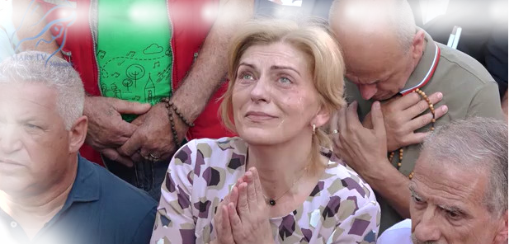

July 2nd 2018
https://video.marytv.tv/watch/iOnlfZsYbVN
“Dear children! I am Mother to all of you and therefore be not afraid, because I hear your prayers. I know that you are searching for me and therefore I pray to my Son for you, my Son who is united with the Heavenly Father and the Spirit Consoler, my Son who leads souls into the Kingdom He came from, the Kingdom of peace and light. My children, you are given freedom to choose, but I as Mother implore you to choose freedom for good. You with pure and simple souls comprehend. If sometimes you do not understand the words, within yourself you feel what is truth. My children, do not loose truth and true life in order to follow lies. With true life the Heavenly Kingdom enters you hearts, and it is the Kingdom of peace, love and harmony. It is then, my children, that there won’t be any selfishness that is distancing you from my Son. There will be love and understanding for your neighbors, because remember, I repeat again, to pray means to also love the others, neighbors, and give yourself to them. Love and give in my Son, then He will work in you, for you. My children, incessantly think of my Son, love him immeasurably and then you will have true life, and that will be for eternity. Thank you apostles of my love!”

This message is a sample from the (planned) booklet of 26 messages through Mirjana in 2017/18.

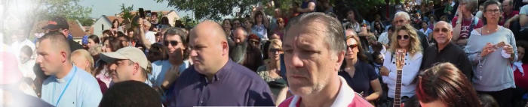

July 2nd 2018
https://video.marytv.tv/watch/iOnlfZsYbVN
“Dear children! I am Mother to all of you and therefore be not afraid, because I hear your prayers. I know that you are searching for me and therefore I pray to my Son for you, my Son who is united with the Heavenly Father and the Spirit Consoler, my Son who leads souls into the Kingdom He came from, the Kingdom of peace and light. My children, you are given freedom to choose, but I as Mother implore you to choose freedom for good. You with pure and simple souls comprehend. If sometimes you do not understand the words, within yourself you feel what is truth. My children, do not loose truth and true life in order to follow lies. With true life the Heavenly Kingdom enters you hearts, and it is the Kingdom of peace, love and harmony. It is then, my children, that there won’t be any selfishness that is distancing you from my Son. There will be love and understanding for your neighbors, because remember, I repeat again, to pray means to also love the others, neighbors, and give yourself to them. Love and give in my Son, then He will work in you, for you. My children, incessantly think of my Son, love him immeasurably and then you will have true life, and that will be for eternity. Thank you apostles of my love!”

This message is a sample from the (planned) booklet of 26 messages through Mirjana in 2017/18.

July 2nd 2018
https://video.marytv.tv/watch/iOnlfZsYbVN
“Dear children! I am Mother to all of you and therefore be not afraid, because I hear your prayers. I know that you are searching for me and therefore I pray to my Son for you, my Son who is united with the Heavenly Father and the Spirit Consoler, my Son who leads souls into the Kingdom He came from, the Kingdom of peace and light. My children, you are given freedom to choose, but I as Mother implore you to choose freedom for good. You with pure and simple souls comprehend. If sometimes you do not understand the words, within yourself you feel what is truth. My children, do not loose truth and true life in order to follow lies. With true life the Heavenly Kingdom enters you hearts, and it is the Kingdom of peace, love and harmony. It is then, my children, that there won’t be any selfishness that is distancing you from my Son. There will be love and understanding for your neighbors, because remember, I repeat again, to pray means to also love the others, neighbors, and give yourself to them. Love and give in my Son, then He will work in you, for you. My children, incessantly think of my Son, love him immeasurably and then you will have true life, and that will be for eternity. Thank you apostles of my love!”

This message is a sample from the (planned) booklet of 26 messages through Mirjana in 2017/18.

July 2nd 2018
https://video.marytv.tv/watch/iOnlfZsYbVN
“Dear children! I am Mother to all of you and therefore be not afraid, because I hear your prayers. I know that you are searching for me and therefore I pray to my Son for you, my Son who is united with the Heavenly Father and the Spirit Consoler, my Son who leads souls into the Kingdom He came from, the Kingdom of peace and light. My children, you are given freedom to choose, but I as Mother implore you to choose freedom for good. You with pure and simple souls comprehend. If sometimes you do not understand the words, within yourself you feel what is truth. My children, do not loose truth and true life in order to follow lies. With true life the Heavenly Kingdom enters you hearts, and it is the Kingdom of peace, love and harmony. It is then, my children, that there won’t be any selfishness that is distancing you from my Son. There will be love and understanding for your neighbors, because remember, I repeat again, to pray means to also love the others, neighbors, and give yourself to them. Love and give in my Son, then He will work in you, for you. My children, incessantly think of my Son, love him immeasurably and then you will have true life, and that will be for eternity. Thank you apostles of my love!”

This message is a sample from the (planned) booklet of 26 messages through Mirjana in 2017/18.

July 2nd 2018
https://video.marytv.tv/watch/iOnlfZsYbVN
“Dear children! I am Mother to all of you and therefore be not afraid, because I hear your prayers. I know that you are searching for me and therefore I pray to my Son for you, my Son who is united with the Heavenly Father and the Spirit Consoler, my Son who leads souls into the Kingdom He came from, the Kingdom of peace and light. My children, you are given freedom to choose, but I as Mother implore you to choose freedom for good. You with pure and simple souls comprehend. If sometimes you do not understand the words, within yourself you feel what is truth. My children, do not loose truth and true life in order to follow lies. With true life the Heavenly Kingdom enters you hearts, and it is the Kingdom of peace, love and harmony. It is then, my children, that there won’t be any selfishness that is distancing you from my Son. There will be love and understanding for your neighbors, because remember, I repeat again, to pray means to also love the others, neighbors, and give yourself to them. Love and give in my Son, then He will work in you, for you. My children, incessantly think of my Son, love him immeasurably and then you will have true life, and that will be for eternity. Thank you apostles of my love!”

This message is a sample from the (planned) booklet of 26 messages through Mirjana in 2017/18.

Our Lady’s message from Međugorje, June 25th 2025, through visionary Marija Pavlović Lunetti
Dear children!
Also today I thank the Almighty that I am with you and that I can lead you towards the God of love and peace. The ideologies which destroy you and your spiritual life are transitory. I am calling you, little children: return to God, because with God you have a future and eternal life.
Thank you for having responded to my call.
(with Ecclesiastical approval)

from https://www.medjugorje.hr, compared to: https://marytv.tv/, https://medjugorje.com, https://thelightofmary.com, https://www.privaterevelation.org/
(with Ecclesiastical approval)
Our Lady’s yearly apparition message of June 25th 2025, through visionary Ivanka Ivanković Elez
Our Lady gave those present Her motherly blessing.
Renew family prayer. Pray, pray, pray!
from https://www.medjugorje.hr, compared to locations
https://marytv.tv, https://www.penzancecatholicchurch.org

Our Lady’s message from Međugorje, June 25th 2025, through visionary Marija Pavlović Lunetti
Dear children!
Also today I thank the Almighty that I am with you and that I can lead you towards the God of love and peace. The ideologies which destroy you and your spiritual life are transitory. I am calling you, little children: return to God, because with God you have future and eternal life.
Thank you for having responded to my call.
(with Ecclesiastical approval)

from https://www.medjugorje.hr, compared to: https://marytv.tv/, https://medjugorje.com, https://thelightofmary.com, https://www.privaterevelation.org/
(with Ecclesiastical approval)
Our Lady’s yearly apparition message of June 25th 2025, through visionary Ivanka Ivanković Elez
Our Lady gave those present Her motherly blessing.
Renew family prayer. Pray, pray, pray!
from https://www.medjugorje.hr, compared to locations
https://marytv.tv, https://www.penzancecatholicchurch.org

Our Lady’s message from Međugorje, June 25th 2025, through visionary Marija Pavlović Lunetti
Dear children!
Also today I thank the Almighty that I am with you and that I can lead you towards the God of love and peace. The ideologies which destroy you and your spiritual life are transitory. I am calling you, little children: return to God, because with God you have future and eternal life.
Thank you for having responded to my call.
(with Ecclesiastical approval)

from https://www.medjugorje.hr, compared to: https://marytv.tv/, https://medjugorje.com, https://thelightofmary.com, https://www.privaterevelation.org/
(with Ecclesiastical approval)
Our Lady’s yearly apparition message of June 25th 2025, through visionary Ivanka Ivanković Elez
Our Lady gave those present Her motherly blessing.
Renew family prayer. Pray, pray, pray!
from https://www.medjugorje.hr, compared to locations
https://thelightofmary.com/ https://www.medjugorje-info.com

Our Lady’s message from Međugorje, June 25th 2025, through visionary Marija Pavlović Lunetti
Dear children!
Also today I thank the Almighty that I am with you and that I can lead you towards the God of love and peace. The ideologies which destroy you and your spiritual life are transitory. I am calling you, little children: return to God, because with God you have future and eternal life.
Thank you for having responded to my call.
(with Ecclesiastical approval)

from https://www.medjugorje.hr, compared to: https://marytv.tv/, https://medjugorje.com, https://thelightofmary.com, https://www.privaterevelation.org/
(with Ecclesiastical approval)
Our Lady’s yearly apparition message of June 25th 2025, through visionary Ivanka Ivanković Elez
Our Lady gave those present Her motherly blessing.
Renew family prayer. Pray, pray, pray!
from https://www.medjugorje.hr, compared to locations
https://marytv.tv, https://www.penzancecatholicchurch.org

Our Lady’s message from Međugorje, June 25th 2025, through visionary Marija Pavlović Lunetti
Dear children!
Also today I thank the Almighty that I am with you and that I can lead you towards the God of love and peace. The ideologies which destroy you and your spiritual life are transitory. I am calling you, little children: return to God, because with God you have future and eternal life.
Thank you for having responded to my call.
(with Ecclesiastical approval)

from https://www.medjugorje.hr, compared to: https://marytv.tv/, https://medjugorje.com, https://thelightofmary.com, https://www.privaterevelation.org/
(with Ecclesiastical approval)
Our Lady’s yearly apparition message of June 25th 2025, through visionary Ivanka Ivanković Elez
Our Lady gave those present Her motherly blessing.
Renew family prayer. Pray, pray, pray!
from https://www.medjugorje.hr, compared to locations
https://marytv.tv, https://www.penzancecatholicchurch.org
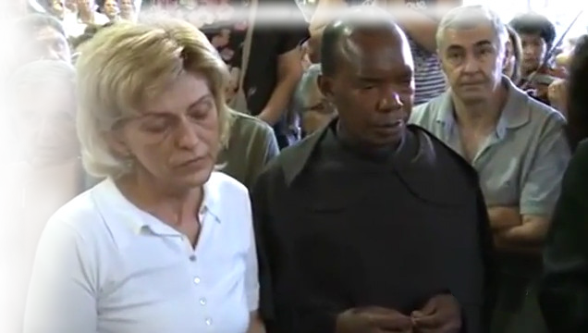

July 2nd 2014
https://video.marytv.tv/watch/iOnkMbsYbae
“Dear children, I, the mother of all of you gathered here and the mother of the entire world, am blessing you with motherly blessing and call you to set out on the way of humility. That way leads to the coming to know the love of my Son. My Son is almighty, He is in everything. If you, my children, do not become cognizant of this, then darkness and blindness rule in your soul. Only humility can heal you. My children, I always lived humbly, courageously and in hope. I knew, I became cognizant that God is in us and we are in God. I am asking the same of you. I desire for all of you to be with me in eternity, because you are a part of me. I will help you on your way. My love will envelop you like a mantle and make of you apostles of my light, of God’s light. With the love that comes forth from humility you will bring light to where darkness and blindness rule. You will be bringing my Son who is the light of the world. I am always alongside your shepherds and I pray that they may always be an example of humility for you. Thank you.”

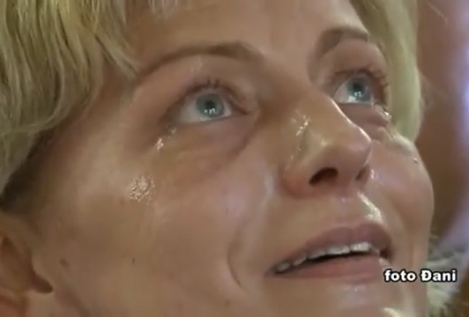

This message is a sample from a booklet with 26 messages through Mirjana in 2013 and 2014
(booklet in English not yet made)

https://video.marytv.tv/watch/iOnkMbsYbae
July 2nd 2014
“Dear children, I, the mother of all of you gathered here and the mother of the entire world, am blessing you with motherly blessing and call you to set out on the way of humility. That way leads to the coming to know the love of my Son. My Son is almighty, He is in everything. If you, my children, do not become cognizant of this, then darkness and blindness rule in your soul. Only humility can heal you. My children, I always lived humbly, courageously and in hope. I knew, I became cognizant that God is in us and we are in God. I am asking the same of you. I desire for all of you to be with me in eternity, because you are a part of me. I will help you on your way. My love will envelop you like a mantle and make of you apostles of my light, of God’s light. With the love that comes forth from humility you will bring light to where darkness and blindness rule. You will be bringing my Son who is the light of the world. I am always alongside your shepherds and I pray that they may always be an example of humility for you. Thank you.”

This message is a sample from a booklet with 26 messages through Mirjana in 2013 and 2014
(booklet in English not yet made)
Udruga Croatia Fidelis odgovara: Miroslav Rovis, miro.rovis@croatiafidelis.hr,
miroslav.rovis@proton.me, 01/6602633 091/2660202

https://video.marytv.tv/watch/iOnkMbsYbae
July 2nd 2014
“Dear children, I, the mother of all of you gathered here and the mother of the entire world, am blessing you with motherly blessing and call you to set out on the way of humility. That way leads to the coming to know the love of my Son. My Son is almighty, He is in everything. If you, my children, do not become cognizant of this, then darkness and blindness rule in your soul. Only humility can heal you. My children, I always lived humbly, courageously and in hope. I knew, I became cognizant that God is in us and we are in God. I am asking the same of you. I desire for all of you to be with me in eternity, because you are a part of me. I will help you on your way. My love will envelop you like a mantle and make of you apostles of my light, of God’s light. With the love that comes forth from humility you will bring light to where darkness and blindness rule. You will be bringing my Son who is the light of the world. I am always alongside your shepherds and I pray that they may always be an example of humility for you. Thank you.”

This message is a sample from a booklet with 26 messages through Mirjana in 2013 and 2014
(booklet in English not yet made)

https://video.marytv.tv/watch/iOnkMbsYbae
July 2nd 2014
“Dear children, I, the mother of all of you gathered here and the mother of the entire world, am blessing you with motherly blessing and call you to set out on the way of humility. That way leads to the coming to know the love of my Son. My Son is almighty, He is in everything. If you, my children, do not become cognizant of this, then darkness and blindness rule in your soul. Only humility can heal you. My children, I always lived humbly, courageously and in hope. I knew, I became cognizant that God is in us and we are in God. I am asking the same of you. I desire for all of you to be with me in eternity, because you are a part of me. I will help you on your way. My love will envelop you like a mantle and make of you apostles of my light, of God’s light. With the love that comes forth from humility you will bring light to where darkness and blindness rule. You will be bringing my Son who is the light of the world. I am always alongside your shepherds and I pray that they may always be an example of humility for you. Thank you.”

This message is a sample from a booklet with 26 messages through Mirjana in 2013 and 2014
(booklet in English not yet made)

https://video.marytv.tv/watch/iOnkMbsYbae
July 2nd 2014
“Dear children, I, the mother of all of you gathered here and the mother of the entire world, am blessing you with motherly blessing and call you to set out on the way of humility. That way leads to the coming to know the love of my Son. My Son is almighty, He is in everything. If you, my children, do not become cognizant of this, then darkness and blindness rule in your soul. Only humility can heal you. My children, I always lived humbly, courageously and in hope. I knew, I became cognizant that God is in us and we are in God. I am asking the same of you. I desire for all of you to be with me in eternity, because you are a part of me. I will help you on your way. My love will envelop you like a mantle and make of you apostles of my light, of God’s light. With the love that comes forth from humility you will bring light to where darkness and blindness rule. You will be bringing my Son who is the light of the world. I am always alongside your shepherds and I pray that they may always be an example of humility for you. Thank you.”

This message is a sample from a booklet with 26 messages through Mirjana in 2013 and 2014
(booklet in English not yet made)

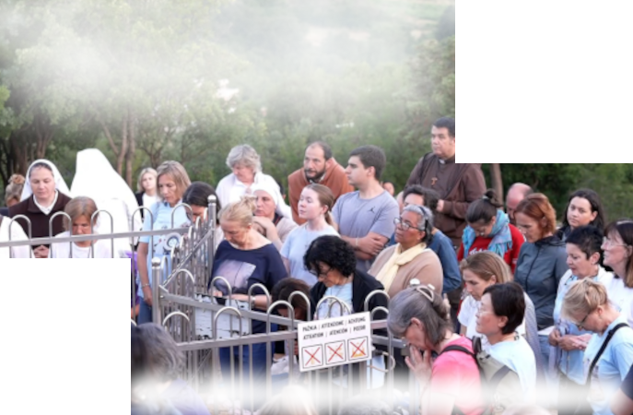
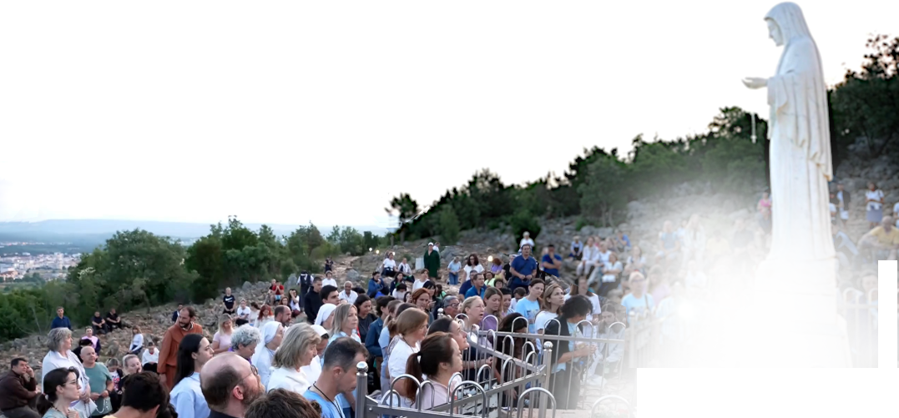

June 16th 2025

On daily apparition the day before, Our Lady called for novena through the seer, mornings at 4:30, and that the apparitions would be at 5 o’clock.
44th Anniversary Novena
https://video.marytv.tv/watch/m7wq5psaaYx
1st Day
Marija Pavlović Lunetti described the vision:
“During the apparition I recommended to Our Lady all of us, all our intentions, and everything that we have on our hearts. In a special way those who are sick, in the soul and in the body. Our Lady prayed
long for peace, for peace in our hearts, in our families,
and in the whole world. She blessed us all
and went to Heaven in peace.”

All the videos by Mary TV of apparitions to this seer are available from the link which you get by scanning of this QR-code, and in the top right is the link to each particular apparition.


https://video.marytv.tv/series/iHnRM8qPsmE
June 16th 2025
https://video.marytv.tv/watch/m7wq5psaaYx
On daily apparition the day before, Our Lady called for novena through the seer, mornings at 4:30, and that the apparitions would be at 5 o’clock.
44th Anniversary Novena
Marija Pavlović Lunetti described the vision:
“During the apparition I recommended to Our Lady all of us, all our intentions, and everything that we have on our hearts. In a special way those who are sick, in the soul and in the body. Our Lady prayed
long for peace, for peace in our hearts, in our families,
and in the whole world. She blessed us all
and went to Heaven in peace.”
1st Day

All the videos by Mary TV of apparitions to this seer are available from the link which you get by scanning of this QR-code, and in the top right is the link to each particular apparition.

https://video.marytv.tv/series/iHnRM8qPsmE
June 16th 2025
https://video.marytv.tv/watch/m7wq5psaaYx
44th Anniversary Novena
On daily apparition the day before, Our Lady called for novena through the seer, mornings at 4:30, and that the apparitions would be at 5 o’clock.
1st Day
Marija Pavlović Lunetti described the vision:
“During the apparition I recommended to Our Lady all of us, all our intentions, and everything that we have on our hearts. In a special way those who are sick, in the soul and in the body. Our Lady prayed
long for peace, for peace in our hearts, in our families,
and in the whole world. She blessed us all
and went to Heaven in peace.”

All the videos by Mary TV of apparitions to this seer are available from the link which you get by scanning of this QR-code, and in the top right is the link to each particular apparition.

https://video.marytv.tv/series/iHnRM8qPsmE
June 16th 2025
https://video.marytv.tv/watch/m7wq5psaaYx
44th Anniversary Novena
On daily apparition the day before, Our Lady called for novena through the seer, mornings at 4:30, and that the apparitions would be at 5 o’clock.
1st Day
Marija Pavlović Lunetti described the vision:
“During the apparition I recommended to Our Lady all of us, all our intentions, and everything that we have on our hearts. In a special way those who are sick, in the soul and in the body. Our Lady prayed
long for peace, for peace in our hearts, in our families,
and in the whole world. She blessed us all
and went to Heaven in peace.”

All the videos by Mary TV of apparitions to this seer are available from the link which you get by scanning of this QR-code, and in the top right is the link to each particular apparition.

https://video.marytv.tv/series/iHnRM8qPsmE
June 16th 2025
https://video.marytv.tv/watch/m7wq5psaaYx
44th Anniversary Novena
On daily apparition the day before, Our Lady called for novena through the seer, mornings at 4:30, and that the apparitions would be at 5 o’clock.
1st Day
Marija Pavlović Lunetti described the vision:
“During the apparition I recommended to Our Lady all of us, all our intentions, and everything that we have on our hearts. In a special way those who are sick, in the soul and in the body. Our Lady prayed
long for peace, for peace in our hearts, in our families,
and in the whole world. She blessed us all
and went to Heaven in peace.”

All the videos by Mary TV of apparitions to this seer are available from the link which you get by scanning of this QR-code, and in the top right is the link to each particular apparition.

https://video.marytv.tv/series/iHnRM8qPsmE
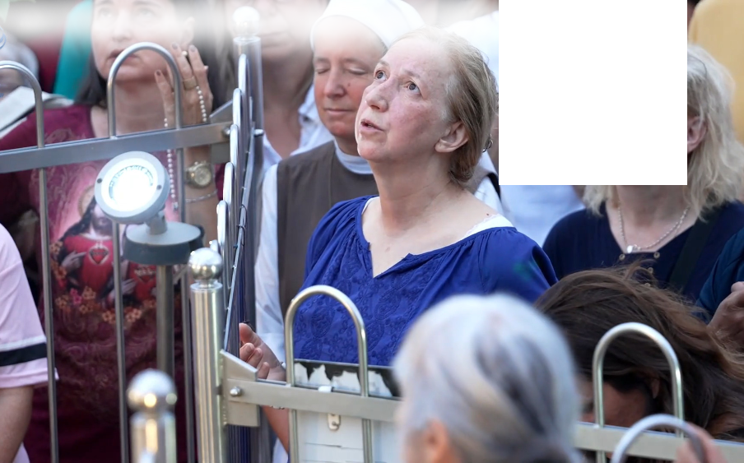
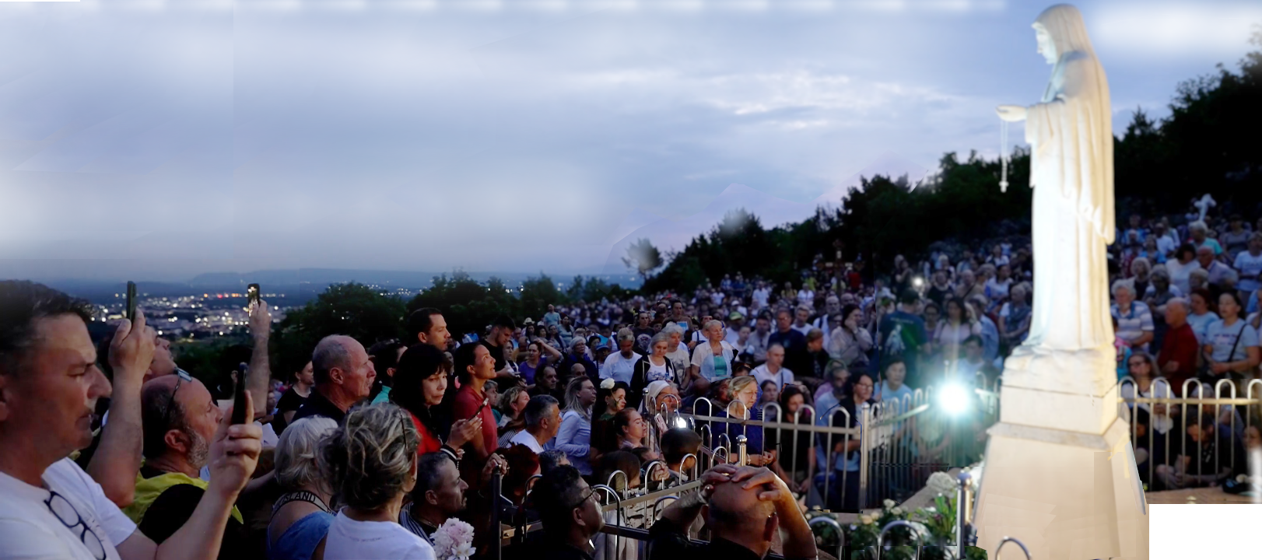

June 17th 2025
https://video.marytv.tv/watch/m7xYL0saagr
44th Anniversary Novena
2nd Day
Marija Pavlović Lunetti described the vision:
“During the apparition I entrusted to Our Lady all of us, all our intentions, and everything that we have on our hearts. Our Lady looked at us and prayed over us. In a special way She prayed for peace, in
our hearts, in our families, and in the whole world. She
blessed us all with the sign of the Cross and went
to Heaven.”

The QR-code gives the above link to the video of this apparition, or use the link given on the page of the 1st Day of the Novena for all these MaryTV videos.

June 17th 2025
https://video.marytv.tv/watch/m7xYL0saagr
44th Anniversary Novena
2nd Day
Marija Pavlović Lunetti described the vision:
“During the apparition I entrusted to Our Lady all of us, all our intentions, and everything that we have on our hearts. Our Lady looked at us and prayed over us. In a special way She prayed for peace, in
our hearts, in our families, and in the whole world. She
blessed us all with the sign of the Cross and went
to Heaven.”

The QR-code gives the above link to the video of this apparition, or use the link given on the page of the 1st Day of the Novena for all these MaryTV videos.

17. lipnja 2025.
https://video.marytv.tv/watch/m7xYL0saagr
44th Anniversary Novena
2nd Day
Marija Pavlović Lunetti described the vision:
“During the apparition I entrusted to Our Lady all of us, all our intentions, and everything that we have on our hearts. Our Lady looked at us and prayed over us. In a special way She prayed for peace, in
our hearts, in our families, and in the whole world. She
blessed us all with the sign of the Cross and went
to Heaven.”

The QR-code gives the above link to the video of this apparition, or use the link given on the page of the 1st Day of the Novena for all these MaryTV videos.

June 17th 2025
https://video.marytv.tv/watch/m7xYL0saagr
44th Anniversary Novena
2nd Day
Marija Pavlović Lunetti described the vision:
“During the apparition I entrusted to Our Lady all of us, all our intentions, and everything that we have on our hearts. Our Lady looked at us and prayed over us. In a special way She prayed for peace, in
our hearts, in our families, and in the whole world. She
blessed us all with the sign of the Cross and went
to Heaven.”

The QR-code gives the above link to the video of this apparition, or use the link given on the page of the 1st Day of the Novena for all these MaryTV videos.

June 17th 2025
https://video.marytv.tv/watch/m7xYL0saagr
44th Anniversary Novena
2nd Day
Marija Pavlović Lunetti described the vision:
“During the apparition I entrusted to Our Lady all of us, all our intentions, and everything that we have on our hearts. Our Lady looked at us and prayed over us. In a special way She prayed for peace, in
our hearts, in our families, and in the whole world. She
blessed us all with the sign of the Cross and went
to Heaven.”

The QR-code gives the above link to the video of this apparition, or use the link given on the page of the 1st Day of the Novena for all these MaryTV videos.

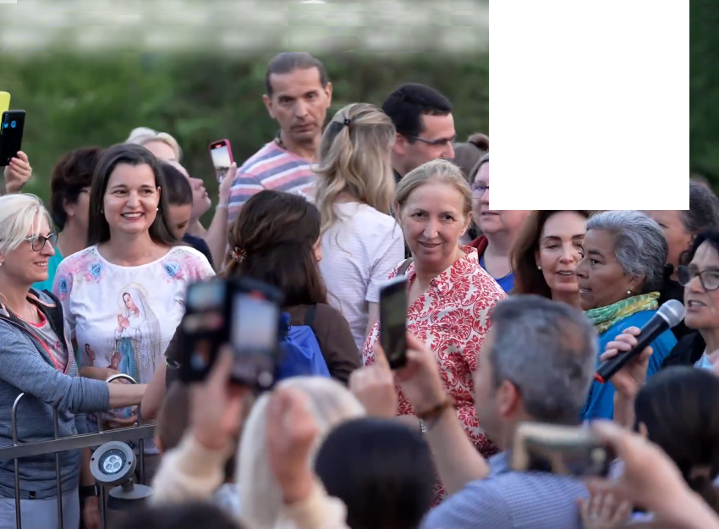
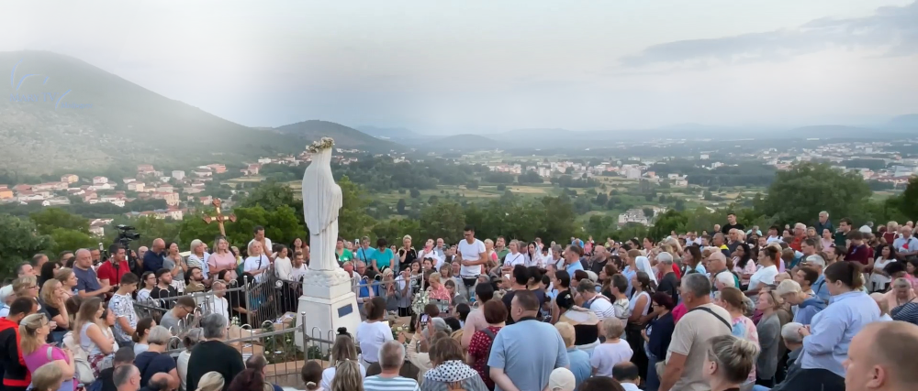

June 18th 2025
https://video.marytv.tv/watch/m7KZSjsaavA
44th Anniversary Novena
3rd Day
Marija Pavlović Lunetti described the vision:
“During the apparition, when Our Lady came, I entrusted to Her all of us, all our intentions, and all that which we have on our hearts, and all the persons who could not come here but are in our prayers.
In a special way I prayed Our Lady to plead before Her Son Jesus for peace in our hearts, peace in our families, and peace in the whole world. Our Lady prayed long over us and blessed us all, and with the sign of the Cross She blessed us and went to Heaven.”

https://video.marytv.tv/watch/m7KZSjsaavA
June 18th 2025
44th Anniversary Novena
3rd Day
Marija Pavlović Lunetti described the vision:
“During the apparition, when Our Lady came, I entrusted to Her all of us, all our intentions, and all that which we have on our hearts, and all the persons who could not come here but are in our prayers.
In a special way I prayed Our Lady to plead before Her Son Jesus for peace in our hearts, peace in our families, and peace in the whole world. Our Lady prayed long over us and blessed us all, and with the sign of the Cross She blessed us and went to Heaven.”

https://video.marytv.tv/watch/m7KZSjsaavA
June 18th 2025
44th Anniversary Novena
3rd Day
Marija Pavlović Lunetti described the vision:
“During the apparition, when Our Lady came, I entrusted to Her all of us, all our intentions, and all that which we have on our hearts, and all the persons who could not come here but are in our prayers.
In a special way I prayed Our Lady to plead before Her Son Jesus for peace in our hearts, peace in our families, and peace in the whole world. Our Lady prayed long over us and blessed us all, and with the sign of the Cross She blessed us and went to Heaven.”

https://video.marytv.tv/watch/m7KZSjsaavA
June 18th 2025
44th Anniversary Novena
3rd Day
Marija Pavlović Lunetti described the vision:
“During the apparition, when Our Lady came, I entrusted to Her all of us, all our intentions, and all that which we have on our hearts, and all the persons who could not come here but are in our prayers.
In a special way I prayed Our Lady to plead before Her Son Jesus for peace in our hearts, peace in our families, and peace in the whole world. Our Lady prayed long over us and blessed us all, and with the sign of the Cross She blessed us and went to Heaven.”

https://video.marytv.tv/watch/m7KZSjsaavA
June 18th 2025
44th Anniversary Novena
3rd Day
Marija Pavlović Lunetti described the vision:
“During the apparition, when Our Lady came, I entrusted to Her all of us, all our intentions, and all that which we have on our hearts, and all the persons who could not come here but are in our prayers.
In a special way I prayed Our Lady to plead before Her Son Jesus for peace in our hearts, peace in our families, and peace in the whole world. Our Lady prayed long over us and blessed us all, and with the sign of the Cross She blessed us and went to Heaven.”

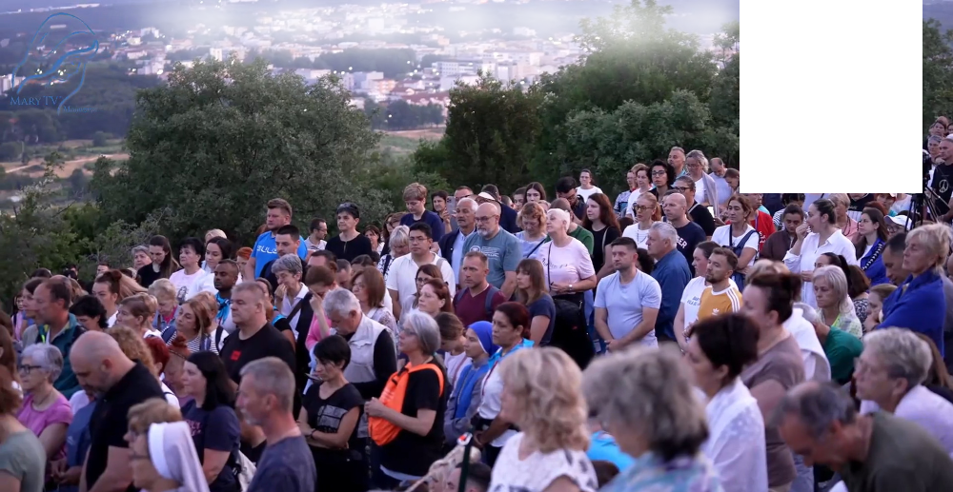
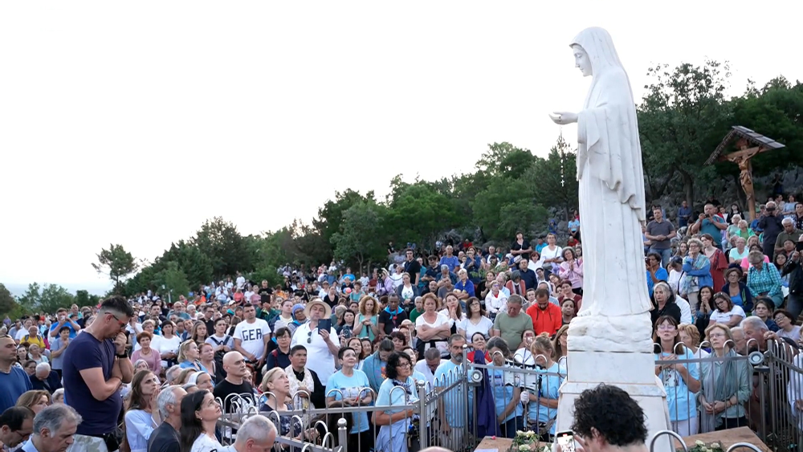

June 19th 2025
https://video.marytv.tv/watch/m7J2UjsaX2q
44th Anniversary Novena
4th Day
Marija Pavlović Lunetti describes:
“During the apparition I recommended to Our Lady all of us, all our intentions, and everything we have on our hearts, and people who asked us to pray for them, the sick in the body and the sick in the soul. Our Lady prayed for long. I asked Our Lady to plead before Her Son Jesus for peace in our hearts, in our families, and in the whole world.
Our Lady prayed long over us and blessed us all, with the sign of the Cross, and went
to Heaven.”

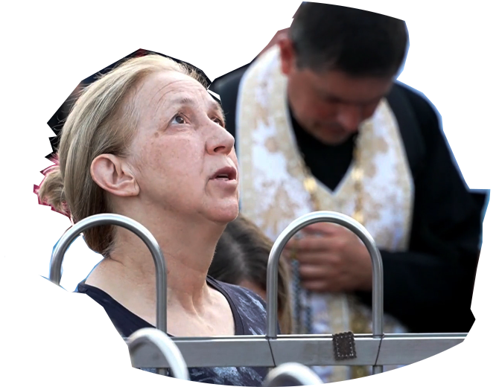

https://video.marytv.tv/watch/m7J2UjsaX2q
44th Anniversary Novena
4th Day
June 19th 2025
Marija Pavlović Lunetti describes:
“During the apparition I recommended to Our Lady all of us, all our intentions, and everything we have on our hearts, and people who asked us to pray for them, the sick in the body and the sick in the soul. Our Lady prayed for long. I asked Our Lady to plead before Her Son Jesus for peace in our hearts, in our families, and in the whole world.
Our Lady prayed long over us and blessed us all, with the sign of the Cross, and went
to Heaven.”

June 19th 2025
https://video.marytv.tv/watch/m7J2UjsaX2q
44th Anniversary Novena
4th Day
Marija Pavlović Lunetti describes:
“During the apparition I recommended to Our Lady all of us, all our intentions, and everything we have on our hearts, and people who asked us to pray for them, the sick in the body and the sick in the soul. Our Lady prayed for long. I asked Our Lady to plead before Her Son Jesus for peace in our hearts, in our families, and in the whole world.
Our Lady prayed long over us and blessed us all, with the sign of the Cross, and went
to Heaven.”

https://video.marytv.tv/watch/m7J2UjsaX2q
44th Anniversary Novena
4th Day
June 19th 2025
Marija Pavlović Lunetti describes:
“During the apparition I recommended to Our Lady all of us, all our intentions, and everything we have on our hearts, and people who asked us to pray for them, the sick in the body and the sick in the soul. Our Lady prayed for long. I asked Our Lady to plead before Her Son Jesus for peace in our hearts, in our families, and in the whole world.
Our Lady prayed long over us and blessed us all, with the sign of the Cross, and went
to Heaven.”

https://video.marytv.tv/watch/m7J2UjsaX2q
44th Anniversary Novena
4th Day
June 19th 2025
Marija Pavlović Lunetti describes:
“During the apparition I recommended to Our Lady all of us, all our intentions, and everything we have on our hearts, and people who asked us to pray for them, the sick in the body and the sick in the soul. Our Lady prayed for long. I asked Our Lady to plead before Her Son Jesus for peace in our hearts, in our families, and in the whole world.
Our Lady prayed long over us and blessed us all, with the sign of the Cross, and went
to Heaven.”


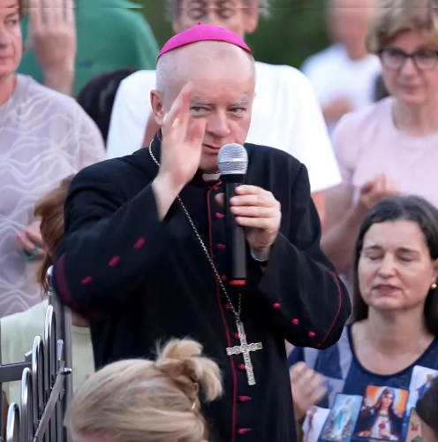
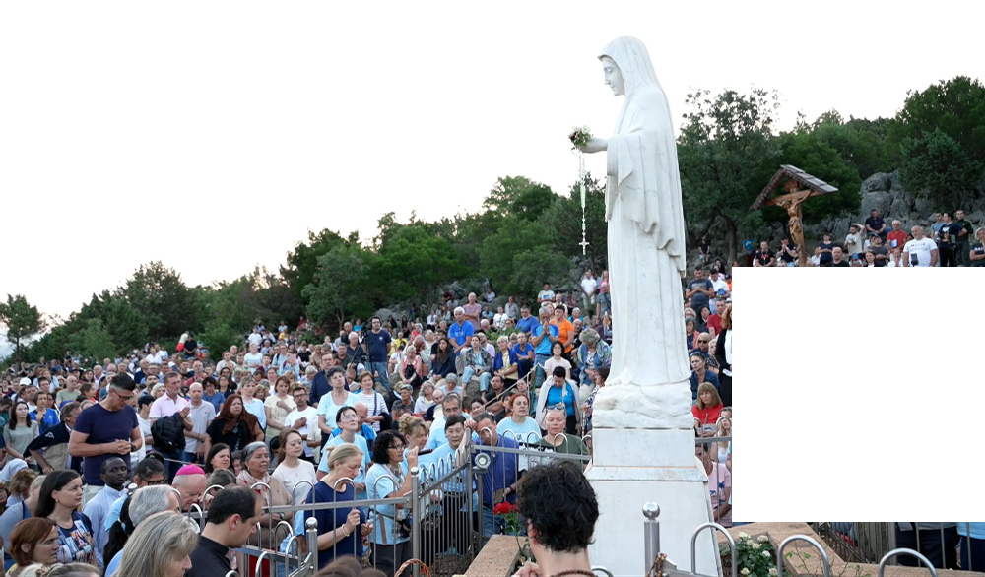
June 20th 2025
https://video.marytv.tv/watch/m7EuGpsaXgG
44th Anniversary Novena
5th Day
Visinary Marija describes the encounter:
“Today, during the time of the apparition, Our Blessed Mother was looking at us, and I presented all of us to her — all our intentions, everything we carry in our hearts, and also the people who couldn’t come and are not physically here but are spiritually present with us in prayer. Our Blessed Mother prayed over us for a long time and looked at us.”

“I especially asked her to intercede before her Son Jesus for peace in our hearts, peace in our families, and peace in the whole world. Our Blessed Mother again prayed for a long time for peace. She blessed all of us with the sign of the Cross and then ascended to Heaven.”
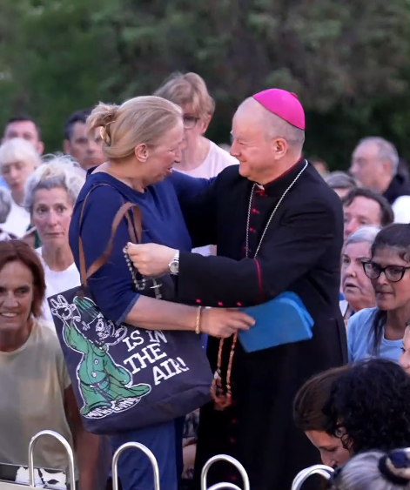
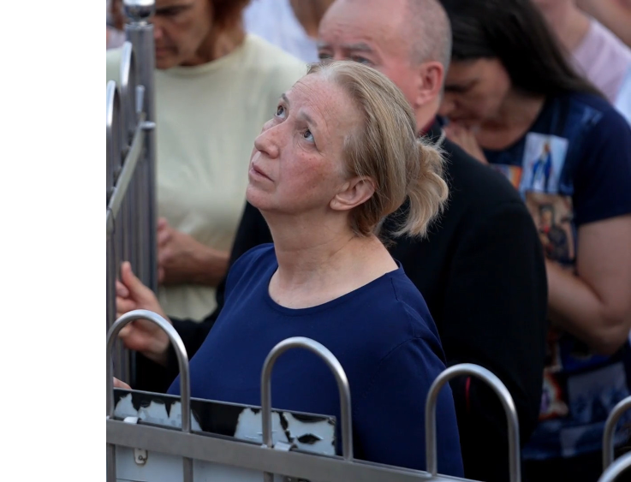



The text is from the report you get with the left QR-code (you get the long link in bottom). The top right QR-code and its link is to the video of the apparition.

https://centermirmedjugorje.com/2025/06/20/5th-day-of-the-novena-for-peace-our-blessed-mother-prayed-over-us-for-a-long-time-and-looked-at-us-marija-pavlovic/
June 20th 2025
https://video.marytv.tv/watch/m7EuGpsaXgG
44th Anniversary Novena
5th Day
Visinary Marija describes the encounter:
“Today, during the time of the apparition, Our Blessed Mother was looking at us, and I presented all of us to her — all our intentions, everything we carry in our hearts, and also the people who couldn’t come and are not physically here but are spiritually present with us in prayer. Our Blessed Mother prayed over us for a long time and looked at us.”

“I especially asked her to intercede before her Son Jesus for peace in our hearts, peace in our families, and peace in the whole world. Our Blessed Mother again prayed for a long time for peace. She blessed all of us with the sign of the Cross and then ascended to Heaven.”

The text is from the report you get with the left QR-code (you get the long link in bottom). The top right QR-code and its link is to the video of the apparition.

https://centermirmedjugorje.com/2025/06/20/5th-day-of-the-novena-for-peace-our-blessed-mother-prayed-over-us-for-a-long-time-and-looked-at-us-marija-pavlovic/
June 20th 2025
https://video.marytv.tv/watch/m7EuGpsaXgG
44th Anniversary Novena
5th Day
Visinary Marija describes the encounter:
“Today, during the time of the apparition, Our Blessed Mother was looking at us, and I presented all of us to her — all our intentions, everything we carry in our hearts, and also the people who couldn’t come and are not physically here but are spiritually present with us in prayer. Our Blessed Mother prayed over us for a long time and looked at us.”

“I especially asked her to intercede before her Son Jesus for peace in our hearts, peace in our families, and peace in the whole world. Our Blessed Mother again prayed for a long time for peace. She blessed all of us with the sign of the Cross and then ascended to Heaven.”

The text is from the report you get with the left QR-code (you get the long link in bottom). The top right QR-code and its link is to the video of the apparition.

https://centermirmedjugorje.com/2025/06/20/5th-day-of-the-novena-for-peace-our-blessed-mother-prayed-over-us-for-a-long-time-and-looked-at-us-marija-pavlovic/
June 20th 2025
https://video.marytv.tv/watch/m7EuGpsaXgG
44th Anniversary Novena
5th Day
Visinary Marija describes the encounter:
“Today, during the time of the apparition, Our Blessed Mother was looking at us, and I presented all of us to her — all our intentions, everything we carry in our hearts, and also the people who couldn’t come and are not physically here but are spiritually present with us in prayer. Our Blessed Mother prayed over us for a long time and looked at us.”

“I especially asked her to intercede before her Son Jesus for peace in our hearts, peace in our families, and peace in the whole world. Our Blessed Mother again prayed for a long time for peace. She blessed all of us with the sign of the Cross and then ascended to Heaven.”

The text is from the report you get with the left QR-code (you get the long link in bottom). The top right QR-code and its link is to the video of the apparition.

https://centermirmedjugorje.com/2025/06/20/5th-day-of-the-novena-for-peace-our-blessed-mother-prayed-over-us-for-a-long-time-and-looked-at-us-marija-pavlovic/
June 20th 2025
https://video.marytv.tv/watch/m7EuGpsaXgG
44th Anniversary Novena
5th Day
Visinary Marija describes the encounter:
“Today, during the time of the apparition, Our Blessed Mother was looking at us, and I presented all of us to her — all our intentions, everything we carry in our hearts, and also the people who couldn’t come and are not physically here but are spiritually present with us in prayer. Our Blessed Mother prayed over us for a long time and looked at us.”

“I especially asked her to intercede before her Son Jesus for peace in our hearts, peace in our families, and peace in the whole world. Our Blessed Mother again prayed for a long time for peace. She blessed all of us with the sign of the Cross and then ascended to Heaven.”

The text is from the report you get with the left QR-code (you get the long link in bottom). The top right QR-code and its link is to the video of the apparition.

https://centermirmedjugorje.com/2025/06/20/5th-day-of-the-novena-for-peace-our-blessed-mother-prayed-over-us-for-a-long-time-and-looked-at-us-marija-pavlovic/
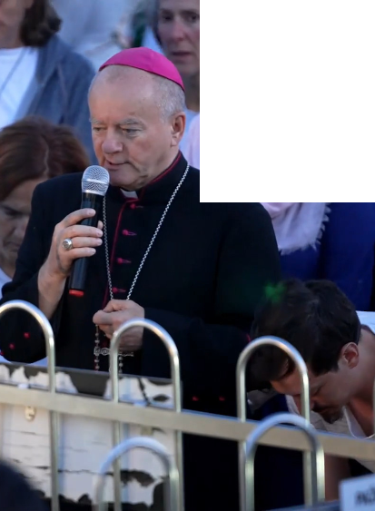
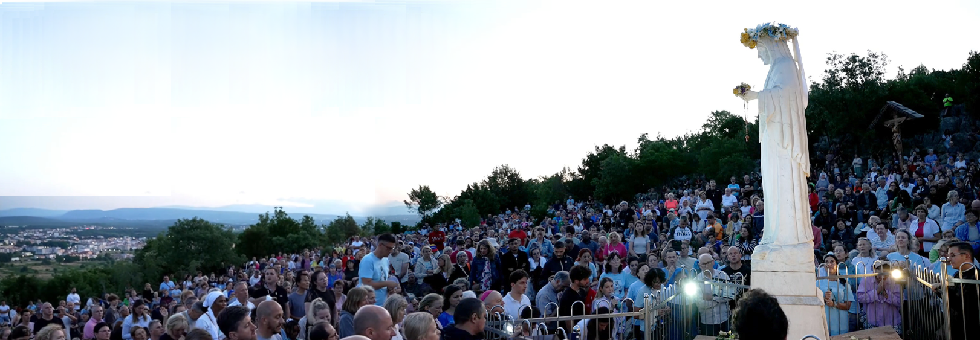

June 21st 2025
https://video.marytv.tv/watch/m7SJ08saXS1
44th Anniversary Novena
6th Day
Marija describes:
“During the apparition, when Our Lady came, I recommended all of us, all our intentions, and all that which we have on our hearts, and the people who asked us to pray for them.
In a special way I prayed Our Lady for peace, that She may plead before Her Son Jesus for us, for peace in our hearts, peace in our families, and peace in the whole world.
Our Lady looked at us, prayed long over us, blessed us and went
to Heaven.”

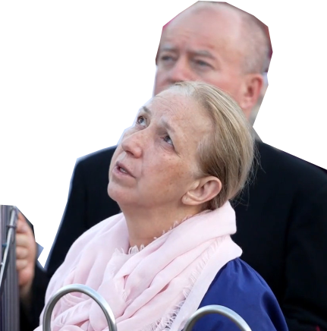

Ukrainian Bishop Jan Sobiło

https://video.marytv.tv/watch/m7SJ08saXS1
44th Anniversary Novena
6th Day
June 21st 2025
Marija describes:
“During the apparition, when Our Lady came, I recommended all of us, all our intentions, and all that which we have on our hearts, and the people who asked us to pray for them.
In a special way I prayed Our Lady for peace, that She may plead before Her Son Jesus for us, for peace in our hearts, peace in our families, and peace in the whole world.
Our Lady looked at us, prayed long over us, blessed us and went
to Heaven.”

Ukrainian Bishop Jan Sobiło

https://video.marytv.tv/watch/m7SJ08saXS1
44th Anniversary Novena
6th Day
June 21st 2025
Marija describes:
“During the apparition, when Our Lady came, I recommended all of us, all our intentions, and all that which we have on our hearts, and the people who asked us to pray for them.
In a special way I prayed Our Lady for peace, that She may plead before Her Son Jesus for us, for peace in our hearts, peace in our families, and peace in the whole world.
Our Lady looked at us, prayed long over us, blessed us and went
to Heaven.”

Ukrainian Bishop Jan Sobiło

21. lipnja 2025.
https://video.marytv.tv/watch/m7SJ08saXS1
44th Anniversary Novena
6th Day
Marija describes:
“During the apparition, when Our Lady came, I recommended all of us, all our intentions, and all that which we have on our hearts, and the people who asked us to pray for them.
In a special way I prayed Our Lady for peace, that She may plead before Her Son Jesus for us, for peace in our hearts, peace in our families, and peace in the whole world.
Our Lady looked at us, prayed long over us, blessed us and went
to Heaven.”

Ukrainian Bishop Jan Sobiło

https://video.marytv.tv/watch/m7SJ08saXS1
44th Anniversary Novena
6th Day
June 21st 2025
Marija describes:
“During the apparition, when Our Lady came, I recommended all of us, all our intentions, and all that which we have on our hearts, and the people who asked us to pray for them.
In a special way I prayed Our Lady for peace, that She may plead before Her Son Jesus for us, for peace in our hearts, peace in our families, and peace in the whole world.
Our Lady looked at us, prayed long over us, blessed us and went
to Heaven.”

Ukrainian Bishop Jan Sobiło

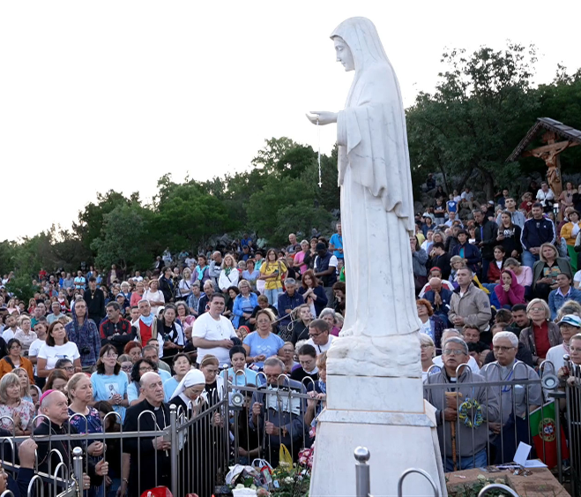
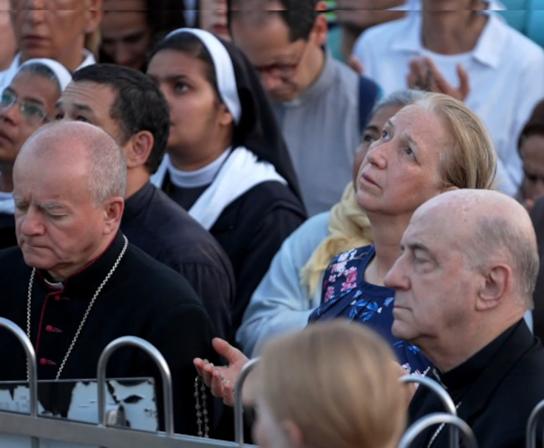
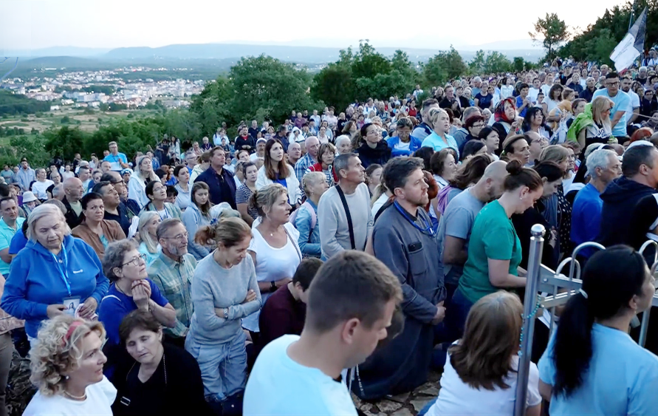

June 22nd 2025
44th Anniversary Novena
https://video.marytv.tv/watch/m7CI4asaki0
7th Day
Marija describes:
“Today Our Lady came, She looked at us all, and immediately began to pray over us. After the prayer I recommended to Our Lady to pray, before Her Son Jesus, for peace in our hearts, peace in our families, and peace in the whole world.
Our Lady began to pray for peace, and She prayed in Her mothertongue, in Aramaic for a longer time and She blessed us all. She also blessed all the religious articles today, and She made the sign of the Cross, the blessing, and went to Heaven, in peace.

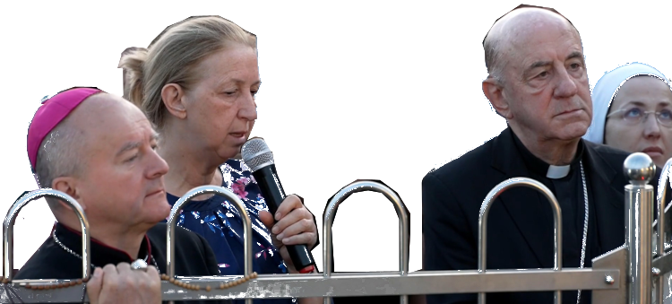

Abp. Murilo Krieger, primate emeritus of the church in Brazil

44th Anniversary Novena
7th Day
https://video.marytv.tv/watch/m7CI4asaki0
June 22nd 2025
Marija Pavlović Lunetti opisuje viđenje:
“Danas je Gospa došla, gledala nas je sve, i odmah je počela molit nad nama. Nakon molitve ja sam preporučila Gospi da moli, sa svojim Sinom Isusom, za mir u našim srcima, u našim obiteljima, i na čitavom svijetu.
Our Lady began to pray for peace, and She prayed in Her mothertongue, in Aramaic for a longer time and She blessed us all. She also blessed all the religious articles today, and She made the sign of the Cross, the blessing, and went to Heaven, in peace.

Abp. Murilo Krieger, primate emeritus of the church in Brazil

44th Anniversary Novena
https://video.marytv.tv/watch/m7CI4asaki0
7th Day
June 22nd 2025
Marija describes:
“Today Our Lady came, She looked at us all, and immediately began to pray over us. After the prayer I recommended to Our Lady to pray, before Her Son Jesus, for peace in our hearts, peace in our families, and peace in the whole world.
Our Lady began to pray for peace, and She prayed in Her mothertongue, in Aramaic for a longer time and She blessed us all. She also blessed all the religious articles today, and She made the sign of the Cross, the blessing, and went to Heaven, in peace.

Abp. Murilo Krieger, primate emeritus of the church in Brazil

44th Anniversary Novena
https://video.marytv.tv/watch/m7CI4asaki0
7th Day
June 22nd 2025
Marija describes:
“Today Our Lady came, She looked at us all, and immediately began to pray over us. After the prayer I recommended to Our Lady to pray, before Her Son Jesus, for peace in our hearts, peace in our families, and peace in the whole world.
Our Lady began to pray for peace, and She prayed in Her mothertongue, in Aramaic for a longer time and She blessed us all. She also blessed all the religious articles today, and She made the sign of the Cross, the blessing, and went to Heaven, in peace.

Abp. Murilo Krieger, primate emeritus of the church in Brazil

44th Anniversary Novena
https://video.marytv.tv/watch/m7CI4asaki0
7th Day
June 22nd 2025
Marija describes:
“Today Our Lady came, She looked at us all, and immediately began to pray over us. After the prayer I recommended to Our Lady to pray, before Her Son Jesus, for peace in our hearts, peace in our families, and peace in the whole world.
Our Lady began to pray for peace, and She prayed in Her mothertongue, in Aramaic for a longer time and She blessed us all. She also blessed all the religious articles today, and She made the sign of the Cross, the blessing, and went to Heaven, in peace.

Abp. Murilo Krieger, primate emeritus of the church in Brazil

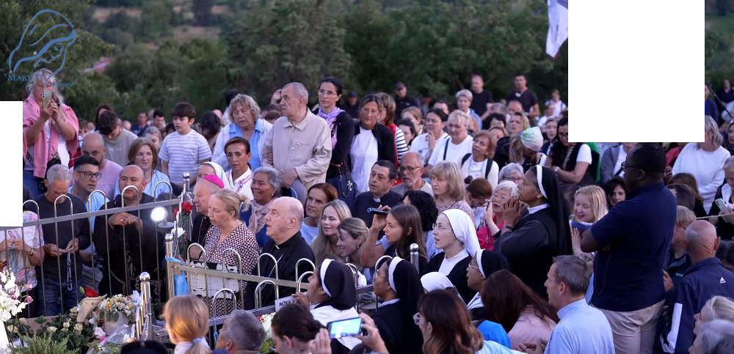
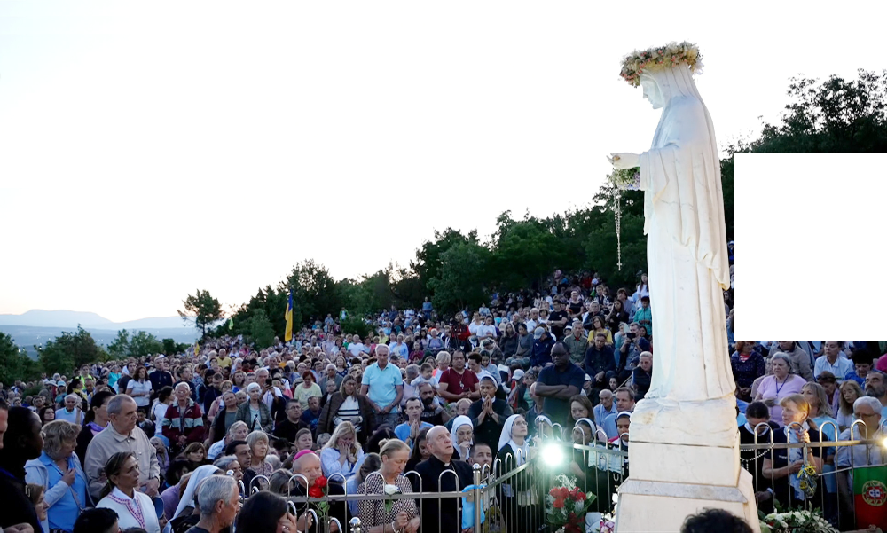

June 23rd 2025
44th Anniversary Novena
https://video.marytv.tv/watch/m7zeSmsakVN
8th Day
Marija describes:
“During the apparition, when Our Lady came, I entrusted to Her all of us, all our intentions, all those who are present here, all those who asked us to pray for them. I prayed in a special way that Our Lady pleads before Her Son Jesus for peace in our hearts, in our families,
and in the whole world.”
“In a special way where there is war, that there may be peace. Our Lady prayed for long over us, and while She was praying for peace, with the sign of the cross She blessed us.”


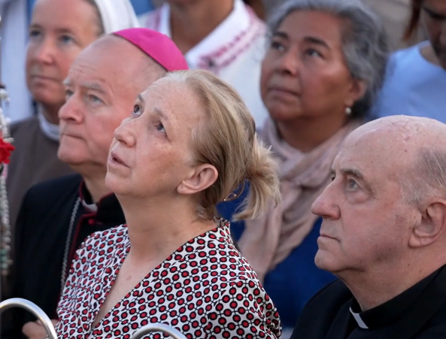

QR-code gives:
https://centermirmedjugorje.com/2025/06/23/8th-day-novena-for-peace/
[*] This citation is from the Official Mir Međugorje Center for English. And it’s the only source of this important information that we were able to find.
The prayer went on at the Blue Cross, where eventually the seer took the microphone and said to us[*]:
“I am very happy with the visit of Msg. Murilo. I’ve known him for almost 40 years. He came to Međugorje for the first time a very long time ago. Today is the last day he will be with us, as he is travelling to Rome for the jubilee of Bishops. I told him that if he sees the Holy Father, to give him our love and greetings from Međugorje.”

44th Anniversary Novena
https://video.marytv.tv/watch/m7zeSmsakVN
8th Day
June 23rd 2025
Marija describes:
“During the apparition, when Our Lady came, I entrusted to Her all of us, all our intentions, all those who are present here, all those who asked us to pray for them. I prayed in a special way that Our Lady pleads before Her Son Jesus for peace in our hearts, in our families,
and in the whole world.”
“Na poseban način tamo gdje je rat, da bude mir. Gospa je dugo molila nad nama, i dok je molila za mir, i znakom križa sve nas je blagoslovila.”
“In a special way where there is war, that there may be peace. Our Lady prayed for long over us, and while She was praying for peace, with the sign of the cross She blessed us.”

QR-code gives:
https://centermirmedjugorje.com/2025/06/23/8th-day-novena-for-peace/
[*] This citation is from the Official Mir Međugorje Center for English. And it’s the only source of this important information that we were able to find.
The prayer went on at the Blue Cross, where eventually the seer took the microphone and said to us[*]:
“I am very happy with the visit of Msg. Murilo. I’ve known him for almost 40 years. He came to Međugorje for the first time a very long time ago. Today is the last day he will be with us, as he is travelling to Rome for the jubilee of Bishops. I told him that if he sees the Holy Father, to give him our love and greetings from Međugorje.”

44th Anniversary Novena
https://video.marytv.tv/watch/m7zeSmsakVN
8th Day
June 23rd 2025
Marija describes:
“During the apparition, when Our Lady came, I entrusted to Her all of us, all our intentions, all those who are present here, all those who asked us to pray for them. I prayed in a special way that Our Lady pleads before Her Son Jesus for peace in our hearts, in our families,
and in the whole world.”
“Na poseban način tamo gdje je rat, da bude mir. Gospa je dugo molila nad nama, i dok je molila za mir, i znakom križa sve nas je blagoslovila.”
“In a special way where there is war, that there may be peace. Our Lady prayed for long over us, and while She was praying for peace, with the sign of the cross She blessed us.”

QR-code gives:
https://centermirmedjugorje.com/2025/06/23/8th-day-novena-for-peace/
[*] This citation is from the Official Mir Međugorje Center for English. And it’s the only source of this important information that we were able to find.
The prayer went on at the Blue Cross, where eventually the seer took the microphone and said to us[*]:
“I am very happy with the visit of Msg. Murilo. I’ve known him for almost 40 years. He came to Međugorje for the first time a very long time ago. Today is the last day he will be with us, as he is travelling to Rome for the jubilee of Bishops. I told him that if he sees the Holy Father, to give him our love and greetings from Međugorje.”

44th Anniversary Novena
https://video.marytv.tv/watch/m7zeSmsakVN
8th Day
June 23rd 2025
Marija describes:
“During the apparition, when Our Lady came, I entrusted to Her all of us, all our intentions, all those who are present here, all those who asked us to pray for them. I prayed in a special way that Our Lady pleads before Her Son Jesus for peace in our hearts, in our families,
and in the whole world.”
“Na poseban način tamo gdje je rat, da bude mir. Gospa je dugo molila nad nama, i dok je molila za mir, i znakom križa sve nas je blagoslovila.”
“In a special way where there is war, that there may be peace. Our Lady prayed for long over us, and while She was praying for peace, with the sign of the cross She blessed us.”

QR-code gives:
https://centermirmedjugorje.com/2025/06/23/8th-day-novena-for-peace/
[*] This citation is from the Official Mir Međugorje Center for English. And it’s the only source of this important information that we were able to find.
The prayer went on at the Blue Cross, where eventually the seer took the microphone and said to us[*]:
“I am very happy with the visit of Msg. Murilo. I’ve known him for almost 40 years. He came to Međugorje for the first time a very long time ago. Today is the last day he will be with us, as he is travelling to Rome for the jubilee of Bishops. I told him that if he sees the Holy Father, to give him our love and greetings from Međugorje.”

44th Anniversary Novena
https://video.marytv.tv/watch/m7zeSmsakVN
8th Day
June 23rd 2025
Marija describes:
“During the apparition, when Our Lady came, I entrusted to Her all of us, all our intentions, all those who are present here, all those who asked us to pray for them. I prayed in a special way that Our Lady pleads before Her Son Jesus for peace in our hearts, in our families,
and in the whole world.”
“Na poseban način tamo gdje je rat, da bude mir. Gospa je dugo molila nad nama, i dok je molila za mir, i znakom križa sve nas je blagoslovila.”
“In a special way where there is war, that there may be peace. Our Lady prayed for long over us, and while She was praying for peace, with the sign of the cross She blessed us.”

QR-code gives:
https://centermirmedjugorje.com/2025/06/23/8th-day-novena-for-peace/
[*] This citation is from the Official Mir Međugorje Center for English. And it’s the only source of this important information that we were able to find.
The prayer went on at the Blue Cross, where eventually the seer took the microphone and said to us[*]:
“I am very happy with the visit of Msg. Murilo. I’ve known him for almost 40 years. He came to Međugorje for the first time a very long time ago. Today is the last day he will be with us, as he is travelling to Rome for the jubilee of Bishops. I told him that if he sees the Holy Father, to give him our love and greetings from Međugorje.”

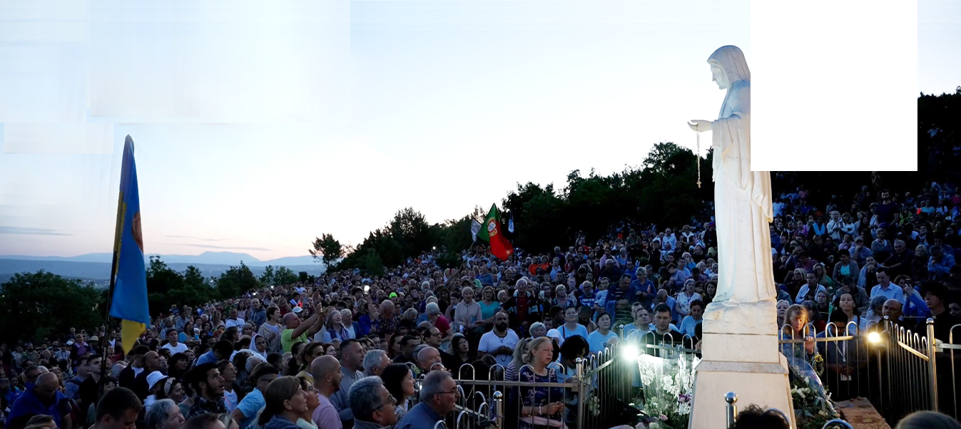
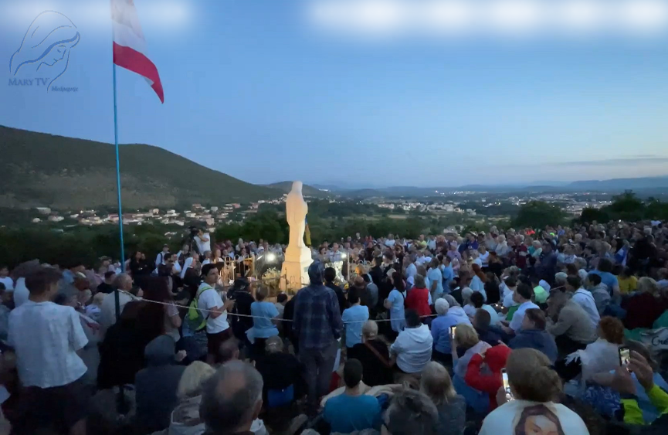

June 24th 2025
https://video.marytv.tv/watch/m7brLYsakvH
44th Anniversary Novena
9th Day
Marija Pavlović Lunetti describes the vision:
“During the appartion when Our Lady came, I entrusted to Her all of us, and all the people who had asked for our prayers.“
“I asked Her to bless us, and to bless all the religious articles we had brought. Our Lady prayed over us and blessed us all. I especially asked Her to plead before Her Son Jesus for peace in our families, in our hearts, and in the whole world. Our Lady prayed for long and at the
end She blessed us all with the Sign of the Cross and
went to Heaven.“

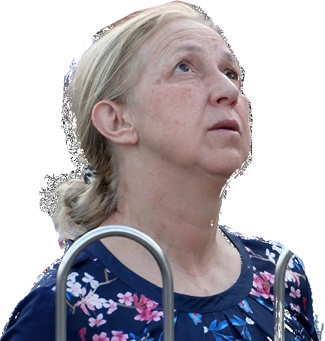

And she added: “Tomorrow in the same
place at the same time,
as Our Lady said.”

https://video.marytv.tv/watch/m7brLYsakvH
44th Anniversary Novena
9th Day
June 24th 2025
Marija Pavlović Lunetti describes the vision:
“During the appartion when Our Lady came, I entrusted to Her all of us, and all the people who had asked for our prayers.“
“I asked Her to bless us, and to bless all the religious articles we had brought. Our Lady prayed over us and blessed us all. I especially asked Her to plead before Her Son Jesus for peace in our families, in our hearts, and in the whole world. Our Lady prayed for long and at the
end She blessed us all with the Sign of the Cross and
went to Heaven.“

And she added: “Tomorrow in the same
place at the same time,
as Our Lady said.”

https://video.marytv.tv/watch/m7brLYsakvH
44th Anniversary Novena
9th Day
June 24th 2025
Marija Pavlović Lunetti describes the vision:
“During the appartion when Our Lady came, I entrusted to Her all of us, and all the people who had asked for our prayers.“
“I asked Her to bless us, and to bless all the religious articles we had brought. Our Lady prayed over us and blessed us all. I especially asked Her to plead before Her Son Jesus for peace in our families, in our hearts, and in the whole world. Our Lady prayed for long and at the
end She blessed us all with the Sign of the Cross and
went to Heaven.“

And she added: “Tomorrow in the same
place at the same time,
as Our Lady said.”

https://video.marytv.tv/watch/m7brLYsakvH
44th Anniversary Novena
9th Day
June 24th 2025
Marija Pavlović Lunetti describes the vision:
“During the appartion when Our Lady came, I entrusted to Her all of us, and all the people who had asked for our prayers.“
“I asked Her to bless us, and to bless all the religious articles we had brought. Our Lady prayed over us and blessed us all. I especially asked Her to plead before Her Son Jesus for peace in our families, in our hearts, and in the whole world. Our Lady prayed for long and at the
end She blessed us all with the Sign of the Cross and
went to Heaven.“

And she added: “Tomorrow in the same
place at the same time,
as Our Lady said.”

https://video.marytv.tv/watch/m7brLYsakvH
44th Anniversary Novena
9th Day
June 24th 2025
Marija Pavlović Lunetti describes the vision:
“During the appartion when Our Lady came, I entrusted to Her all of us, and all the people who had asked for our prayers.“
“I asked Her to bless us, and to bless all the religious articles we had brought. Our Lady prayed over us and blessed us all. I especially asked Her to plead before Her Son Jesus for peace in our families, in our hearts, and in the whole world. Our Lady prayed for long and at the
end She blessed us all with the Sign of the Cross and
went to Heaven.“

And she added: “Tomorrow in the same
place at the same time,
as Our Lady said.”

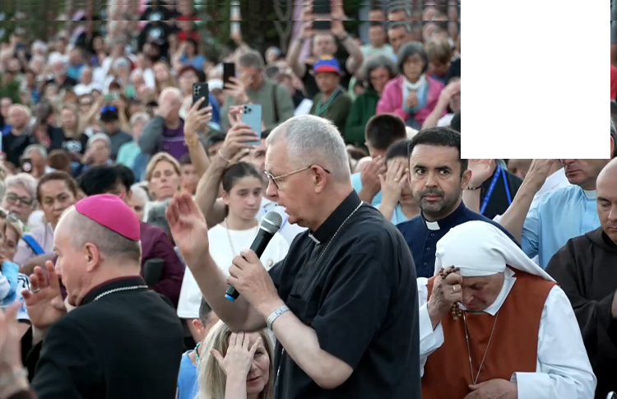
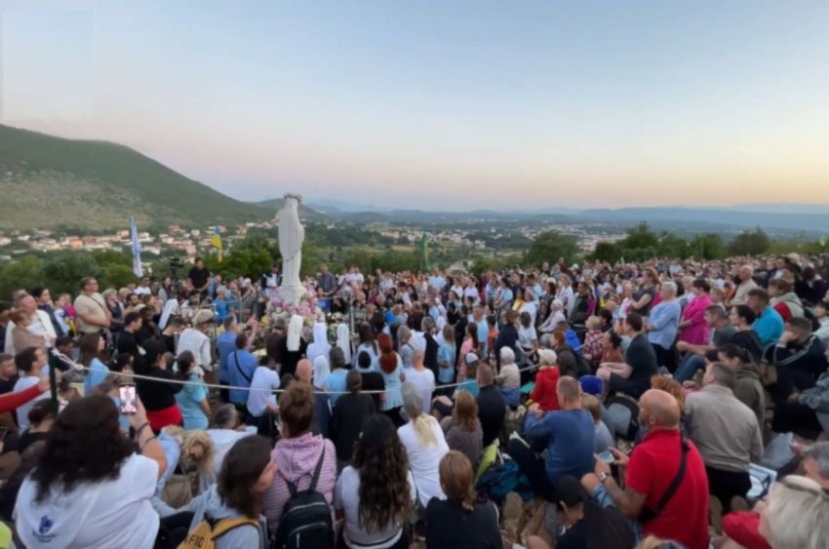

June 25th 2025
https://video.marytv.tv/watch/m73LTDsaZcW
Our Lady’s Message on the 44th Anniversary
The seer described the vision:
During the apparition, whe Our Lady came, I entrusted to Her all of us present and all those who we carry in our hearts. Our Lady prayed over us.
In a special way I asked and entrusted to Our Lady to plead before Her Son Jesus for peace, peace in our hearts, peace in our families and peace in the whole world. Our Lady prayed over us and blessed us all.
And I asked Our Lady if She had a message for us. Our Lady smiled, extended Her arms and began to pray in Her mother tongue, Aramaic. And at the end She said to us:
“Dear children, be peacemakers. Satan is strong and he wants war and restlessness, he wants hatred. Therefore I call you to be my children, children of my Heart.”


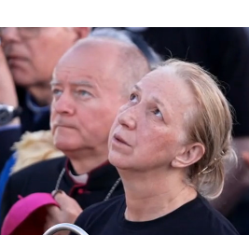

Abp. Tomasz Peta, primate of the church in Kazakhstan

https://video.marytv.tv/watch/m73LTDsaZcW
Our Lady’s Message on the 44th Anniversary
June 25th 2025
The seer described the vision:
During the apparition, whe Our Lady came, I entrusted to Her all of us present and all those who we carry in our hearts. Our Lady prayed over us.
In a special way I asked and entrusted to Our Lady to plead before Her Son Jesus for peace, peace in our hearts, peace in our families and peace in the whole world. Our Lady prayed over us and blessed us all.
And I asked Our Lady if She had a message for us. Our Lady smiled, extended Her arms and began to pray in Her mother tongue, Aramaic. And at the end She said to us:
“Dear children, be peacemakers. Satan is strong and he wants war and restlessness, he wants hatred. Therefore I call you to be my children, children of my Heart.”

Abp. Tomasz Peta, primate of the church in Kazakhstan

https://video.marytv.tv/watch/m73LTDsaZcW
Our Lady’s Message on the 44th Anniversary
June 25th 2025
The seer described the vision:
During the apparition, whe Our Lady came, I entrusted to Her all of us present and all those who we carry in our hearts. Our Lady prayed over us.
In a special way I asked and entrusted to Our Lady to plead before Her Son Jesus for peace, peace in our hearts, peace in our families and peace in the whole world. Our Lady prayed over us and blessed us all.
And I asked Our Lady if She had a message for us. Our Lady smiled, extended Her arms and began to pray in Her mother tongue, Aramaic. And at the end She said to us:
“Dear children, be peacemakers. Satan is strong and he wants war and restlessness, he wants hatred. Therefore I call you to be my children, children of my Heart.”

Abp. Tomasz Peta, primate of the church in Kazakhstan

https://video.marytv.tv/watch/m73LTDsaZcW
Our Lady’s Message on the 44th Anniversary
June 25th 2025
The seer described the vision:
During the apparition, whe Our Lady came, I entrusted to Her all of us present and all those who we carry in our hearts. Our Lady prayed over us.
In a special way I asked and entrusted to Our Lady to plead before Her Son Jesus for peace, peace in our hearts, peace in our families and peace in the whole world. Our Lady prayed over us and blessed us all.
And I asked Our Lady if She had a message for us. Our Lady smiled, extended Her arms and began to pray in Her mother tongue, Aramaic. And at the end She said to us:
“Dear children, be peacemakers. Satan is strong and he wants war and restlessness, he wants hatred. Therefore I call you to be my children, children of my Heart.”

Abp. Tomasz Peta, primate of the church in Kazakhstan

https://video.marytv.tv/watch/m73LTDsaZcW
Our Lady’s Message on the 44th Anniversary
June 25th 2025
The seer described the vision:
During the apparition, whe Our Lady came, I entrusted to Her all of us present and all those who we carry in our hearts. Our Lady prayed over us.
In a special way I asked and entrusted to Our Lady to plead before Her Son Jesus for peace, peace in our hearts, peace in our families and peace in the whole world. Our Lady prayed over us and blessed us all.
And I asked Our Lady if She had a message for us. Our Lady smiled, extended Her arms and began to pray in Her mother tongue, Aramaic. And at the end She said to us:
“Dear children, be peacemakers. Satan is strong and he wants war and restlessness, he wants hatred. Therefore I call you to be my children, children of my Heart.”

Abp. Tomasz Peta, primate of the church in Kazakhstan

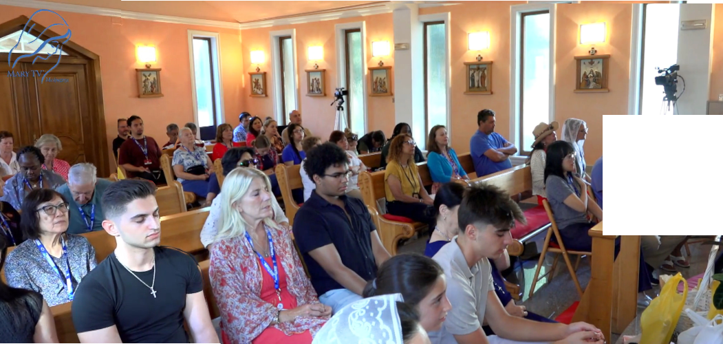

https://video.marytv.tv/watch/m75BDTsakxd
June 23rd 2025
Our Lady’s Apparition to Ivan Dragičević
She prays especially over you priest and you sick. [...] After that Our Lady continues for some time praying for the peace in the world. [...]
She bestows onto us all Her motherly blessing and blesses all of you, all that you brought for blessing.
[…] She leaves in the sign of the light of the cross with the greeting: “Go in peace my dear children!”’
From Ivan’s speech after the apparition:
‘Today as well Our Lady came to us joyous and merry and She greets us all with Her motherly greeting: “Praised be Jeus, my dear children!”
After that She raises Her gaze onto us all and extends Her hands and in Her Aramaic language prays over all of us.’


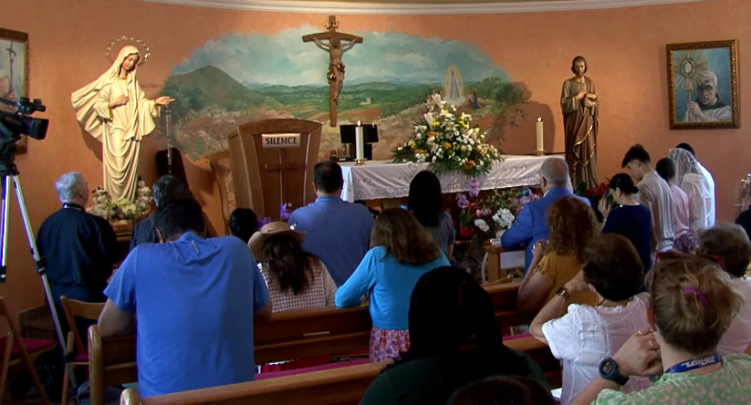
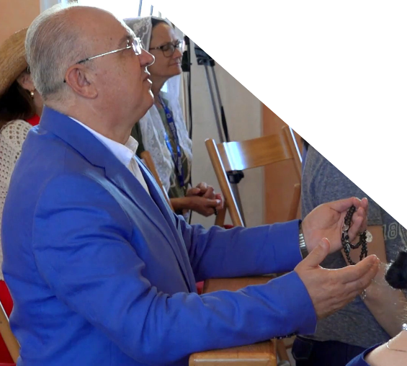

https://video.marytv.tv/series/io9bJjUxsmS
from this link you can access all the videos with apparitions to Ivan from this booklet

scanning the QR-code above you get that link to the Mary TV video of this prayer and apparition
https://video.marytv.tv/watch/m75BDTsakxd
June 23rd 2025
Our Lady’s Apparition to Ivan Dragičević
From Ivan’s speech after the apparition:
‘Today as well Our Lady came to us joyous and merry and She greets us all with Her motherly greeting: “Praised be Jeus, my dear children!”
After that She raises Her gaze onto us all and extends Her hands and in Her Aramaic language prays over all of us.’
She prays especially over you priest and you sick. [...] After that Our Lady continues for some time praying for the peace in the world. [...]
She bestows onto us all Her motherly blessing and blesses all of you, all that you brought for blessing.
[…] She leaves in the sign of the light of the cross with the greeting: “Go in peace my dear children!”’

https://video.marytv.tv/series/io9bJjUxsmS
from this link you can access all the videos with apparitions to Ivan from this booklet

skeniranjem QR-koda dobijete gornju poveznicu na snimku Mary TV ove molitve i ukazanja
https://video.marytv.tv/watch/m75BDTsakxd
June 23rd 2025
Our Lady’s Apparition to Ivan Dragičević
From Ivan’s speech after the apparition:
‘Today as well Our Lady came to us joyous and merry and She greets us all with Her motherly greeting: “Praised be Jeus, my dear children!”
After that She raises Her gaze onto us all and extends Her hands and in Her Aramaic language prays over all of us.’
She prays especially over you priest and you sick. [...] After that Our Lady continues for some time praying for the peace in the world. [...]
She bestows onto us all Her motherly blessing and blesses all of you, all that you brought for blessing.
[…] She leaves in the sign of the light of the cross with the greeting: “Go in peace my dear children!”’

https://video.marytv.tv/series/io9bJjUxsmS
from this link you can access all the videos with apparitions to Ivan from this booklet

scanning the QR-code above you get that link to the Mary TV video of this prayer and apparition
https://video.marytv.tv/watch/m75BDTsakxd
June 23rd 2025
Our Lady’s Apparition to Ivan Dragičević
From Ivan’s speech after the apparition:
‘Today as well Our Lady came to us joyous and merry and She greets us all with Her motherly greeting: “Praised be Jeus, my dear children!”
After that She raises Her gaze onto us all and extends Her hands and in Her Aramaic language prays over all of us.’
She prays especially over you priest and you sick. [...] After that Our Lady continues for some time praying for the peace in the world. [...]
She bestows onto us all Her motherly blessing and blesses all of you, all that you brought for blessing.
[…] She leaves in the sign of the light of the cross with the greeting: “Go in peace my dear children!”’

https://video.marytv.tv/series/io9bJjUxsmS
from this link you can access all the videos with apparitions to Ivan from this booklet

scanning the QR-code above you get that link to the Mary TV video of this prayer and apparition
https://video.marytv.tv/watch/m75BDTsakxd
Our Lady’s Apparition to Ivan Dragičević
June 23rd 2025
From Ivan’s speech after the apparition:
‘Today as well Our Lady came to us joyous and merry and She greets us all with Her motherly greeting: “Praised be Jeus, my dear children!”
After that She raises Her gaze onto us all and extends Her hands and in Her Aramaic language prays over all of us.’
She prays especially over you priest and you sick. [...] After that Our Lady continues for some time praying for the peace in the world. [...]
She bestows onto us all Her motherly blessing and blesses all of you, all that you brought for blessing.
[…] She leaves in the sign of the light of the cross with the greeting: “Go in peace my dear children!”’

https://video.marytv.tv/series/io9bJjUxsmS
from this link you can access all the videos with apparitions to Ivan from this booklet

scanning the QR-code above you get that link to the Mary TV video of this prayer and apparition

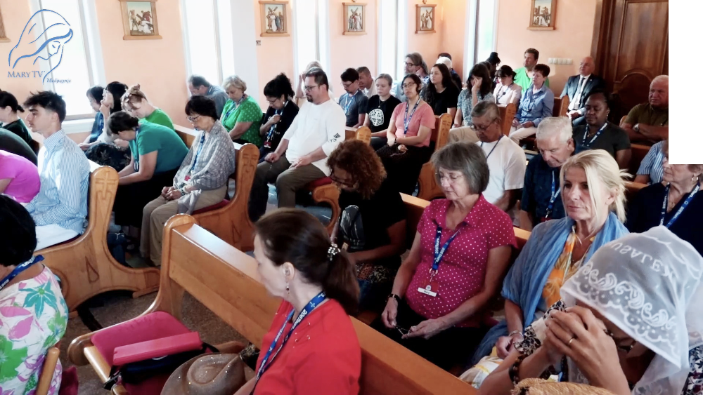
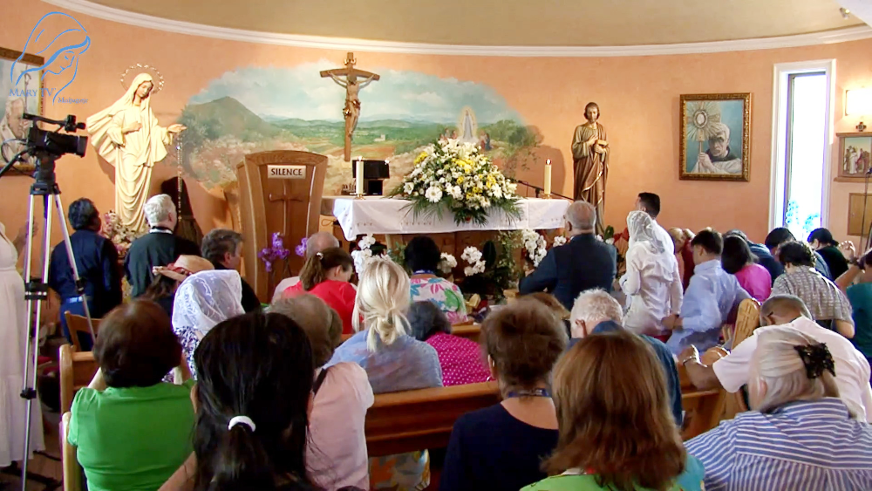

June 24th 2025
https://video.marytv.tv/watch/m7d42asakQG
Our Lady’s Apparition to Ivan Dragičević
Ivan said after the apparition:
‘To me personally, certainly, these days today and tomorrow are special.
Thes two days, indeed, I’d say, embrace my [entire] life. [...]
She also prays over all those who attend the prayer program in the church. […] After that Our Lady for some time continues, prays for peace, and in that prayer She leaves in the sign of the light of the Cross with the greeting: “Go in peace, my dear children!”’
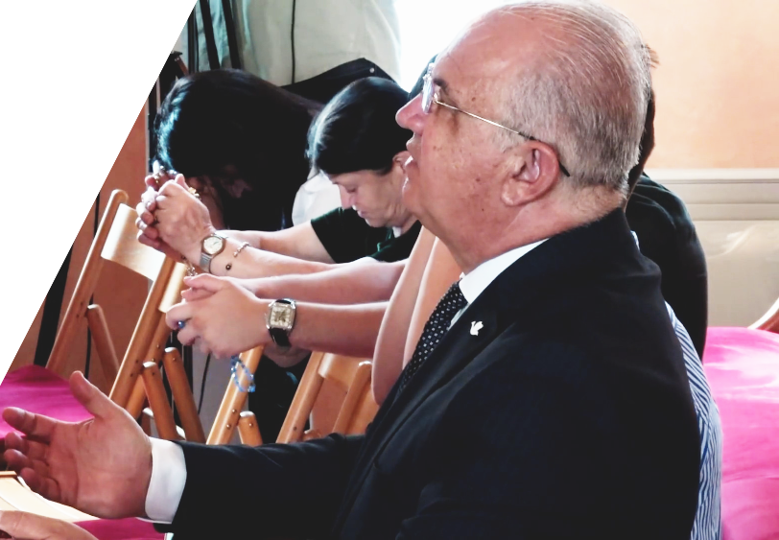

June 24th 2025
https://video.marytv.tv/watch/m7d42asakQG
Our Lady’s Apparition to Ivan Dragičević
Ivan said after the apparition:
‘To me personally, certainly, these days today and tomorrow are special.
Thes two days, indeed, I’d say, embrace my [entire] life. [...]
She also prays over all those who attend the prayer program in the church. […] After that Our Lady for some time continues, prays for peace, and in that prayer She leaves in the sign of the light of the Cross with the greeting: “Go in peace, my dear children!”’

June 24th 2025
https://video.marytv.tv/watch/m7d42asakQG
Our Lady’s Apparition to Ivan Dragičević
Ivan said after the apparition:
‘To me personally, certainly, these days today and tomorrow are special.
Thes two days, indeed, I’d say, embrace my [entire] life. [...]
She also prays over all those who attend the prayer program in the church. […] After that Our Lady for some time continues, prays for peace, and in that prayer She leaves in the sign of the light of the Cross with the greeting: “Go in peace, my dear children!”’

June 24th 2025
https://video.marytv.tv/watch/m7d42asakQG
Our Lady’s Apparition to Ivan Dragičević
Ivan said after the apparition:
‘To me personally, certainly, these days today and tomorrow are special.
Thes two days, indeed, I’d say, embrace my [entire] life. [...]
She also prays over all those who attend the prayer program in the church. […] After that Our Lady for some time continues, prays for peace, and in that prayer She leaves in the sign of the light of the Cross with the greeting: “Go in peace, my dear children!”’

June 24th 2025
https://video.marytv.tv/watch/m7d42asakQG
Our Lady’s Apparition to Ivan Dragičević
Ivan said after the apparition:
‘To me personally, certainly, these days today and tomorrow are special.
Thes two days, indeed, I’d say, embrace my [entire] life. [...]
She also prays over all those who attend the prayer program in the church. […] After that Our Lady for some time continues, prays for peace, and in that prayer She leaves in the sign of the light of the Cross with the greeting: “Go in peace, my dear children!”’

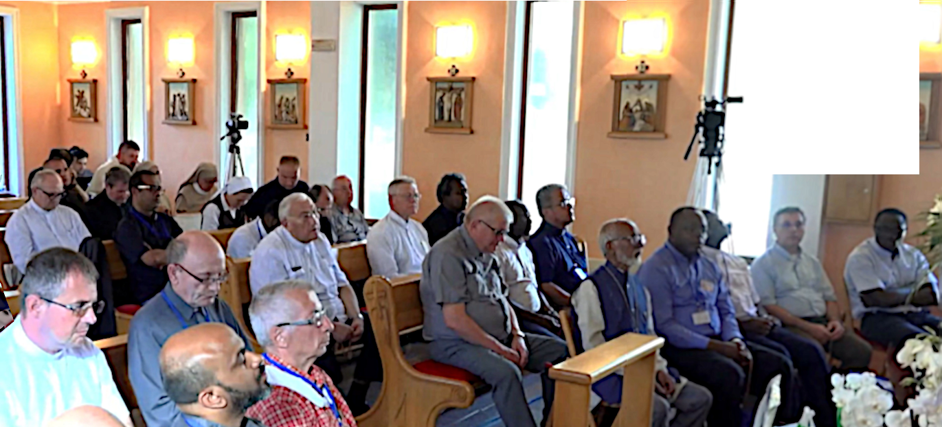
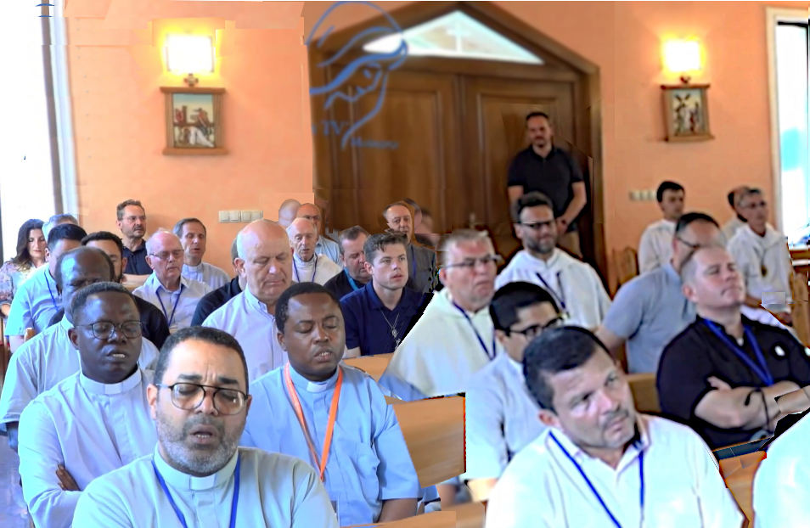

June 26th 2025
https://video.marytv.tv/watch/m7rIUFsaZJ1
Our Lady’s Apparition to Ivan Dragičević
From Ivan’s speech after the apparition:
‘Always when there are priests present at the apparition, there is indeed a great joy, when She comes, on Her face, smile, joy.
Therefore She always greets Her priests with words: ”Dear beloved children of mine!” […]
She raises Her gaze upon us all, I repeat, in great joy,
She extends Her hands and in Her Aramaic language She prays over all of us. She especially prays also for the parishes you come from.’

June 26th 2025
https://video.marytv.tv/watch/m7rIUFsaZJ1
Our Lady’s Apparition to Ivan Dragičević
From Ivan’s speech after the apparition:
‘Always when there are priests present at the apparition, there is indeed a great joy, when She comes, on Her face, smile, joy.
Therefore She always greets Her priests with words: ”Dear beloved children of mine!” […]
She raises Her gaze upon us all, I repeat, in great joy,
She extends Her hands and in Her Aramaic language She prays over all of us. She especially prays also for the parishes you come from.’

June 26th 2025
https://video.marytv.tv/watch/m7rIUFsaZJ1
Our Lady’s Apparition to Ivan Dragičević
From Ivan’s speech after the apparition:
‘Always when there are priests present at the apparition, there is indeed a great joy, when She comes, on Her face, smile, joy.
Therefore She always greets Her priests with words: ”Dear beloved children of mine!” […]
She raises Her gaze upon us all, I repeat, in great joy,
She extends Her hands and in Her Aramaic language She prays over all of us. She especially prays also for the parishes you come from.’

June 26th 2025
https://video.marytv.tv/watch/m7rIUFsaZJ1
Our Lady’s Apparition to Ivan Dragičević
From Ivan’s speech after the apparition:
‘Always when there are priests present at the apparition, there is indeed a great joy, when She comes, on Her face, smile, joy.
Therefore She always greets Her priests with words: ”Dear beloved children of mine!” […]
She raises Her gaze upon us all, I repeat, in great joy,
She extends Her hands and in Her Aramaic language She prays over all of us. She especially prays also for the parishes you come from.’

June 26th 2025
https://video.marytv.tv/watch/m7rIUFsaZJ1
Our Lady’s Apparition to Ivan Dragičević
From Ivan’s speech after the apparition:
‘Always when there are priests present at the apparition, there is indeed a great joy, when She comes, on Her face, smile, joy.
Therefore She always greets Her priests with words: ”Dear beloved children of mine!” […]
She raises Her gaze upon us all, I repeat, in great joy,
She extends Her hands and in Her Aramaic language She prays over all of us. She especially prays also for the parishes you come from.’

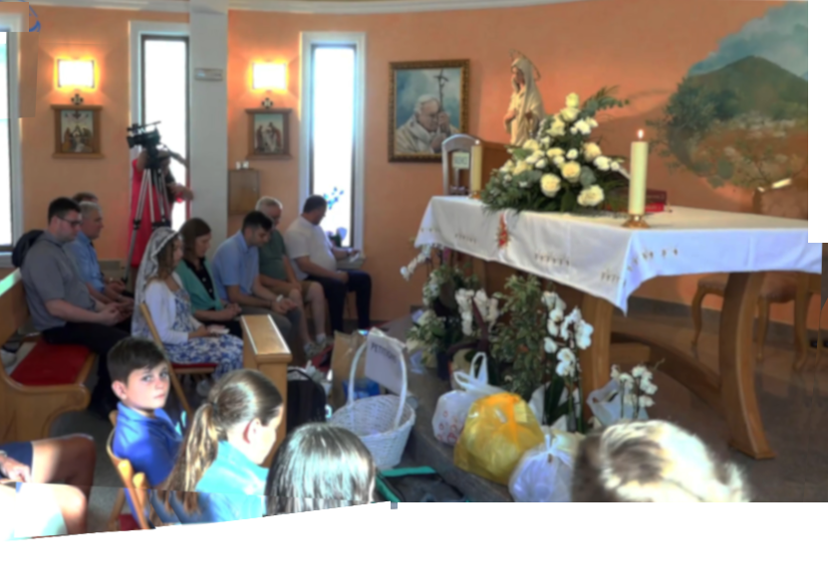
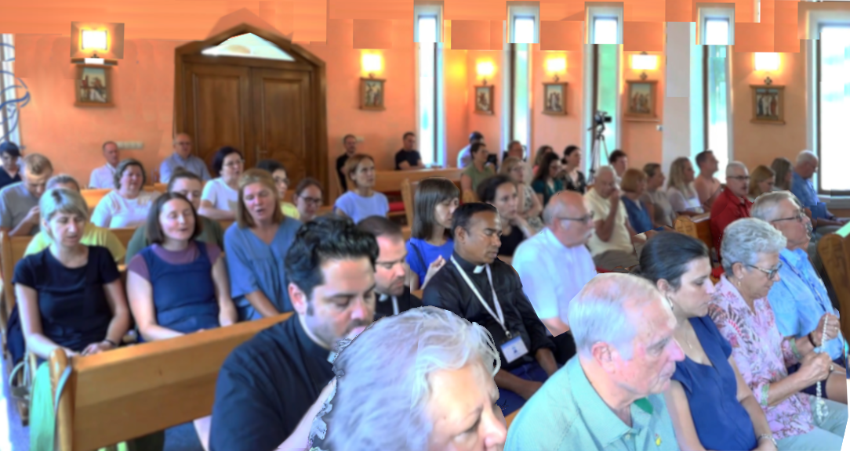

July 5th 2025
https://video.marytv.tv/watch/mlUSHasaPhQ
Our Lady’s Apparition to Ivan Dragičević
From Ivan’s speech after the apparition:
‘Wha I always want to repeat on every meeting and here before you, is the love wich which Our Lady loves us and with that love guides us.
Our Lady was today so joyous also for the children who prayed the Rosary, She looked at them today in such special way during the encounter.

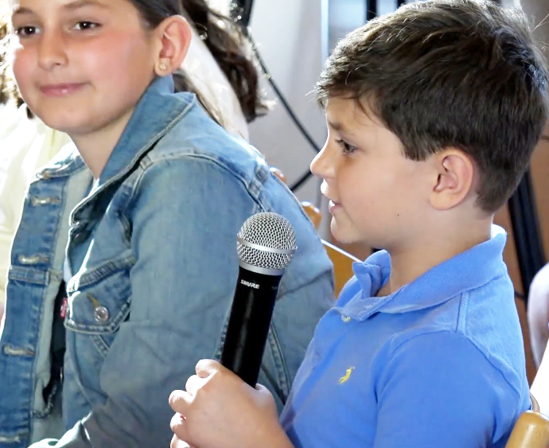
Especially She prays here over you priests present and She prays for those parishes where you come from. Then Our Lady in particular prays for some time for the gift of forgiveness, gift of forgiveness in the family. Therefore She invites us to pray on that intention.

July 5th 2025
https://video.marytv.tv/watch/mlUSHasaPhQ
Our Lady’s Apparition to Ivan Dragičević
Our Lady was today so joyous also for the children who prayed the Rosary, She looked at them today in such special way during the encounter.
From Ivan’s speech after the apparition:
‘Wha I always want to repeat on every meeting and here before you, is the love wich which Our Lady loves us and with that love guides us.

Especially She prays here over you priests present and She prays for those parishes where you come from. Then Our Lady in particular prays for some time for the gift of forgiveness, gift of forgiveness in the family. Therefore She invites us to pray on that intention.

July 5th 2025
https://video.marytv.tv/watch/mlUSHasaPhQ
Our Lady’s Apparition to Ivan Dragičević
From Ivan’s speech after the apparition:
‘Wha I always want to repeat on every meeting and here before you, is the love wich which Our Lady loves us and with that love guides us.
Our Lady was today so joyous also for the children who prayed the Rosary, She looked at them today in such special way during the encounter.

Especially She prays here over you priests present and She prays for those parishes where you come from. Then Our Lady in particular prays for some time for the gift of forgiveness, gift of forgiveness in the family. Therefore She invites us to pray on that intention.

July 5th 2025
https://video.marytv.tv/watch/mlUSHasaPhQ
Our Lady’s Apparition to Ivan Dragičević
From Ivan’s speech after the apparition:
‘Wha I always want to repeat on every meeting and here before you, is the love wich which Our Lady loves us and with that love guides us.
Our Lady was today so joyous also for the children who prayed the Rosary, She looked at them today in such special way during the encounter.

Especially She prays here over you priests present and She prays for those parishes where you come from. Then Our Lady in particular prays for some time for the gift of forgiveness, gift of forgiveness in the family. Therefore She invites us to pray on that intention.

July 5th 2025
https://video.marytv.tv/watch/mlUSHasaPhQ
Our Lady’s Apparition to Ivan Dragičević
From Ivan’s speech after the apparition:
‘Wha I always want to repeat on every meeting and here before you, is the love wich which Our Lady loves us and with that love guides us.
Our Lady was today so joyous also for the children who prayed the Rosary, She looked at them today in such special way during the encounter.

Especially She prays here over you priests present and She prays for those parishes where you come from. Then Our Lady in particular prays for some time for the gift of forgiveness, gift of forgiveness in the family. Therefore She invites us to pray on that intention.

