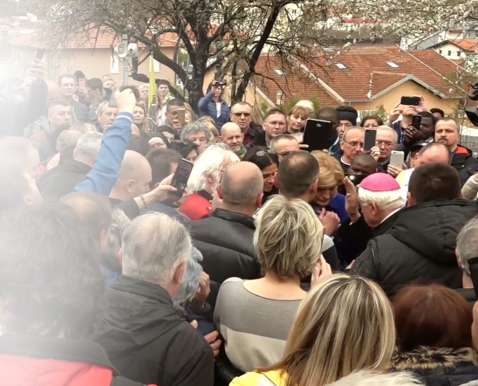
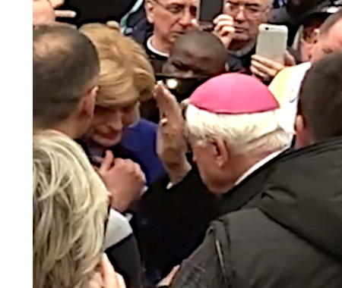
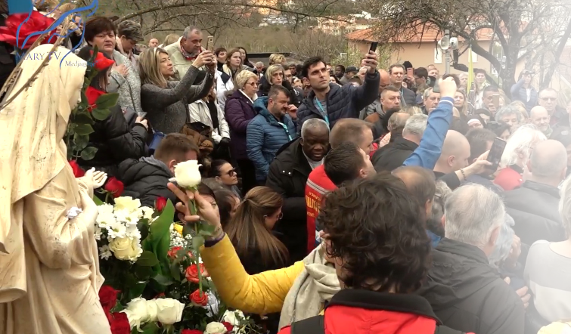
Međugorje
English
Our Lady’s
Messages through
Mirjana Dragičević
of year 2019
and later

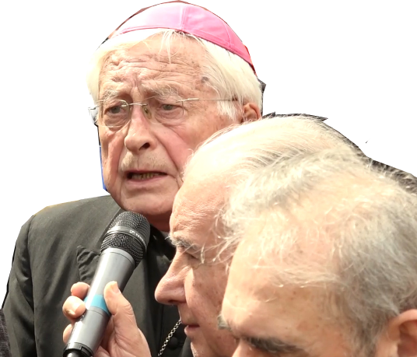

“My words are neither old nor new, they are eternal.”

(from the message of the Queen of Peace
through Mirjana on May 2nd 2016)

Međugorje
English
Our Lady’s
Messages through
Mirjana Dragičević
of year 2019
and later

“My words are neither old nor new, they are eternal.”

(from the message of the Queen of Peace
through Mirjana on May 2nd 2016)

Međugorje
English
Our Lady’s
Messages through
Mirjana Dragičević
of year 2019
and later

“My words are neither old nor new, they are eternal.”

(from the message of the Queen of Peace
through Mirjana on May 2nd 2016)

Međugorje
English
Our Lady’s
Messages through
Mirjana Dragičević
of year 2019
and later

“My words are neither old nor new, they are eternal.”

(from the message of the Queen of Peace
through Mirjana on May 2nd 2016)

Međugorje
English
Our Lady’s
Messages through
Mirjana Dragičević
of year 2019
and later

“My words are neither old nor new, they are eternal.”

(from the message of the Queen of Peace
through Mirjana on May 2nd 2016)

Notes to the Printed Versions of Messages in this Booklet

The basis for English versions of messages in this booklet are the messages in Croatian as read by the (friar), which must have precedence over modified versions e.g. for reasons of style or redactor’s (own, turned official) spelling inclinations, which can be found in various archives, because it is, except in rare cases of mistakes, by all accounts very likely the closest to truly pronounced words by the Most Holy Virgin.
The English versions in this booklet are a best effort translation of the mentioned original versions in Croatian especially where video-documented first reading of the message is available, but also some modifications are made to other translations.
Please look at this translator’s attempt as suggestions on each of the messages, if you are unable to use it to study what The Most Holy Virgin said. This translator’s understanding of Croatian is proficient as any other Croatian intellectual’s, and he holds Cambridge Certificate of Proficiency in English since 1996.
https://www.medjugorje.ws/en/messages/
This is the most important history that is breaking all these years. Neither wars or disasters, nor elections of governments or presidents of countries, without diminishing their historic essence, are more important historic events than messages and apparitions of the Mother of God.
MaryTV’s archive, who film all apparitions they can, is truly precious for verification and comparison of sometimes differing versions of Our Lady’s messages in archives available on the Internet.
You can hear all the messages from 2019 and three from 2020 right after Mirjana dictated them to a (friar) who wrote the first version and read it loud in Croatian first, then (usually) in English, by opening the video which you get by scanning the QR-code for every single message (if you’re not censored, you’ll get exactly the address near the QR-code; those have been multiple-checked, errors are very rare).
You can select here some other of more than 30 languages in which they were translated, and you find the messages by years in the menu on the left; these messages are under year 2019. and later

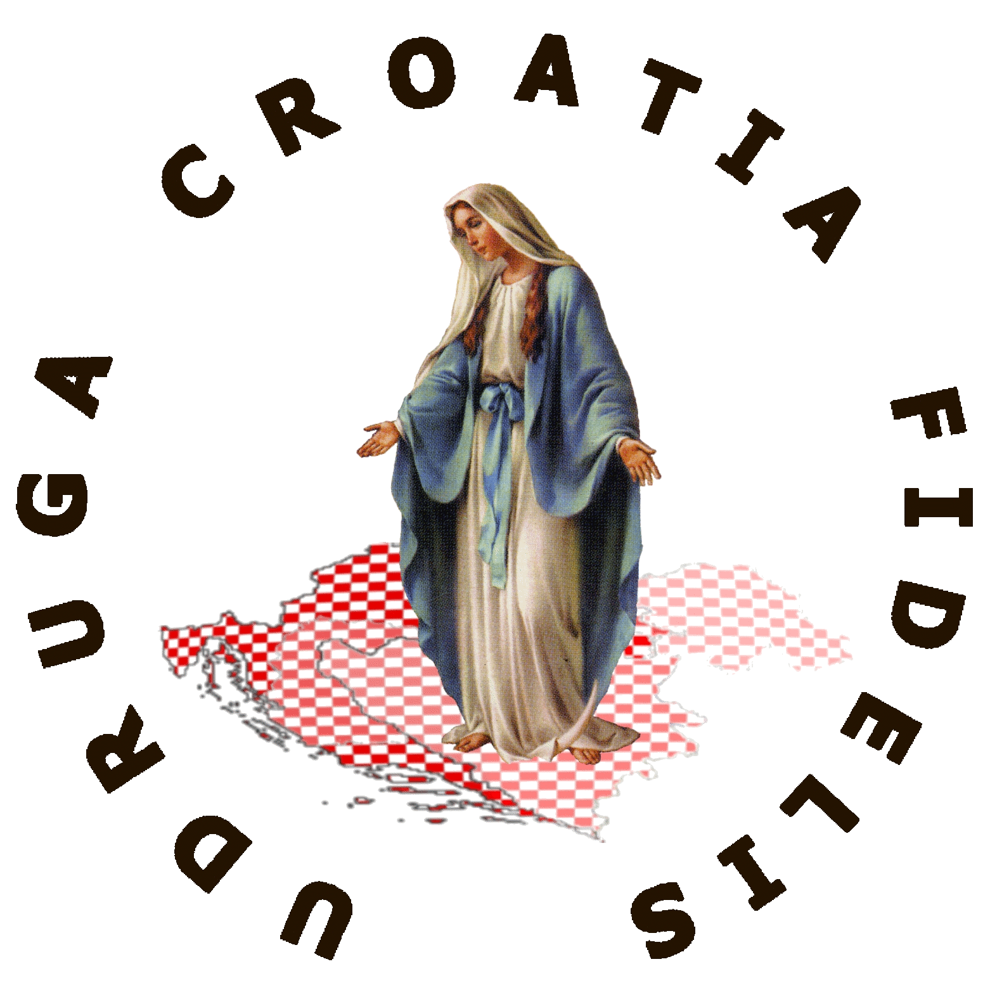
Compare for yourself (the differences are not always numerous). There are other locations but they, in this compiler’s Internet searches, did not have well and systematically archived all of Our Lady’s messages from this period.
not
for sale


However, no daily use in speech, and insufficiently in listening and writing, in years, has made his English less proficient. Open to discussion on any of the versions in this booklet, he will gladly receive suggestions for improvements if you can get past the censorship. Contacts →
Version 2025-11-11, minimally improved from 2025-09-26 initial, for lack of time, Zagreb, Croatia.
Association Croatia Fidelis contact: Miroslav Rovis, miro.rovis@croatiafidelis.hr,
miroslav.rovis@proton.me,
+385 1 6602633 +385 91 2660202
For all the Mary TV’s videos of apparitions to Mirjana scan the QR-code
to visit the link:
https://video.marytv.tv/series/iHLYyISwsmJ
Notes to the Printed Versions of Messages in this Booklet
https://www.medjugorje.ws/en/messages/
This is the most important history that is breaking all these years. Neither wars or disasters, nor elections of governments or presidents of countries, without diminishing their historic essence, are more important historic events than messages and apparitions of the Mother of God.
MaryTV’s archive, who film all apparitions they can, is truly precious for verification and comparison of sometimes differing versions of Our Lady’s messages in archives available on the Internet.
You can hear all the messages from 2019 and three from 2020 right after Mirjana dictated them to a (friar) who wrote the first version and read it loud in Croatian first, then (usually) in English, by opening the video which you get by scanning the QR-code for every single message (if you’re not censored, you’ll get exactly the address near the QR-code; those have been multiple-checked, errors are very rare).
The basis for English versions of messages in this booklet are the messages in Croatian as read by the (friar), which must have precedence over modified versions e.g. for reasons of style or redactor’s (own, turned official) spelling inclinations, which can be found in various archives, because it is, except in rare cases of mistakes, by all accounts very likely the closest to truly pronounced words by the Most Holy Virgin.
The English versions in this booklet are a best effort translation of the mentioned original versions in Croatian especially where video-documented first reading of the message is available, but also some modifications are made to other translations.
Please look at this translator’s attempt as suggestions on each of the messages, if you are unable to use it to study what The Most Holy Virgin said. This translator’s understanding of Croatian is proficient as any other Croatian intellectual’s, and he holds Cambridge Certificate of Proficiency in English since 1996.
You can select here some other of more than 30 languages in which they were translated, and you find the messages by years in the menu on the left; these messages are under year 2019. and later

Compare for yourself (the differences are not always numerous). There are other locations but they, in this compiler’s Internet searches, did not have well and systematically archived all of Our Lady’s messages from this period.
not
for sale

However, no daily use in speech, and insufficiently in listening and writing, in years, has made his English less proficient. Open to discussion on any of the versions in this booklet, he will gladly receive suggestions for improvements if you can get past the censorship. Contacts →
Version 2025-11-11, minimally improved from 2025-09-26 initial, for lack of time, Zagreb, Croatia.
Association Croatia Fidelis contact: Miroslav Rovis, miro.rovis@croatiafidelis.hr,
miroslav.rovis@proton.me,
+385 1 6602633 +385 91 2660202
For all the Mary TV’s videos of apparitions to Mirjana scan the QR-code
to visit the link:
https://video.marytv.tv/series/iHLYyISwsmJ
Notes to the Printed Versions of Messages in this Booklet
https://www.medjugorje.ws/en/messages/
This is the most important history that is breaking all these years. Neither wars or disasters, nor elections of governments or presidents of countries, without diminishing their historic essence, are more important historic events than messages and apparitions of the Mother of God.
MaryTV’s archive, who film all apparitions they can, is truly precious for verification and comparison of sometimes differing versions of Our Lady’s messages in archives available on the Internet.
You can hear all the messages from 2019 and three from 2020 right after Mirjana dictated them to a (friar) who wrote the first version and read it loud in Croatian first, then (usually) in English, by opening the video which you get by scanning the QR-code for every single message (if you’re not censored, you’ll get exactly the address near the QR-code; those have been multiple-checked, errors are very rare).
The basis for English versions of messages in this booklet are the messages in Croatian as read by the (friar), which must have precedence over modified versions e.g. for reasons of style or redactor’s (own, turned official) spelling inclinations, which can be found in various archives, because it is, except in rare cases of mistakes, by all accounts very likely the closest to truly pronounced words by the Most Holy Virgin.
The English versions in this booklet are a best effort translation of the mentioned original versions in Croatian especially where video-documented first reading of the message is available, but also some modifications are made to other translations.
Please look at this translator’s attempt as suggestions on each of the messages, if you are unable to use it to study what The Most Holy Virgin said. This translator’s understanding of Croatian is proficient as any other Croatian intellectual’s, and he holds Cambridge Certificate of Proficiency in English since 1996.
You can select here some other of more than 30 languages in which they were translated, and you find the messages by years in the menu on the left; these messages are under year 2019. and later

Compare for yourself (the differences are not always numerous). There are other locations but they, in this compiler’s Internet searches, did not have well and systematically archived all of Our Lady’s messages from this period.
not
for sale

However, no daily use in speech, and insufficiently in listening and writing, in years, has made his English less proficient. Open to discussion on any of the versions in this booklet, he will gladly receive suggestions for improvements if you can get past the censorship. Contacts →
Version 2025-11-11, minimally improved from 2025-09-26 initial, for lack of time, Zagreb, Croatia.
Association Croatia Fidelis contact: Miroslav Rovis, miro.rovis@croatiafidelis.hr,
miroslav.rovis@proton.me,
+385 1 6602633 +385 91 2660202
For all the Mary TV’s videos of apparitions to Mirjana scan the QR-code
to visit the link:
https://video.marytv.tv/series/iHLYyISwsmJ
Notes to the Printed Versions of Messages in this Booklet
https://www.medjugorje.ws/en/messages/
This is the most important history that is breaking all these years. Neither wars or disasters, nor elections of governments or presidents of countries, without diminishing their historic essence, are more important historic events than messages and apparitions of the Mother of God.
MaryTV’s archive, who film all apparitions they can, is truly precious for verification and comparison of sometimes differing versions of Our Lady’s messages in archives available on the Internet.
You can hear all the messages from 2019 and three from 2020 right after Mirjana dictated them to a (friar) who wrote the first version and read it loud in Croatian first, then (usually) in English, by opening the video which you get by scanning the QR-code for every single message (if you’re not censored, you’ll get exactly the address near the QR-code; those have been multiple-checked, errors are very rare).
The basis for English versions of messages in this booklet are the messages in Croatian as read by the (friar), which must have precedence over modified versions e.g. for reasons of style or redactor’s (own, turned official) spelling inclinations, which can be found in various archives, because it is, except in rare cases of mistakes, by all accounts very likely the closest to truly pronounced words by the Most Holy Virgin.
The English versions in this booklet are a best effort translation of the mentioned original versions in Croatian especially where video-documented first reading of the message is available, but also some modifications are made to other translations.
Please look at this translator’s attempt as suggestions on each of the messages, if you are unable to use it to study what The Most Holy Virgin said. This translator’s understanding of Croatian is proficient as any other Croatian intellectual’s, and he holds Cambridge Certificate of Proficiency in English since 1996.
You can select here some other of more than 30 languages in which they were translated, and you find the messages by years in the menu on the left; these messages are under year 2019. and later

Compare for yourself (the differences are not always numerous). There are other locations but they, in this compiler’s Internet searches, did not have well and systematically archived all of Our Lady’s messages from this period.
not
for sale

However, no daily use in speech, and insufficiently in listening and writing, in years, has made his English less proficient. Open to discussion on any of the versions in this booklet, he will gladly receive suggestions for improvements if you can get past the censorship. Contacts →
Version 2025-11-11, minimally improved from 2025-09-26 initial, for lack of time, Zagreb, Croatia.
Association Croatia Fidelis contact: Miroslav Rovis, miro.rovis@croatiafidelis.hr,
miroslav.rovis@proton.me,
+385 1 6602633 +385 91 2660202
For all the Mary TV’s videos of apparitions to Mirjana scan the QR-code
to visit the link:
https://video.marytv.tv/series/iHLYyISwsmJ
Notes to the Printed Versions of Messages in this Booklet
https://www.medjugorje.ws/en/messages/
This is the most important history that is breaking all these years. Neither wars or disasters, nor elections of governments or presidents of countries, without diminishing their historic essence, are more important historic events than messages and apparitions of the Mother of God.
MaryTV’s archive, who film all apparitions they can, is truly precious for verification and comparison of sometimes differing versions of Our Lady’s messages in archives available on the Internet.
You can hear all the messages from 2019 and three from 2020 right after Mirjana dictated them to a (friar) who wrote the first version and read it loud in Croatian first, then (usually) in English, by opening the video which you get by scanning the QR-code for every single message (if you’re not censored, you’ll get exactly the address near the QR-code; those have been multiple-checked, errors are very rare).
The basis for English versions of messages in this booklet are the messages in Croatian as read by the (friar), which must have precedence over modified versions e.g. for reasons of style or redactor’s (own, turned official) spelling inclinations, which can be found in various archives, because it is, except in rare cases of mistakes, by all accounts very likely the closest to truly pronounced words by the Most Holy Virgin.
The English versions in this booklet are a best effort translation of the mentioned original versions in Croatian especially where video-documented first reading of the message is available, but also some modifications are made to other translations.
Please look at this translator’s attempt as suggestions on each of the messages, if you are unable to use it to study what The Most Holy Virgin said. This translator’s understanding of Croatian is proficient as any other Croatian intellectual’s, and he holds Cambridge Certificate of Proficiency in English since 1996.
You can select here some other of more than 30 languages in which they were translated, and you find the messages by years in the menu on the left; these messages are under year 2019. and later

Compare for yourself (the differences are not always numerous). There are other locations but they, in this compiler’s Internet searches, did not have well and systematically archived all of Our Lady’s messages from this period.
not
for sale

However, no daily use in speech, and insufficiently in listening and writing, in years, has made his English less proficient. Open to discussion on any of the versions in this booklet, he will gladly receive suggestions for improvements if you can get past the censorship. Contacts →
Version 2025-11-11, minimally improved from 2025-09-26 initial, for lack of time, Zagreb, Croatia.
Association Croatia Fidelis contact: Miroslav Rovis, miro.rovis@croatiafidelis.hr,
miroslav.rovis@proton.me,
+385 1 6602633 +385 91 2660202
For all the Mary TV’s videos of apparitions to Mirjana scan the QR-code
to visit the link:
https://video.marytv.tv/series/iHLYyISwsmJ
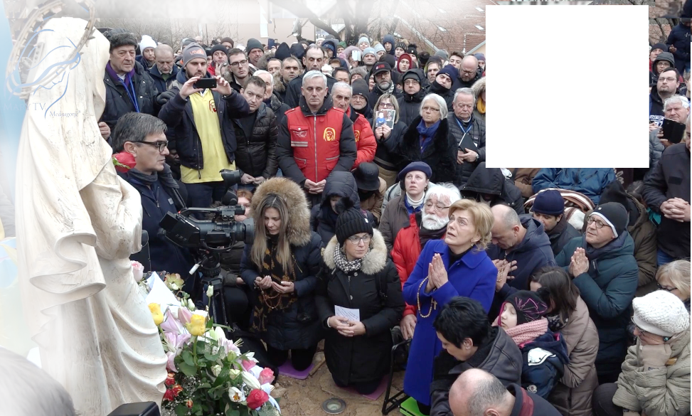

January 2nd 2019
https://video.marytv.tv/watch/9hRNYFsc0bW
“Dear children! Sadly, among you, my children, there is so much battle, hatred, personal interests and selfishness. My children, so easily you forget my Son, His words, His love. Faith is being extinguished in many souls, and hearts are being seized by material things of the world. But my motherly heart knows that there are still those who believe and love, who seek how to draw all the closer to my Son, who tirelessly seek my Son, so then they also seek me. These are the humble and gentle with their pain and suffering which they carry in silence, with their hopes and above all with their faith. These are apostles of my love. My children, apostles of my love, I teach you that my Son does not ask for continuous prayers, but also for acts and feelings, that you believe, that you pray with personal prayers and that you grow in faith, that you grow in love. To love each other, that is what He asks for, that is the way to eternal life. My children, do not forget that my Son brought the light to this world, and He brought it to those who wanted to see it and receive it. You be those, because it is the light of truth, peace and love. I motherly lead you to adore my Son, to love my Son with me, that your thoughts, words and actions be directed to My Son, that they be in His name. Then my heart will be fulfilled. Thank you.”

January 2nd 2019
https://video.marytv.tv/watch/9hRNYFsc0bW
“Dear children! Sadly, among you, my children, there is so much battle, hatred, personal interests and selfishness. My children, so easily you forget my Son, His words, His love. Faith is being extinguished in many souls, and hearts are being seized by material things of the world. But my motherly heart knows that there are still those who believe and love, who seek how to draw all the closer to my Son, who tirelessly seek my Son, so then they also seek me. These are the humble and gentle with their pain and suffering which they carry in silence, with their hopes and above all with their faith. These are apostles of my love. My children, apostles of my love, I teach you that my Son does not ask for continuous prayers, but also for acts and feelings, that you believe, that you pray with personal prayers and that you grow in faith, that you grow in love. To love each other, that is what He asks for, that is the way to eternal life. My children, do not forget that my Son brought the light to this world, and He brought it to those who wanted to see it and receive it. You be those, because it is the light of truth, peace and love. I motherly lead you to adore my Son, to love my Son with me, that your thoughts, words and actions be directed to My Son, that they be in His name. Then my heart will be fulfilled. Thank you.”

January 2nd 2019
https://video.marytv.tv/watch/9hRNYFsc0bW
“Dear children! Sadly, among you, my children, there is so much battle, hatred, personal interests and selfishness. My children, so easily you forget my Son, His words, His love. Faith is being extinguished in many souls, and hearts are being seized by material things of the world. But my motherly heart knows that there are still those who believe and love, who seek how to draw all the closer to my Son, who tirelessly seek my Son, so then they also seek me. These are the humble and gentle with their pain and suffering which they carry in silence, with their hopes and above all with their faith. These are apostles of my love. My children, apostles of my love, I teach you that my Son does not ask for continuous prayers, but also for acts and feelings, that you believe, that you pray with personal prayers and that you grow in faith, that you grow in love. To love each other, that is what He asks for, that is the way to eternal life. My children, do not forget that my Son brought the light to this world, and He brought it to those who wanted to see it and receive it. You be those, because it is the light of truth, peace and love. I motherly lead you to adore my Son, to love my Son with me, that your thoughts, words and actions be directed to My Son, that they be in His name. Then my heart will be fulfilled. Thank you.”

January 2nd 2019
https://video.marytv.tv/watch/9hRNYFsc0bW
“Dear children! Sadly, among you, my children, there is so much battle, hatred, personal interests and selfishness. My children, so easily you forget my Son, His words, His love. Faith is being extinguished in many souls, and hearts are being seized by material things of the world. But my motherly heart knows that there are still those who believe and love, who seek how to draw all the closer to my Son, who tirelessly seek my Son, so then they also seek me. These are the humble and gentle with their pain and suffering which they carry in silence, with their hopes and above all with their faith. These are apostles of my love. My children, apostles of my love, I teach you that my Son does not ask for continuous prayers, but also for acts and feelings, that you believe, that you pray with personal prayers and that you grow in faith, that you grow in love. To love each other, that is what He asks for, that is the way to eternal life. My children, do not forget that my Son brought the light to this world, and He brought it to those who wanted to see it and receive it. You be those, because it is the light of truth, peace and love. I motherly lead you to adore my Son, to love my Son with me, that your thoughts, words and actions be directed to My Son, that they be in His name. Then my heart will be fulfilled. Thank you.”

January 2nd 2019
https://video.marytv.tv/watch/9hRNYFsc0bW
“Dear children! Sadly, among you, my children, there is so much battle, hatred, personal interests and selfishness. My children, so easily you forget my Son, His words, His love. Faith is being extinguished in many souls, and hearts are being seized by material things of the world. But my motherly heart knows that there are still those who believe and love, who seek how to draw all the closer to my Son, who tirelessly seek my Son, so then they also seek me. These are the humble and gentle with their pain and suffering which they carry in silence, with their hopes and above all with their faith. These are apostles of my love. My children, apostles of my love, I teach you that my Son does not ask for continuous prayers, but also for acts and feelings, that you believe, that you pray with personal prayers and that you grow in faith, that you grow in love. To love each other, that is what He asks for, that is the way to eternal life. My children, do not forget that my Son brought the light to this world, and He brought it to those who wanted to see it and receive it. You be those, because it is the light of truth, peace and love. I motherly lead you to adore my Son, to love my Son with me, that your thoughts, words and actions be directed to My Son, that they be in His name. Then my heart will be fulfilled. Thank you.”
R


February 2nd 2019
https://video.marytv.tv/watch/9w2bYSscf4e
“Dear children! The love and goodness of the Heavenly Father give revelations which make faith grow, that interpretations are done, that peace, certainty and hope are brought. In this way, I, too, my children, through the merciful love of the Heavenly Father, always anew show you the way to my Son, to eternal salvation. But, sadly, many of my children do not want to hear me, many of my children hesitate. And I, I have always, in time and above time, magnified the Lord for all that He has done in me and through me. My Son gives Himself to you and breaks the bread with you, He speaks the words of eternal life to you so that you may carry them to everyone. And you, my children, apostles of my love, what are you afraid of when my Son is with you? Show your souls to Him so that He can be in them and that He can make you instruments of faith, instruments of love. My children, live the Gospel, live merciful love for your neighbors, and, above all, live love for the Heavenly Father. My children, you are not united by chance. The Heavenly Father does not unite anyone by chance. My Son speaks to your souls. I speak to your heart. As Mother I say to you, set out with me, love one another, bear witness. Do not be afraid to defend the truth with your example, the Word of God which is eternal and never changes. My children, who acts in the light of merciful love and truth is always helped by Heaven and is not alone. Apostles of my love, may you always be recognized among all others by your hiddenness, love and serenity. I am with you. Thank you.”
Our Lady was sad.
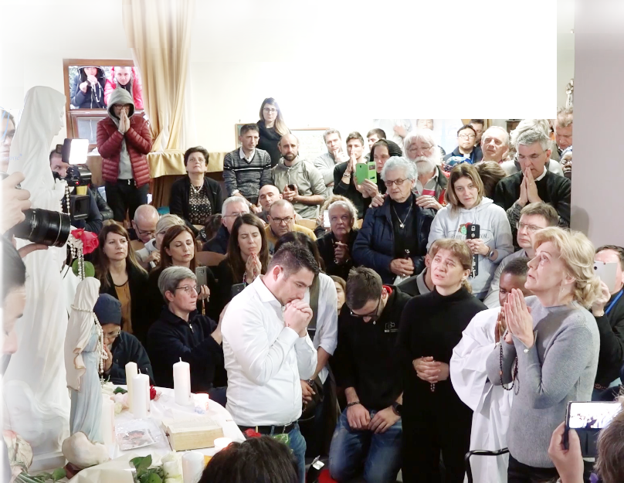

February 2nd 2019
https://video.marytv.tv/watch/9w2bYSscf4e
“Dear children! The love and goodness of the Heavenly Father give revelations which make faith grow, that interpretations are done, that peace, certainty and hope are brought. In this way, I, too, my children, through the merciful love of the Heavenly Father, always anew show you the way to my Son, to eternal salvation. But, sadly, many of my children do not want to hear me, many of my children hesitate. And I, I have always, in time and above time, magnified the Lord for all that He has done in me and through me. My Son gives Himself to you and breaks the bread with you, He speaks the words of eternal life to you so that you may carry them to everyone. And you, my children, apostles of my love, what are you afraid of when my Son is with you? Show your souls to Him so that He can be in them and that He can make you instruments of faith, instruments of love. My children, live the Gospel, live merciful love for your neighbors, and, above all, live love for the Heavenly Father. My children, you are not united by chance. The Heavenly Father does not unite anyone by chance. My Son speaks to your souls. I speak to your heart. As Mother I say to you, set out with me, love one another, bear witness. Do not be afraid to defend the truth with your example, the Word of God which is eternal and never changes. My children, who acts in the light of merciful love and truth is always helped by Heaven and is not alone. Apostles of my love, may you always be recognized among all others by your hiddenness, love and serenity. I am with you. Thank you.”
Our Lady was sad.

February 2nd 2019
https://video.marytv.tv/watch/9w2bYSscf4e
“Dear children! The love and goodness of the Heavenly Father give revelations which make faith grow, that interpretations are done, that peace, certainty and hope are brought. In this way, I, too, my children, through the merciful love of the Heavenly Father, always anew show you the way to my Son, to eternal salvation. But, sadly, many of my children do not want to hear me, many of my children hesitate. And I, I have always, in time and above time, magnified the Lord for all that He has done in me and through me. My Son gives Himself to you and breaks the bread with you, He speaks the words of eternal life to you so that you may carry them to everyone. And you, my children, apostles of my love, what are you afraid of when my Son is with you? Show your souls to Him so that He can be in them and that He can make you instruments of faith, instruments of love. My children, live the Gospel, live merciful love for your neighbors, and, above all, live love for the Heavenly Father. My children, you are not united by chance. The Heavenly Father does not unite anyone by chance. My Son speaks to your souls. I speak to your heart. As Mother I say to you, set out with me, love one another, bear witness. Do not be afraid to defend the truth with your example, the Word of God which is eternal and never changes. My children, who acts in the light of merciful love and truth is always helped by Heaven and is not alone. Apostles of my love, may you always be recognized among all others by your hiddenness, love and serenity. I am with you. Thank you.”
Our Lady was sad.

February 2nd 2019
https://video.marytv.tv/watch/9w2bYSscf4e
“Dear children! The love and goodness of the Heavenly Father give revelations which make faith grow, that interpretations are done, that peace, certainty and hope are brought. In this way, I, too, my children, through the merciful love of the Heavenly Father, always anew show you the way to my Son, to eternal salvation. But, sadly, many of my children do not want to hear me, many of my children hesitate. And I, I have always, in time and above time, magnified the Lord for all that He has done in me and through me. My Son gives Himself to you and breaks the bread with you, He speaks the words of eternal life to you so that you may carry them to everyone. And you, my children, apostles of my love, what are you afraid of when my Son is with you? Show your souls to Him so that He can be in them and that He can make you instruments of faith, instruments of love. My children, live the Gospel, live merciful love for your neighbors, and, above all, live love for the Heavenly Father. My children, you are not united by chance. The Heavenly Father does not unite anyone by chance. My Son speaks to your souls. I speak to your heart. As Mother I say to you, set out with me, love one another, bear witness. Do not be afraid to defend the truth with your example, the Word of God which is eternal and never changes. My children, who acts in the light of merciful love and truth is always helped by Heaven and is not alone. Apostles of my love, may you always be recognized among all others by your hiddenness, love and serenity. I am with you. Thank you.”
Our Lady was sad.

February 2nd 2019
https://video.marytv.tv/watch/9w2bYSscf4e
“Dear children! The love and goodness of the Heavenly Father give revelations which make faith grow, that interpretations are done, that peace, certainty and hope are brought. In this way, I, too, my children, through the merciful love of the Heavenly Father, always anew show you the way to my Son, to eternal salvation. But, sadly, many of my children do not want to hear me, many of my children hesitate. And I, I have always, in time and above time, magnified the Lord for all that He has done in me and through me. My Son gives Himself to you and breaks the bread with you, He speaks the words of eternal life to you so that you may carry them to everyone. And you, my children, apostles of my love, what are you afraid of when my Son is with you? Show your souls to Him so that He can be in them and that He can make you instruments of faith, instruments of love. My children, live the Gospel, live merciful love for your neighbors, and, above all, live love for the Heavenly Father. My children, you are not united by chance. The Heavenly Father does not unite anyone by chance. My Son speaks to your souls. I speak to your heart. As Mother I say to you, set out with me, love one another, bear witness. Do not be afraid to defend the truth with your example, the Word of God which is eternal and never changes. My children, who acts in the light of merciful love and truth is always helped by Heaven and is not alone. Apostles of my love, may you always be recognized among all others by your hiddenness, love and serenity. I am with you. Thank you.”
Our Lady was sad.
r
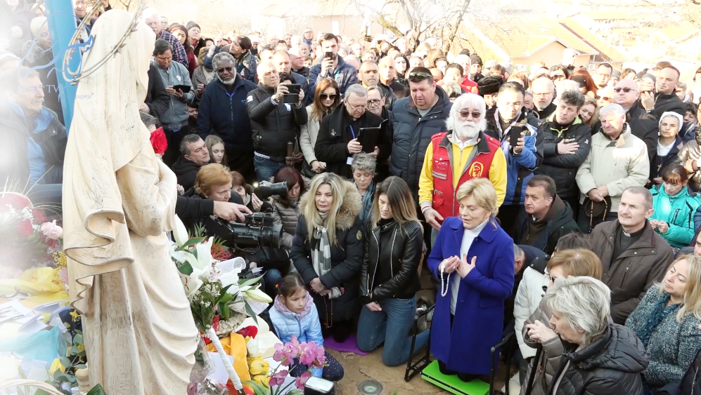

March 2nd 2019
https://video.marytv.tv/watch/95vKS7scWGS
“Dear children, I call you apostles of my love. I am showing you my Son who is the true peace and the true love. As Mother, through the grace of God, I desire to lead you to Him. My children, this is why I call you to reflect on yourselves, starting out from my Son, that you look at Him with the heart and that you see with the heart where you are and where your life is going. My children, I call you to comprehend that it is thanks to my Son that you live, through His love and sacrifice. You ask of my Son to be merciful to you and I call you to mercy. You ask of Him to be good to you and to forgive you, and for how long have I been imploring you, my children, to forgive and to love all the people you meet? When you comprehend my words with the heart, you will comprehend and come to know the true love and you will be able to be apostles of that love, my apostles, my dear children. Thank you.”
Our Lady was very sad.

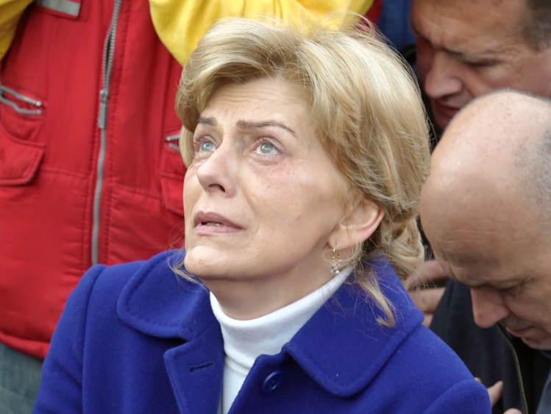

March 2nd 2019
https://video.marytv.tv/watch/95vKS7scWGS
“Dear children, I call you apostles of my love. I am showing you my Son who is the true peace and the true love. As Mother, through the grace of God, I desire to lead you to Him. My children, this is why I call you to reflect on yourselves, starting out from my Son, that you look at Him with the heart and that you see with the heart where you are and where your life is going. My children, I call you to comprehend that it is thanks to my Son that you live, through His love and sacrifice. You ask of my Son to be merciful to you and I call you to mercy. You ask of Him to be good to you and to forgive you, and for how long have I been imploring you, my children, to forgive and to love all the people you meet? When you comprehend my words with the heart, you will comprehend and come to know the true love and you will be able to be apostles of that love, my apostles, my dear children. Thank you.”
Our Lady was very sad.

March 2nd 2019
https://video.marytv.tv/watch/95vKS7scWGS
“Dear children, I call you apostles of my love. I am showing you my Son who is the true peace and the true love. As Mother, through the grace of God, I desire to lead you to Him. My children, this is why I call you to reflect on yourselves, starting out from my Son, that you look at Him with the heart and that you see with the heart where you are and where your life is going. My children, I call you to comprehend that it is thanks to my Son that you live, through His love and sacrifice. You ask of my Son to be merciful to you and I call you to mercy. You ask of Him to be good to you and to forgive you, and for how long have I been imploring you, my children, to forgive and to love all the people you meet? When you comprehend my words with the heart, you will comprehend and come to know the true love and you will be able to be apostles of that love, my apostles, my dear children. Thank you.”
Our Lady was very sad.

March 2nd 2019
https://video.marytv.tv/watch/95vKS7scWGS
“Dear children, I call you apostles of my love. I am showing you my Son who is the true peace and the true love. As Mother, through the grace of God, I desire to lead you to Him. My children, this is why I call you to reflect on yourselves, starting out from my Son, that you look at Him with the heart and that you see with the heart where you are and where your life is going. My children, I call you to comprehend that it is thanks to my Son that you live, through His love and sacrifice. You ask of my Son to be merciful to you and I call you to mercy. You ask of Him to be good to you and to forgive you, and for how long have I been imploring you, my children, to forgive and to love all the people you meet? When you comprehend my words with the heart, you will comprehend and come to know the true love and you will be able to be apostles of that love, my apostles, my dear children. Thank you.”
Our Lady was very sad.

March 2nd 2019
https://video.marytv.tv/watch/95vKS7scWGS
“Dear children, I call you apostles of my love. I am showing you my Son who is the true peace and the true love. As Mother, through the grace of God, I desire to lead you to Him. My children, this is why I call you to reflect on yourselves, starting out from my Son, that you look at Him with the heart and that you see with the heart where you are and where your life is going. My children, I call you to comprehend that it is thanks to my Son that you live, through His love and sacrifice. You ask of my Son to be merciful to you and I call you to mercy. You ask of Him to be good to you and to forgive you, and for how long have I been imploring you, my children, to forgive and to love all the people you meet? When you comprehend my words with the heart, you will comprehend and come to know the true love and you will be able to be apostles of that love, my apostles, my dear children. Thank you.”
Our Lady was very sad.
r
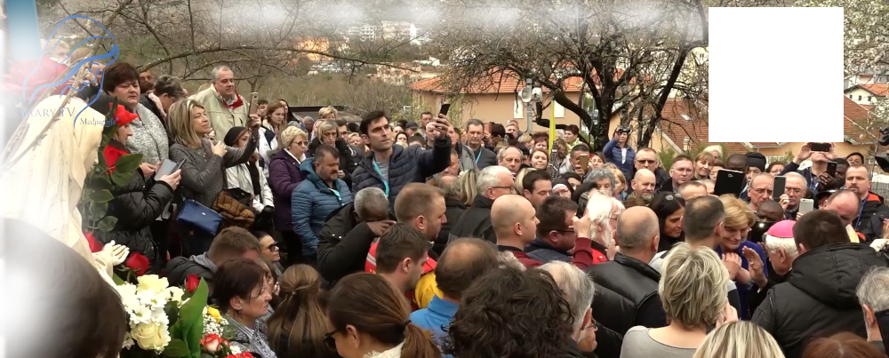

March 18th 2019
https://video.marytv.tv/watch/KOkRUVscThe
“My children, As Mother, as the Queen of Peace, I am call you to accept my Son so that He can grant you peace of soul, that He can grant you that which is just, which is good for you. My children, my Son knows you. He lived the life of man, and at the same time of God, a wondrous life, human flesh, Divine spirit. Therefore, my children, while my Son is looking at you with His eyes of God, He penetrates into your hearts. His tender, warm eyes are looking for Himself in your heart. Can He find Himself [in your heart], my children? Receive Him, and then the moments of pain and suffering will become moments of tenderness. Receive Him, and you will have peace in the soul, you will spread peace to everyone around you, and this is what you now need the most. Heed me, my children. Pray for the shepherds, for those whose hands my Son has blessed. Thank you.”

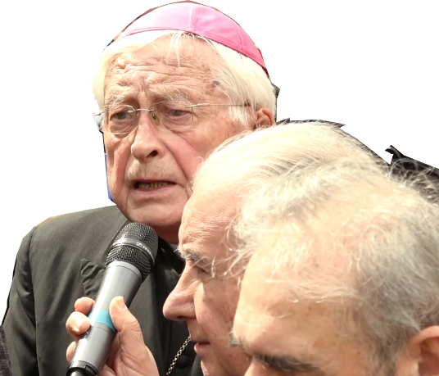

March 18th 2019
https://video.marytv.tv/watch/KOkRUVscThe
“My children, As Mother, as the Queen of Peace, I am call you to accept my Son so that He can grant you peace of soul, that He can grant you that which is just, which is good for you. My children, my Son knows you. He lived the life of man, and at the same time of God, a wondrous life, human flesh, Divine spirit. Therefore, my children, while my Son is looking at you with His eyes of God, He penetrates into your hearts. His tender, warm eyes are looking for Himself in your heart. Can He find Himself [in your heart], my children? Receive Him, and then the moments of pain and suffering will become moments of tenderness. Receive Him, and you will have peace in the soul, you will spread peace to everyone around you, and this is what you now need the most. Heed me, my children. Pray for the shepherds, for those whose hands my Son has blessed. Thank you.”

March 18th 2019
https://video.marytv.tv/watch/KOkRUVscThe
“My children, As Mother, as the Queen of Peace, I am call you to accept my Son so that He can grant you peace of soul, that He can grant you that which is just, which is good for you. My children, my Son knows you. He lived the life of man, and at the same time of God, a wondrous life, human flesh, Divine spirit. Therefore, my children, while my Son is looking at you with His eyes of God, He penetrates into your hearts. His tender, warm eyes are looking for Himself in your heart. Can He find Himself [in your heart], my children? Receive Him, and then the moments of pain and suffering will become moments of tenderness. Receive Him, and you will have peace in the soul, you will spread peace to everyone around you, and this is what you now need the most. Heed me, my children. Pray for the shepherds, for those whose hands my Son has blessed. Thank you.”

March 18th 2019
https://video.marytv.tv/watch/KOkRUVscThe
“My children, As Mother, as the Queen of Peace, I am call you to accept my Son so that He can grant you peace of soul, that He can grant you that which is just, which is good for you. My children, my Son knows you. He lived the life of man, and at the same time of God, a wondrous life, human flesh, Divine spirit. Therefore, my children, while my Son is looking at you with His eyes of God, He penetrates into your hearts. His tender, warm eyes are looking for Himself in your heart. Can He find Himself [in your heart], my children? Receive Him, and then the moments of pain and suffering will become moments of tenderness. Receive Him, and you will have peace in the soul, you will spread peace to everyone around you, and this is what you now need the most. Heed me, my children. Pray for the shepherds, for those whose hands my Son has blessed. Thank you.”

March 18th 2019
https://video.marytv.tv/watch/KOkRUVscThe
“My children, As Mother, as the Queen of Peace, I am call you to accept my Son so that He can grant you peace of soul, that He can grant you that which is just, which is good for you. My children, my Son knows you. He lived the life of man, and at the same time of God, a wondrous life, human flesh, Divine spirit. Therefore, my children, while my Son is looking at you with His eyes of God, He penetrates into your hearts. His tender, warm eyes are looking for Himself in your heart. Can He find Himself [in your heart], my children? Receive Him, and then the moments of pain and suffering will become moments of tenderness. Receive Him, and you will have peace in the soul, you will spread peace to everyone around you, and this is what you now need the most. Heed me, my children. Pray for the shepherds, for those whose hands my Son has blessed. Thank you.”
r
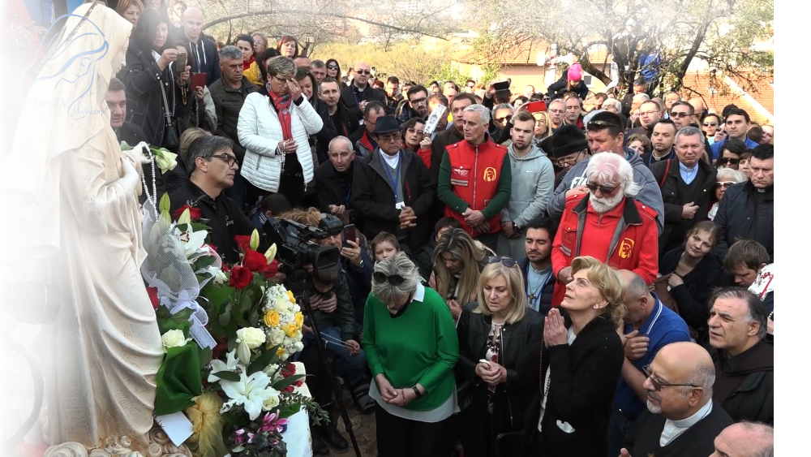

April 2nd 2019

https://video.marytv.tv/watch/KopzxIsch17
“Dear children, as Mother who knows her children, I know that you are crying for my Son. I know that you are crying for truth, for peace, for that which is pure and not deceptive. That is why I, as Mother, by the love of God, address you and call you to, praying with pure and open heart, by yourselves, come to know my Son, His love, His merciful Heart. My Son saw beauty in all things. He seeks good in all souls, even that small and hidden, to forgive evil. Therefore, my children, apostles of my love, I call you to adore Him, to incessantly give Him thanks, and to be worthy. Because He has spoken to you divine words, the words of God, the words which are for everyone and for ever. Therefore, my children, live joy, serenity, unity and mutual love. This is what you need in today's world. In this way you will be apostles of my love. In this way you will witness my Son in the right manner. Thank you.”
Our Lady was decisive.

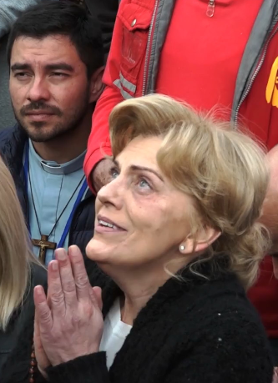

April 2nd 2019

https://video.marytv.tv/watch/KopzxIsch17
“Dear children, as Mother who knows her children, I know that you are crying for my Son. I know that you are crying for truth, for peace, for that which is pure and not deceptive. That is why I, as Mother, by the love of God, address you and call you to, praying with pure and open heart, by yourselves, come to know my Son, His love, His merciful Heart. My Son saw beauty in all things. He seeks good in all souls, even that small and hidden, to forgive evil. Therefore, my children, apostles of my love, I call you to adore Him, to incessantly give Him thanks, and to be worthy. Because He has spoken to you divine words, the words of God, the words which are for everyone and for ever. Therefore, my children, live joy, serenity, unity and mutual love. This is what you need in today's world. In this way you will be apostles of my love. In this way you will witness my Son in the right manner. Thank you.”
Our Lady was decisive.

April 2nd 2019

https://video.marytv.tv/watch/KopzxIsch17
“Dear children, as Mother who knows her children, I know that you are crying for my Son. I know that you are crying for truth, for peace, for that which is pure and not deceptive. That is why I, as Mother, by the love of God, address you and call you to, praying with pure and open heart, by yourselves, come to know my Son, His love, His merciful Heart. My Son saw beauty in all things. He seeks good in all souls, even that small and hidden, to forgive evil. Therefore, my children, apostles of my love, I call you to adore Him, to incessantly give Him thanks, and to be worthy. Because He has spoken to you divine words, the words of God, the words which are for everyone and for ever. Therefore, my children, live joy, serenity, unity and mutual love. This is what you need in today's world. In this way you will be apostles of my love. In this way you will witness my Son in the right manner. Thank you.”
Our Lady was decisive.

April 2nd 2019

https://video.marytv.tv/watch/KopzxIsch17
“Dear children, as Mother who knows her children, I know that you are crying for my Son. I know that you are crying for truth, for peace, for that which is pure and not deceptive. That is why I, as Mother, by the love of God, address you and call you to, praying with pure and open heart, by yourselves, come to know my Son, His love, His merciful Heart. My Son saw beauty in all things. He seeks good in all souls, even that small and hidden, to forgive evil. Therefore, my children, apostles of my love, I call you to adore Him, to incessantly give Him thanks, and to be worthy. Because He has spoken to you divine words, the words of God, the words which are for everyone and for ever. Therefore, my children, live joy, serenity, unity and mutual love. This is what you need in today's world. In this way you will be apostles of my love. In this way you will witness my Son in the right manner. Thank you.”
Our Lady was decisive.

April 2nd 2019

https://video.marytv.tv/watch/KopzxIsch17
“Dear children, as Mother who knows her children, I know that you are crying for my Son. I know that you are crying for truth, for peace, for that which is pure and not deceptive. That is why I, as Mother, by the love of God, address you and call you to, praying with pure and open heart, by yourselves, come to know my Son, His love, His merciful Heart. My Son saw beauty in all things. He seeks good in all souls, even that small and hidden, to forgive evil. Therefore, my children, apostles of my love, I call you to adore Him, to incessantly give Him thanks, and to be worthy. Because He has spoken to you divine words, the words of God, the words which are for everyone and for ever. Therefore, my children, live joy, serenity, unity and mutual love. This is what you need in today's world. In this way you will be apostles of my love. In this way you will witness my Son in the right manner. Thank you.”
Our Lady was decisive.
r
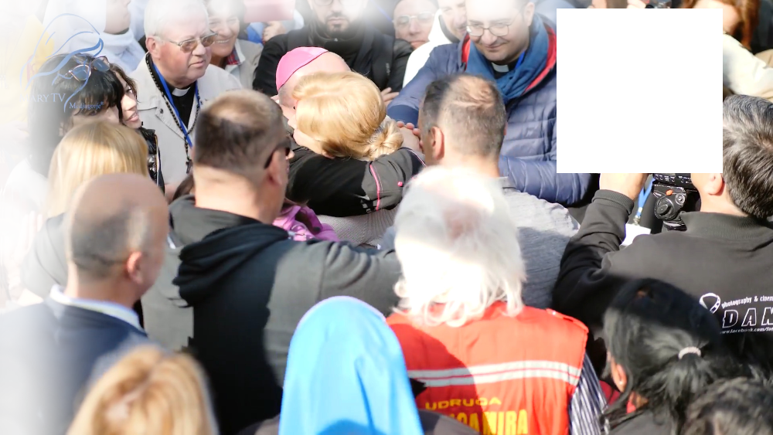

May 2nd 2019

https://video.marytv.tv/watch/KkNQ3YscD4O
“Dear children, with motherly love I call you to, with pure and open heart, with complete trust, respond to the great love of my Son. I know the greatness of His love. I carried Him within me, Host in the heart, light and love of the world. My children, also my addressing you is a sign of love and tenderness of the Heavenly Father, a big smile filled with the love of my Son, a call to eternal life. The Blood of my Son was shed out of love for you. That Precious Blood is for your salvation, for eternal life. The Heavenly Father created man for eternal happiness. It is not possible that you die, you who know the love of my Son, who follow Him. Life has triumphed, my Son is alive. Therefore, my children, apostles of my love, let prayer show you the way, the manner of spreading the love of my Son in the most exalted form. My children, also when you strive to live the words of my Son, you pray. When you love people who you meet, you are spreading the love of my Son. It is love that opens the door of Paradise. My children, from the beginning I prayed for the Church. Therefore, I also call you, apostles of my love, to pray for the Church and her servants, for those whom my Son called. Thank you.”

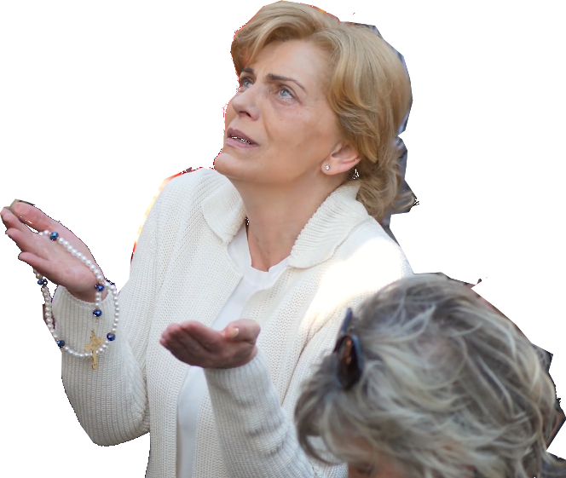
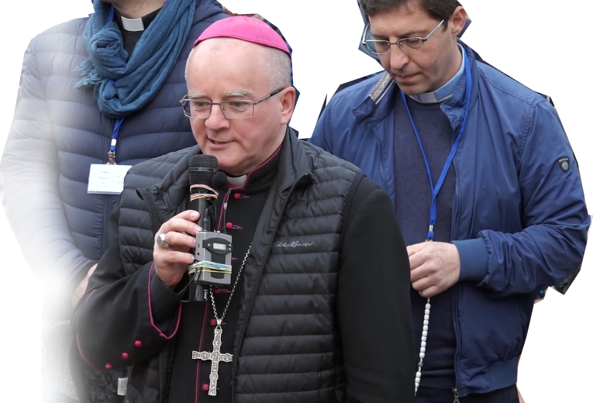

May 2nd 2019

https://video.marytv.tv/watch/KkNQ3YscD4O
“Dear children, with motherly love I call you to, with pure and open heart, with complete trust, respond to the great love of my Son. I know the greatness of His love. I carried Him within me, Host in the heart, light and love of the world. My children, also my addressing you is a sign of love and tenderness of the Heavenly Father, a big smile filled with the love of my Son, a call to eternal life. The Blood of my Son was shed out of love for you. That Precious Blood is for your salvation, for eternal life. The Heavenly Father created man for eternal happiness. It is not possible that you die, you who know the love of my Son, who follow Him. Life has triumphed, my Son is alive. Therefore, my children, apostles of my love, let prayer show you the way, the manner of spreading the love of my Son in the most exalted form. My children, also when you strive to live the words of my Son, you pray. When you love people who you meet, you are spreading the love of my Son. It is love that opens the door of Paradise. My children, from the beginning I prayed for the Church. Therefore, I also call you, apostles of my love, to pray for the Church and her servants, for those whom my Son called. Thank you.”

May 2nd 2019

https://video.marytv.tv/watch/KkNQ3YscD4O
“Dear children, with motherly love I call you to, with pure and open heart, with complete trust, respond to the great love of my Son. I know the greatness of His love. I carried Him within me, Host in the heart, light and love of the world. My children, also my addressing you is a sign of love and tenderness of the Heavenly Father, a big smile filled with the love of my Son, a call to eternal life. The Blood of my Son was shed out of love for you. That Precious Blood is for your salvation, for eternal life. The Heavenly Father created man for eternal happiness. It is not possible that you die, you who know the love of my Son, who follow Him. Life has triumphed, my Son is alive. Therefore, my children, apostles of my love, let prayer show you the way, the manner of spreading the love of my Son in the most exalted form. My children, also when you strive to live the words of my Son, you pray. When you love people who you meet, you are spreading the love of my Son. It is love that opens the door of Paradise. My children, from the beginning I prayed for the Church. Therefore, I also call you, apostles of my love, to pray for the Church and her servants, for those whom my Son called. Thank you.”

May 2nd 2019

https://video.marytv.tv/watch/KkNQ3YscD4O
“Dear children, with motherly love I call you to, with pure and open heart, with complete trust, respond to the great love of my Son. I know the greatness of His love. I carried Him within me, Host in the heart, light and love of the world. My children, also my addressing you is a sign of love and tenderness of the Heavenly Father, a big smile filled with the love of my Son, a call to eternal life. The Blood of my Son was shed out of love for you. That Precious Blood is for your salvation, for eternal life. The Heavenly Father created man for eternal happiness. It is not possible that you die, you who know the love of my Son, who follow Him. Life has triumphed, my Son is alive. Therefore, my children, apostles of my love, let prayer show you the way, the manner of spreading the love of my Son in the most exalted form. My children, also when you strive to live the words of my Son, you pray. When you love people who you meet, you are spreading the love of my Son. It is love that opens the door of Paradise. My children, from the beginning I prayed for the Church. Therefore, I also call you, apostles of my love, to pray for the Church and her servants, for those whom my Son called. Thank you.”

May 2nd 2019

https://video.marytv.tv/watch/KkNQ3YscD4O
“Dear children, with motherly love I call you to, with pure and open heart, with complete trust, respond to the great love of my Son. I know the greatness of His love. I carried Him within me, Host in the heart, light and love of the world. My children, also my addressing you is a sign of love and tenderness of the Heavenly Father, a big smile filled with the love of my Son, a call to eternal life. The Blood of my Son was shed out of love for you. That Precious Blood is for your salvation, for eternal life. The Heavenly Father created man for eternal happiness. It is not possible that you die, you who know the love of my Son, who follow Him. Life has triumphed, my Son is alive. Therefore, my children, apostles of my love, let prayer show you the way, the manner of spreading the love of my Son in the most exalted form. My children, also when you strive to live the words of my Son, you pray. When you love people who you meet, you are spreading the love of my Son. It is love that opens the door of Paradise. My children, from the beginning I prayed for the Church. Therefore, I also call you, apostles of my love, to pray for the Church and her servants, for those whom my Son called. Thank you.”
r
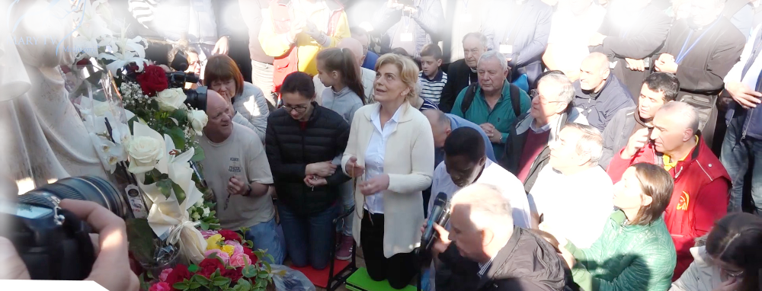

June 2nd 2019
https://video.marytv.tv/watch/Kbe4ufsclj9
“Dear children! Only pure and open heart will make that you truly come to know my Son and that all those who do not know His love come to know it through you. Only love will make that you comprehend that it is stronger than death because true love conquered death and made it that death does not exist. My children, forgiveness is exalted form of love. You, as apostles of my love, must pray to be strong in spirit and to be able to comprehend and forgive. You, apostles of my love, with understanding and forgiveness, give example of love and mercy. To be able to comprehend and forgive is a gift for which you need to pray, and nurture it. Forgiving you show that you are able to love. Behold, my children, how the Heavenly Father loves you with great love, comprehension, forgiveness and justice, how He gives you me, the Mother of your hearts. And here I am among you to bless you with motherly blessing, to call you to pray, to fast, to keep telling you to believe, to hope, to forgive, to pray for your shepherds, and above all to love without limits. My children, follow me. My way is the way of peace and love, the way of my Son. It is the way that leads to the triumph of my heart. Thank you.”

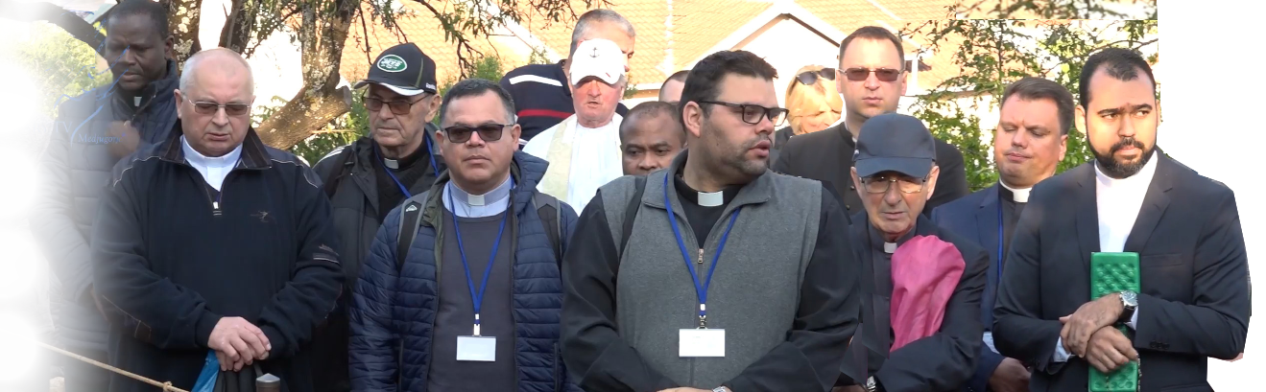

June 2nd 2019
https://video.marytv.tv/watch/Kbe4ufsclj9
“Dear children! Only pure and open heart will make that you truly come to know my Son and that all those who do not know His love come to know it through you. Only love will make that you comprehend that it is stronger than death because true love conquered death and made it that death does not exist. My children, forgiveness is exalted form of love. You, as apostles of my love, must pray to be strong in spirit and to be able to comprehend and forgive. You, apostles of my love, with understanding and forgiveness, give example of love and mercy. To be able to comprehend and forgive is a gift for which you need to pray, and nurture it. Forgiving you show that you are able to love. Behold, my children, how the Heavenly Father loves you with great love, comprehension, forgiveness and justice, how He gives you me, the Mother of your hearts. And here I am among you to bless you with motherly blessing, to call you to pray, to fast, to keep telling you to believe, to hope, to forgive, to pray for your shepherds, and above all to love without limits. My children, follow me. My way is the way of peace and love, the way of my Son. It is the way that leads to the triumph of my heart. Thank you.”

June 2nd 2019
https://video.marytv.tv/watch/Kbe4ufsclj9
“Dear children! Only pure and open heart will make that you truly come to know my Son and that all those who do not know His love come to know it through you. Only love will make that you comprehend that it is stronger than death because true love conquered death and made it that death does not exist. My children, forgiveness is exalted form of love. You, as apostles of my love, must pray to be strong in spirit and to be able to comprehend and forgive. You, apostles of my love, with understanding and forgiveness, give example of love and mercy. To be able to comprehend and forgive is a gift for which you need to pray, and nurture it. Forgiving you show that you are able to love. Behold, my children, how the Heavenly Father loves you with great love, comprehension, forgiveness and justice, how He gives you me, the Mother of your hearts. And here I am among you to bless you with motherly blessing, to call you to pray, to fast, to keep telling you to believe, to hope, to forgive, to pray for your shepherds, and above all to love without limits. My children, follow me. My way is the way of peace and love, the way of my Son. It is the way that leads to the triumph of my heart. Thank you.”

June 2nd 2019
https://video.marytv.tv/watch/Kbe4ufsclj9
“Dear children! Only pure and open heart will make that you truly come to know my Son and that all those who do not know His love come to know it through you. Only love will make that you comprehend that it is stronger than death because true love conquered death and made it that death does not exist. My children, forgiveness is exalted form of love. You, as apostles of my love, must pray to be strong in spirit and to be able to comprehend and forgive. You, apostles of my love, with understanding and forgiveness, give example of love and mercy. To be able to comprehend and forgive is a gift for which you need to pray, and nurture it. Forgiving you show that you are able to love. Behold, my children, how the Heavenly Father loves you with great love, comprehension, forgiveness and justice, how He gives you me, the Mother of your hearts. And here I am among you to bless you with motherly blessing, to call you to pray, to fast, to keep telling you to believe, to hope, to forgive, to pray for your shepherds, and above all to love without limits. My children, follow me. My way is the way of peace and love, the way of my Son. It is the way that leads to the triumph of my heart. Thank you.”

June 2nd 2019
https://video.marytv.tv/watch/Kbe4ufsclj9
“Dear children! Only pure and open heart will make that you truly come to know my Son and that all those who do not know His love come to know it through you. Only love will make that you comprehend that it is stronger than death because true love conquered death and made it that death does not exist. My children, forgiveness is exalted form of love. You, as apostles of my love, must pray to be strong in spirit and to be able to comprehend and forgive. You, apostles of my love, with understanding and forgiveness, give example of love and mercy. To be able to comprehend and forgive is a gift for which you need to pray, and nurture it. Forgiving you show that you are able to love. Behold, my children, how the Heavenly Father loves you with great love, comprehension, forgiveness and justice, how He gives you me, the Mother of your hearts. And here I am among you to bless you with motherly blessing, to call you to pray, to fast, to keep telling you to believe, to hope, to forgive, to pray for your shepherds, and above all to love without limits. My children, follow me. My way is the way of peace and love, the way of my Son. It is the way that leads to the triumph of my heart. Thank you.”
r
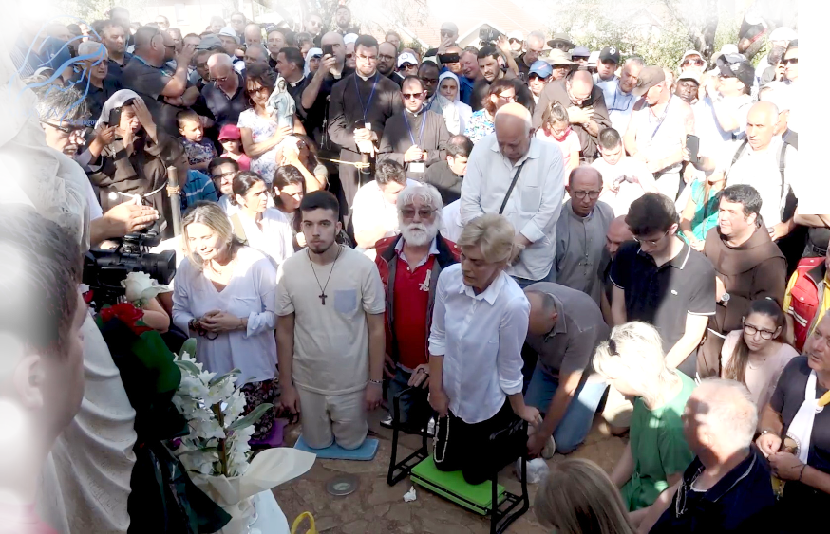

July 2nd 2019
https://video.marytv.tv/watch/IW2v1xscpLT
“Dear children, by the will of the Merciful Father, I have given you, and will give you longer, clear signs of my motherly presence. My children, this is the motherly desire for the healing of souls. This is the desire that every child of mine has true faith, to live through wondrous experiences, drinking from the spring of the words of my Son, the words of life. My children, the light of faith was brought into the world by my Son with His love and sacrifice, and He showed you the way of faith, because, my children, faith elevates pain and suffering. True faith makes prayer be more deeply felt, and does acts of mercy, a conversation, an alm. Those of my children who have faith, true faith, are happy despite everything because they live the beginning of heavenly happiness on earth. Therefore, my children, apostles of my love, I call you to give example of true faith, to bring light where there is darkness, to live my Son. My children, as mother I tell you, you cannot walk the way of faith and follow my Son without your shepherds. Pray that they have the strength and love to lead you. May your prayers always support them. Thank you.”

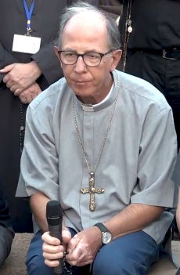

July 2nd 2019
https://video.marytv.tv/watch/IW2v1xscpLT
“Dear children, by the will of the Merciful Father, I have given you, and will give you longer, clear signs of my motherly presence. My children, this is the motherly desire for the healing of souls. This is the desire that every child of mine has true faith, to live through wondrous experiences, drinking from the spring of the words of my Son, the words of life. My children, the light of faith was brought into the world by my Son with His love and sacrifice, and He showed you the way of faith, because, my children, faith elevates pain and suffering. True faith makes prayer be more deeply felt, and does acts of mercy, a conversation, an alm. Those of my children who have faith, true faith, are happy despite everything because they live the beginning of heavenly happiness on earth. Therefore, my children, apostles of my love, I call you to give example of true faith, to bring light where there is darkness, to live my Son. My children, as mother I tell you, you cannot walk the way of faith and follow my Son without your shepherds. Pray that they have the strength and love to lead you. May your prayers always support them. Thank you.”

July 2nd 2019
https://video.marytv.tv/watch/IW2v1xscpLT
“Dear children, by the will of the Merciful Father, I have given you, and will give you longer, clear signs of my motherly presence. My children, this is the motherly desire for the healing of souls. This is the desire that every child of mine has true faith, to live through wondrous experiences, drinking from the spring of the words of my Son, the words of life. My children, the light of faith was brought into the world by my Son with His love and sacrifice, and He showed you the way of faith, because, my children, faith elevates pain and suffering. True faith makes prayer be more deeply felt, and does acts of mercy, a conversation, an alm. Those of my children who have faith, true faith, are happy despite everything because they live the beginning of heavenly happiness on earth. Therefore, my children, apostles of my love, I call you to give example of true faith, to bring light where there is darkness, to live my Son. My children, as mother I tell you, you cannot walk the way of faith and follow my Son without your shepherds. Pray that they have the strength and love to lead you. May your prayers always support them. Thank you.”

July 2nd 2019
https://video.marytv.tv/watch/IW2v1xscpLT
“Dear children, by the will of the Merciful Father, I have given you, and will give you longer, clear signs of my motherly presence. My children, this is the motherly desire for the healing of souls. This is the desire that every child of mine has true faith, to live through wondrous experiences, drinking from the spring of the words of my Son, the words of life. My children, the light of faith was brought into the world by my Son with His love and sacrifice, and He showed you the way of faith, because, my children, faith elevates pain and suffering. True faith makes prayer be more deeply felt, and does acts of mercy, a conversation, an alm. Those of my children who have faith, true faith, are happy despite everything because they live the beginning of heavenly happiness on earth. Therefore, my children, apostles of my love, I call you to give example of true faith, to bring light where there is darkness, to live my Son. My children, as mother I tell you, you cannot walk the way of faith and follow my Son without your shepherds. Pray that they have the strength and love to lead you. May your prayers always support them. Thank you.”

July 2nd 2019
https://video.marytv.tv/watch/IW2v1xscpLT
“Dear children, by the will of the Merciful Father, I have given you, and will give you longer, clear signs of my motherly presence. My children, this is the motherly desire for the healing of souls. This is the desire that every child of mine has true faith, to live through wondrous experiences, drinking from the spring of the words of my Son, the words of life. My children, the light of faith was brought into the world by my Son with His love and sacrifice, and He showed you the way of faith, because, my children, faith elevates pain and suffering. True faith makes prayer be more deeply felt, and does acts of mercy, a conversation, an alm. Those of my children who have faith, true faith, are happy despite everything because they live the beginning of heavenly happiness on earth. Therefore, my children, apostles of my love, I call you to give example of true faith, to bring light where there is darkness, to live my Son. My children, as mother I tell you, you cannot walk the way of faith and follow my Son without your shepherds. Pray that they have the strength and love to lead you. May your prayers always support them. Thank you.”
r

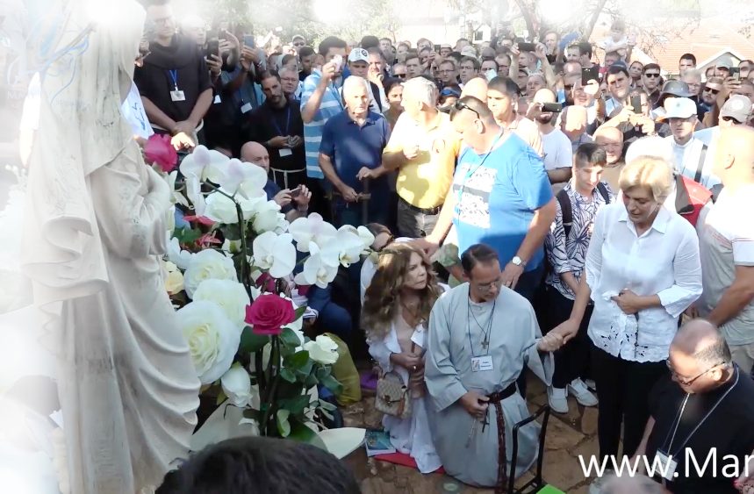
August 2nd 2019
https://video.marytv.tv/watch/I9W30LscXtZ
“Dear children! Great is the love of my Son. If you were to come to know the greatness of His love, you would never cease to adore and thank Him. He is always alive with you in the Eucharist, because the Eucharist is His Heart. The Eucharist is the heart of faith. He has never left you. Even when you tried to go away from Him, He has not [left] you. That is why my motherly heart is happy when I watch how you-filled with love return to Him, when I see that you come to Him through reconciliation, love and hope. My motherly heart knows that when you set out on the way of faith, you are shoots, buds, but with prayer and fasting you will be fruits, my flowers, apostles of my love. You will be carriers of light and will illuminate with love and wisdom all around you. My children, as Mother I implore you: pray, think, and contemplate. Everything beautiful, painful, joyful that happens to you, makes you grow spiritually, so that my Son may grow in you. My children, surrender yourselves to Him, believe Him, trust in His love, let Him lead you. Let the Eucharist be the place where you will feed your souls, and afterwards will spread love and truth, will bear witness to my Son. Thank you.”

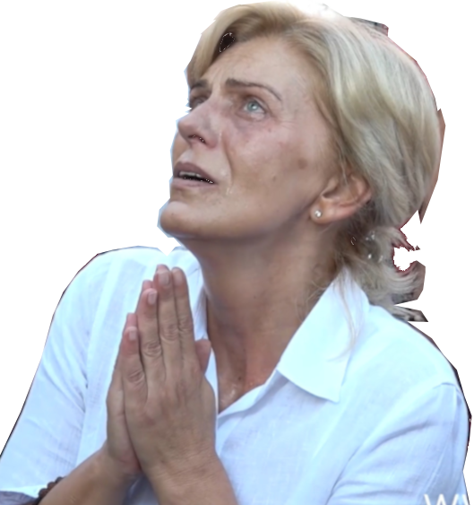

August 2nd 2019
https://video.marytv.tv/watch/I9W30LscXtZ
“Dear children! Great is the love of my Son. If you were to come to know the greatness of His love, you would never cease to adore and thank Him. He is always alive with you in the Eucharist, because the Eucharist is His Heart. The Eucharist is the heart of faith. He has never left you. Even when you tried to go away from Him, He has not [left] you. That is why my motherly heart is happy when I watch how you-filled with love return to Him, when I see that you come to Him through reconciliation, love and hope. My motherly heart knows that when you set out on the way of faith, you are shoots, buds, but with prayer and fasting you will be fruits, my flowers, apostles of my love. You will be carriers of light and will illuminate with love and wisdom all around you. My children, as Mother I implore you: pray, think, and contemplate. Everything beautiful, painful, joyful that happens to you, makes you grow spiritually, so that my Son may grow in you. My children, surrender yourselves to Him, believe Him, trust in His love, let Him lead you. Let the Eucharist be the place where you will feed your souls, and afterwards will spread love and truth, will bear witness to my Son. Thank you.”

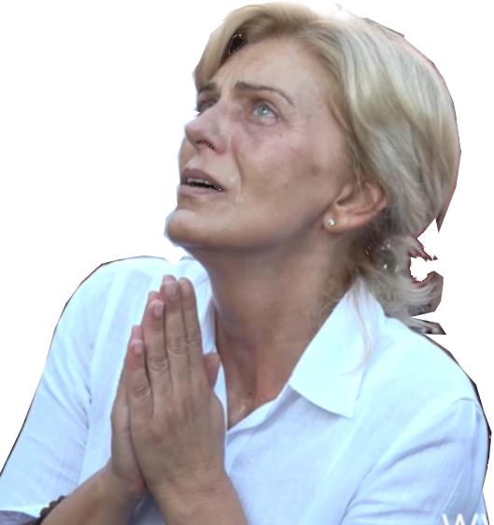

August 2nd 2019
https://video.marytv.tv/watch/I9W30LscXtZ
“Dear children! Great is the love of my Son. If you were to come to know the greatness of His love, you would never cease to adore and thank Him. He is always alive with you in the Eucharist, because the Eucharist is His Heart. The Eucharist is the heart of faith. He has never left you. Even when you tried to go away from Him, He has not [left] you. That is why my motherly heart is happy when I watch how you-filled with love return to Him, when I see that you come to Him through reconciliation, love and hope. My motherly heart knows that when you set out on the way of faith, you are shoots, buds, but with prayer and fasting you will be fruits, my flowers, apostles of my love. You will be carriers of light and will illuminate with love and wisdom all around you. My children, as Mother I implore you: pray, think, and contemplate. Everything beautiful, painful, joyful that happens to you, makes you grow spiritually, so that my Son may grow in you. My children, surrender yourselves to Him, believe Him, trust in His love, let Him lead you. Let the Eucharist be the place where you will feed your souls, and afterwards will spread love and truth, will bear witness to my Son. Thank you.”

August 2nd 2019
https://video.marytv.tv/watch/I9W30LscXtZ
“Dear children! Great is the love of my Son. If you were to come to know the greatness of His love, you would never cease to adore and thank Him. He is always alive with you in the Eucharist, because the Eucharist is His Heart. The Eucharist is the heart of faith. He has never left you. Even when you tried to go away from Him, He has not [left] you. That is why my motherly heart is happy when I watch how you-filled with love return to Him, when I see that you come to Him through reconciliation, love and hope. My motherly heart knows that when you set out on the way of faith, you are shoots, buds, but with prayer and fasting you will be fruits, my flowers, apostles of my love. You will be carriers of light and will illuminate with love and wisdom all around you. My children, as Mother I implore you: pray, think, and contemplate. Everything beautiful, painful, joyful that happens to you, makes you grow spiritually, so that my Son may grow in you. My children, surrender yourselves to Him, believe Him, trust in His love, let Him lead you. Let the Eucharist be the place where you will feed your souls, and afterwards will spread love and truth, will bear witness to my Son. Thank you.”

August 2nd 2019
https://video.marytv.tv/watch/I9W30LscXtZ
“Dear children! Great is the love of my Son. If you were to come to know the greatness of His love, you would never cease to adore and thank Him. He is always alive with you in the Eucharist, because the Eucharist is His Heart. The Eucharist is the heart of faith. He has never left you. Even when you tried to go away from Him, He has not [left] you. That is why my motherly heart is happy when I watch how you-filled with love return to Him, when I see that you come to Him through reconciliation, love and hope. My motherly heart knows that when you set out on the way of faith, you are shoots, buds, but with prayer and fasting you will be fruits, my flowers, apostles of my love. You will be carriers of light and will illuminate with love and wisdom all around you. My children, as Mother I implore you: pray, think, and contemplate. Everything beautiful, painful, joyful that happens to you, makes you grow spiritually, so that my Son may grow in you. My children, surrender yourselves to Him, believe Him, trust in His love, let Him lead you. Let the Eucharist be the place where you will feed your souls, and afterwards will spread love and truth, will bear witness to my Son. Thank you.”
r
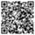
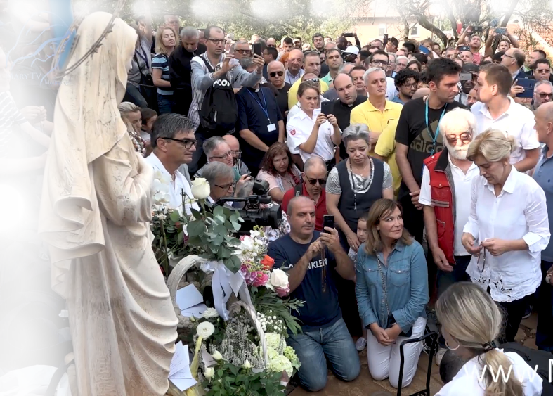
September 2nd 2019
https://video.marytv.tv/watch/InC9Njsc1NM
“Dear children, Pray! Pray the Rosary every day, that wreath of flowers which, as Mother, directly connects me with your pains, sufferings, desires, and hopes. Apostles of my love, I am with you through the grace and love of my Son, and I ask prayers from you. The world so much needs your prayers for souls to convert. Open your hearts with complete trust to my Son, and He will write in them the summary of His words which is love. Live with unbreakable connection to the Most Sacred Heart of my Son. My children, as Mother, I tell you that it is high time for you to kneel down before my Son to acknowledge Him as your God, the center of your life. Offer gifts to Him, that which He loves the most and which is love towards neighbour, mercy, and pure hearts. Apostles of my love, many of my children still do not acknowledge my Son as their God, they have not yet come to know His love. But you, with your prayer pronounced from pure and open heart, with gifts you offer to my Son, will make even the hardest of hearts open. Apostles of my love, the strength of prayer pronounced from the heart, powerful prayer full of love, changes the world. Therefore, my children: pray, pray, pray. I am with you. Thank you.”

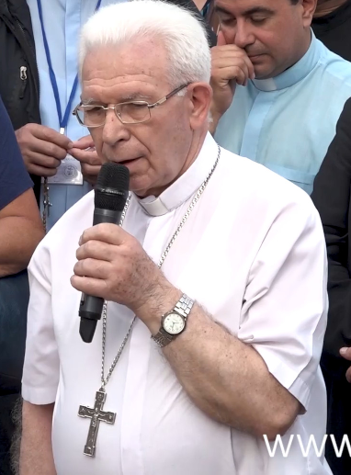

https://video.marytv.tv/watch/InC9Njsc1NM
September 2nd 2019
“Dear children, Pray! Pray the Rosary every day, that wreath of flowers which, as Mother, directly connects me with your pains, sufferings, desires, and hopes. Apostles of my love, I am with you through the grace and love of my Son, and I ask prayers from you. The world so much needs your prayers for souls to convert. Open your hearts with complete trust to my Son, and He will write in them the summary of His words which is love. Live with unbreakable connection to the Most Sacred Heart of my Son. My children, as Mother, I tell you that it is high time for you to kneel down before my Son to acknowledge Him as your God, the center of your life. Offer gifts to Him, that which He loves the most and which is love towards neighbour, mercy, and pure hearts. Apostles of my love, many of my children still do not acknowledge my Son as their God, they have not yet come to know His love. But you, with your prayer pronounced from pure and open heart, with gifts you offer to my Son, will make even the hardest of hearts open. Apostles of my love, the strength of prayer pronounced from the heart, powerful prayer full of love, changes the world. Therefore, my children: pray, pray, pray. I am with you. Thank you.”

https://video.marytv.tv/watch/InC9Njsc1NM
September 2nd 2019
“Dear children, Pray! Pray the Rosary every day, that wreath of flowers which, as Mother, directly connects me with your pains, sufferings, desires, and hopes. Apostles of my love, I am with you through the grace and love of my Son, and I ask prayers from you. The world so much needs your prayers for souls to convert. Open your hearts with complete trust to my Son, and He will write in them the summary of His words which is love. Live with unbreakable connection to the Most Sacred Heart of my Son. My children, as Mother, I tell you that it is high time for you to kneel down before my Son to acknowledge Him as your God, the center of your life. Offer gifts to Him, that which He loves the most and which is love towards neighbour, mercy, and pure hearts. Apostles of my love, many of my children still do not acknowledge my Son as their God, they have not yet come to know His love. But you, with your prayer pronounced from pure and open heart, with gifts you offer to my Son, will make even the hardest of hearts open. Apostles of my love, the strength of prayer pronounced from the heart, powerful prayer full of love, changes the world. Therefore, my children: pray, pray, pray. I am with you. Thank you.”

https://video.marytv.tv/watch/InC9Njsc1NM
September 2nd 2019
“Dear children, Pray! Pray the Rosary every day, that wreath of flowers which, as Mother, directly connects me with your pains, sufferings, desires, and hopes. Apostles of my love, I am with you through the grace and love of my Son, and I ask prayers from you. The world so much needs your prayers for souls to convert. Open your hearts with complete trust to my Son, and He will write in them the summary of His words which is love. Live with unbreakable connection to the Most Sacred Heart of my Son. My children, as Mother, I tell you that it is high time for you to kneel down before my Son to acknowledge Him as your God, the center of your life. Offer gifts to Him, that which He loves the most and which is love towards neighbour, mercy, and pure hearts. Apostles of my love, many of my children still do not acknowledge my Son as their God, they have not yet come to know His love. But you, with your prayer pronounced from pure and open heart, with gifts you offer to my Son, will make even the hardest of hearts open. Apostles of my love, the strength of prayer pronounced from the heart, powerful prayer full of love, changes the world. Therefore, my children: pray, pray, pray. I am with you. Thank you.”

https://video.marytv.tv/watch/InC9Njsc1NM
September 2nd 2019
“Dear children, Pray! Pray the Rosary every day, that wreath of flowers which, as Mother, directly connects me with your pains, sufferings, desires, and hopes. Apostles of my love, I am with you through the grace and love of my Son, and I ask prayers from you. The world so much needs your prayers for souls to convert. Open your hearts with complete trust to my Son, and He will write in them the summary of His words which is love. Live with unbreakable connection to the Most Sacred Heart of my Son. My children, as Mother, I tell you that it is high time for you to kneel down before my Son to acknowledge Him as your God, the center of your life. Offer gifts to Him, that which He loves the most and which is love towards neighbour, mercy, and pure hearts. Apostles of my love, many of my children still do not acknowledge my Son as their God, they have not yet come to know His love. But you, with your prayer pronounced from pure and open heart, with gifts you offer to my Son, will make even the hardest of hearts open. Apostles of my love, the strength of prayer pronounced from the heart, powerful prayer full of love, changes the world. Therefore, my children: pray, pray, pray. I am with you. Thank you.”
r

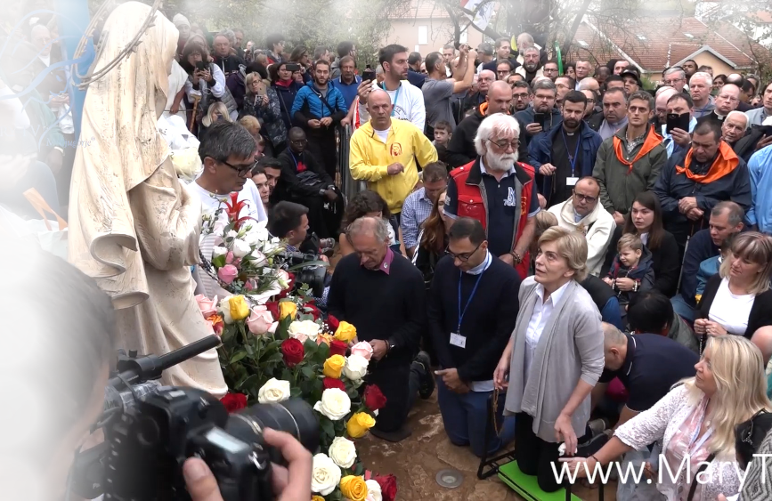
October 2nd 2019
https://video.marytv.tv/watch/GlnMU5scx0v
“Dear children, the will and the love of the Heavenly Father make that I am among you, to help you with motherly love grow faith in the heart, that you may truly comprehend the purpose of earthly life and the greatness of the heavenly one. My children, the earthly life is the way to eternity, to truth, to life, to my Son. That way I desire to take you. You, my children, you who always thirst for more love, truth and faith, may you know that there is only one spring from which you can drink. the trust in the Heavenly Father, the trust in His love. Abandon yourselves completely to His will and do not be afraid. Everything that is best for you, everything that leads you to eternal life, will be given to you. You will comprehend that the purpose of life is not always to will and to have, but to love and to give. You will have true peace and true love, you will be apostles of love, you will with your example make that those children who do not know my Son and His love will desire to come to know Him. My children, apostles of my love, adore my Son with me and love Him above all. Always strive to live in His truth. Thank you.”

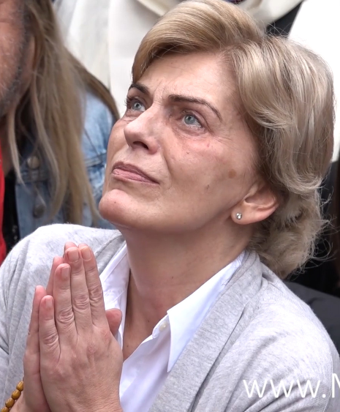

October 2nd 2019
https://video.marytv.tv/watch/GlnMU5scx0v
“Dear children, the will and the love of the Heavenly Father make that I am among you, to help you with motherly love grow faith in the heart, that you may truly comprehend the purpose of earthly life and the greatness of the heavenly one. My children, the earthly life is the way to eternity, to truth, to life, to my Son. That way I desire to take you. You, my children, you who always thirst for more love, truth and faith, may you know that there is only one spring from which you can drink. the trust in the Heavenly Father, the trust in His love. Abandon yourselves completely to His will and do not be afraid. Everything that is best for you, everything that leads you to eternal life, will be given to you. You will comprehend that the purpose of life is not always to will and to have, but to love and to give. You will have true peace and true love, you will be apostles of love, you will with your example make that those children who do not know my Son and His love will desire to come to know Him. My children, apostles of my love, adore my Son with me and love Him above all. Always strive to live in His truth. Thank you.”

October 2nd 2019
https://video.marytv.tv/watch/GlnMU5scx0v

“Dear children, the will and the love of the Heavenly Father make that I am among you, to help you with motherly love grow faith in the heart, that you may truly comprehend the purpose of earthly life and the greatness of the heavenly one. My children, the earthly life is the way to eternity, to truth, to life, to my Son. That way I desire to take you. You, my children, you who always thirst for more love, truth and faith, may you know that there is only one spring from which you can drink. the trust in the Heavenly Father, the trust in His love. Abandon yourselves completely to His will and do not be afraid. Everything that is best for you, everything that leads you to eternal life, will be given to you. You will comprehend that the purpose of life is not always to will and to have, but to love and to give. You will have true peace and true love, you will be apostles of love, you will with your example make that those children who do not know my Son and His love will desire to come to know Him. My children, apostles of my love, adore my Son with me and love Him above all. Always strive to live in His truth. Thank you.”

October 2nd 2019
https://video.marytv.tv/watch/GlnMU5scx0v
“Dear children, the will and the love of the Heavenly Father make that I am among you, to help you with motherly love grow faith in the heart, that you may truly comprehend the purpose of earthly life and the greatness of the heavenly one. My children, the earthly life is the way to eternity, to truth, to life, to my Son. That way I desire to take you. You, my children, you who always thirst for more love, truth and faith, may you know that there is only one spring from which you can drink. the trust in the Heavenly Father, the trust in His love. Abandon yourselves completely to His will and do not be afraid. Everything that is best for you, everything that leads you to eternal life, will be given to you. You will comprehend that the purpose of life is not always to will and to have, but to love and to give. You will have true peace and true love, you will be apostles of love, you will with your example make that those children who do not know my Son and His love will desire to come to know Him. My children, apostles of my love, adore my Son with me and love Him above all. Always strive to live in His truth. Thank you.”

October 2nd 2019
https://video.marytv.tv/watch/GlnMU5scx0v
“Dear children, the will and the love of the Heavenly Father make that I am among you, to help you with motherly love grow faith in the heart, that you may truly comprehend the purpose of earthly life and the greatness of the heavenly one. My children, the earthly life is the way to eternity, to truth, to life, to my Son. That way I desire to take you. You, my children, you who always thirst for more love, truth and faith, may you know that there is only one spring from which you can drink. the trust in the Heavenly Father, the trust in His love. Abandon yourselves completely to His will and do not be afraid. Everything that is best for you, everything that leads you to eternal life, will be given to you. You will comprehend that the purpose of life is not always to will and to have, but to love and to give. You will have true peace and true love, you will be apostles of love, you will with your example make that those children who do not know my Son and His love will desire to come to know Him. My children, apostles of my love, adore my Son with me and love Him above all. Always strive to live in His truth. Thank you.”
r
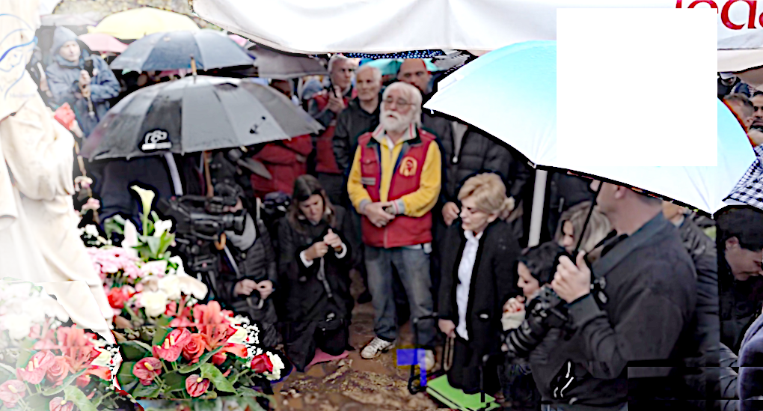

November 2nd 2019
https://video.marytv.tv/watch/GbiWAPscGOZ
“Dear children, my beloved Son always prayed and glorified the Heavenly Father. He always said everything to Him and trusted in His will. This is what you, my children, should also do, because the Heavenly Father always listens to His children. One heart in one heart, love, light and life. The Heavenly Father gave Himself through a human face, and this face is the face of my Son. You, apostles of my love, you should always carry the face of my Son in your hearts and your thoughts. You should always think of His love and His sacrifice. You should pray to always feel His presence, because, apostles of my love, that is the way for you to help all those who do not know my Son, who have not come to know His love. My children, read the book of the Gospel. It is always something new, it is what binds you to my Son who was born to bring the words of life to all of my children and to sacrifice Himself for all. Apostles of my love, carried by the love for my Son, bring love and peace to all of your brothers. Judge no one. Love everyone through the love for my Son. In this way, you will also be caring for your soul, and it is the most precious thing that truly belongs to you. Thank you.”

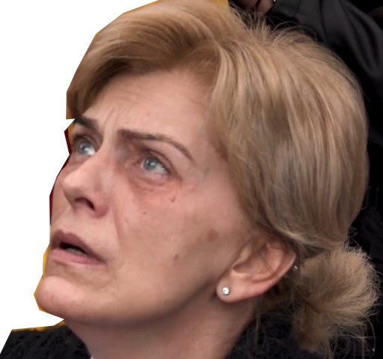

November 2nd 2019
https://video.marytv.tv/watch/GbiWAPscGOZ
“Dear children, my beloved Son always prayed and glorified the Heavenly Father. He always said everything to Him and trusted in His will. This is what you, my children, should also do, because the Heavenly Father always listens to His children. One heart in one heart, love, light and life. The Heavenly Father gave Himself through a human face, and this face is the face of my Son. You, apostles of my love, you should always carry the face of my Son in your hearts and your thoughts. You should always think of His love and His sacrifice. You should pray to always feel His presence, because, apostles of my love, that is the way for you to help all those who do not know my Son, who have not come to know His love. My children, read the book of the Gospel. It is always something new, it is what binds you to my Son who was born to bring the words of life to all of my children and to sacrifice Himself for all. Apostles of my love, carried by the love for my Son, bring love and peace to all of your brothers. Judge no one. Love everyone through the love for my Son. In this way, you will also be caring for your soul, and it is the most precious thing that truly belongs to you. Thank you.”

November 2nd 2019
https://video.marytv.tv/watch/GbiWAPscGOZ
“Dear children, my beloved Son always prayed and glorified the Heavenly Father. He always said everything to Him and trusted in His will. This is what you, my children, should also do, because the Heavenly Father always listens to His children. One heart in one heart, love, light and life. The Heavenly Father gave Himself through a human face, and this face is the face of my Son. You, apostles of my love, you should always carry the face of my Son in your hearts and your thoughts. You should always think of His love and His sacrifice. You should pray to always feel His presence, because, apostles of my love, that is the way for you to help all those who do not know my Son, who have not come to know His love. My children, read the book of the Gospel. It is always something new, it is what binds you to my Son who was born to bring the words of life to all of my children and to sacrifice Himself for all. Apostles of my love, carried by the love for my Son, bring love and peace to all of your brothers. Judge no one. Love everyone through the love for my Son. In this way, you will also be caring for your soul, and it is the most precious thing that truly belongs to you. Thank you.”

November 2nd 2019
https://video.marytv.tv/watch/GbiWAPscGOZ
“Dear children, my beloved Son always prayed and glorified the Heavenly Father. He always said everything to Him and trusted in His will. This is what you, my children, should also do, because the Heavenly Father always listens to His children. One heart in one heart, love, light and life. The Heavenly Father gave Himself through a human face, and this face is the face of my Son. You, apostles of my love, you should always carry the face of my Son in your hearts and your thoughts. You should always think of His love and His sacrifice. You should pray to always feel His presence, because, apostles of my love, that is the way for you to help all those who do not know my Son, who have not come to know His love. My children, read the book of the Gospel. It is always something new, it is what binds you to my Son who was born to bring the words of life to all of my children and to sacrifice Himself for all. Apostles of my love, carried by the love for my Son, bring love and peace to all of your brothers. Judge no one. Love everyone through the love for my Son. In this way, you will also be caring for your soul, and it is the most precious thing that truly belongs to you. Thank you.”

November 2nd 2019
https://video.marytv.tv/watch/GbiWAPscGOZ
“Dear children, my beloved Son always prayed and glorified the Heavenly Father. He always said everything to Him and trusted in His will. This is what you, my children, should also do, because the Heavenly Father always listens to His children. One heart in one heart, love, light and life. The Heavenly Father gave Himself through a human face, and this face is the face of my Son. You, apostles of my love, you should always carry the face of my Son in your hearts and your thoughts. You should always think of His love and His sacrifice. You should pray to always feel His presence, because, apostles of my love, that is the way for you to help all those who do not know my Son, who have not come to know His love. My children, read the book of the Gospel. It is always something new, it is what binds you to my Son who was born to bring the words of life to all of my children and to sacrifice Himself for all. Apostles of my love, carried by the love for my Son, bring love and peace to all of your brothers. Judge no one. Love everyone through the love for my Son. In this way, you will also be caring for your soul, and it is the most precious thing that truly belongs to you. Thank you.”
r
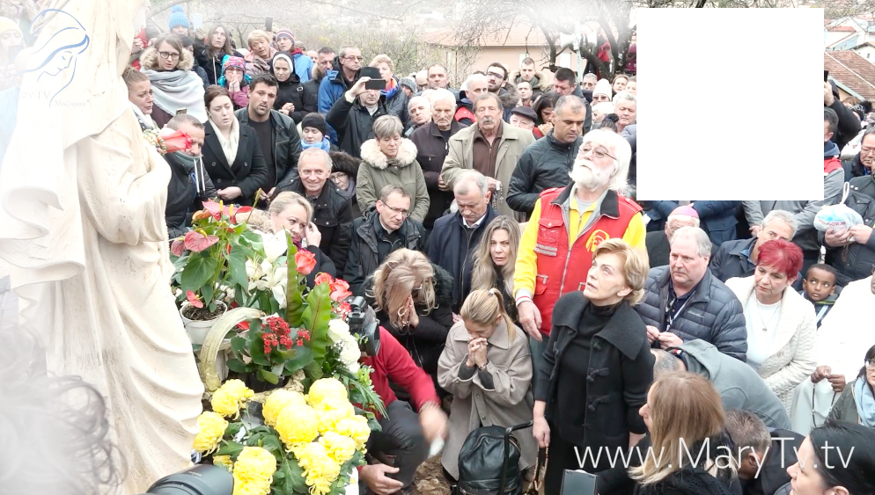

December 2nd 2019
https://video.marytv.tv/watch/J4tl2UscE0C
“Dear children, as I am looking at you who love my Son, my heart is being filled with sweetness. I am blessing you with motherly blessing. With motherly blessing, I am also blessing your shepherds, you who speak the words of my Son, who bless with His hands and who love Him so much to be ready to make every sacrifice for Him with joy. You follow Him, who was the first shepherd, the first missionary. My children, apostles of my love, to live and work for others, for all those whom you love through my Son, is the joy and comfort of earthly life. If through prayer, love and sacrifice the Kingdom of God is in your hearts, then your life is joyful and serene. Among those who love my Son and who love each other through Him, words are not necessary. A gaze is sufficient for the unspoken words and unexpressed feelings to be heard. Where love reigns, time no longer counts. We are with you. My Son knows you and loves you. Love is that which brings you to me and through that love I will come to you and speak to you of the works of salvation. I desire for all of my children to have faith and to feel my motherly love which leads them to Jesus. Therefore, you, my children, wherever you go, illuminate with love and faith as apostles of love. Thank you.”

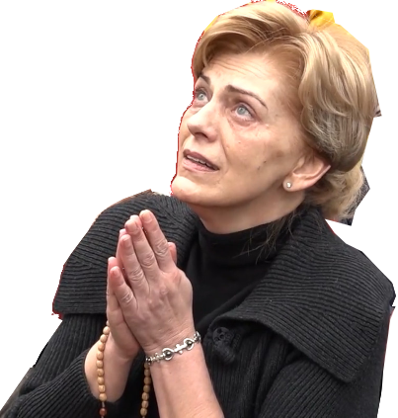

December 2nd 2019
https://video.marytv.tv/watch/J4tl2UscE0C
“Dear children, as I am looking at you who love my Son, my heart is being filled with sweetness. I am blessing you with motherly blessing. With motherly blessing, I am also blessing your shepherds, you who speak the words of my Son, who bless with His hands and who love Him so much to be ready to make every sacrifice for Him with joy. You follow Him, who was the first shepherd, the first missionary. My children, apostles of my love, to live and work for others, for all those whom you love through my Son, is the joy and comfort of earthly life. If through prayer, love and sacrifice the Kingdom of God is in your hearts, then your life is joyful and serene. Among those who love my Son and who love each other through Him, words are not necessary. A gaze is sufficient for the unspoken words and unexpressed feelings to be heard. Where love reigns, time no longer counts. We are with you. My Son knows you and loves you. Love is that which brings you to me and through that love I will come to you and speak to you of the works of salvation. I desire for all of my children to have faith and to feel my motherly love which leads them to Jesus. Therefore, you, my children, wherever you go, illuminate with love and faith as apostles of love. Thank you.”

December 2nd 2019
https://video.marytv.tv/watch/J4tl2UscE0C
“Dear children, as I am looking at you who love my Son, my heart is being filled with sweetness. I am blessing you with motherly blessing. With motherly blessing, I am also blessing your shepherds, you who speak the words of my Son, who bless with His hands and who love Him so much to be ready to make every sacrifice for Him with joy. You follow Him, who was the first shepherd, the first missionary. My children, apostles of my love, to live and work for others, for all those whom you love through my Son, is the joy and comfort of earthly life. If through prayer, love and sacrifice the Kingdom of God is in your hearts, then your life is joyful and serene. Among those who love my Son and who love each other through Him, words are not necessary. A gaze is sufficient for the unspoken words and unexpressed feelings to be heard. Where love reigns, time no longer counts. We are with you. My Son knows you and loves you. Love is that which brings you to me and through that love I will come to you and speak to you of the works of salvation. I desire for all of my children to have faith and to feel my motherly love which leads them to Jesus. Therefore, you, my children, wherever you go, illuminate with love and faith as apostles of love. Thank you.”

December 2nd 2019
https://video.marytv.tv/watch/J4tl2UscE0C
“Dear children, as I am looking at you who love my Son, my heart is being filled with sweetness. I am blessing you with motherly blessing. With motherly blessing, I am also blessing your shepherds, you who speak the words of my Son, who bless with His hands and who love Him so much to be ready to make every sacrifice for Him with joy. You follow Him, who was the first shepherd, the first missionary. My children, apostles of my love, to live and work for others, for all those whom you love through my Son, is the joy and comfort of earthly life. If through prayer, love and sacrifice the Kingdom of God is in your hearts, then your life is joyful and serene. Among those who love my Son and who love each other through Him, words are not necessary. A gaze is sufficient for the unspoken words and unexpressed feelings to be heard. Where love reigns, time no longer counts. We are with you. My Son knows you and loves you. Love is that which brings you to me and through that love I will come to you and speak to you of the works of salvation. I desire for all of my children to have faith and to feel my motherly love which leads them to Jesus. Therefore, you, my children, wherever you go, illuminate with love and faith as apostles of love. Thank you.”

December 2nd 2019
https://video.marytv.tv/watch/J4tl2UscE0C
“Dear children, as I am looking at you who love my Son, my heart is being filled with sweetness. I am blessing you with motherly blessing. With motherly blessing, I am also blessing your shepherds, you who speak the words of my Son, who bless with His hands and who love Him so much to be ready to make every sacrifice for Him with joy. You follow Him, who was the first shepherd, the first missionary. My children, apostles of my love, to live and work for others, for all those whom you love through my Son, is the joy and comfort of earthly life. If through prayer, love and sacrifice the Kingdom of God is in your hearts, then your life is joyful and serene. Among those who love my Son and who love each other through Him, words are not necessary. A gaze is sufficient for the unspoken words and unexpressed feelings to be heard. Where love reigns, time no longer counts. We are with you. My Son knows you and loves you. Love is that which brings you to me and through that love I will come to you and speak to you of the works of salvation. I desire for all of my children to have faith and to feel my motherly love which leads them to Jesus. Therefore, you, my children, wherever you go, illuminate with love and faith as apostles of love. Thank you.”
r
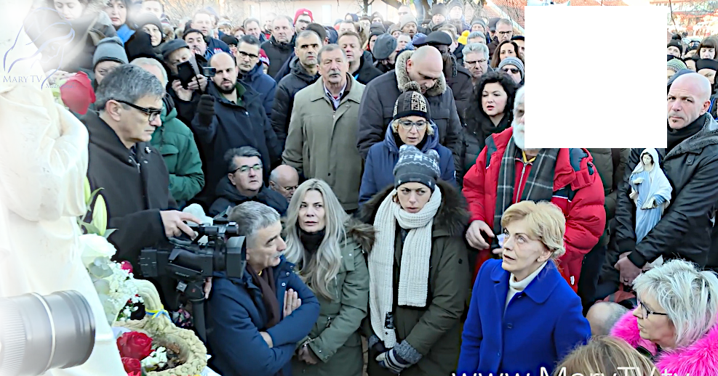

January 2nd 2020
https://video.marytv.tv/watch/JZb7AzscSFp
“Dear children, I know that I am present in your lives and in your hearts. I feel your love. I hear your prayers. I direct them to my Son. But, my children, I desire to be with motherly love in the lives of all of my children. All of my children I desire to gather around me, under my motherly mantle. This is why I invite you and call you, apostles of my love, to help me. My children, my Son pronounced the words of the ‘Our Father’, and Our Father who are everywhere and in our hearts, because He desires to teach you to pray with words and feelings. He desires that you always be better, that you live merciful love which is prayer and limitless sacrifice for others. My children, give to my Son love for your neighbors, give words of consolation, compassion and acts of justice to your neighbors. Everything that you give to others, apostles of my love, my Son accepts as a gift. I am also with you, because my Son desires that my love, as ray of light, bring your souls to life, that I help you in the quest for peace and eternal happiness. Therefore, my children, love one another, be united through my Son, be children of God who all together, with full, open and pure heart, pronounce the ‘Our Father’. And do not be afraid! Thank you.”

January 2nd 2020
https://video.marytv.tv/watch/JZb7AzscSFp
“Dear children, I know that I am present in your lives and in your hearts. I feel your love. I hear your prayers. I direct them to my Son. But, my children, I desire to be with motherly love in the lives of all of my children. All of my children I desire to gather around me, under my motherly mantle. This is why I invite you and call you, apostles of my love, to help me. My children, my Son pronounced the words of the ‘Our Father’, and Our Father who are everywhere and in our hearts, because He desires to teach you to pray with words and feelings. He desires that you always be better, that you live merciful love which is prayer and limitless sacrifice for others. My children, give to my Son love for your neighbors, give words of consolation, compassion and acts of justice to your neighbors. Everything that you give to others, apostles of my love, my Son accepts as a gift. I am also with you, because my Son desires that my love, as ray of light, bring your souls to life, that I help you in the quest for peace and eternal happiness. Therefore, my children, love one another, be united through my Son, be children of God who all together, with full, open and pure heart, pronounce the ‘Our Father’. And do not be afraid! Thank you.”

January 2nd 2020
https://video.marytv.tv/watch/JZb7AzscSFp
“Dear children, I know that I am present in your lives and in your hearts. I feel your love. I hear your prayers. I direct them to my Son. But, my children, I desire to be with motherly love in the lives of all of my children. All of my children I desire to gather around me, under my motherly mantle. This is why I invite you and call you, apostles of my love, to help me. My children, my Son pronounced the words of the ‘Our Father’, and Our Father who are everywhere and in our hearts, because He desires to teach you to pray with words and feelings. He desires that you always be better, that you live merciful love which is prayer and limitless sacrifice for others. My children, give to my Son love for your neighbors, give words of consolation, compassion and acts of justice to your neighbors. Everything that you give to others, apostles of my love, my Son accepts as a gift. I am also with you, because my Son desires that my love, as ray of light, bring your souls to life, that I help you in the quest for peace and eternal happiness. Therefore, my children, love one another, be united through my Son, be children of God who all together, with full, open and pure heart, pronounce the ‘Our Father’. And do not be afraid! Thank you.”

January 2nd 2020
https://video.marytv.tv/watch/JZb7AzscSFp
“Dear children, I know that I am present in your lives and in your hearts. I feel your love. I hear your prayers. I direct them to my Son. But, my children, I desire to be with motherly love in the lives of all of my children. All of my children I desire to gather around me, under my motherly mantle. This is why I invite you and call you, apostles of my love, to help me. My children, my Son pronounced the words of the ‘Our Father’, and Our Father who are everywhere and in our hearts, because He desires to teach you to pray with words and feelings. He desires that you always be better, that you live merciful love which is prayer and limitless sacrifice for others. My children, give to my Son love for your neighbors, give words of consolation, compassion and acts of justice to your neighbors. Everything that you give to others, apostles of my love, my Son accepts as a gift. I am also with you, because my Son desires that my love, as ray of light, bring your souls to life, that I help you in the quest for peace and eternal happiness. Therefore, my children, love one another, be united through my Son, be children of God who all together, with full, open and pure heart, pronounce the ‘Our Father’. And do not be afraid! Thank you.”

January 2nd 2020
https://video.marytv.tv/watch/JZb7AzscSFp
“Dear children, I know that I am present in your lives and in your hearts. I feel your love. I hear your prayers. I direct them to my Son. But, my children, I desire to be with motherly love in the lives of all of my children. All of my children I desire to gather around me, under my motherly mantle. This is why I invite you and call you, apostles of my love, to help me. My children, my Son pronounced the words of the ‘Our Father’, and Our Father who are everywhere and in our hearts, because He desires to teach you to pray with words and feelings. He desires that you always be better, that you live merciful love which is prayer and limitless sacrifice for others. My children, give to my Son love for your neighbors, give words of consolation, compassion and acts of justice to your neighbors. Everything that you give to others, apostles of my love, my Son accepts as a gift. I am also with you, because my Son desires that my love, as ray of light, bring your souls to life, that I help you in the quest for peace and eternal happiness. Therefore, my children, love one another, be united through my Son, be children of God who all together, with full, open and pure heart, pronounce the ‘Our Father’. And do not be afraid! Thank you.”
r
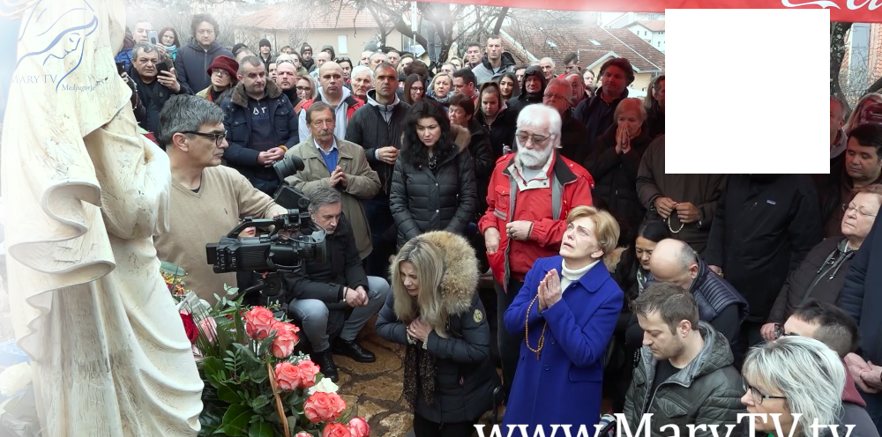

February 2nd 2020
https://video.marytv.tv/watch/Jy24W8scNoC
“Dear children! By the act of decision and love of God, I am chosen to be the Mother of God and your mother. But also by my will and my immeasurable love for the Heavenly Father and my complete trust in Him, my body was the chalice of the God-Man. I was in the service of truth, love and salvation. As I am now here among you to call you, my children, apostles of my love, to be carriers of truth, to call you to, by your will and love for my Son, spread His words, the words of salvation, to, with your actions, show, to all those who have not come to know my Son, His love. The strength you will find in the Eucharist, my Son who feeds you with His Body and strengthens you with His Blood. My children, fold your hands and look at the Cross in silence. In this way, you are drawing faith to be able to transmit it, you are drawing truth to be able to discern, you are drawing love that you may know to love truly. My children, apostles of my love, fold your hands, look at the Cross. Only in the Cross is salvation. Thank you.”

February 2nd 2020
https://video.marytv.tv/watch/Jy24W8scNoC
“Dear children! By the act of decision and love of God, I am chosen to be the Mother of God and your mother. But also by my will and my immeasurable love for the Heavenly Father and my complete trust in Him, my body was the chalice of the God-Man. I was in the service of truth, love and salvation. As I am now here among you to call you, my children, apostles of my love, to be carriers of truth, to call you to, by your will and love for my Son, spread His words, the words of salvation, to, with your actions, show, to all those who have not come to know my Son, His love. The strength you will find in the Eucharist, my Son who feeds you with His Body and strengthens you with His Blood. My children, fold your hands and look at the Cross in silence. In this way, you are drawing faith to be able to transmit it, you are drawing truth to be able to discern, you are drawing love that you may know to love truly. My children, apostles of my love, fold your hands, look at the Cross. Only in the Cross is salvation. Thank you.”

February 2nd 2020
https://video.marytv.tv/watch/Jy24W8scNoC
“Dear children! By the act of decision and love of God, I am chosen to be the Mother of God and your mother. But also by my will and my immeasurable love for the Heavenly Father and my complete trust in Him, my body was the chalice of the God-Man. I was in the service of truth, love and salvation. As I am now here among you to call you, my children, apostles of my love, to be carriers of truth, to call you to, by your will and love for my Son, spread His words, the words of salvation, to, with your actions, show, to all those who have not come to know my Son, His love. The strength you will find in the Eucharist, my Son who feeds you with His Body and strengthens you with His Blood. My children, fold your hands and look at the Cross in silence. In this way, you are drawing faith to be able to transmit it, you are drawing truth to be able to discern, you are drawing love that you may know to love truly. My children, apostles of my love, fold your hands, look at the Cross. Only in the Cross is salvation. Thank you.”

February 2nd 2020
https://video.marytv.tv/watch/Jy24W8scNoC
“Dear children! By the act of decision and love of God, I am chosen to be the Mother of God and your mother. But also by my will and my immeasurable love for the Heavenly Father and my complete trust in Him, my body was the chalice of the God-Man. I was in the service of truth, love and salvation. As I am now here among you to call you, my children, apostles of my love, to be carriers of truth, to call you to, by your will and love for my Son, spread His words, the words of salvation, to, with your actions, show, to all those who have not come to know my Son, His love. The strength you will find in the Eucharist, my Son who feeds you with His Body and strengthens you with His Blood. My children, fold your hands and look at the Cross in silence. In this way, you are drawing faith to be able to transmit it, you are drawing truth to be able to discern, you are drawing love that you may know to love truly. My children, apostles of my love, fold your hands, look at the Cross. Only in the Cross is salvation. Thank you.”

February 2nd 2020
https://video.marytv.tv/watch/Jy24W8scNoC
“Dear children! By the act of decision and love of God, I am chosen to be the Mother of God and your mother. But also by my will and my immeasurable love for the Heavenly Father and my complete trust in Him, my body was the chalice of the God-Man. I was in the service of truth, love and salvation. As I am now here among you to call you, my children, apostles of my love, to be carriers of truth, to call you to, by your will and love for my Son, spread His words, the words of salvation, to, with your actions, show, to all those who have not come to know my Son, His love. The strength you will find in the Eucharist, my Son who feeds you with His Body and strengthens you with His Blood. My children, fold your hands and look at the Cross in silence. In this way, you are drawing faith to be able to transmit it, you are drawing truth to be able to discern, you are drawing love that you may know to love truly. My children, apostles of my love, fold your hands, look at the Cross. Only in the Cross is salvation. Thank you.”

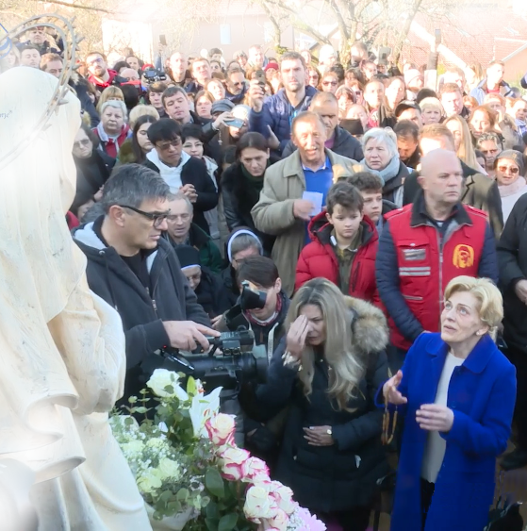
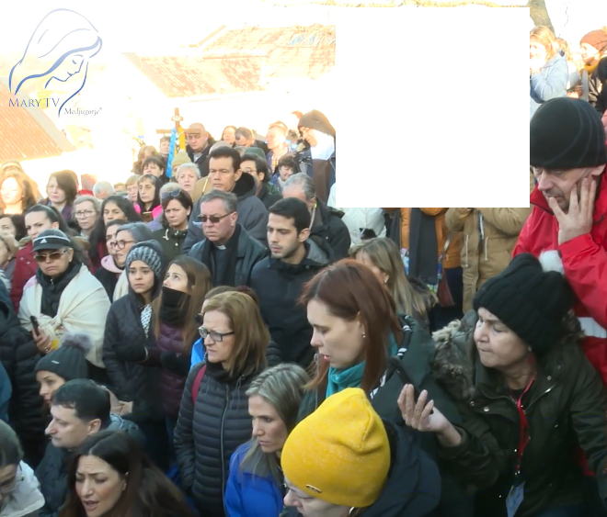

March 2nd 2020
https://video.marytv.tv/watch/FpOat1scBDk
“Dear children, Your pure and sincere love attracts my motherly heart. Your faith and trust in the Heavenly Father are fragrant roses which you offer to me, the most beautiful bouquet of roses which consist of your prayers, acts of mercy and of love. Apostles of my love, you who sincerely and with a pure heart strive to follow my Son, you who sincerely love Him, you help, you be an example to those who have not yet come to know the love of my Son. But, my children, not only with words but also with acts and pure feelings through which you glorify the Heavenly Father. Apostles of my love, it is time of vigilance, and I ask love from you, not to judge, anyone, because the Heavenly Father will judge everyone. I ask you to love, that you carry the truth, because truth is old, it is not new, it is eternal, it is truth. It testifies to God’s eternity. Bring the light of my Son and keep breaking the darkness which all the more wants to seize you. Do not be afraid. Through the grace and the love of my Son, I am with you. Thank you.”

\

March 2nd 2020
https://video.marytv.tv/watch/FpOat1scBDk
“Dear children, Your pure and sincere love attracts my motherly heart. Your faith and trust in the Heavenly Father are fragrant roses which you offer to me, the most beautiful bouquet of roses which consist of your prayers, acts of mercy and of love. Apostles of my love, you who sincerely and with a pure heart strive to follow my Son, you who sincerely love Him, you help, you be an example to those who have not yet come to know the love of my Son. But, my children, not only with words but also with acts and pure feelings through which you glorify the Heavenly Father. Apostles of my love, it is time of vigilance, and I ask love from you, not to judge, anyone, because the Heavenly Father will judge everyone. I ask you to love, that you carry the truth, because truth is old, it is not new, it is eternal, it is truth. It testifies to God’s eternity. Bring the light of my Son and keep breaking the darkness which all the more wants to seize you. Do not be afraid. Through the grace and the love of my Son, I am with you. Thank you.”

March 2nd 2020
https://video.marytv.tv/watch/FpOat1scBDk
“Dear children, Your pure and sincere love attracts my motherly heart. Your faith and trust in the Heavenly Father are fragrant roses which you offer to me, the most beautiful bouquet of roses which consist of your prayers, acts of mercy and of love. Apostles of my love, you who sincerely and with a pure heart strive to follow my Son, you who sincerely love Him, you help, you be an example to those who have not yet come to know the love of my Son. But, my children, not only with words but also with acts and pure feelings through which you glorify the Heavenly Father. Apostles of my love, it is time of vigilance, and I ask love from you, not to judge, anyone, because the Heavenly Father will judge everyone. I ask you to love, that you carry the truth, because truth is old, it is not new, it is eternal, it is truth. It testifies to God’s eternity. Bring the light of my Son and keep breaking the darkness which all the more wants to seize you. Do not be afraid. Through the grace and the love of my Son, I am with you. Thank you.”

March 2nd 2020
https://video.marytv.tv/watch/FpOat1scBDk
“Dear children, Your pure and sincere love attracts my motherly heart. Your faith and trust in the Heavenly Father are fragrant roses which you offer to me, the most beautiful bouquet of roses which consist of your prayers, acts of mercy and of love. Apostles of my love, you who sincerely and with a pure heart strive to follow my Son, you who sincerely love Him, you help, you be an example to those who have not yet come to know the love of my Son. But, my children, not only with words but also with acts and pure feelings through which you glorify the Heavenly Father. Apostles of my love, it is time of vigilance, and I ask love from you, not to judge, anyone, because the Heavenly Father will judge everyone. I ask you to love, that you carry the truth, because truth is old, it is not new, it is eternal, it is truth. It testifies to God’s eternity. Bring the light of my Son and keep breaking the darkness which all the more wants to seize you. Do not be afraid. Through the grace and the love of my Son, I am with you. Thank you.”

March 2nd 2020
https://video.marytv.tv/watch/FpOat1scBDk
“Dear children, Your pure and sincere love attracts my motherly heart. Your faith and trust in the Heavenly Father are fragrant roses which you offer to me, the most beautiful bouquet of roses which consist of your prayers, acts of mercy and of love. Apostles of my love, you who sincerely and with a pure heart strive to follow my Son, you who sincerely love Him, you help, you be an example to those who have not yet come to know the love of my Son. But, my children, not only with words but also with acts and pure feelings through which you glorify the Heavenly Father. Apostles of my love, it is time of vigilance, and I ask love from you, not to judge, anyone, because the Heavenly Father will judge everyone. I ask you to love, that you carry the truth, because truth is old, it is not new, it is eternal, it is truth. It testifies to God’s eternity. Bring the light of my Son and keep breaking the darkness which all the more wants to seize you. Do not be afraid. Through the grace and the love of my Son, I am with you. Thank you.”
r
March 18th 2020
March 18th 2021
“Dear children, My Son, as God, always looked above time. I, as His mother, through Him, see in time. I see beautiful and sad things. But I see that there is still love, and that it needs doing for it to be known. My children, you cannot be happy if you do not love each other, if you do not have love in every situation and at every moment of your life. Also, I, as a mother, am coming to you through love, to help you to come to know true love, to come to know my Son. This is why I am calling you, always anew to thirst all the more for love, faith, and hope. The only spring from which you can drink is trust in God, my Son. My children, in moments of peacelessness and renunciation you just seek the face of my Son. You just live His words and do not be afraid. Pray and love with sincere feelings, with good acts, and help so that the world may change and that my heart may win. Like my Son, I also say to you: love each other because without love there is no salvation. Thank you my children.”
“Dear children! I motherly call you to return to the joy and truth of the Gospel, to return to the love of my Son, because He is waiting for you with open arms. that everything you do in life you do with my Son, with love, that it may be blessed for you, so that your spirituality may be internal, and not just external. Only in that way will you be humble, generous, filled with love and joyful. And my motherly heart will rejoice with you. Thank you.”

March 18th 2020
March 18th 2021
“Dear children, My Son, as God, always looked above time. I, as His mother, through Him, see in time. I see beautiful and sad things. But I see that there is still love, and that it needs doing for it to be known. My children, you cannot be happy if you do not love each other, if you do not have love in every situation and at every moment of your life. Also, I, as a mother, am coming to you through love, to help you to come to know true love, to come to know my Son. This is why I am calling you, always anew to thirst all the more for love, faith, and hope. The only spring from which you can drink is trust in God, my Son. My children, in moments of peacelessness and renunciation you just seek the face of my Son. You just live His words and do not be afraid. Pray and love with sincere feelings, with good acts, and help so that the world may change and that my heart may win. Like my Son, I also say to you: love each other because without love there is no salvation. Thank you my children.”
“Dear children! I motherly call you to return to the joy and truth of the Gospel, to return to the love of my Son, because He is waiting for you with open arms. that everything you do in life you do with my Son, with love, that it may be blessed for you, so that your spirituality may be internal, and not just external. Only in that way will you be humble, generous, filled with love and joyful. And my motherly heart will rejoice with you. Thank you.”

March 18th 2020
March 18th 2021
“Dear children, My Son, as God, always looked above time. I, as His mother, through Him, see in time. I see beautiful and sad things. But I see that there is still love, and that it needs doing for it to be known. My children, you cannot be happy if you do not love each other, if you do not have love in every situation and at every moment of your life. Also, I, as a mother, am coming to you through love, to help you to come to know true love, to come to know my Son. This is why I am calling you, always anew to thirst all the more for love, faith, and hope. The only spring from which you can drink is trust in God, my Son. My children, in moments of peacelessness and renunciation you just seek the face of my Son. You just live His words and do not be afraid. Pray and love with sincere feelings, with good acts, and help so that the world may change and that my heart may win. Like my Son, I also say to you: love each other because without love there is no salvation. Thank you my children.”
“Dear children! I motherly call you to return to the joy and truth of the Gospel, to return to the love of my Son, because He is waiting for you with open arms. that everything you do in life you do with my Son, with love, that it may be blessed for you, so that your spirituality may be internal, and not just external. Only in that way will you be humble, generous, filled with love and joyful. And my motherly heart will rejoice with you. Thank you.”

March 18th 2020
March 18th 2021
“Dear children, My Son, as God, always looked above time. I, as His mother, through Him, see in time. I see beautiful and sad things. But I see that there is still love, and that it needs doing for it to be known. My children, you cannot be happy if you do not love each other, if you do not have love in every situation and at every moment of your life. Also, I, as a mother, am coming to you through love, to help you to come to know true love, to come to know my Son. This is why I am calling you, always anew to thirst all the more for love, faith, and hope. The only spring from which you can drink is trust in God, my Son. My children, in moments of peacelessness and renunciation you just seek the face of my Son. You just live His words and do not be afraid. Pray and love with sincere feelings, with good acts, and help so that the world may change and that my heart may win. Like my Son, I also say to you: love each other because without love there is no salvation. Thank you my children.”
“Dear children! I motherly call you to return to the joy and truth of the Gospel, to return to the love of my Son, because He is waiting for you with open arms. that everything you do in life you do with my Son, with love, that it may be blessed for you, so that your spirituality may be internal, and not just external. Only in that way will you be humble, generous, filled with love and joyful. And my motherly heart will rejoice with you. Thank you.”

March 18th 2020
March 18th 2021
“Dear children, My Son, as God, always looked above time. I, as His mother, through Him, see in time. I see beautiful and sad things. But I see that there is still love, and that it needs doing for it to be known. My children, you cannot be happy if you do not love each other, if you do not have love in every situation and at every moment of your life. Also, I, as a mother, am coming to you through love, to help you to come to know true love, to come to know my Son. This is why I am calling you, always anew to thirst all the more for love, faith, and hope. The only spring from which you can drink is trust in God, my Son. My children, in moments of peacelessness and renunciation you just seek the face of my Son. You just live His words and do not be afraid. Pray and love with sincere feelings, with good acts, and help so that the world may change and that my heart may win. Like my Son, I also say to you: love each other because without love there is no salvation. Thank you my children.”
“Dear children! I motherly call you to return to the joy and truth of the Gospel, to return to the love of my Son, because He is waiting for you with open arms. that everything you do in life you do with my Son, with love, that it may be blessed for you, so that your spirituality may be internal, and not just external. Only in that way will you be humble, generous, filled with love and joyful. And my motherly heart will rejoice with you. Thank you.”

March 18th 2023
March 18th 2022
“Dear children! With motherly love I call you to, full of strength, faith and trust, look towards my Son. Keep opening your hearts to Him and do not be afraid. Because my Son is the Light of the world and in Him is peace and hope. That is why anew, anew I call you to pray for those of my children who have not come to know the love of my Son. So that my Son, with His light of love and hope, may illuminate also their hearts, and that He may strengthen and give peace and hope to you, my children. I am with you. Thank you.”
“Dear children, I call you to, through prayer and mercy, come to know my Son all the better. To learn to listen with pure and open heart. To listen to what my Son is saying to you in order to come to see spiritually. To bear witness to the truth with your life as one people of God in communion with my Son. Pray, my children, that, together with my Son, you can bring only peace, joy and love to all your brothers and sisters. I am with you and I am blessing you with motherly blessing.”

March 18th 2023
March 18th 2022
“Dear children! With motherly love I call you to, full of strength, faith and trust, look towards my Son. Keep opening your hearts to Him and do not be afraid. Because my Son is the Light of the world and in Him is peace and hope. That is why anew, anew I call you to pray for those of my children who have not come to know the love of my Son. So that my Son, with His light of love and hope, may illuminate also their hearts, and that He may strengthen and give peace and hope to you, my children. I am with you. Thank you.”
“Dear children, I call you to, through prayer and mercy, come to know my Son all the better. To learn to listen with pure and open heart. To listen to what my Son is saying to you in order to come to see spiritually. To bear witness to the truth with your life as one people of God in communion with my Son. Pray, my children, that, together with my Son, you can bring only peace, joy and love to all your brothers and sisters. I am with you and I am blessing you with motherly blessing.”

March 18th 2023
March 18th 2022
“Dear children! With motherly love I call you to, full of strength, faith and trust, look towards my Son. Keep opening your hearts to Him and do not be afraid. Because my Son is the Light of the world and in Him is peace and hope. That is why anew, anew I call you to pray for those of my children who have not come to know the love of my Son. So that my Son, with His light of love and hope, may illuminate also their hearts, and that He may strengthen and give peace and hope to you, my children. I am with you. Thank you.”
“Dear children, I call you to, through prayer and mercy, come to know my Son all the better. To learn to listen with pure and open heart. To listen to what my Son is saying to you in order to come to see spiritually. To bear witness to the truth with your life as one people of God in communion with my Son. Pray, my children, that, together with my Son, you can bring only peace, joy and love to all your brothers and sisters. I am with you and I am blessing you with motherly blessing.”

March 18th 2022
March 18th 2023
“Dear children! With motherly love I call you to, full of strength, faith and trust, look towards my Son. Keep opening your hearts to Him and do not be afraid. Because my Son is the Light of the world and in Him is peace and hope. That is why anew, anew I call you to pray for those of my children who have not come to know the love of my Son. So that my Son, with His light of love and hope, may illuminate also their hearts, and that He may strengthen and give peace and hope to you, my children. I am with you. Thank you.”
“Dear children, I call you to, through prayer and mercy, come to know my Son all the better. To learn to listen with pure and open heart. To listen to what my Son is saying to you in order to come to see spiritually. To bear witness to the truth with your life as one people of God in communion with my Son. Pray, my children, that, together with my Son, you can bring only peace, joy and love to all your brothers and sisters. I am with you and I am blessing you with motherly blessing.”

March 18th 2022
March 18th 2023
“Dear children! With motherly love I call you to, full of strength, faith and trust, look towards my Son. Keep opening your hearts to Him and do not be afraid. Because my Son is the Light of the world and in Him is peace and hope. That is why anew, anew I call you to pray for those of my children who have not come to know the love of my Son. So that my Son, with His light of love and hope, may illuminate also their hearts, and that He may strengthen and give peace and hope to you, my children. I am with you. Thank you.”
“Dear children, I call you to, through prayer and mercy, come to know my Son all the better. To learn to listen with pure and open heart. To listen to what my Son is saying to you in order to come to see spiritually. To bear witness to the truth with your life as one people of God in communion with my Son. Pray, my children, that, together with my Son, you can bring only peace, joy and love to all your brothers and sisters. I am with you and I am blessing you with motherly blessing.”

March 18th 2024
March 18th 2025
“Dear children, by the merciful love of God, I am with you. And that is why, as Mother, I call you to believe in love. The love that is togetherness with my Son. With love you help others to open their hearts, to come to know my Son and to come to love Him. My children, love makes that my Son illuminates your hearts with His grace, grows in you and gives you peace. My children, if you live love, if you live my Son, you will have peace and you will be happy. In love is victory. Thank you.”
”Dear children! With motherly love I implore you: give me your folded hands, give me your hearts cleansed in confession and I will lead you to my Son. Because, my children, only my Son, with His light, can illuminate the darkness, only He, with His word, can remove suffering. Therefore, do not be afraid to walk with me, because I am leading you to my Son, salvation. Thank you.”

March 18th 2024
March 18th 2025
“Dear children, by the merciful love of God, I am with you. And that is why, as Mother, I call you to believe in love. The love that is togetherness with my Son. With love you help others to open their hearts, to come to know my Son and to come to love Him. My children, love makes that my Son illuminates your hearts with His grace, grows in you and gives you peace. My children, if you live love, if you live my Son, you will have peace and you will be happy. In love is victory. Thank you.”
”Dear children! With motherly love I implore you: give me your folded hands, give me your hearts cleansed in confession and I will lead you to my Son. Because, my children, only my Son, with His light, can illuminate the darkness, only He, with His word, can remove suffering. Therefore, do not be afraid to walk with me, because I am leading you to my Son, salvation. Thank you.”

March 18th 2024
March 18th 2025
“Dear children, by the merciful love of God, I am with you. And that is why, as Mother, I call you to believe in love. The love that is togetherness with my Son. With love you help others to open their hearts, to come to know my Son and to come to love Him. My children, love makes that my Son illuminates your hearts with His grace, grows in you and gives you peace. My children, if you live love, if you live my Son, you will have peace and you will be happy. In love is victory. Thank you.”
”Dear children! With motherly love I implore you: give me your folded hands, give me your hearts cleansed in confession and I will lead you to my Son. Because, my children, only my Son, with His light, can illuminate the darkness, only He, with His word, can remove suffering. Therefore, do not be afraid to walk with me, because I am leading you to my Son, salvation. Thank you.”

March 18th 2024
March 18th 2025
“Dear children, by the merciful love of God, I am with you. And that is why, as Mother, I call you to believe in love. The love that is togetherness with my Son. With love you help others to open their hearts, to come to know my Son and to come to love Him. My children, love makes that my Son illuminates your hearts with His grace, grows in you and gives you peace. My children, if you live love, if you live my Son, you will have peace and you will be happy. In love is victory. Thank you.”
”Dear children! With motherly love I implore you: give me your folded hands, give me your hearts cleansed in confession and I will lead you to my Son. Because, my children, only my Son, with His light, can illuminate the darkness, only He, with His word, can remove suffering. Therefore, do not be afraid to walk with me, because I am leading you to my Son, salvation. Thank you.”

March 18th 2024
March 18th 2025
“Dear children, by the merciful love of God, I am with you. And that is why, as Mother, I call you to believe in love. The love that is togetherness with my Son. With love you help others to open their hearts, to come to know my Son and to come to love Him. My children, love makes that my Son illuminates your hearts with His grace, grows in you and gives you peace. My children, if you live love, if you live my Son, you will have peace and you will be happy. In love is victory. Thank you.”
”Dear children! With motherly love I implore you: give me your folded hands, give me your hearts cleansed in confession and I will lead you to my Son. Because, my children, only my Son, with His light, can illuminate the darkness, only He, with His word, can remove suffering. Therefore, do not be afraid to walk with me, because I am leading you to my Son, salvation. Thank you.”

March 18th 2025
Some of our Office documents, including this that you’re reading you get by scanning the QR-code to the left to visit the link below (unless we’re censored and/or our domain blocked/hacked), so that who want may print them themselves:


And here’s how almost anyone can print this and other booklets like this with not much financial investment, just a cheap printer, a good cutter and a few even simpler tools. However, the time needed to manually do all the printing, and all the cutting and sorting and stapling, may be a real obstacle for some. See how it’s done:
is



https://rumble.com/v6uv951-medjugorje-print.html
https://exdeo.net/medjugor/print/index.php
March 18th 2025
Some of our Office documents, including this that you’re reading you get by scanning the QR-code to the left to visit the link below (unless we’re censored and/or our domain blocked/hacked), so that who want may print them themselves:

And here’s how almost anyone can print this and other booklets like this with not much financial investment, just a cheap printer, a good cutter and a few even simpler tools. However, the time needed to manually do all the printing, and all the cutting and sorting and stapling, may be a real obstacle for some. See how it’s done:
is

https://rumble.com/v6uv951-medjugorje-print.html
https://exdeo.net/medjugor/print/index.php
March 18th 2025
Some of our Office documents, including this that you’re reading you get by scanning the QR-code to the left to visit the link below (unless we’re censored and/or our domain blocked/hacked), so that who want may print them themselves:

And here’s how almost anyone can print this and other booklets like this with not much financial investment, just a cheap printer, a good cutter and a few even simpler tools. However, the time needed to manually do all the printing, and all the cutting and sorting and stapling, may be a real obstacle for some. See how it’s done:
is

https://rumble.com/v6uv951-medjugorje-print.html
https://exdeo.net/medjugor/print/index.php
March 18th 2025
Some of our Office documents, including this that you’re reading you get by scanning the QR-code to the left to visit the link below (unless we’re censored and/or our domain blocked/hacked), so that who want may print them themselves:

And here’s how almost anyone can print this and other booklets like this with not much financial investment, just a cheap printer, a good cutter and a few even simpler tools. However, the time needed to manually do all the printing, and all the cutting and sorting and stapling, may be a real obstacle for some. See how it’s done:
is

https://rumble.com/v6uv951-medjugorje-print.html
https://exdeo.net/medjugor/print/index.php
March 18th 2025
Some of our Office documents, including this that you’re reading you get by scanning the QR-code to the left to visit the link below (unless we’re censored and/or our domain blocked/hacked), so that who want may print them themselves:

And here’s how almost anyone can print this and other booklets like this with not much financial investment, just a cheap printer, a good cutter and a few even simpler tools. However, the time needed to manually do all the printing, and all the cutting and sorting and stapling, may be a real obstacle for some. See how it’s done:
is

https://rumble.com/v6uv951-medjugorje-print.html
https://exdeo.net/medjugor/print/index.php

