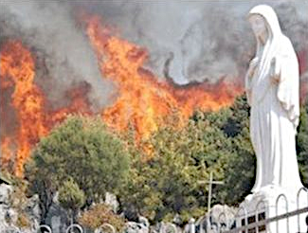
Brdo Ukazanja, Međugorje. U noći 28. na 29. kolovoza 2008.g., netko je udaravši kip čekićem oštetio lice kipa (ožiljak je ostao i nakon popravka, slika dolje), i otkinuo lijevu ruku, a nekoliko dana kasnije (dok još kip nije bio popravljen, vidi sliku desno, kip nema lijeve ruke) netko je podmetnuo požar na više mjesta na Brdu Ukazanja koje je skoro cijelo gorjelo, pod jakim vjetrom. No u blizini kipa vjetar je promijenio smijer, i sveto je mjesto sačuvano.

‘

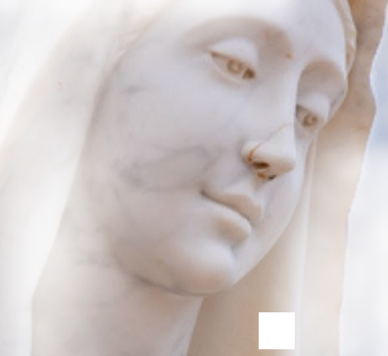
Apparition Hill, Međugorje. On the night between 28 and 29 August 2008, someone hit the statue with a hammer in the face (the scar remained after repair, see the image) and taking off its left hand, and a few days later (while the statue still hadn’t been repaired, image on the right, the left hand is missing) someone ignited a fire in several places on the Hill of Apparitions which was almost completely on fire, under strong wind. But close to the statue the wind changed direction, and the sacred place was safe.

Most Holy Virgin
and Mother, Queen of Peace!
Presveta Djevice i Majko, Kraljice Mira!

Pray and obtain conversion
to all of us,
Pray and obtain
to all of us peace
in our hearts,
Peace in our families,
Izmoli nam svima obraćenje,

Izmoli nam svima mir u srcima,

Mir u našim obiteljima,
I mir u cijelome svijetu!

o ovom žalosnom napadu na Sveto (ali ne o požaru) našli smo na forumu www.tebe-trazim.com, QR-code dolje lijevo daje poveznicu
stranica dolje desno na engl., je naš prvi izvornik, a veliku sliku s ožiljkom preuzeli smo s youtube-kanala centermirmedjugorje.com

And peace in the
whole world!

scan the
QR-code for the link next to it to the source of this info

Association Croatia Fidelis
Vankina 4, Zapruđe, Zagreb
contact: Miroslav Rovis miro.rovis@croatiafidelis.hr
miroslav.rovis@proton.me
+385 1 6602633
+385 91 2660202
https://www.tebe-trazim.com/forum/viewtopic.php?f=1&t=1056&start=230#p77169
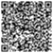
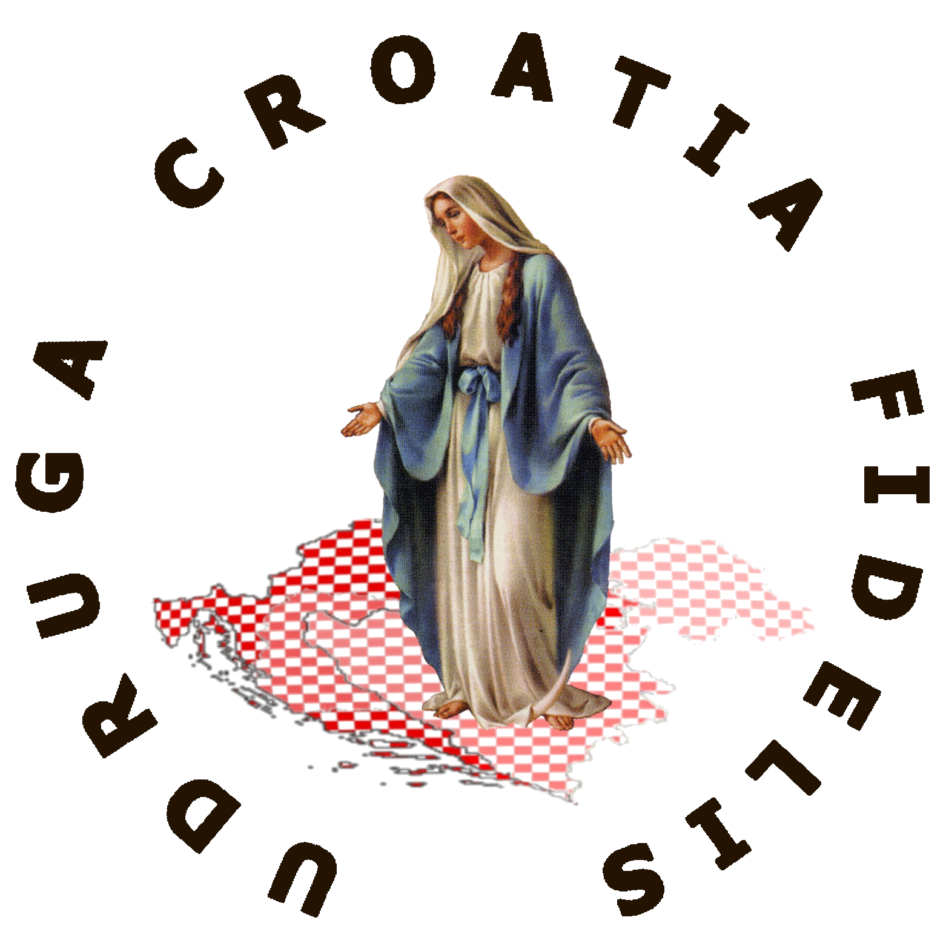
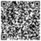
https://mysticpost.com/the-miracle-that-built-the-famous-statue-on-apparition-hill-20-years-ago/
not for sale
nije na prodaju

